
Center for Coastline Security
Appendix: Port Evergaldes Simulation

CAD Drawing of Port Everglades 5
CAD Drawing of Port Everglades 6
Close-up of channel with bottom texture applied 17
Channel placed into 3D Arial Photo 20
Wireframe of cargo containers 44
Wireframe model of Regional Transit Authority Train 48
Rendering of proposed Regional Transit Authority Train 48
Cargo Ship Wireframe Model 51
Cargo Ship Rendering 52
Queen Marie Two Wireframe Model 53
Rendering of Queen Mary 2 54
Queen Mary 2 Rear View 55
Queen Mary 2 Levels of Detail 56
Ticonderoga Class Battleship Wire frame 57
Ticonderoga Class Battleship Rendering 58
Yacht Wireframe model 59
Yacht Rendering 60
Truck Type 1 Rendering 61
Truck Type 2 Rendering 62
Truck Type 3 Rendering 63
Rendering of Port From Above 64
Rendering of Port Entrance 65
Rendering of Port Entrance 66
Rendering of Building Outside of Port Gate 67
Power plant Inside of Port 68
Administrative Building at Port Everglades 69
Administrative Building at Port Everglades 70
Eller Drive Security Checkpoint 71
Eller Drive Security Checkpoint 72
Main Administration Building 73
Container Area 74
Eller Drive Rendering 75
Eller Drive Rendering Approaching Harbor Master’s Building 76
Harbor Masters Building 77
Harbor Masters Building 78
View from Harbor Masters Building 79
View from Harbor Masters Building 80
USS Ticonderoga 81
17th St Bridge near Port Everglades 82
17th St Bridge near Port Everglades 83
17th St Bridge near Port Everglades 84
17th St Bridge near Port Everglades 85
Cruise Terminal 86
Cruise Terminal Aerial 87
Tank Farm Storage Area 88
Tank Farm Storage Area 89
Queen Mary 2 by Gentry Loading Cranes 90
Gentry Loading Cranes by Queen Mary 2 91
Queen Mary 2 Close-up 92
Cargo Containers 93
Gentry Loading Cranes 94
Loading Crane Close-up 95
Underwater scene with LIDAR generated Port Channel 96
Underwater Scene with LIDAR generated Port Channel 97
Fog Simulation 98
Fog Simulation 99
Fog Simulation 100
Flooding Scenario 101
Flooding Scenario 102
Night Time Port View 103
Night Time Port View 104
Cargo Ship Entering Port at Night 105

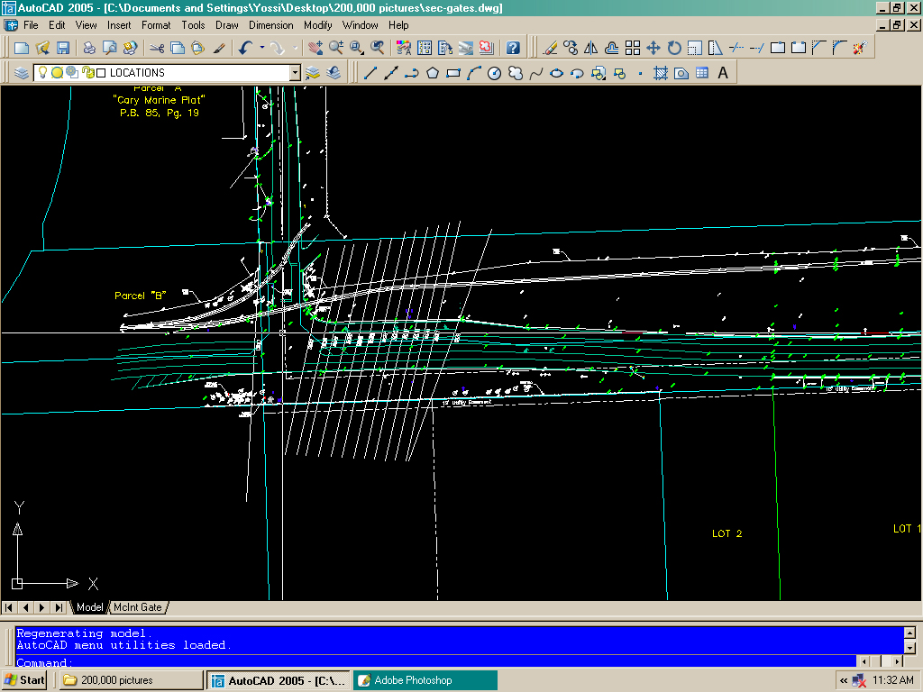
CAD Drawing of Port Everglades
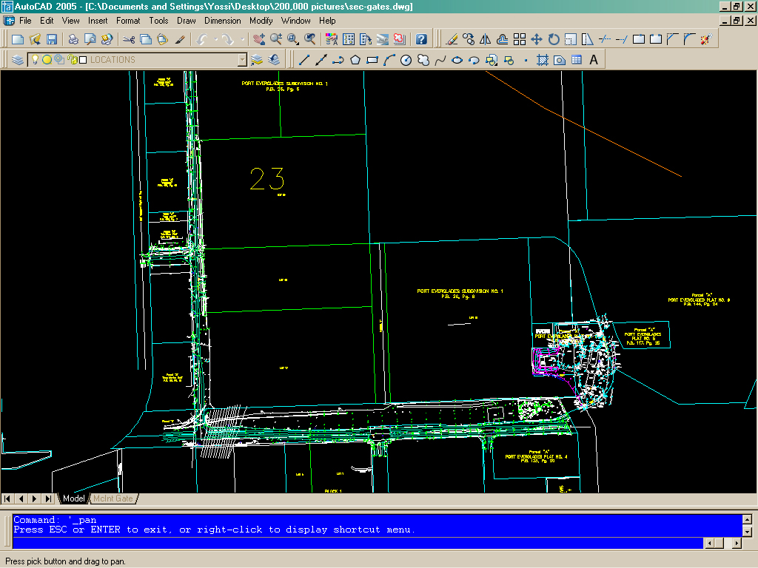

CAD Drawing of Port Everglades
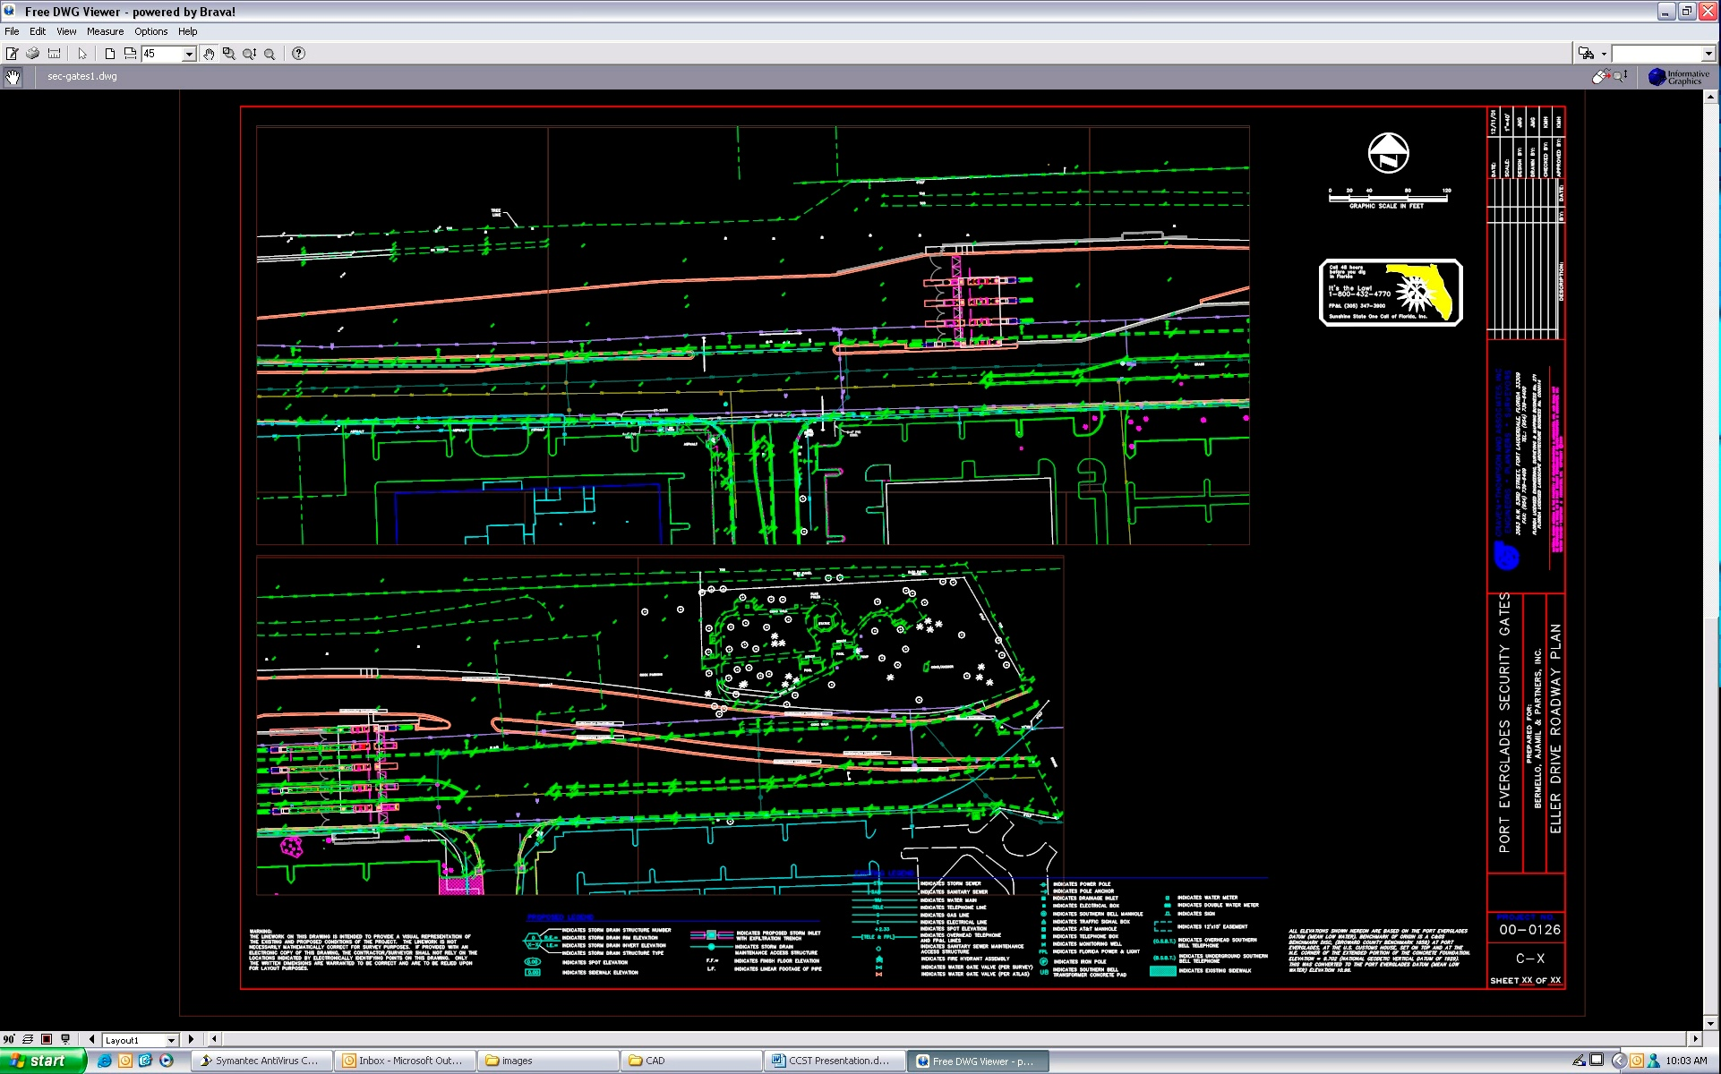

CAD Drawing of Port Everglades

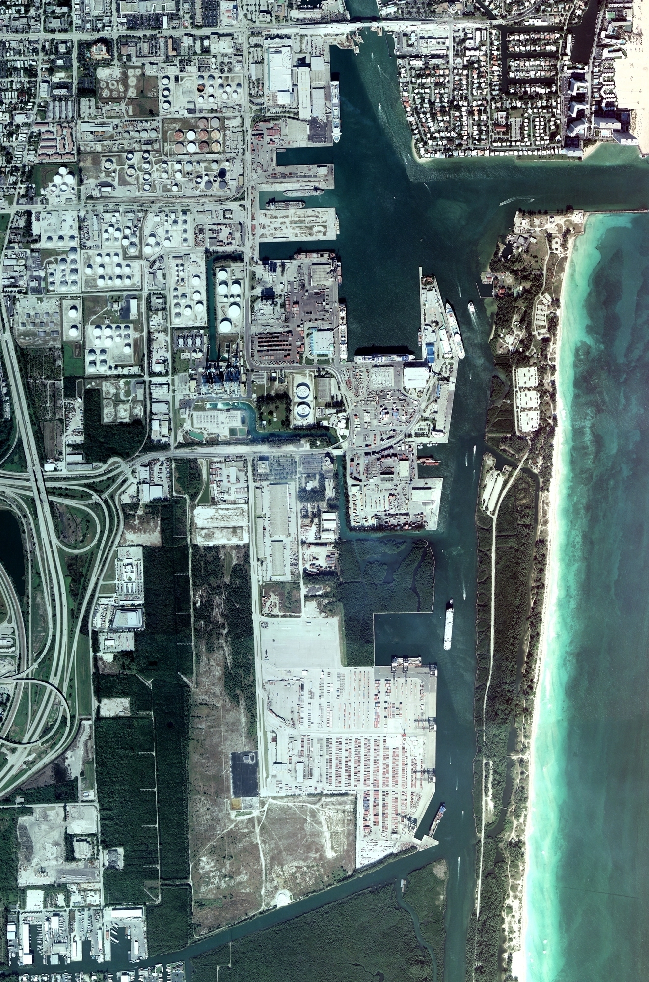
Aerial Photograph of Port Everglades
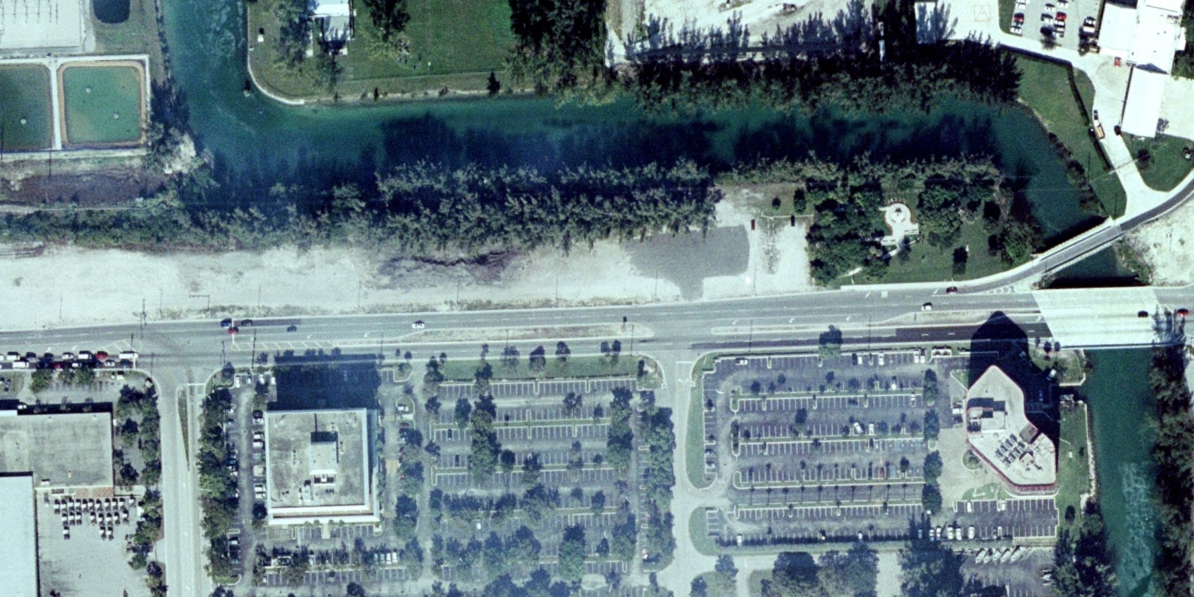 Aerial Photograph of Port Everglades Above Proposed Security Gates
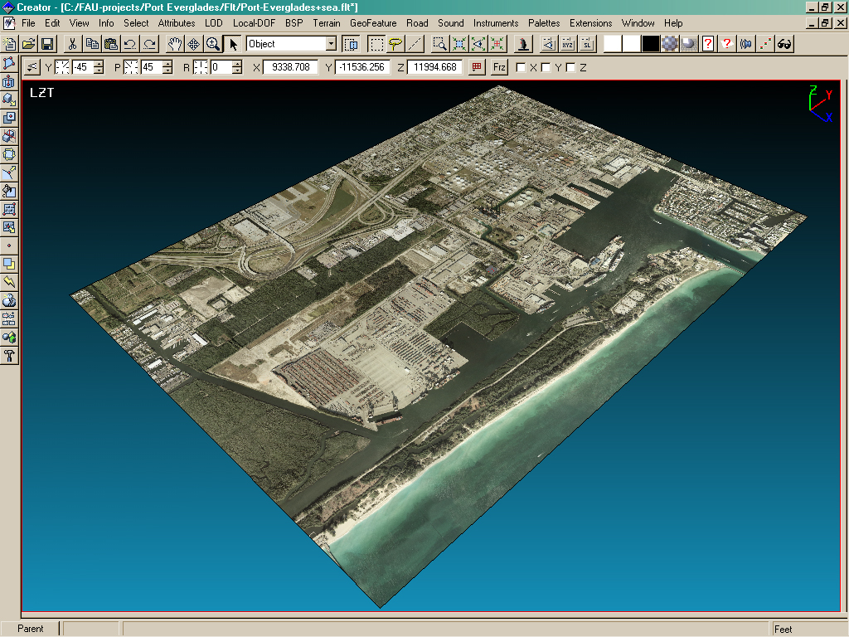
Aerial Photograph of Port Everglades Projected on 3D Plane
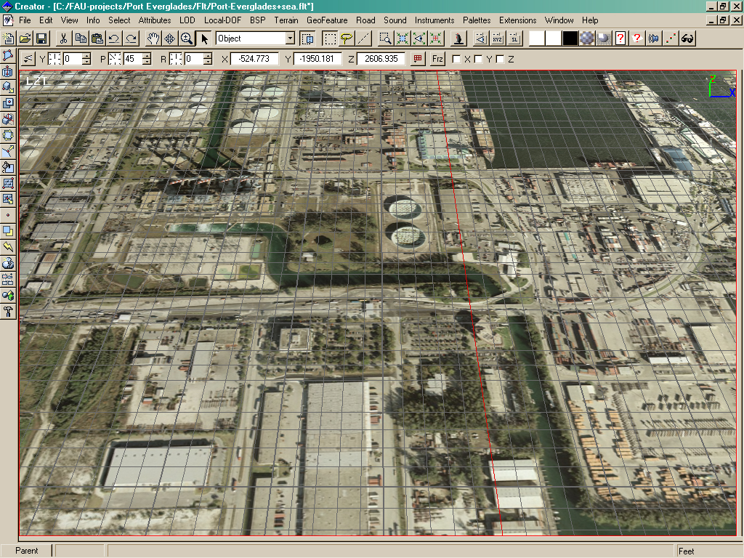
Aerial Photograph of Port Everglades Projected on 3D Plane
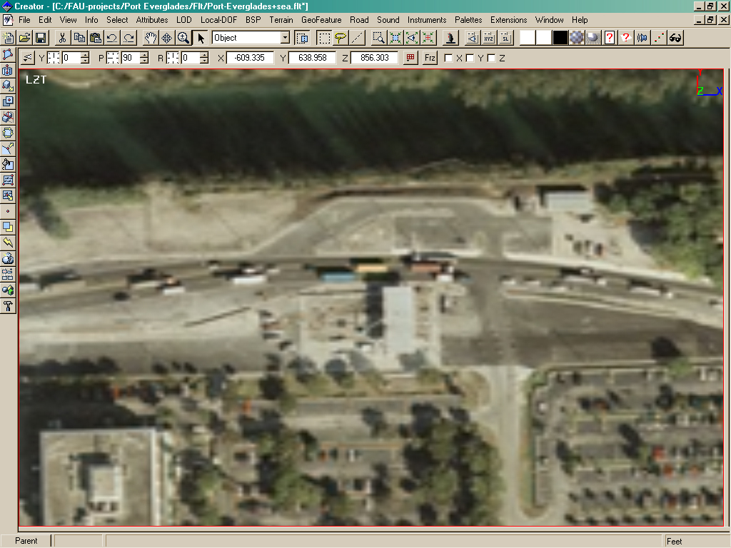
Aerial Photograph of Security Gates at Port Everglades Projected on 3D Plane
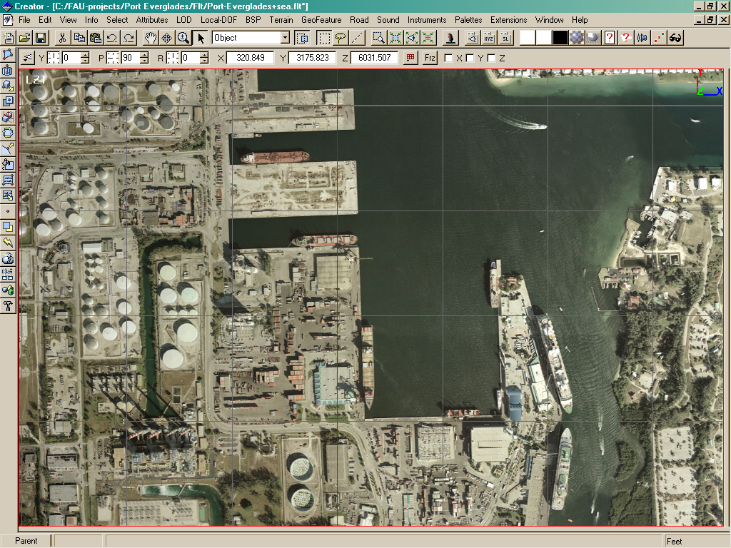
Aerial Photograph of docks at Port Everglades Projected on 3D Plane
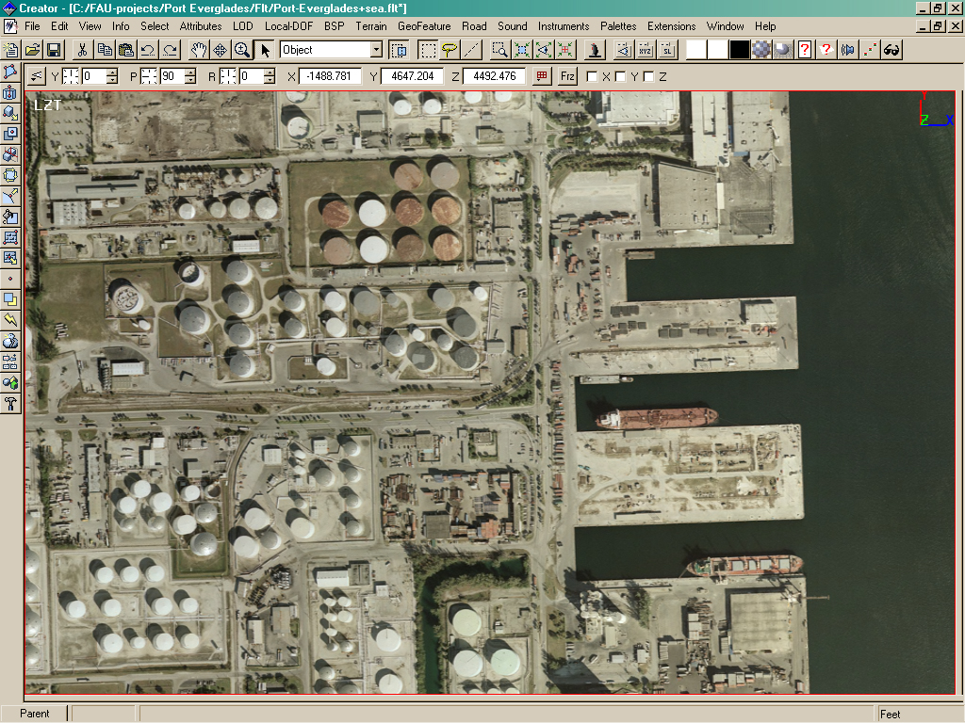
Aerial Photograph of tank farm at Port Everglades Projected on 3D Plane
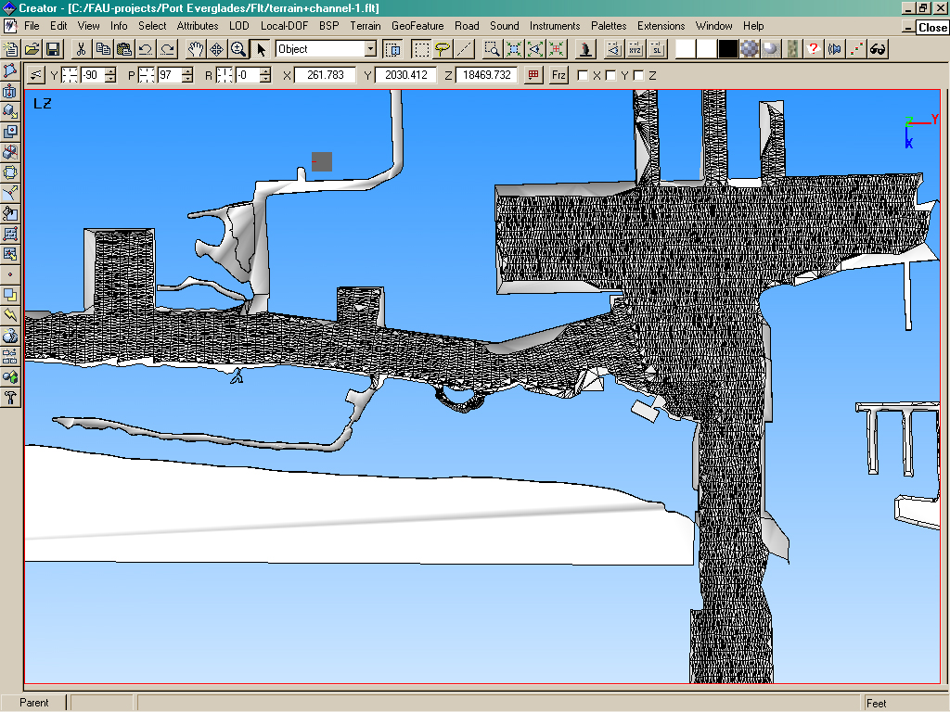
3D Model generated of Channel LIDAR(LIght Detecting and Ranging) Data
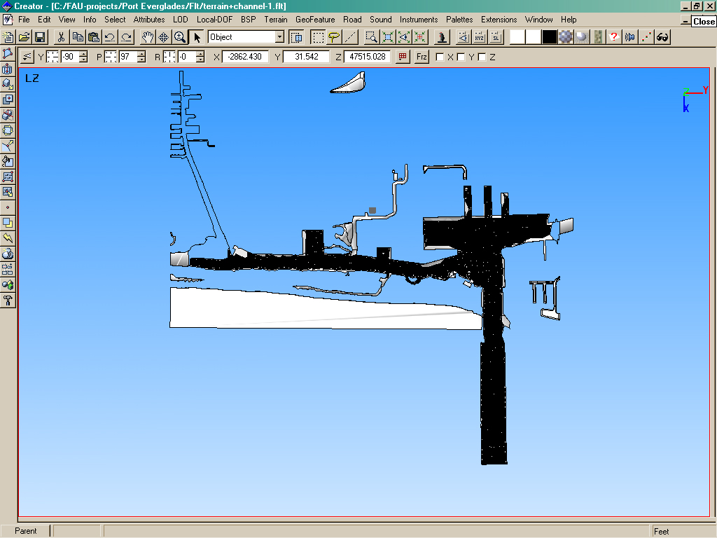
Rendering of the entire channel from LIDAR Data
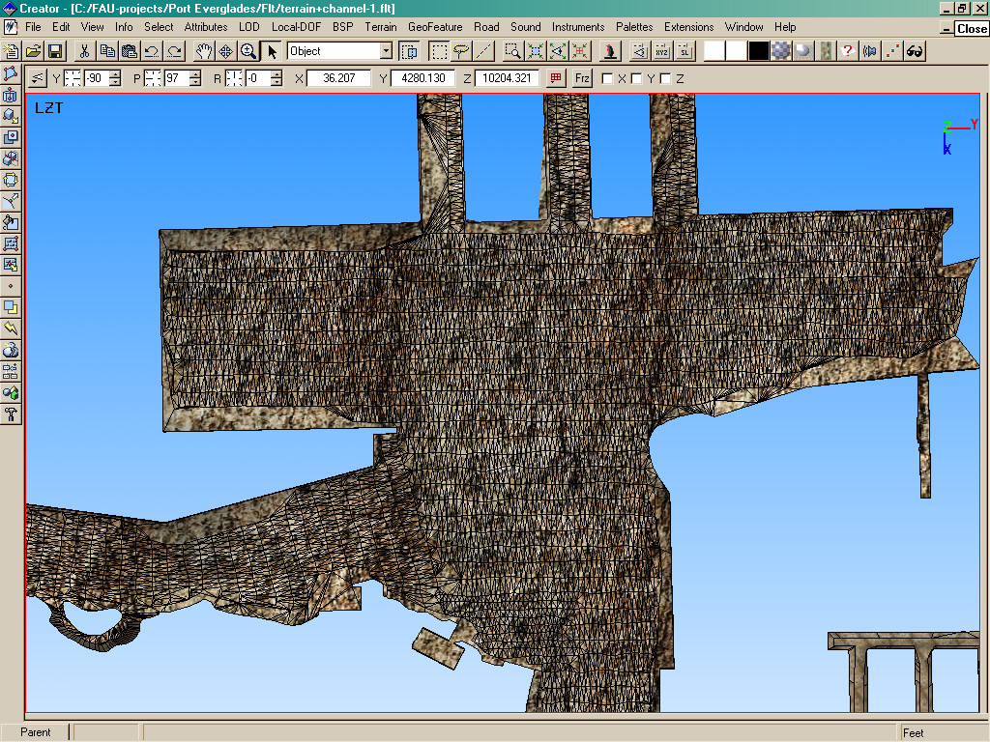

Close-up of channel with bottom texture applied
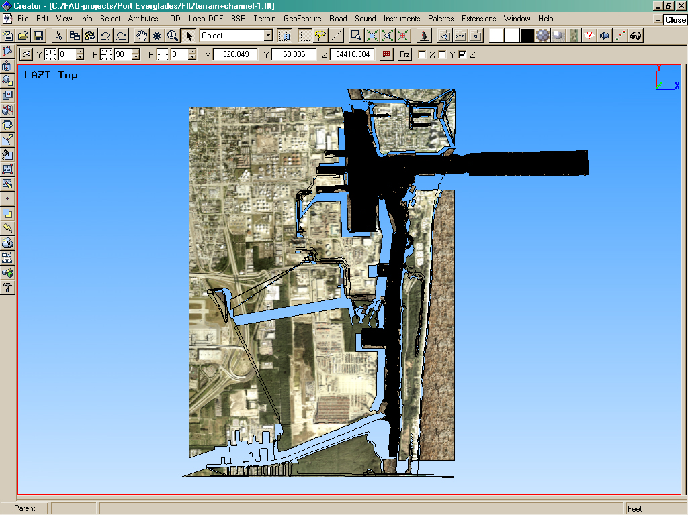
Channel placed into 3D Arial Photo
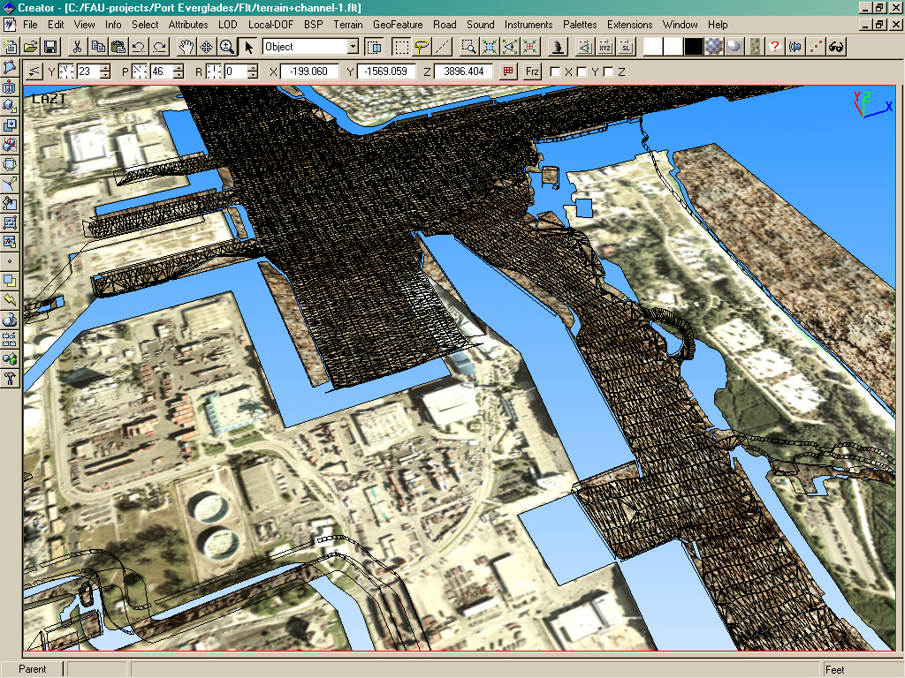
Channel placed into 3D Arial Photo
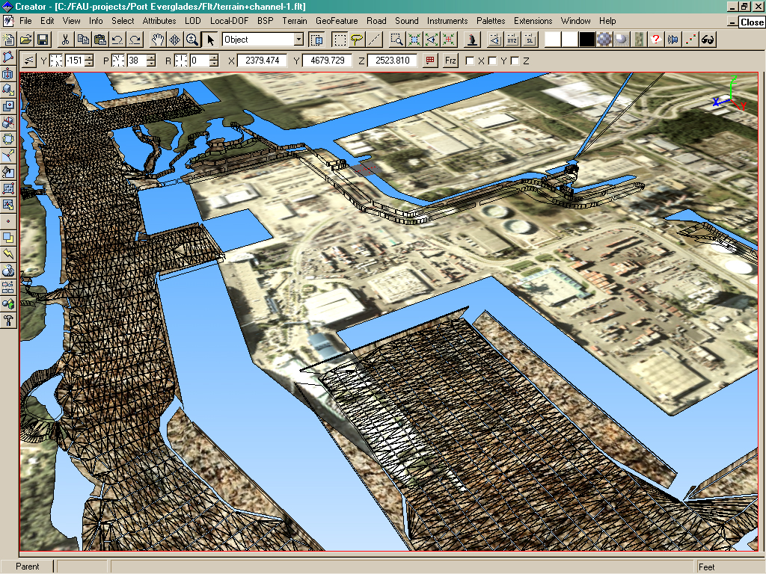

Channel placed into 3D Arial Photo
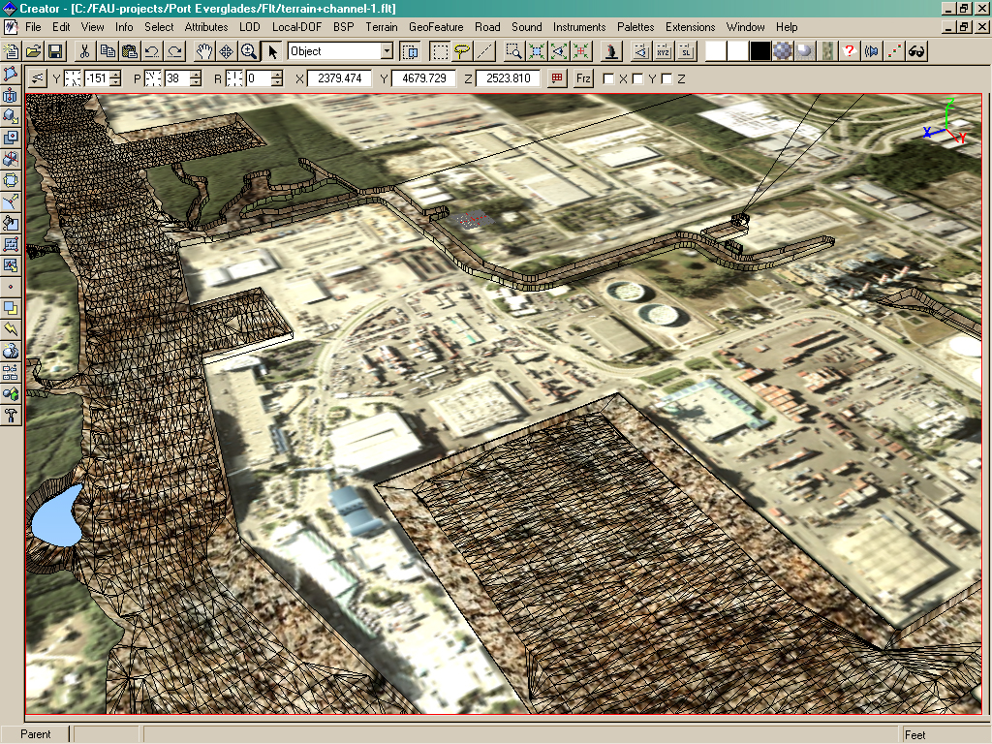
Model stitched into terrain
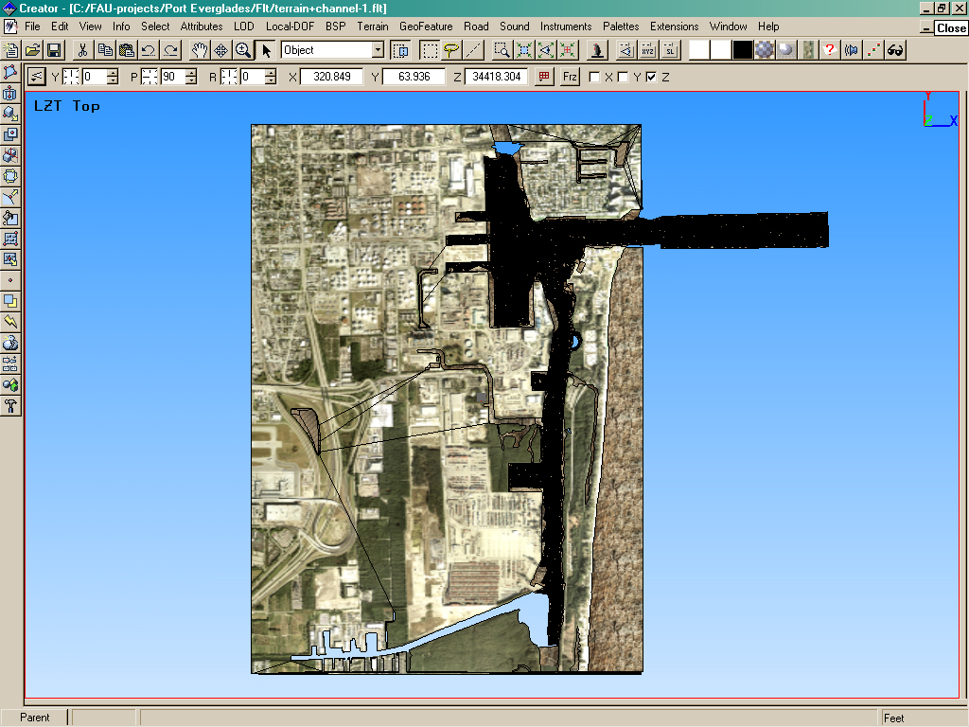
Channel in terrain as seen from above
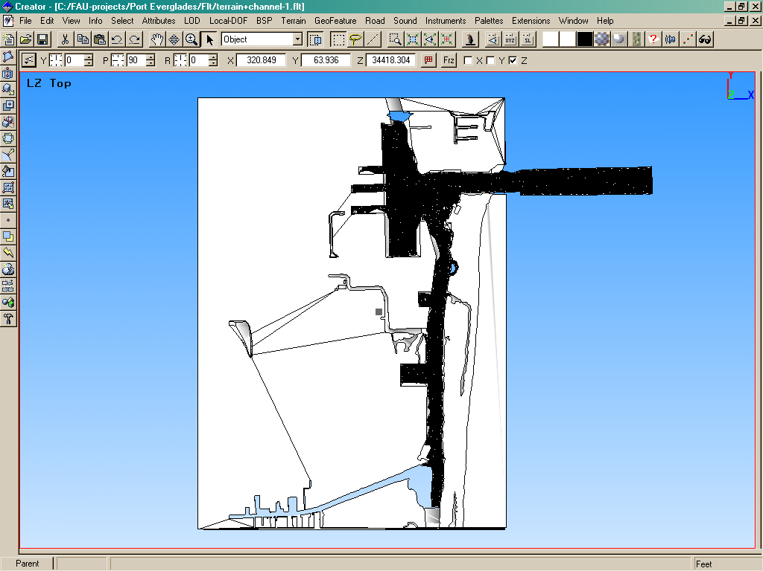
Untextured Wire frame of channel with terrain
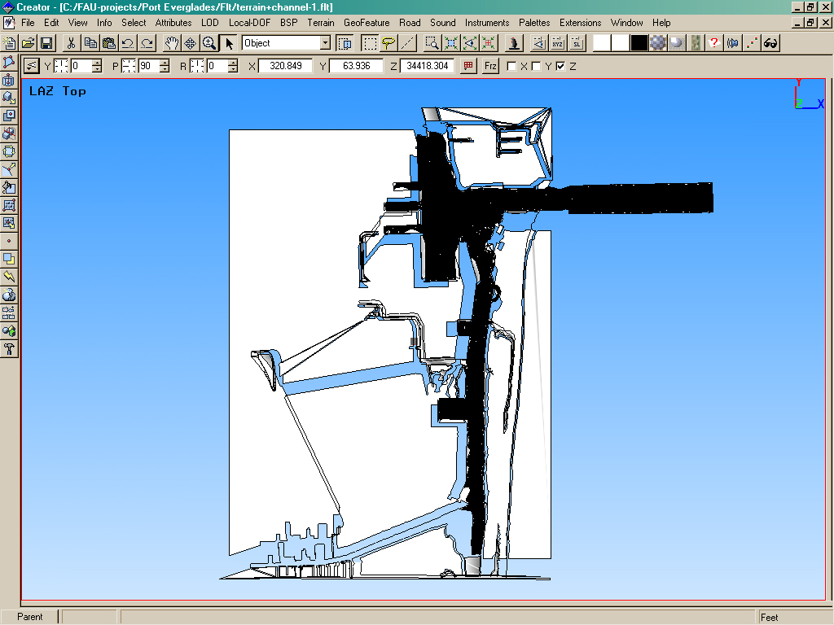
Untextured Wire frame of channel with terrain
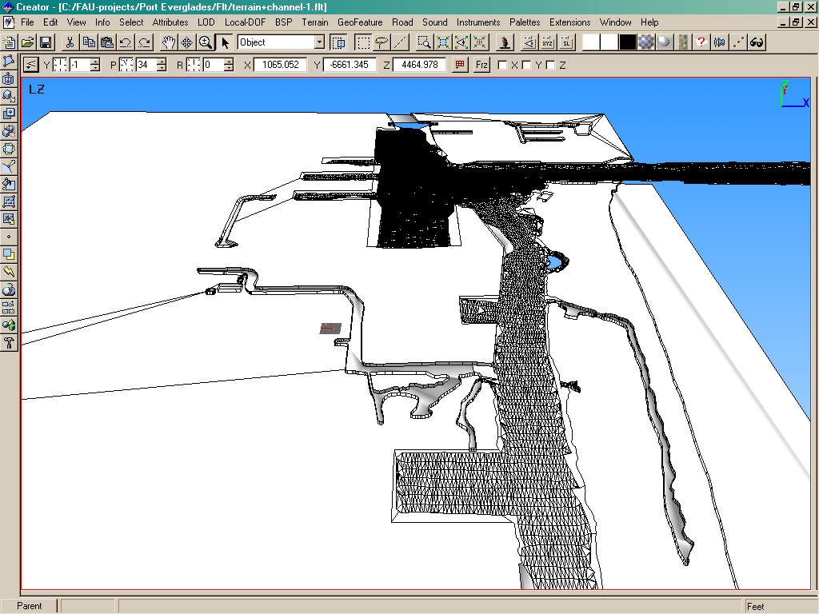
Untextured Wire frame of channel with terrain
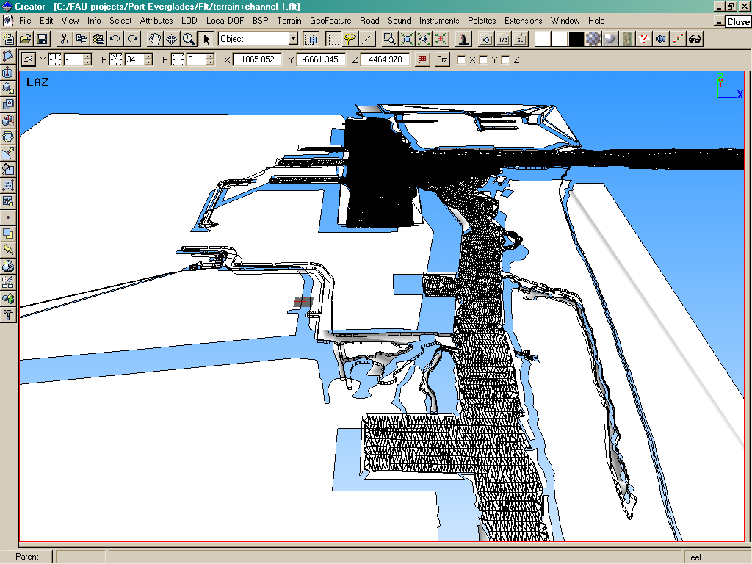
Untextured Wire frame of channel with terrain
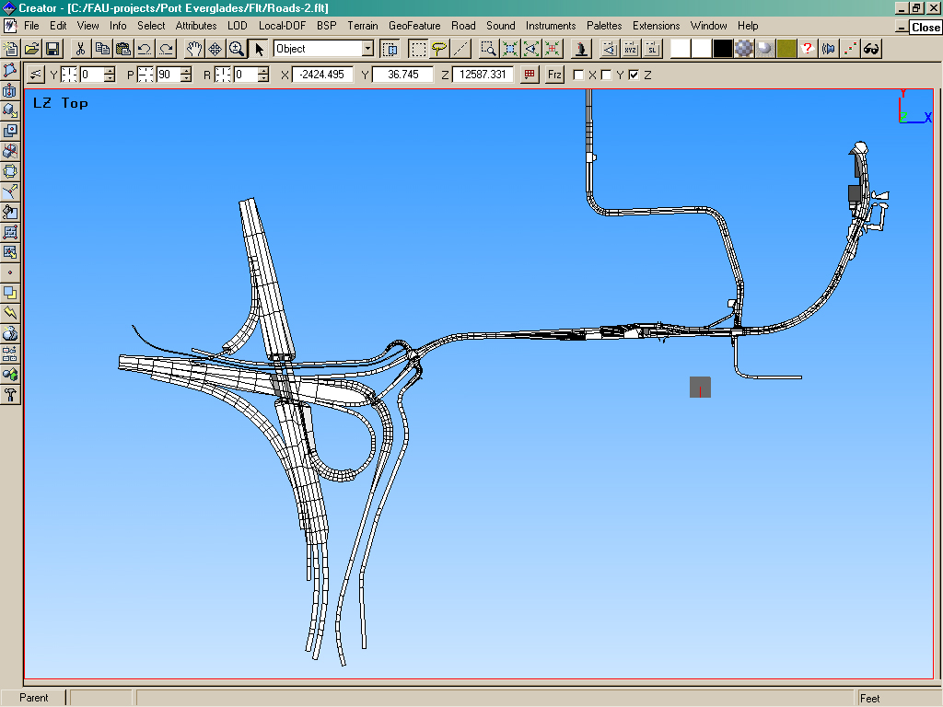
Untextured model of roadways around port
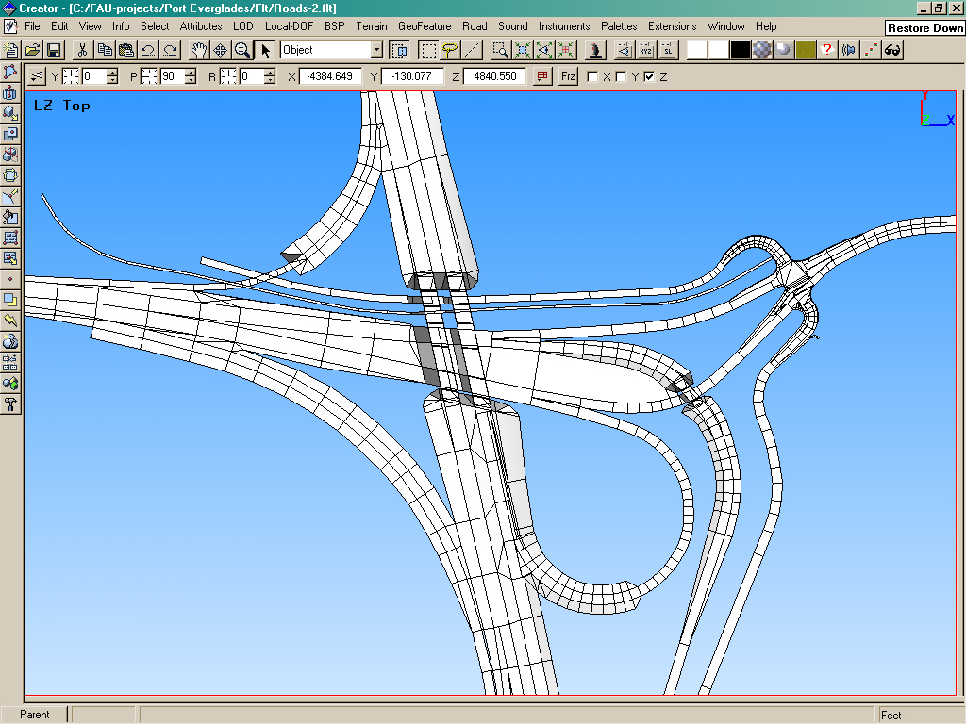
Untextured model of roadways around port
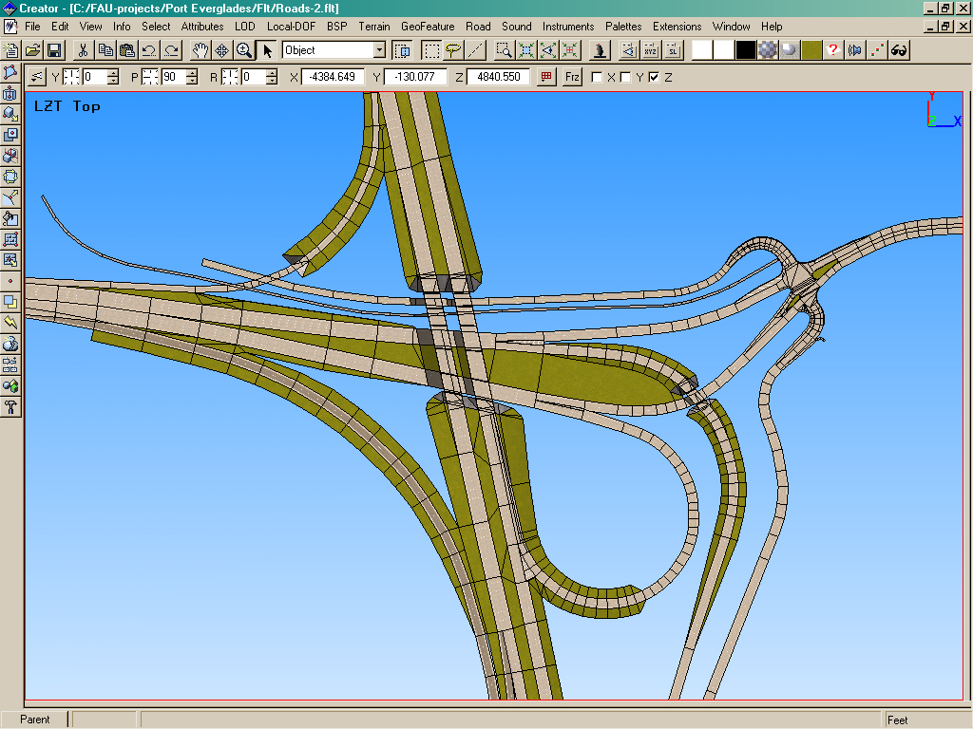
Textured model of roadways around port
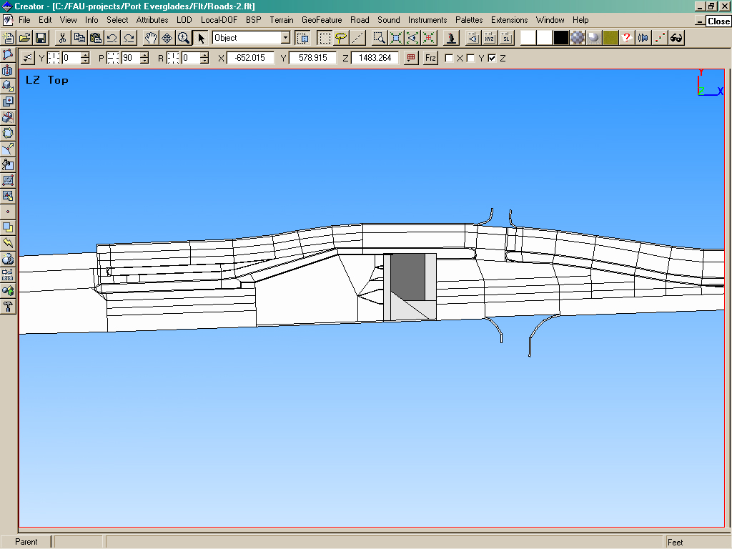
Untextured close-up of roadways around port
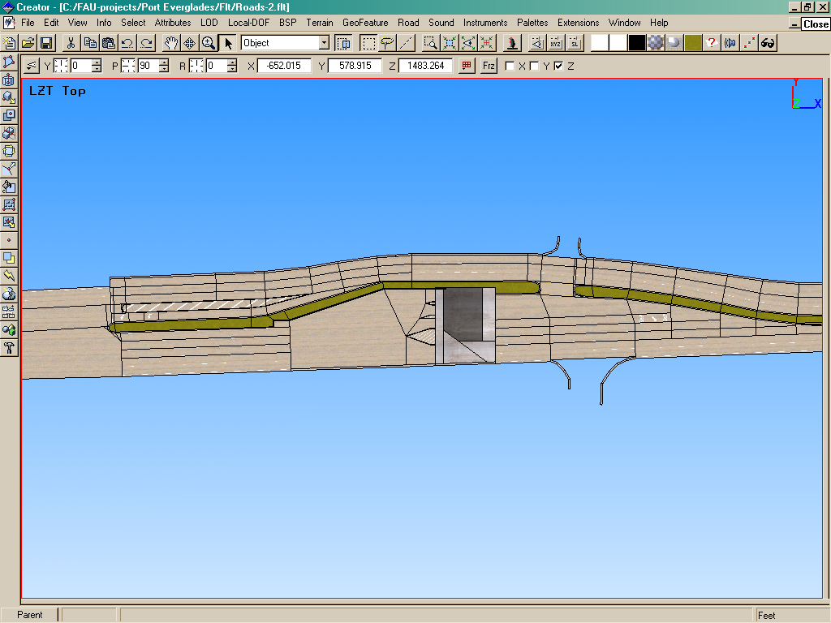
Textured close-up of roadways around port
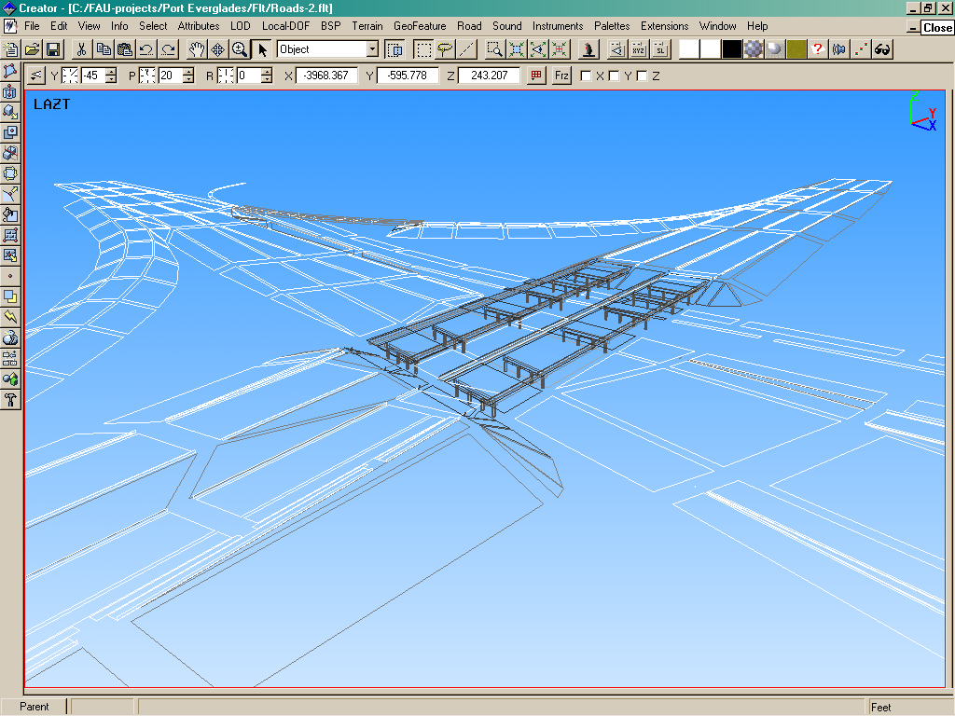
Wireframe of overpass near port
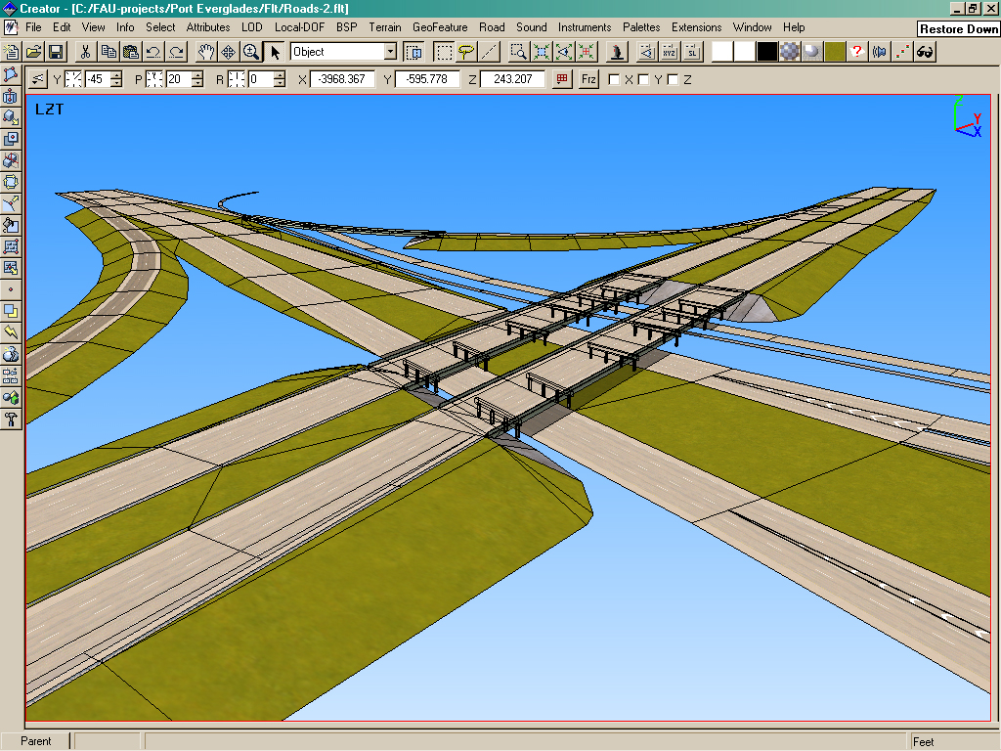
Textured Wireframe model of Overpass near port
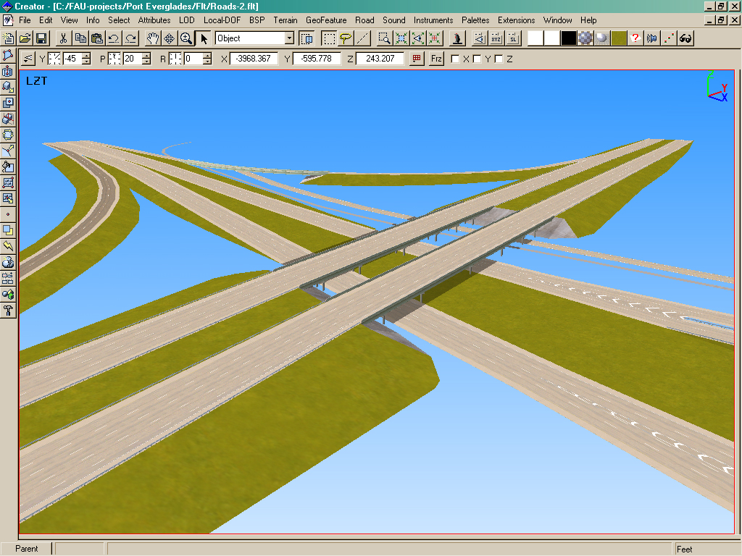
Rendering of overpass
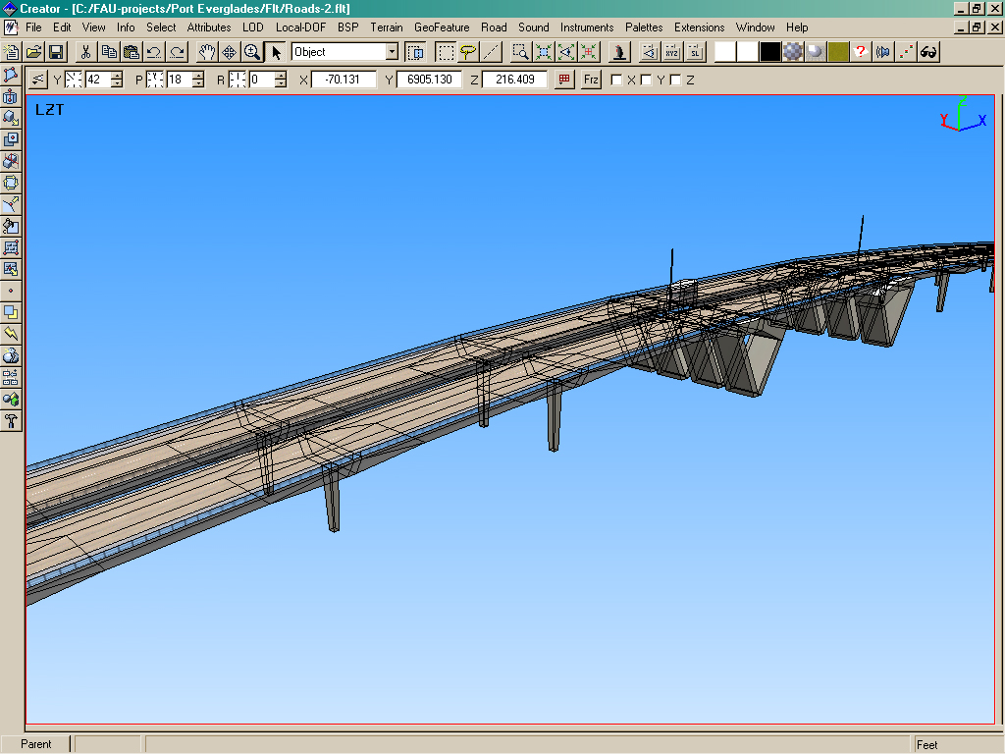
Textures wireframe model of bridge north of Port Everglades
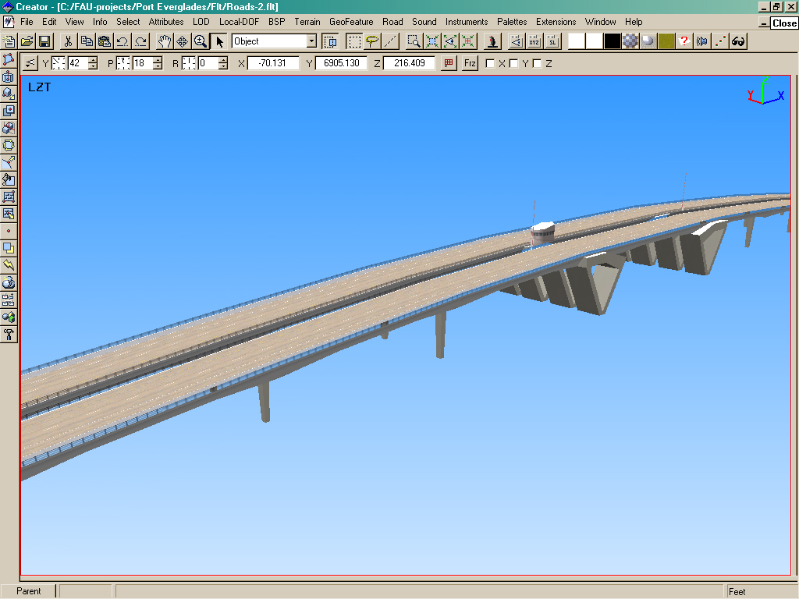
Rendering of bridge north of Port Everglades
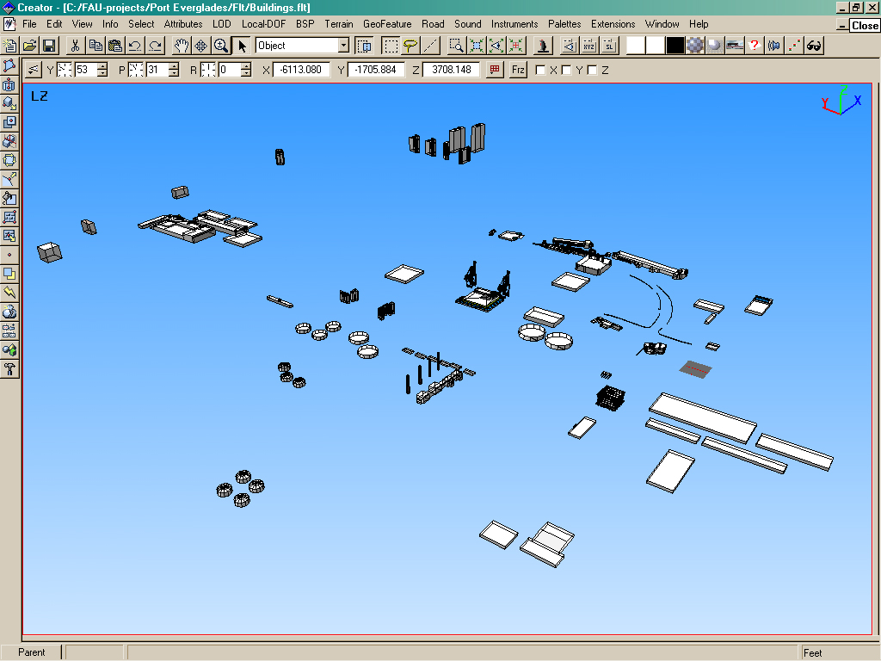
Wireframe of various building structures around Port Everglades
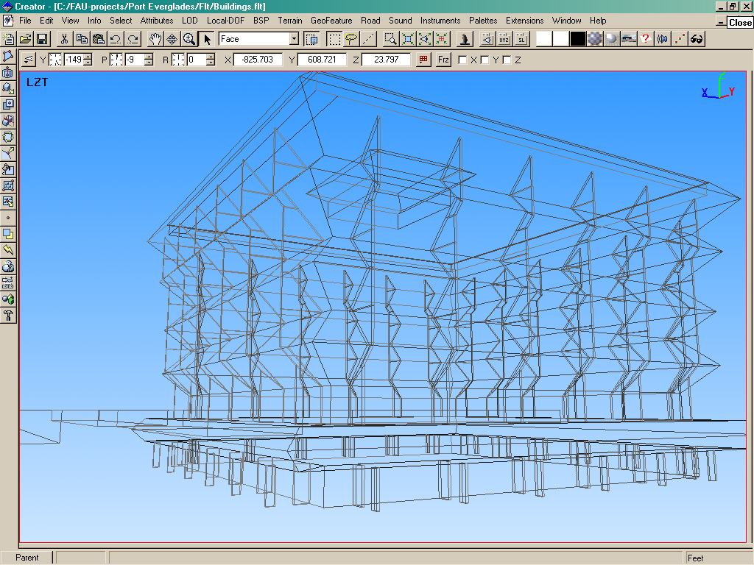
Wireframe model of building
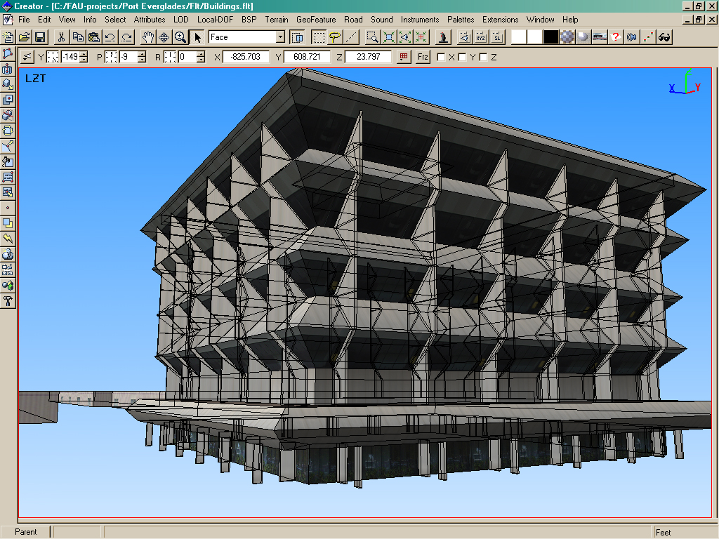
Textures wireframe of building
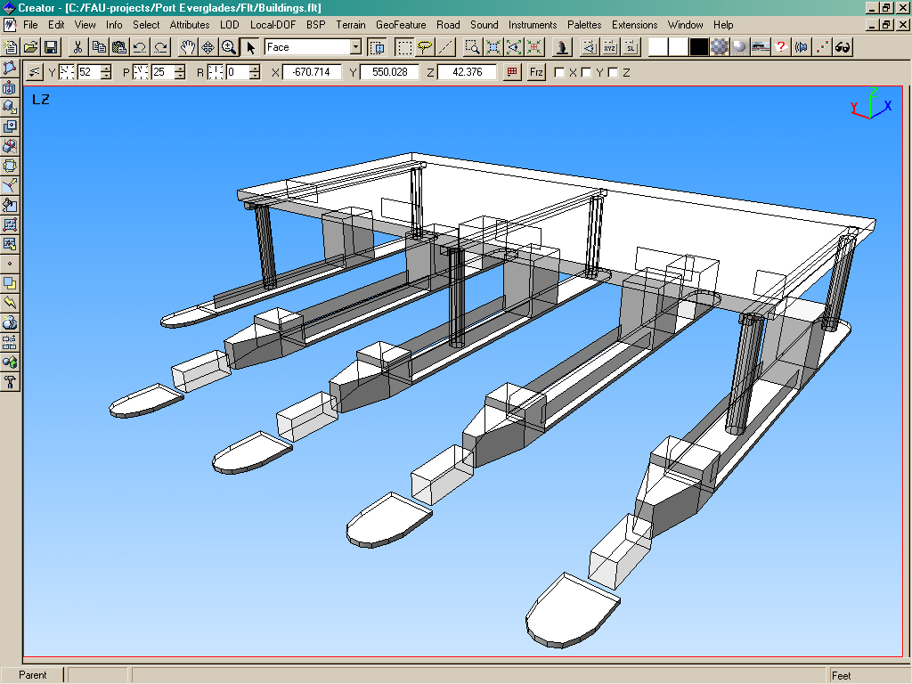
Untextured model of security gate
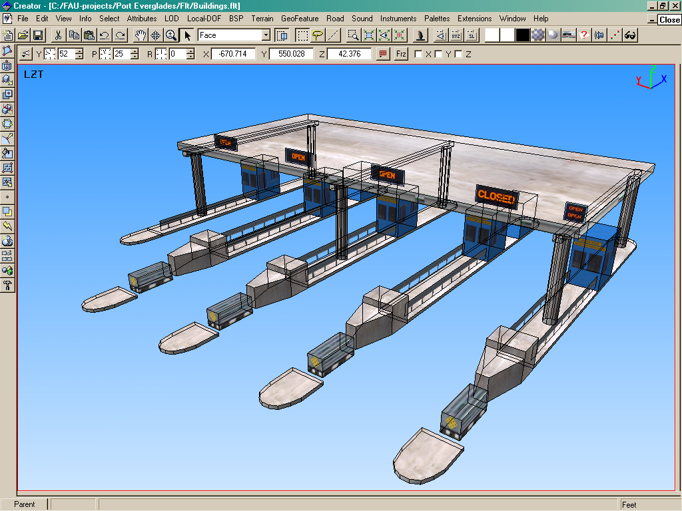
Textured wireframe of security gate
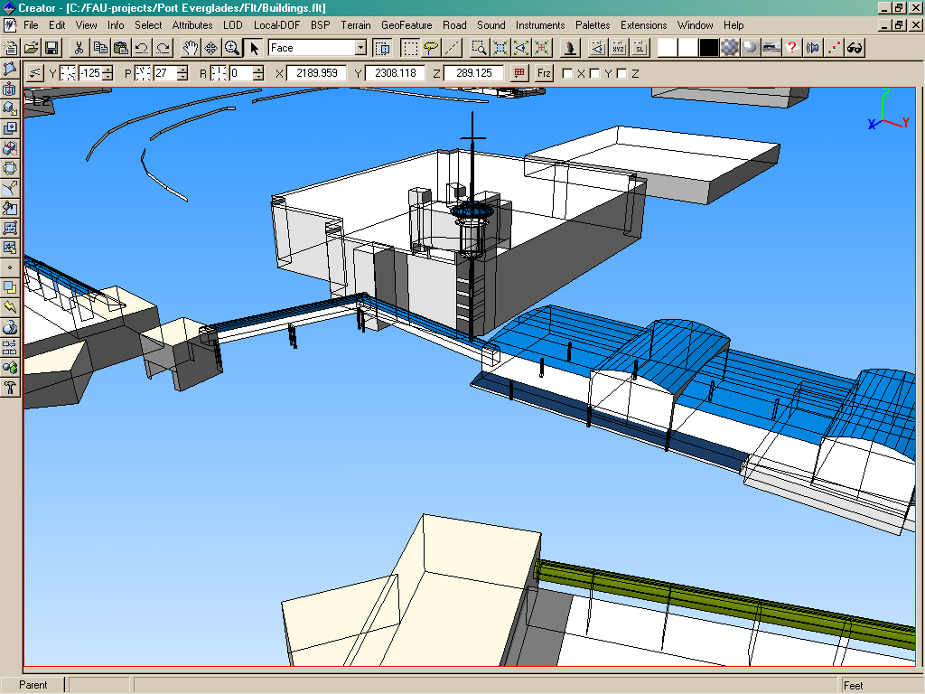
Wireframe of harbormaster’s tower
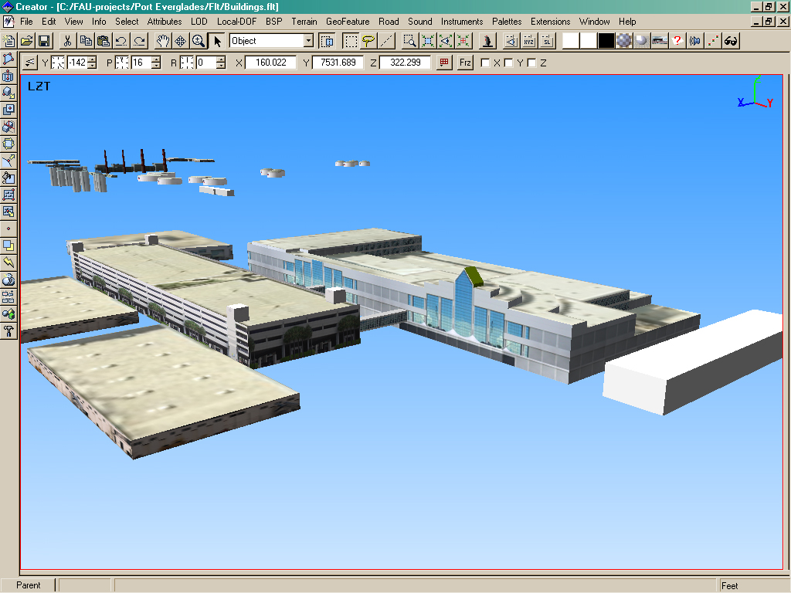
Rendering of cruise terminal and parking garage
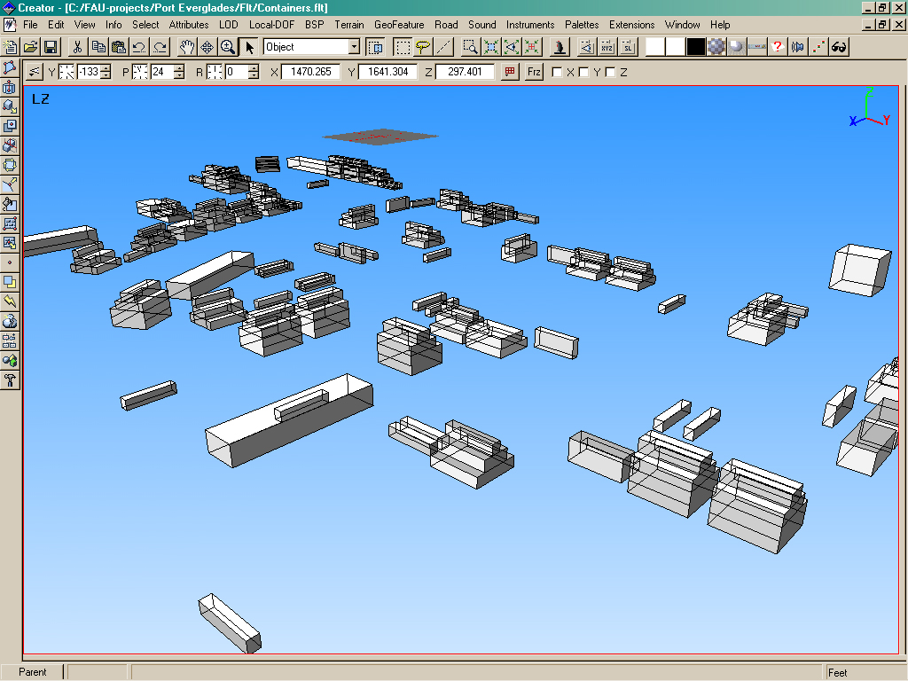

Wireframe of cargo containers
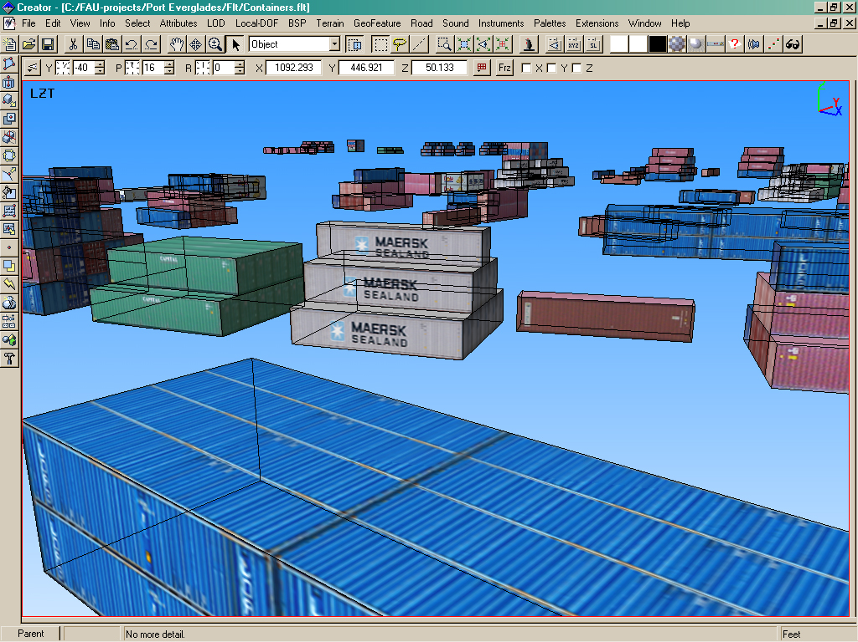
Textured wireframe of cargo containers
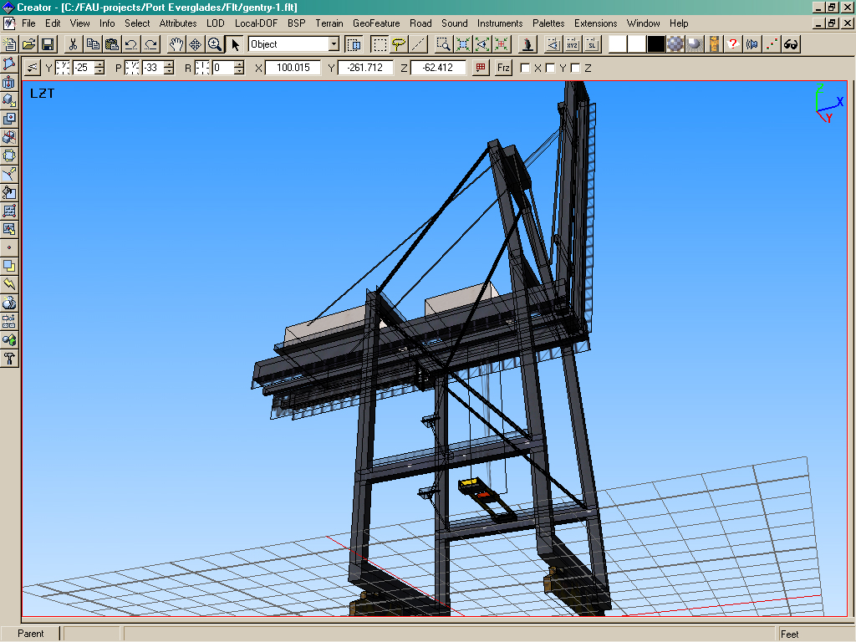
Textured wireframe of gentry crane
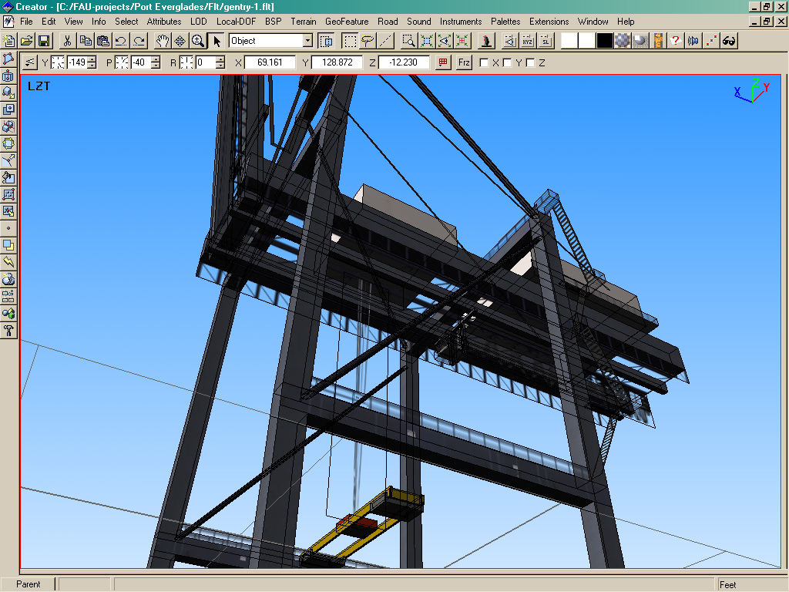
Textured wireframe of gentry crane
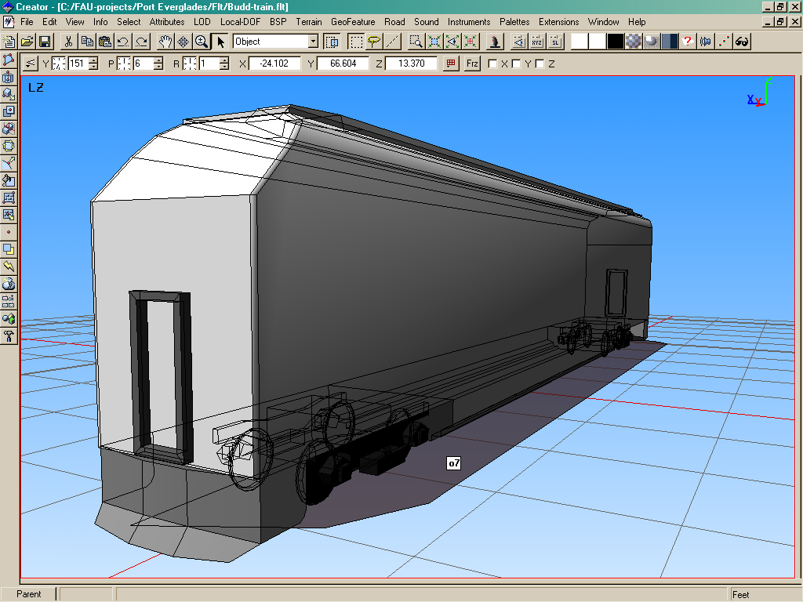

Wireframe model of Regional Transit Authority Train
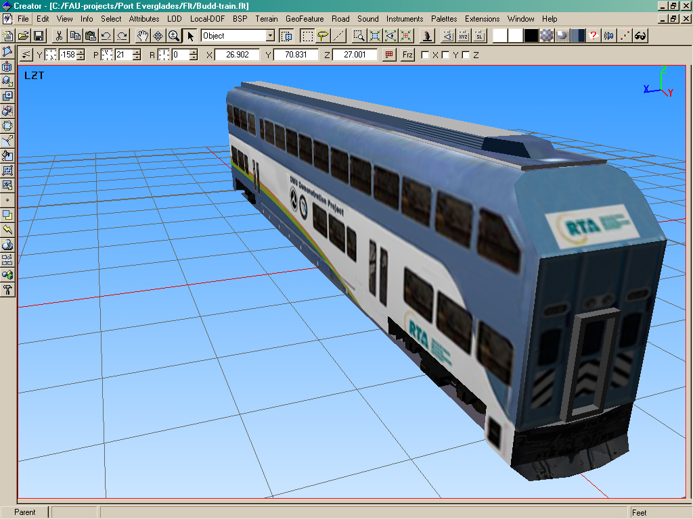

Rendering of proposed Regional Transit Authority Train
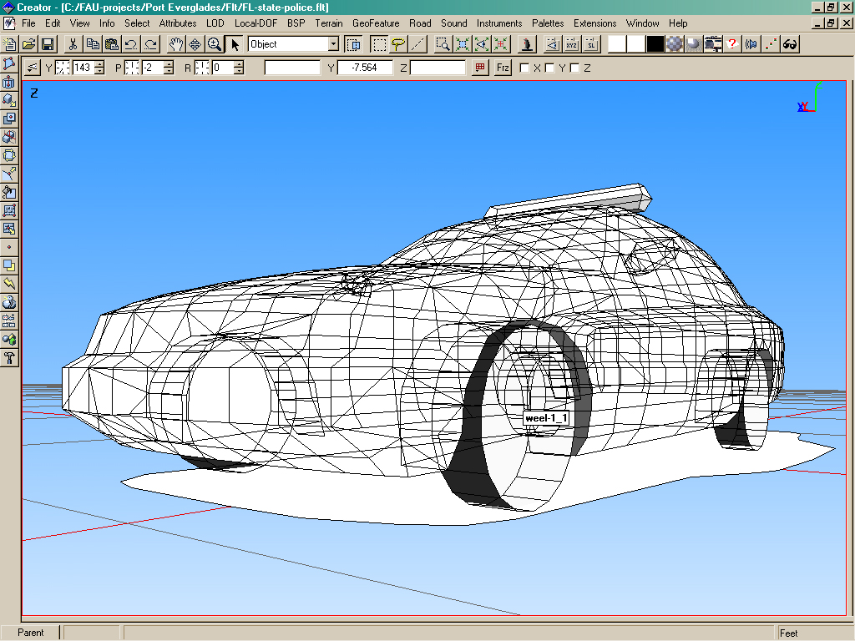
Wireframe of police car model
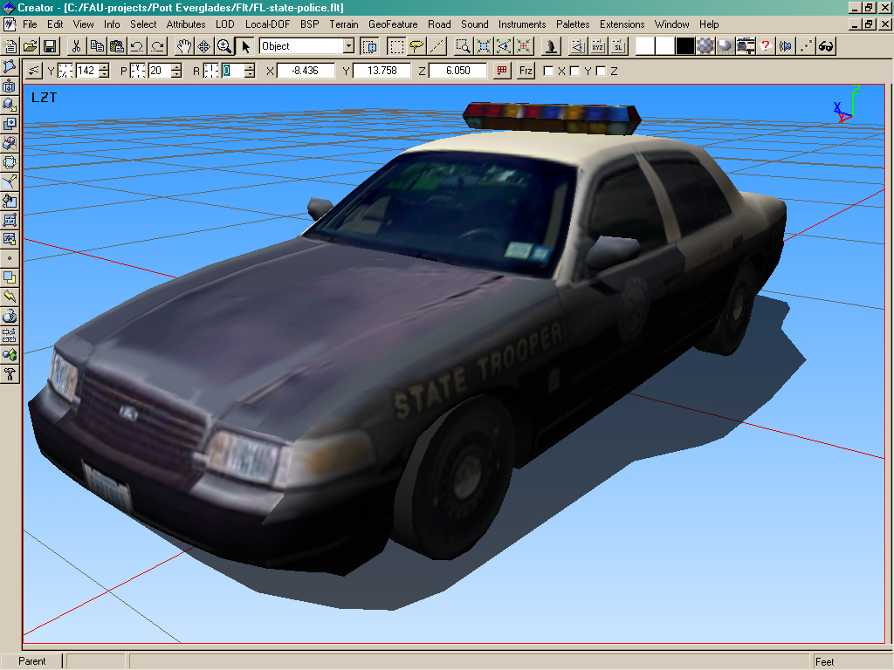
Rendering of police car model
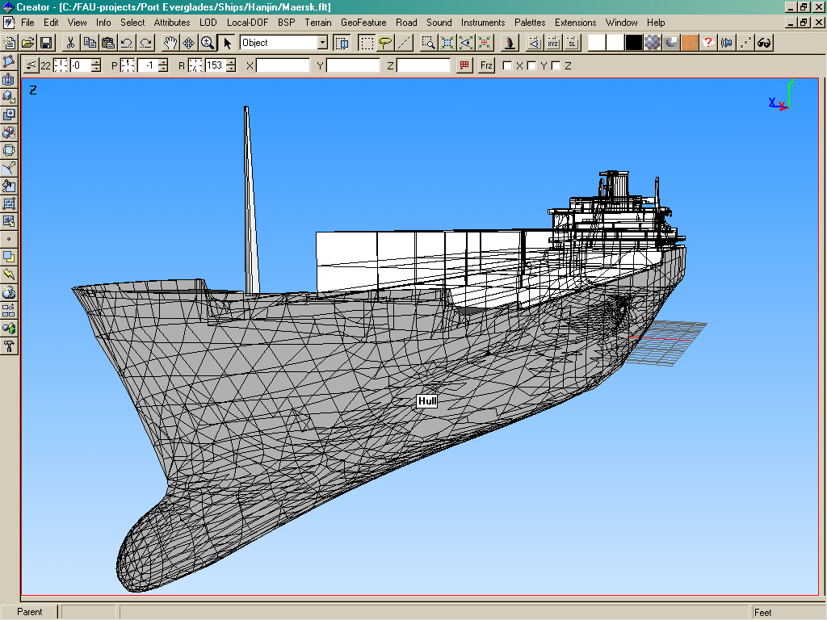

Cargo Ship Wireframe Model
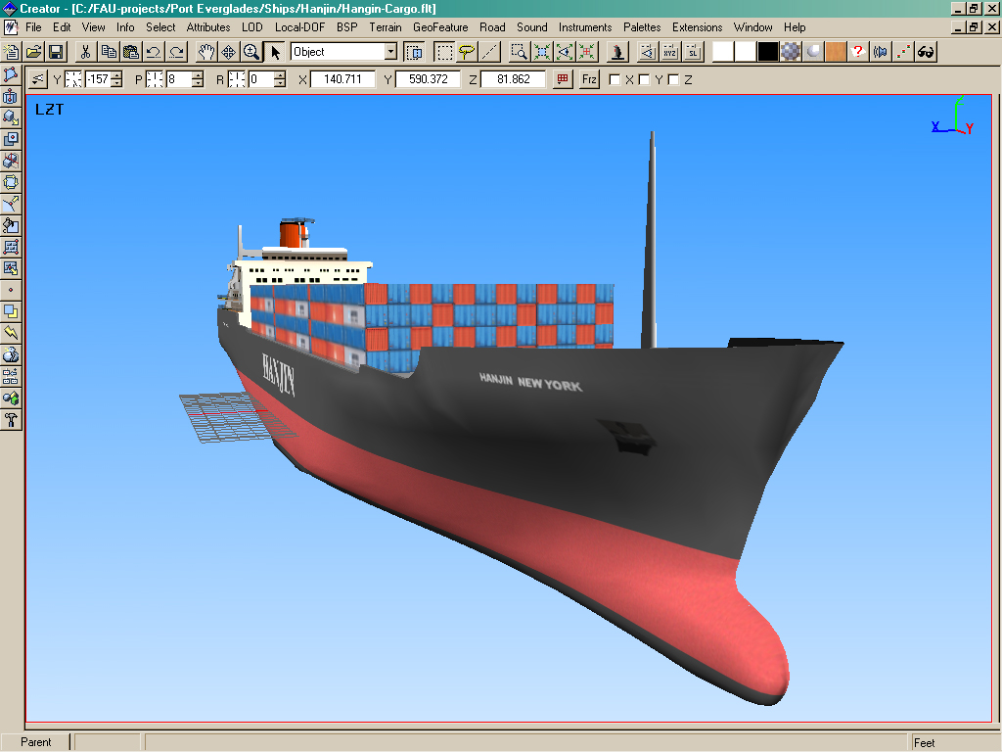

Cargo Ship Rendering

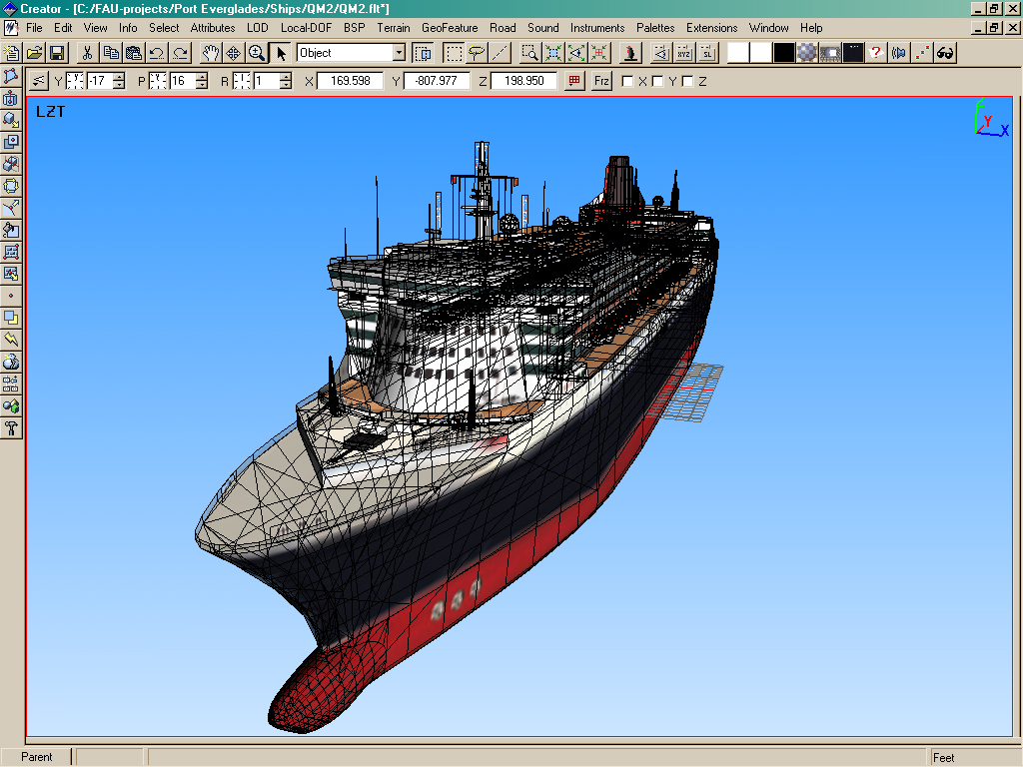

Queen Marie Two Wireframe Model
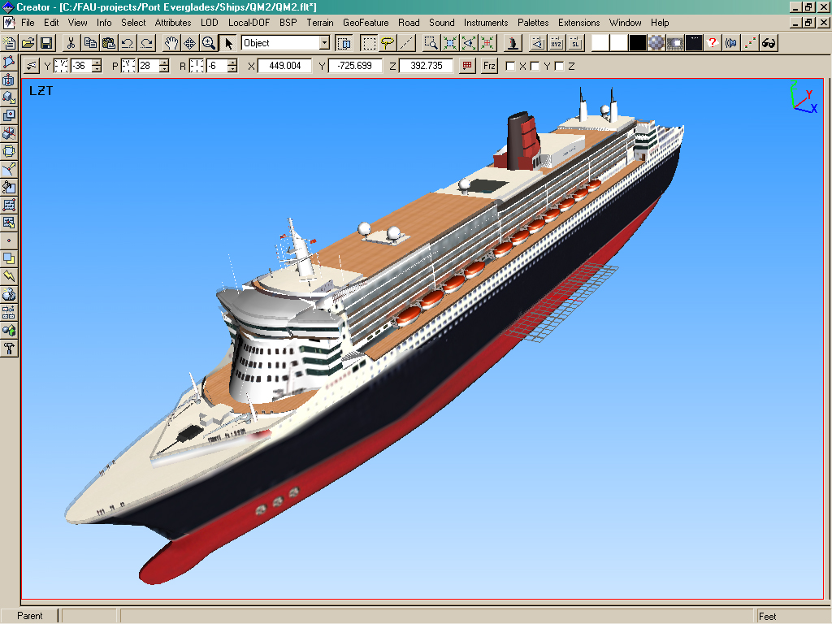

Rendering of Queen Mary 2

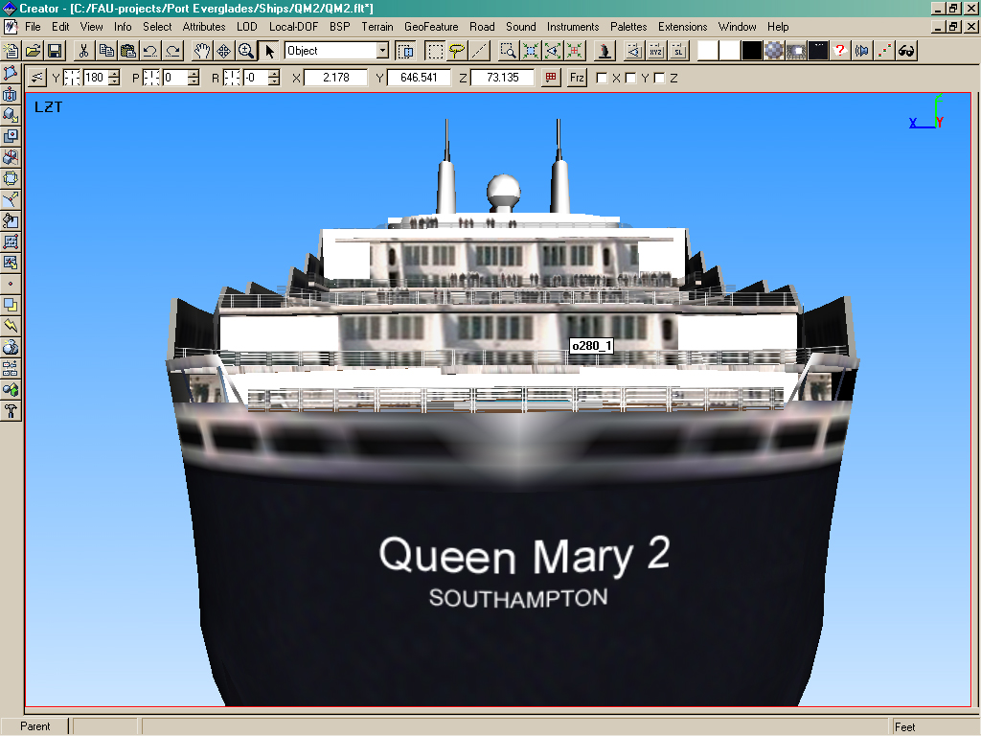

Queen Mary 2 Rear View
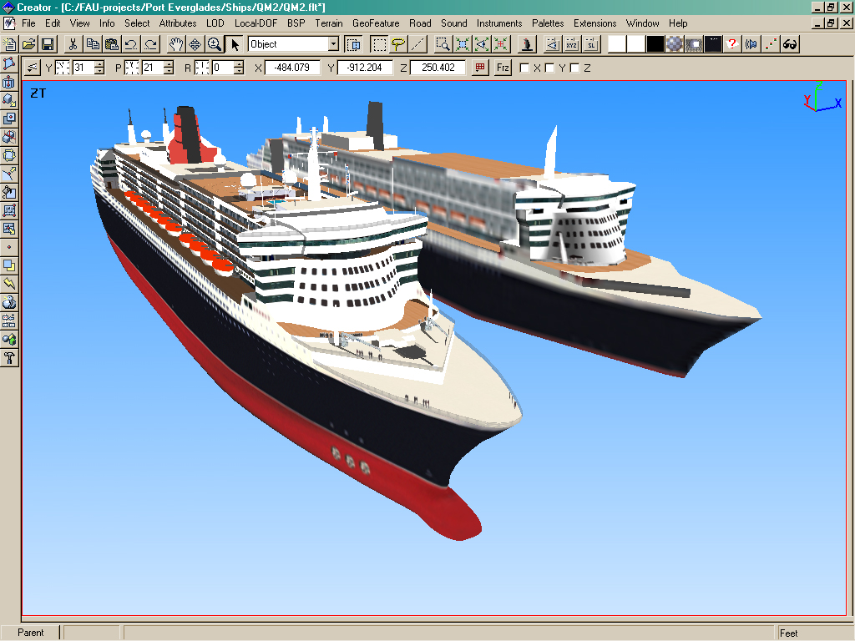

Queen Mary 2 Levels of Detail

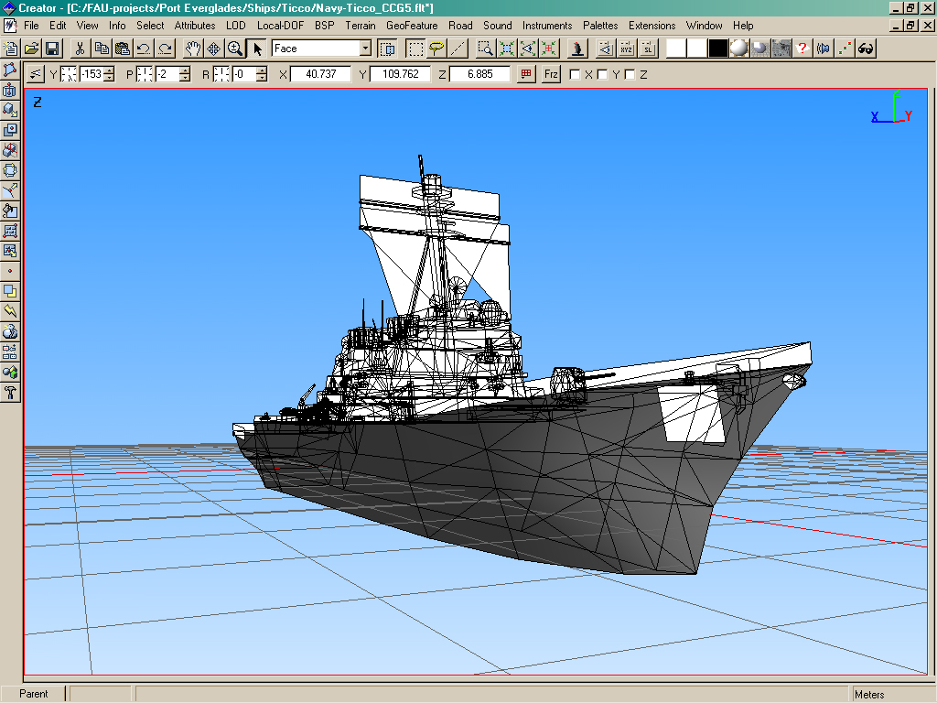

Ticonderoga Class Battleship Wire frame

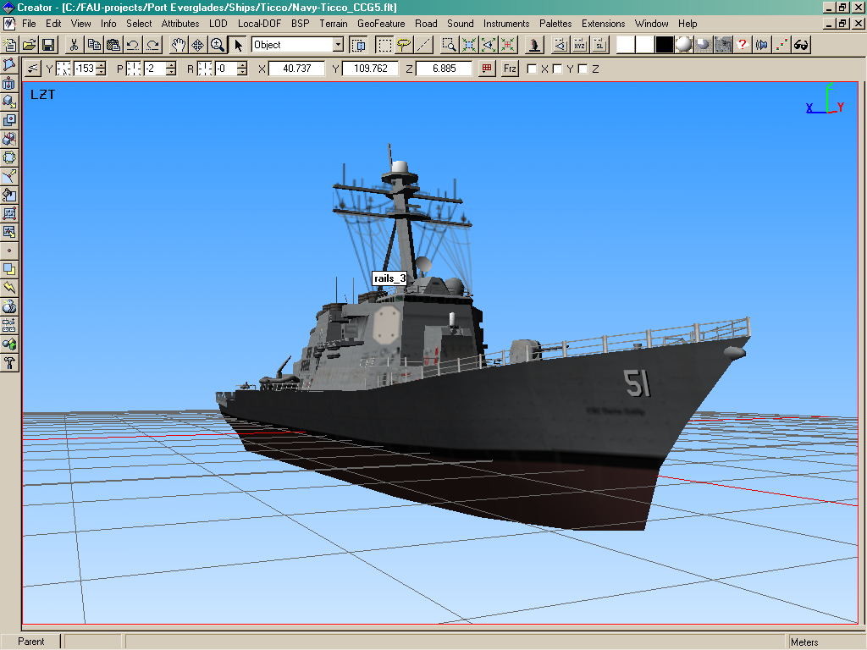

Ticonderoga Class Battleship Rendering

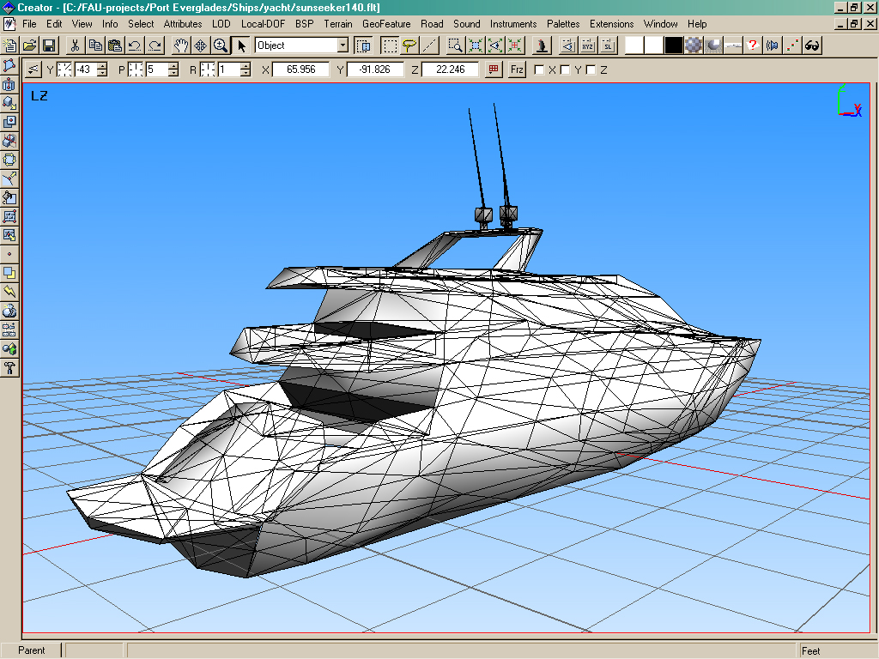

Yacht Wireframe model

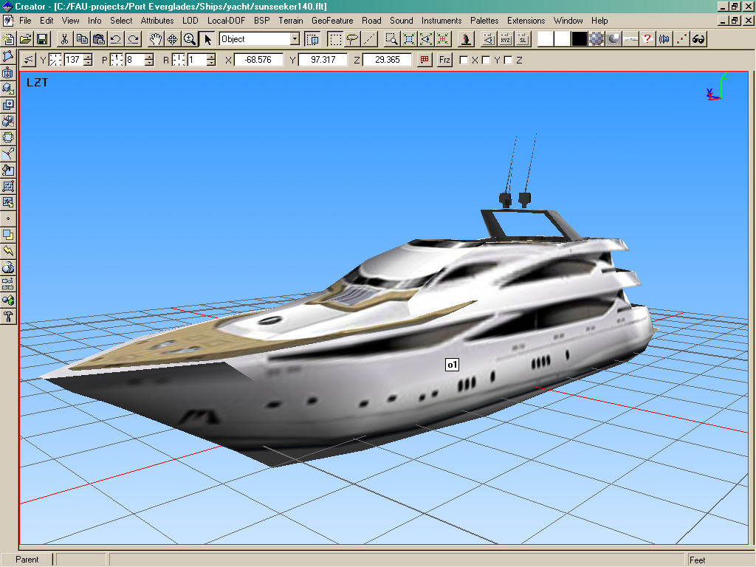

Yacht Rendering

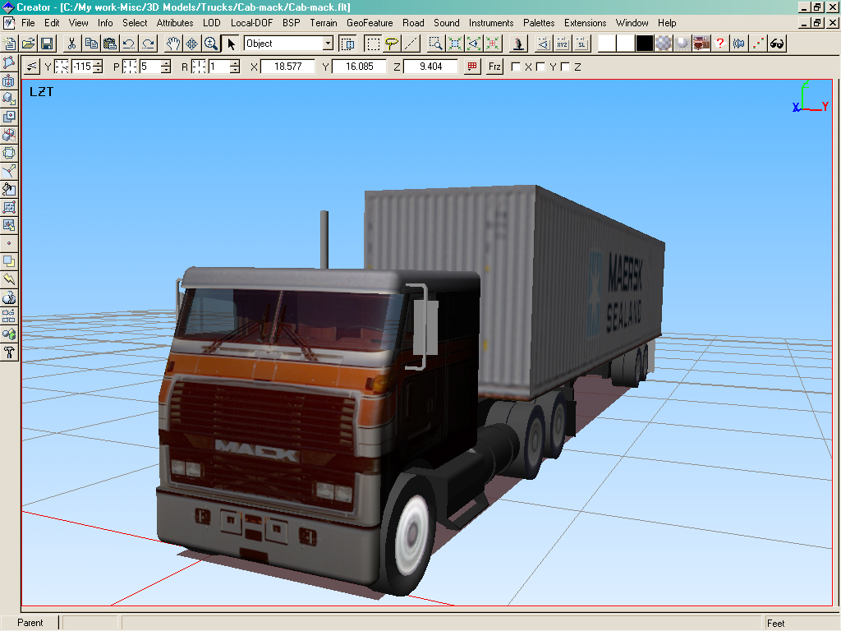

Truck Type 1 Rendering

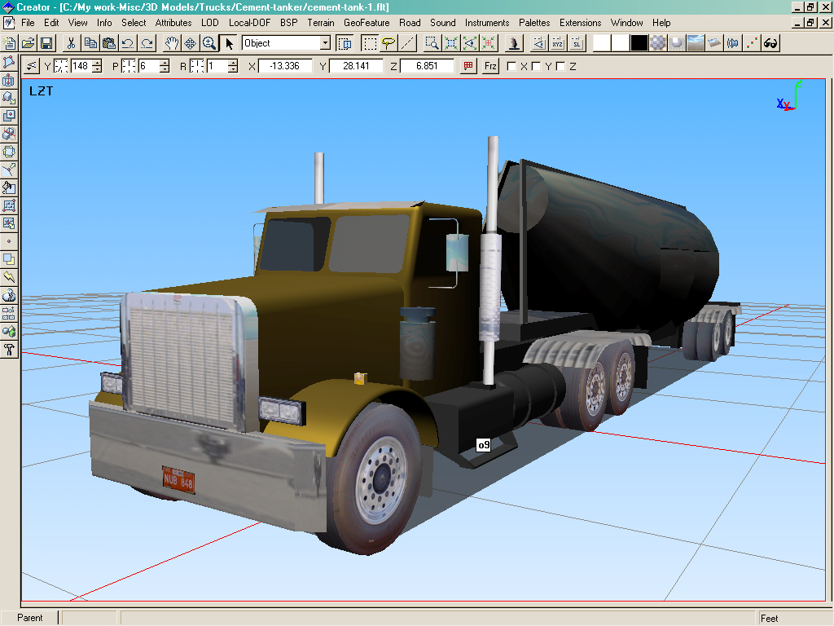

Truck Type 2 Rendering

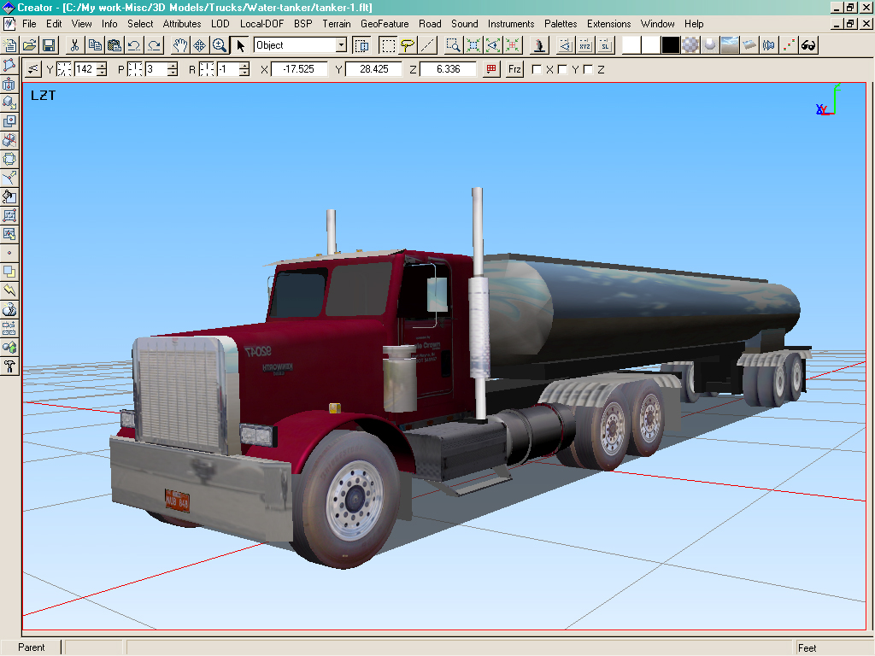

Truck Type 3 Rendering

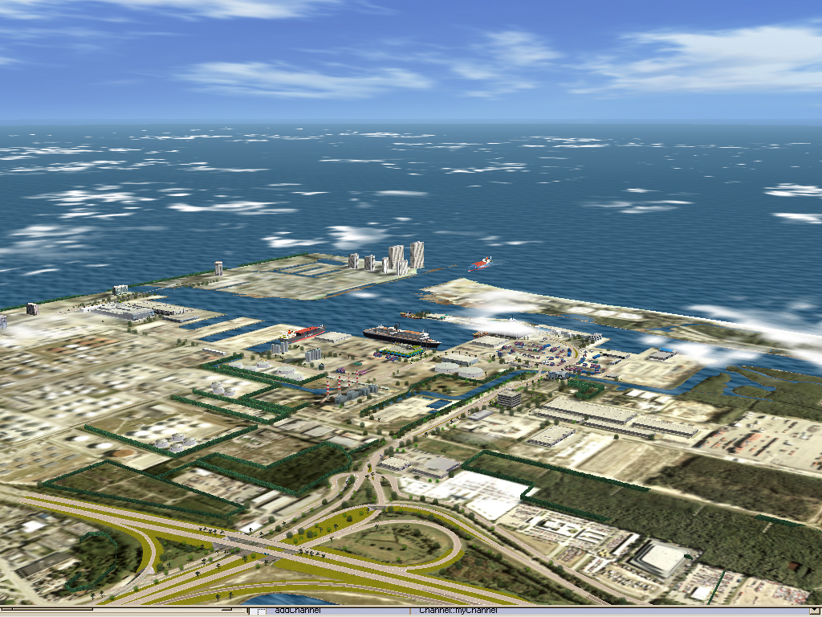

Rendering of Port From Above

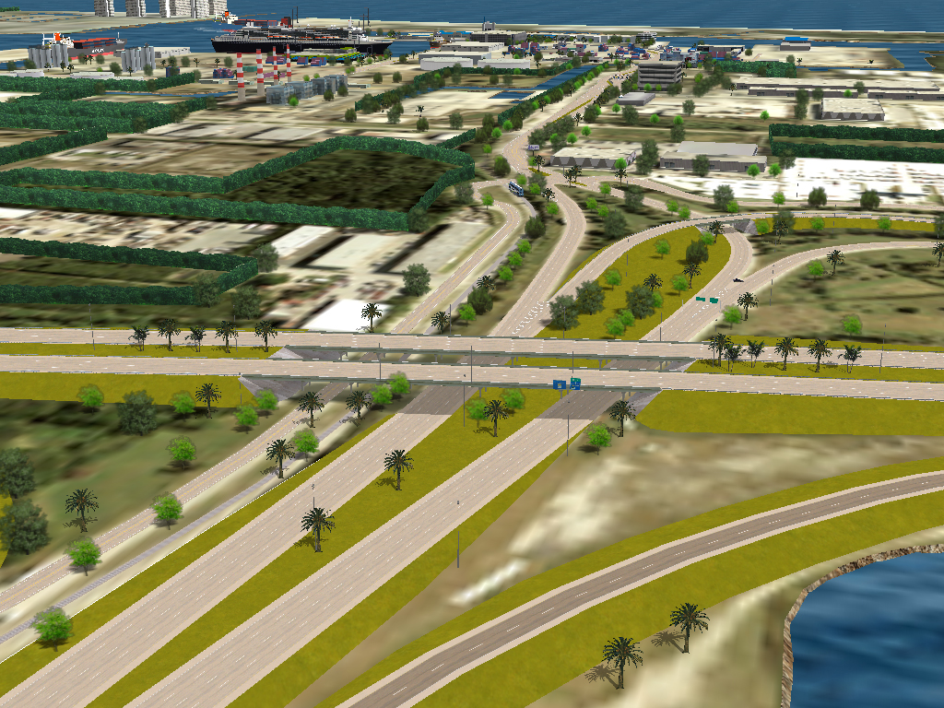

Rendering of Port Entrance

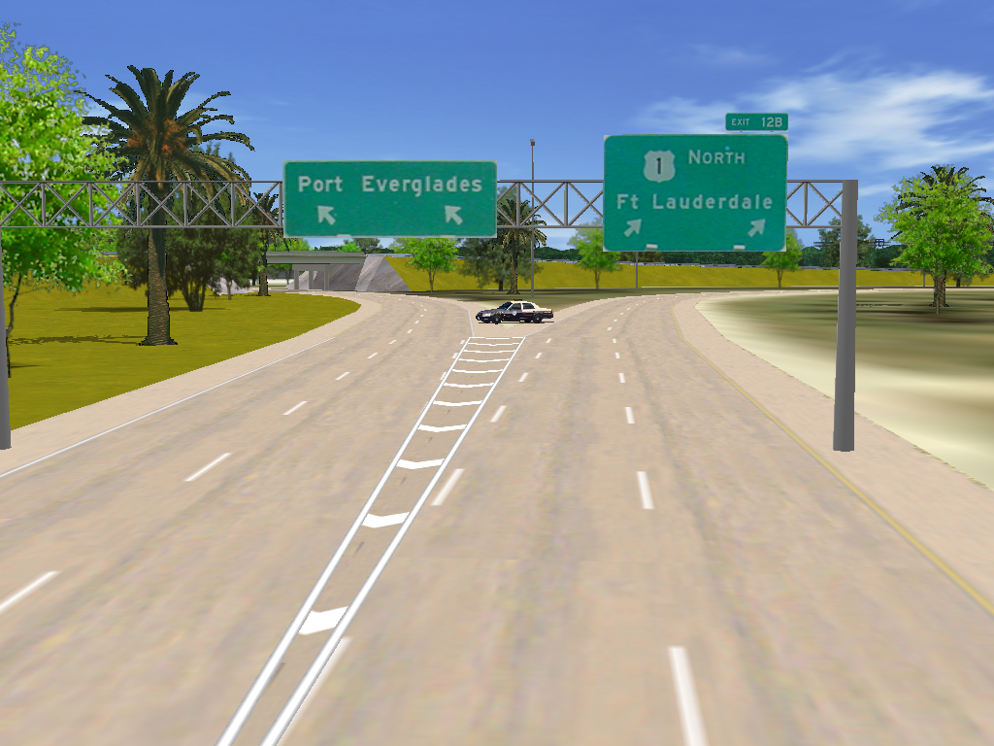

Rendering of Port Entrance

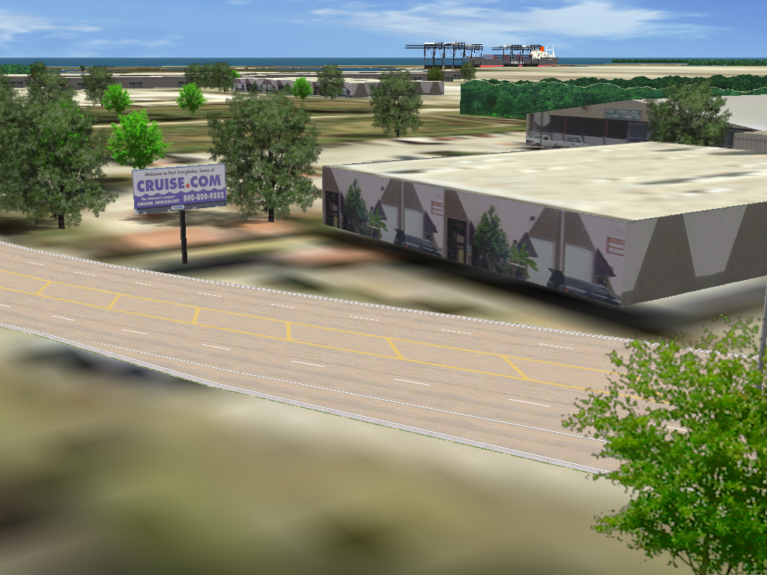

Rendering of Building Outside of Port Gate

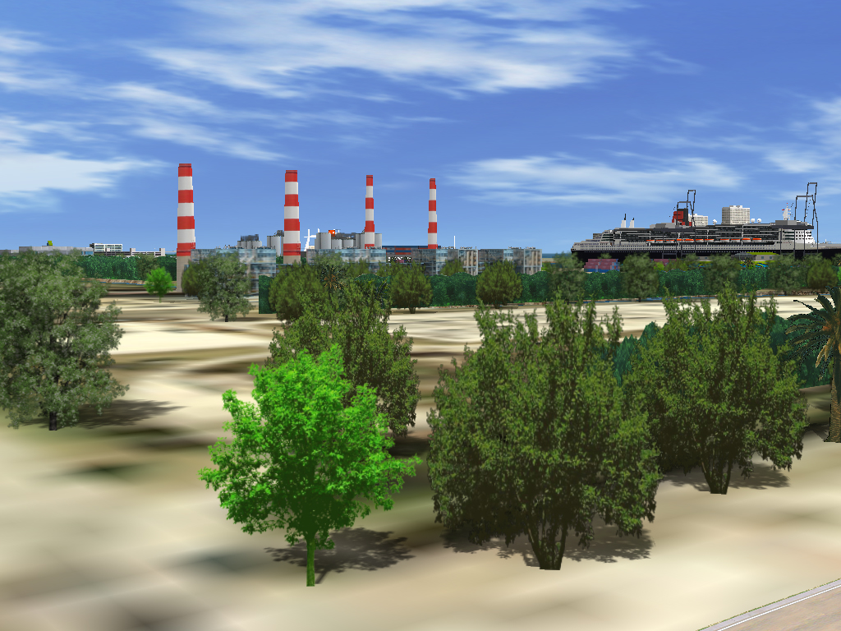

Power plant Inside of Port

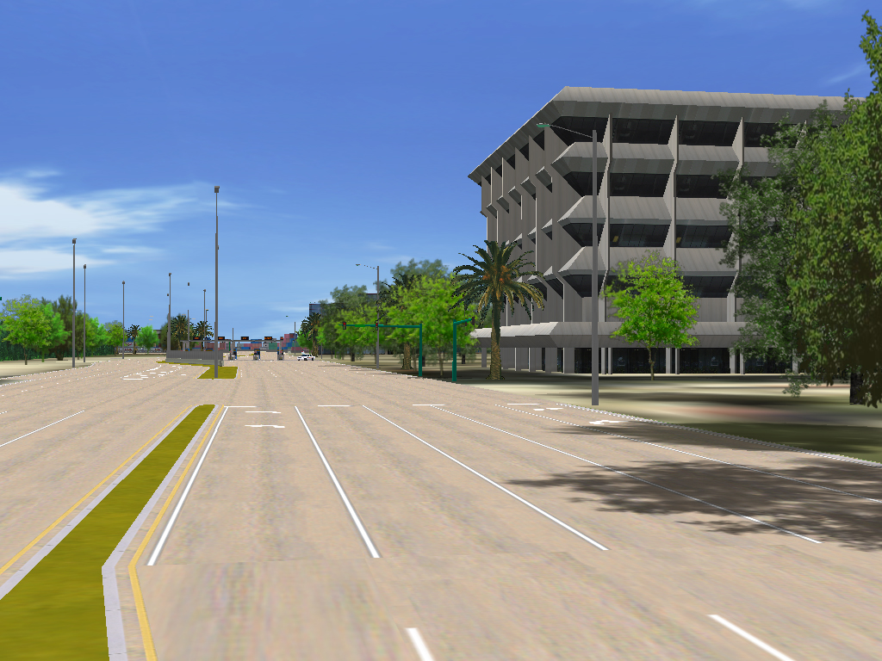

Administrative Building at Port Everglades

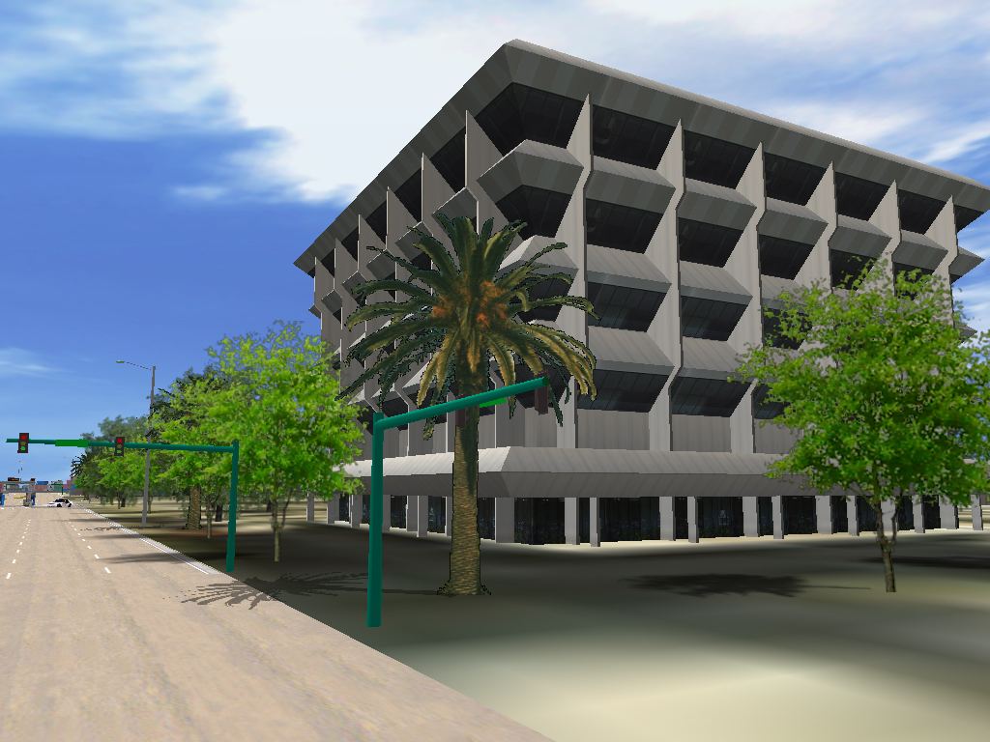

Administrative Building at Port Everglades

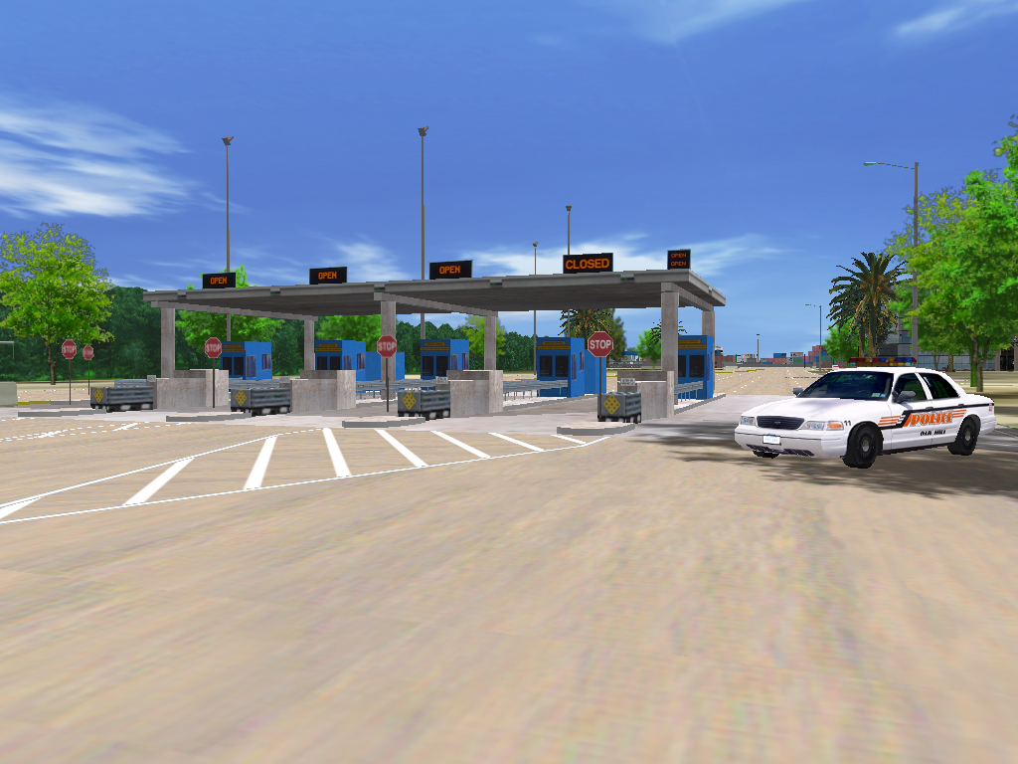

Eller Drive Security Checkpoint

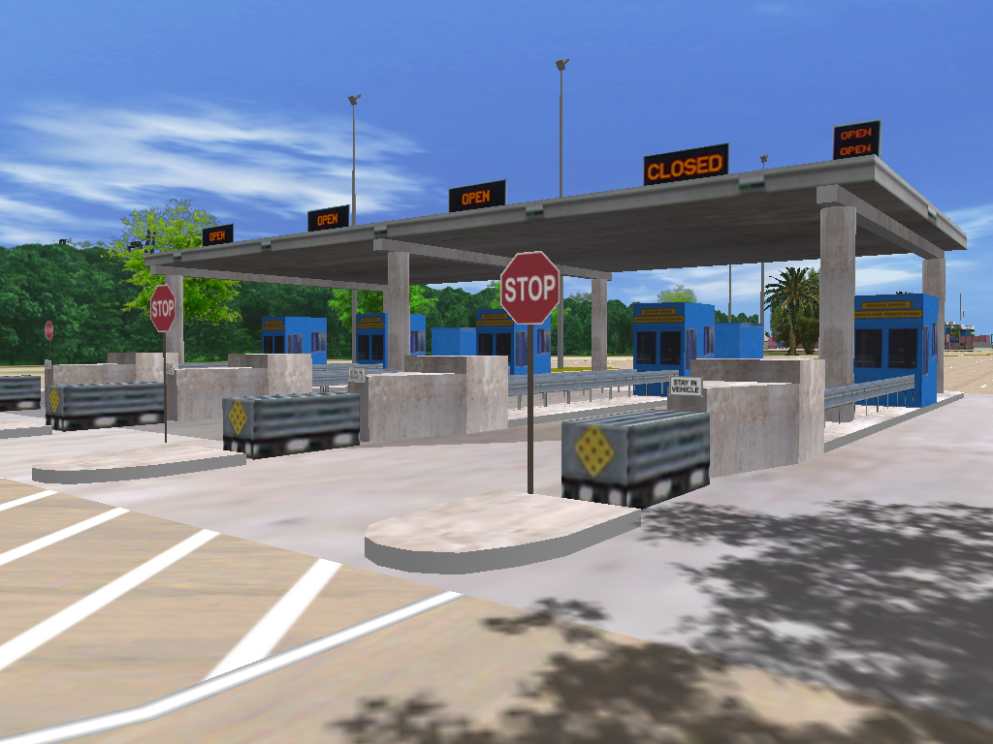

Eller Drive Security Checkpoint

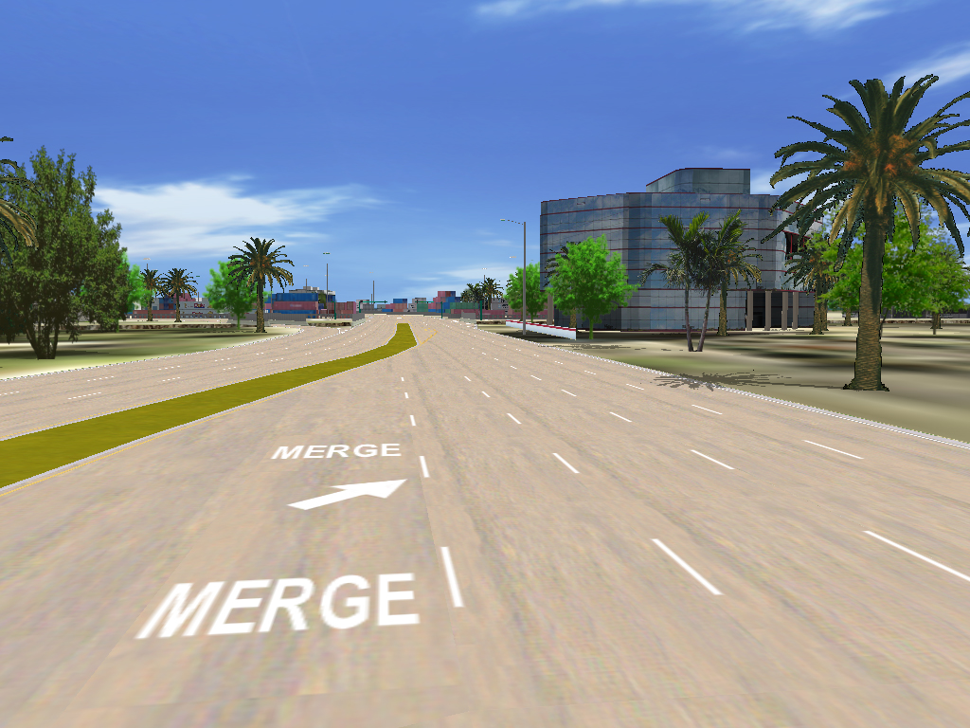

Main Administration Building

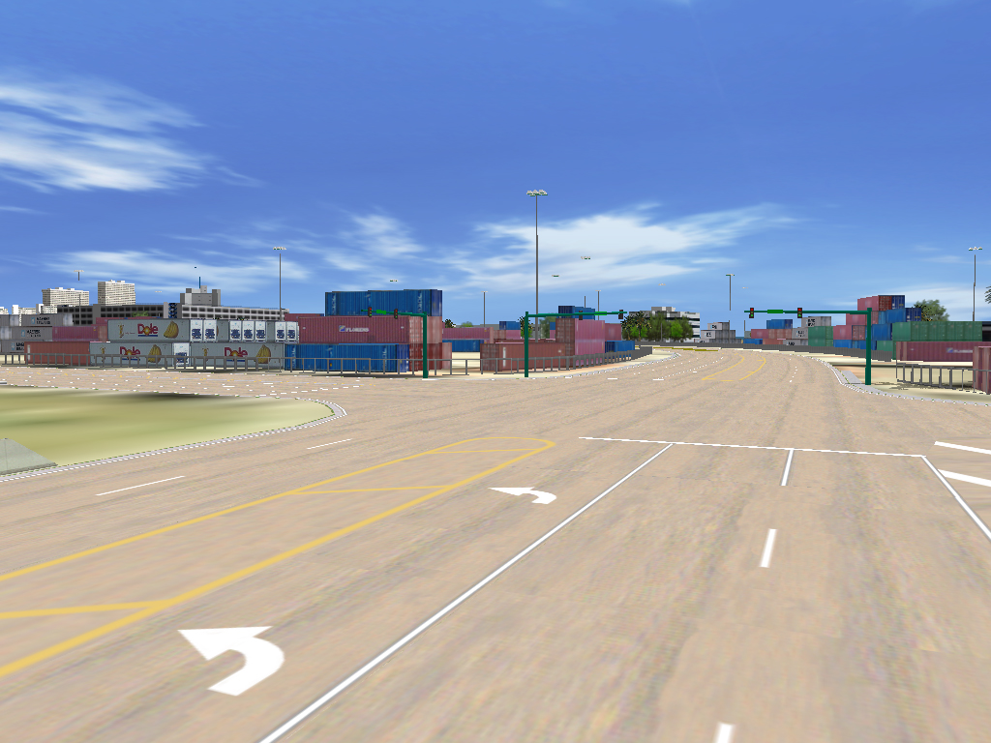

Container Area

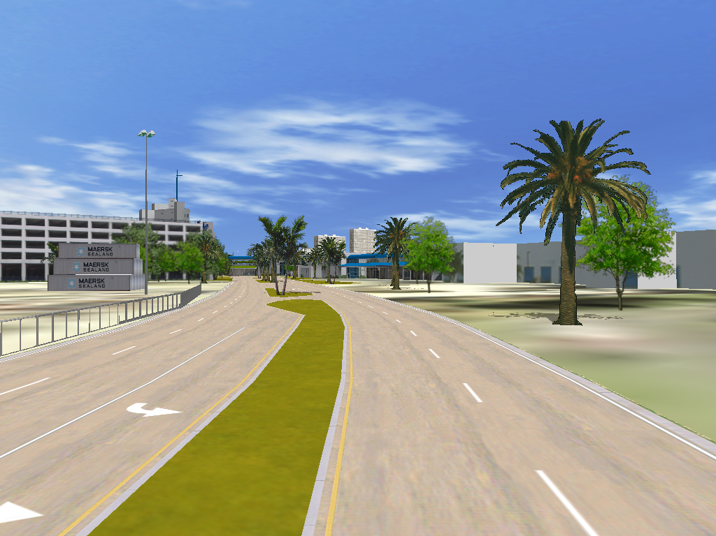

Eller Drive Rendering

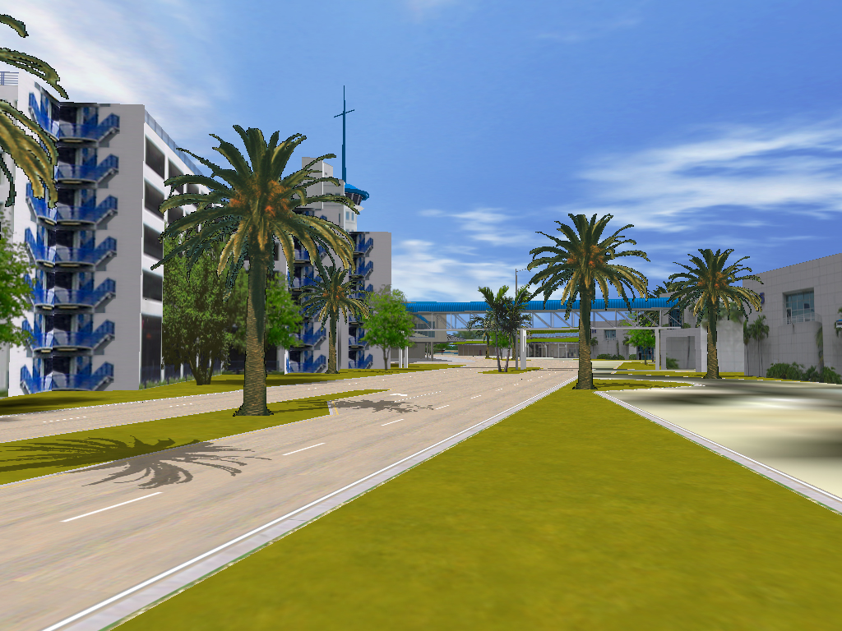

Eller Drive Rendering Approaching Harbor Master’s Building

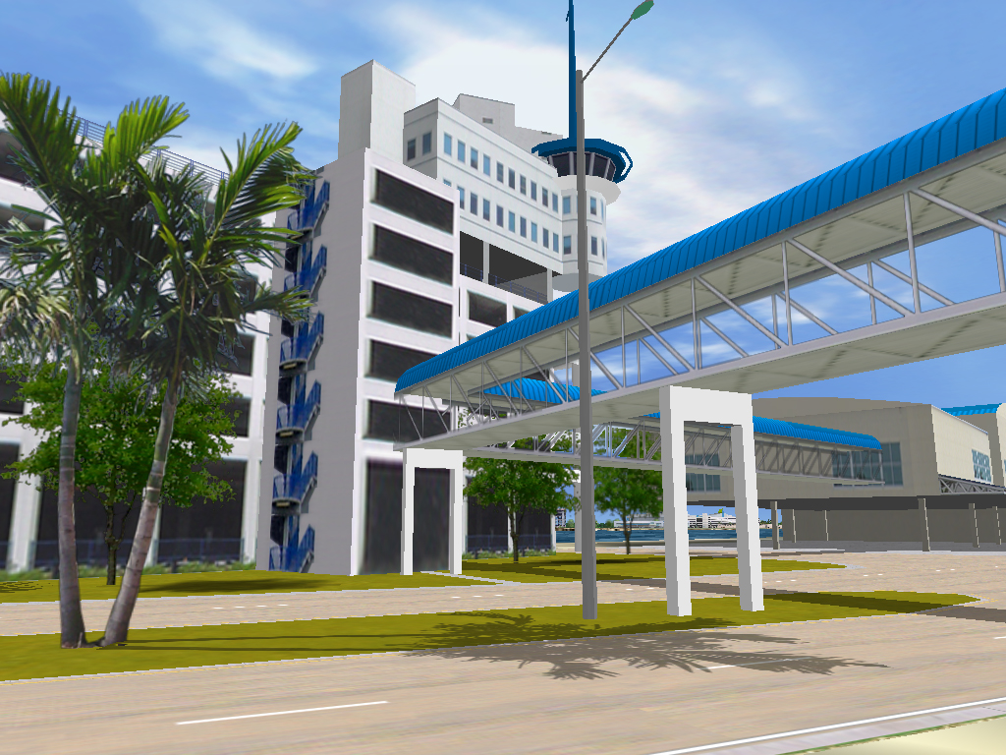

Harbor Masters Building

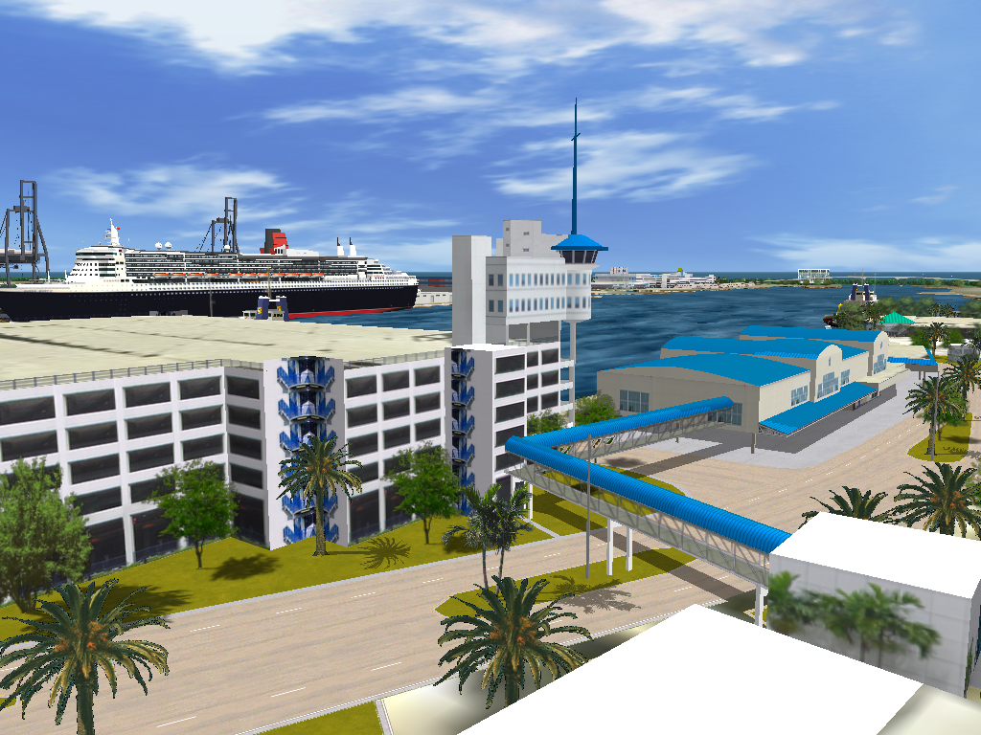

Harbor Masters Building

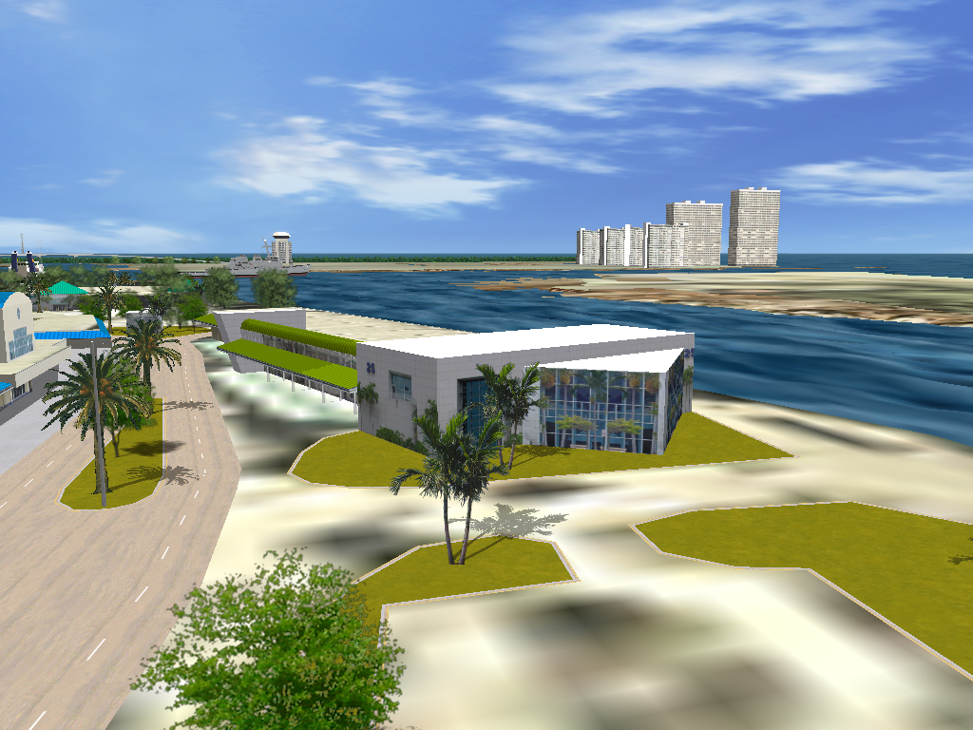

View from Harbor Masters Building

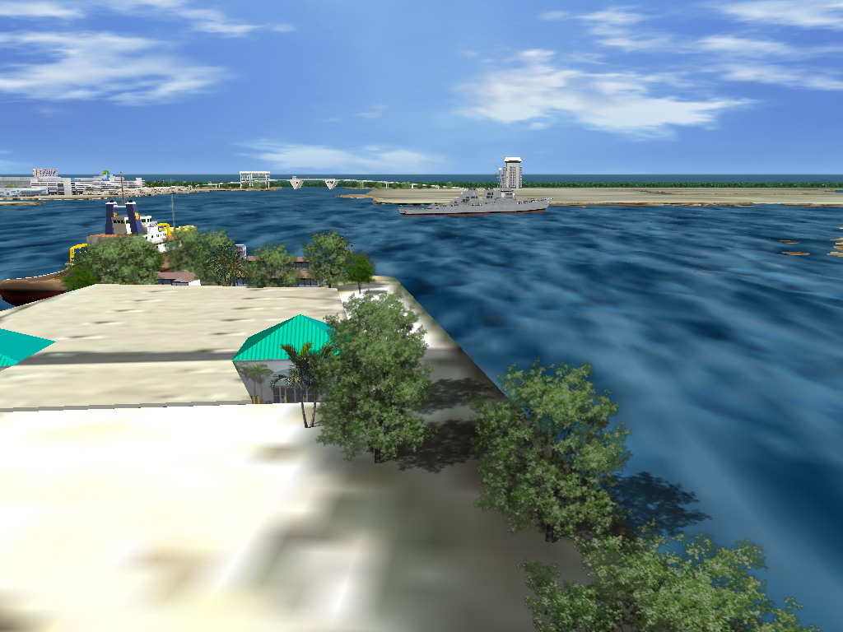

View from Harbor Masters Building

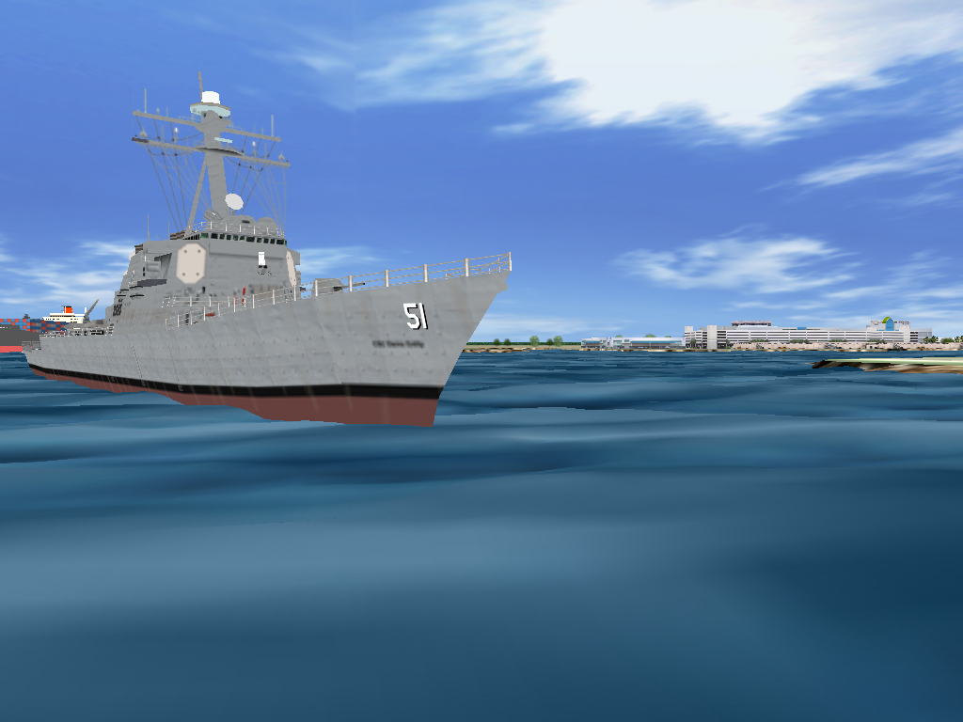

USS Ticonderoga

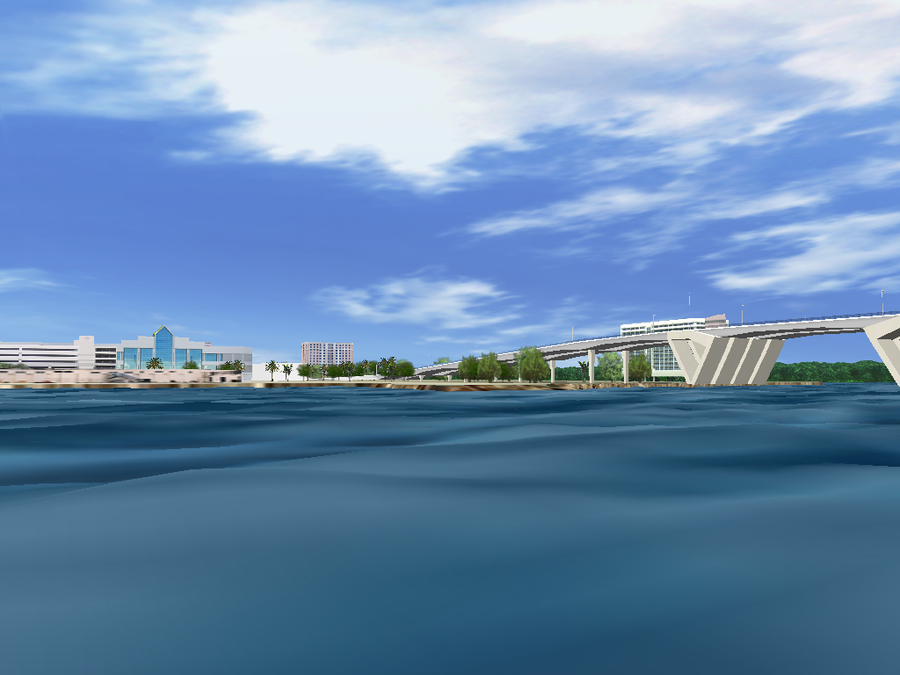

17th St Bridge near Port Everglades

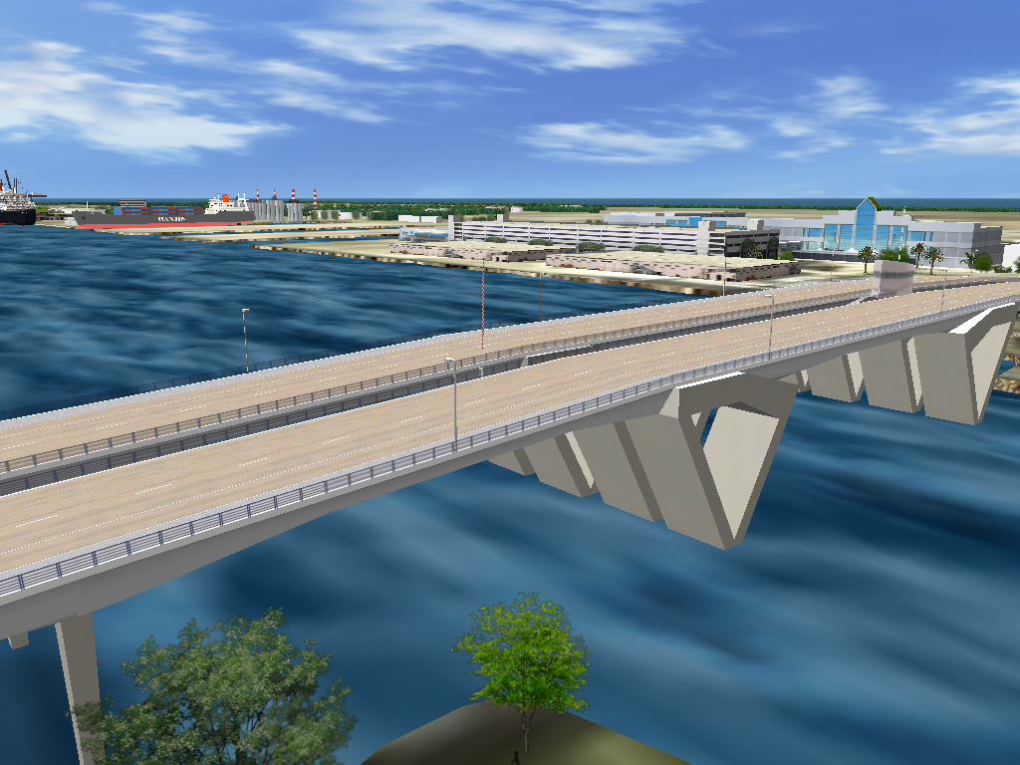

17th St Bridge near Port Everglades

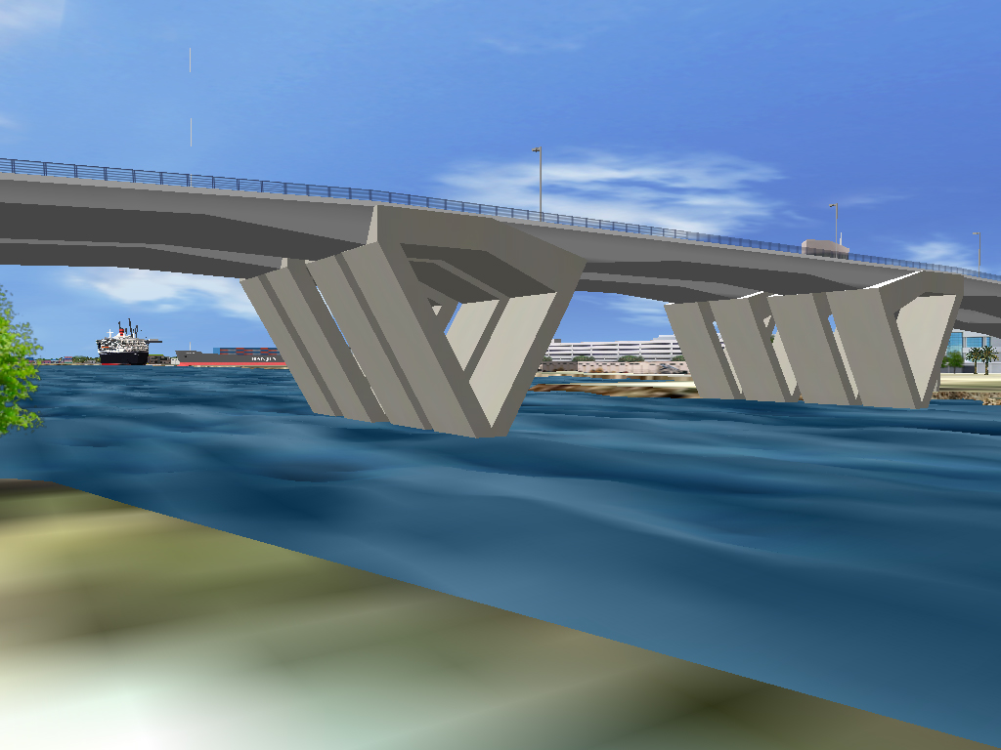

17th St Bridge near Port Everglades

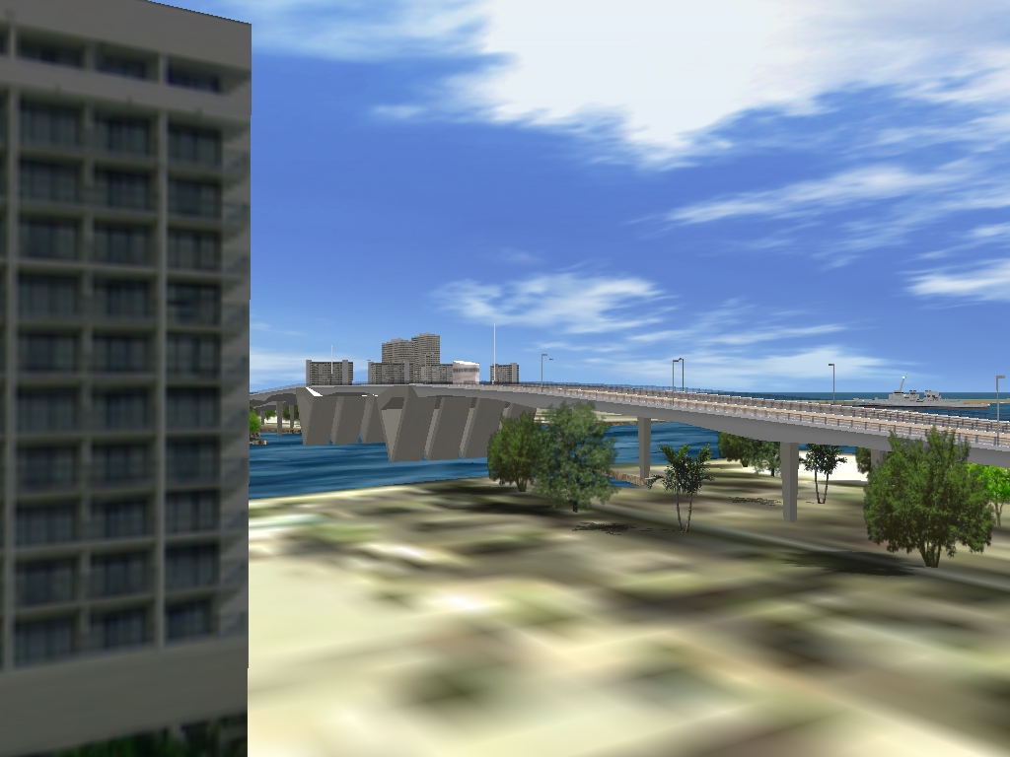

17th St Bridge near Port Everglades

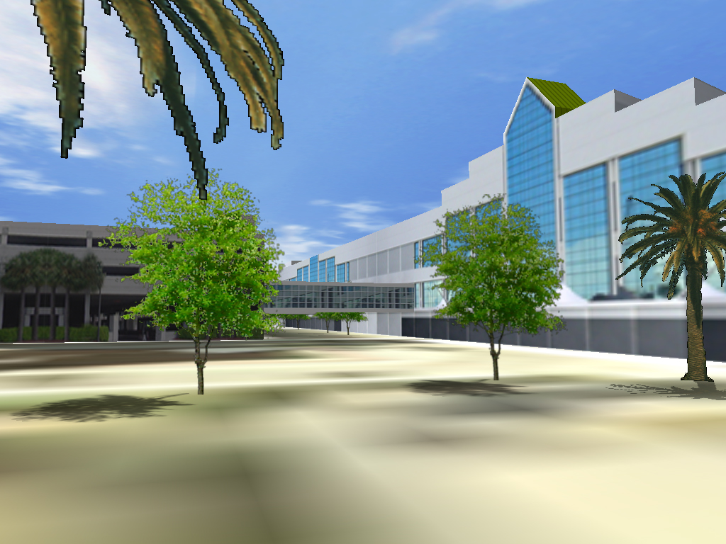

Cruise Terminal

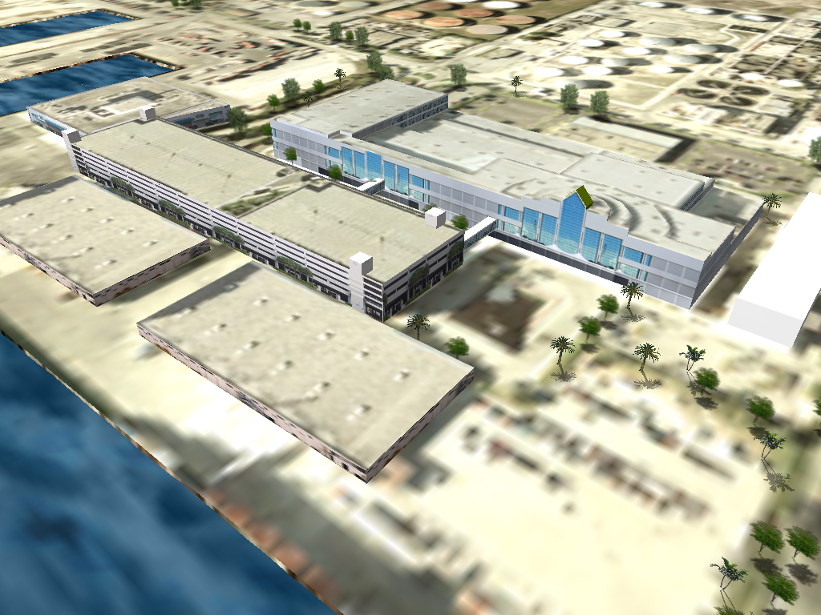

Cruise Terminal Aerial

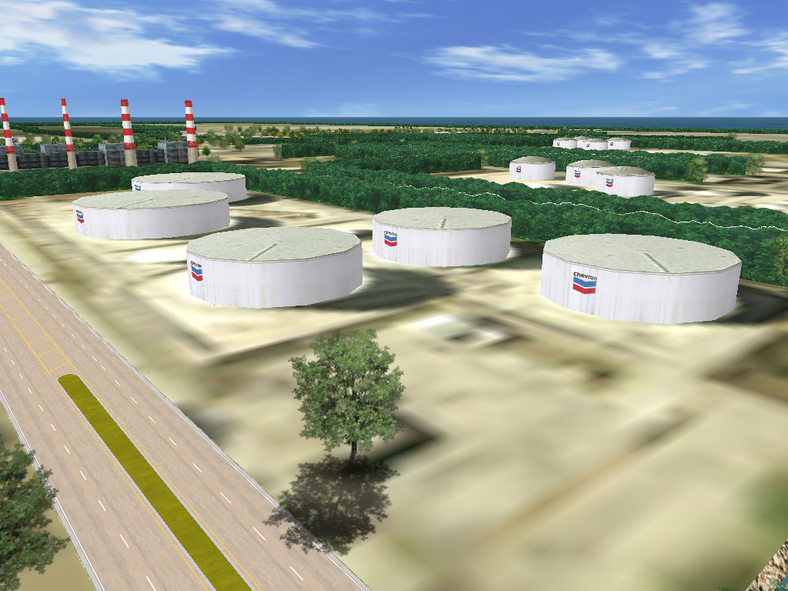

Tank Farm Storage Area

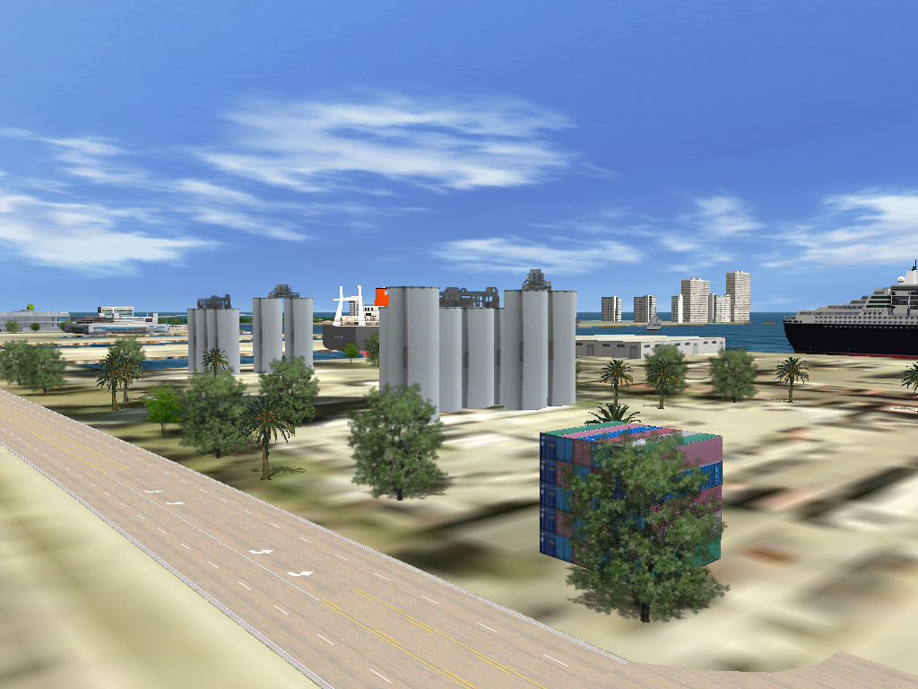

Tank Farm Storage Area

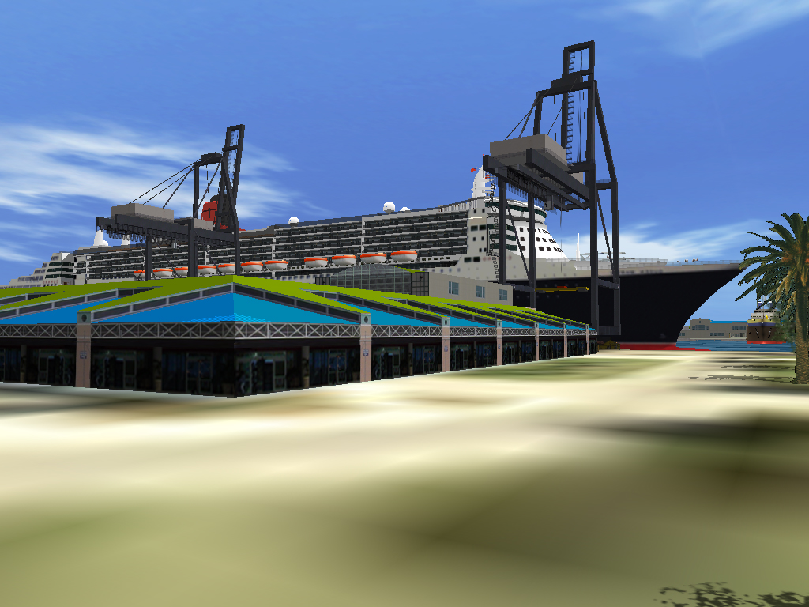

Queen Mary 2 by Gentry Loading Cranes

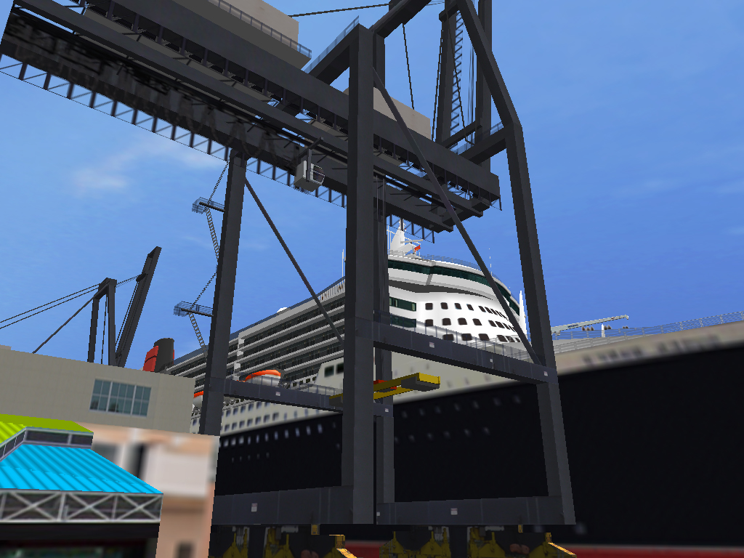

Gentry Loading Cranes by Queen Mary 2

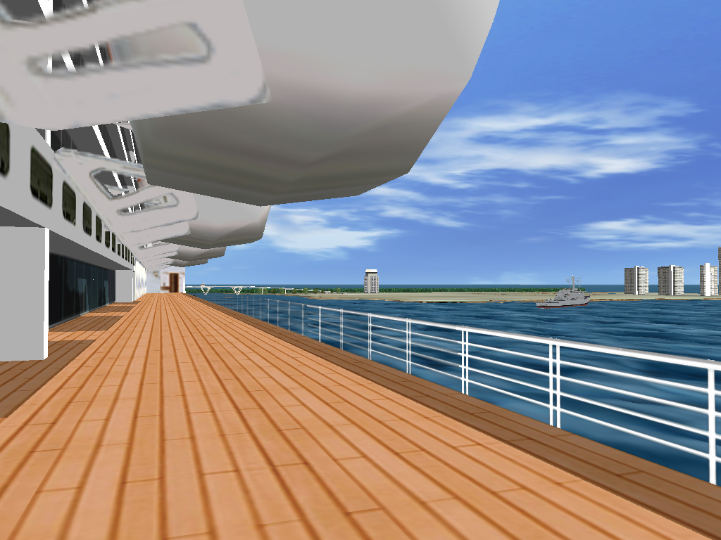

Queen Mary 2 Close-up

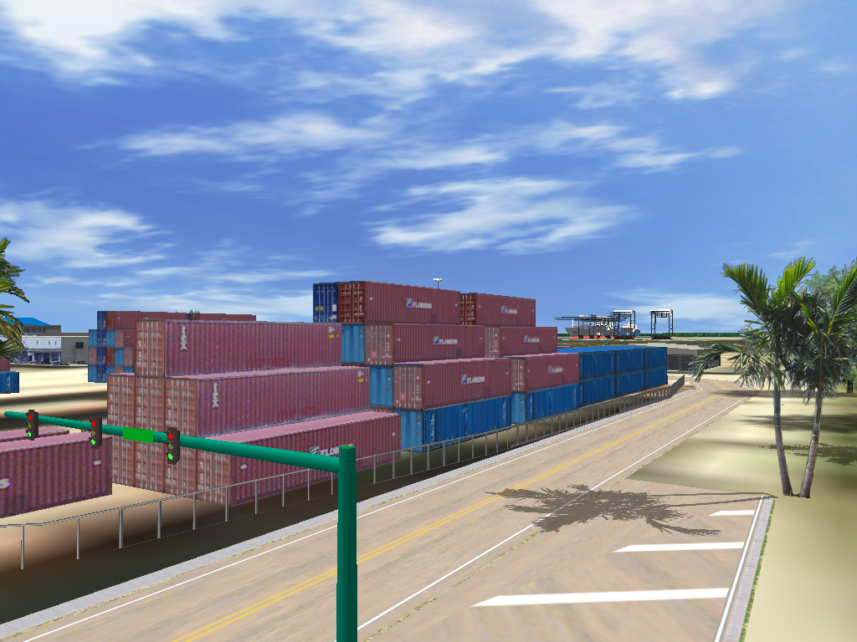

Cargo Containers

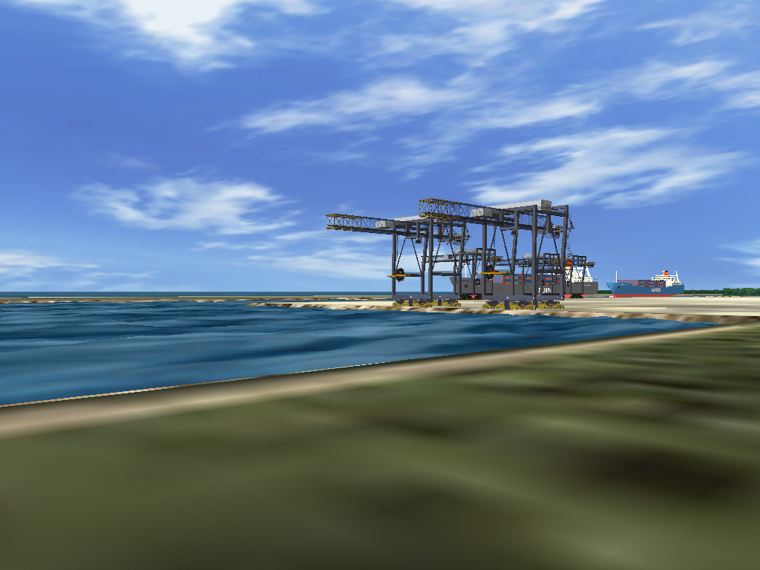

Gentry Loading Cranes

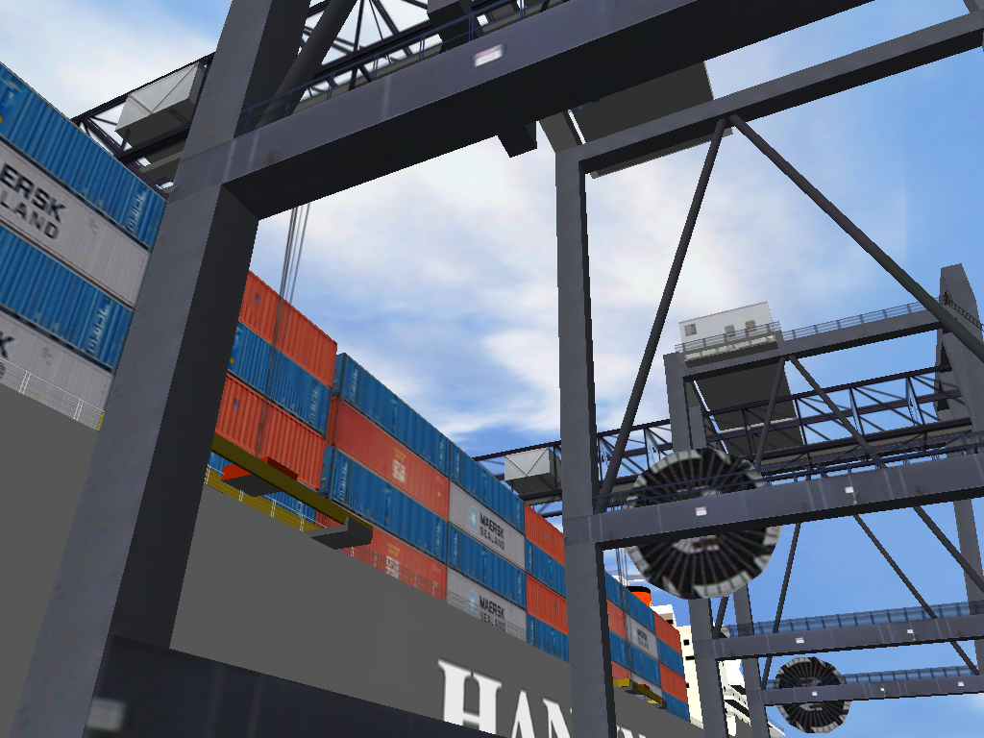

Loading Crane Close-up

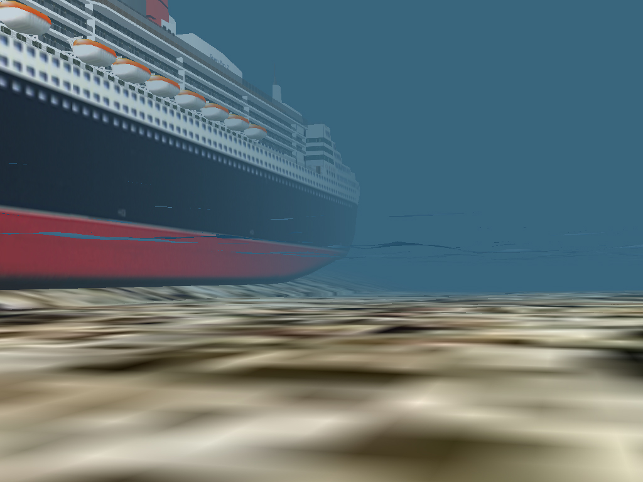

Underwater scene with LIDAR generated Port Channel

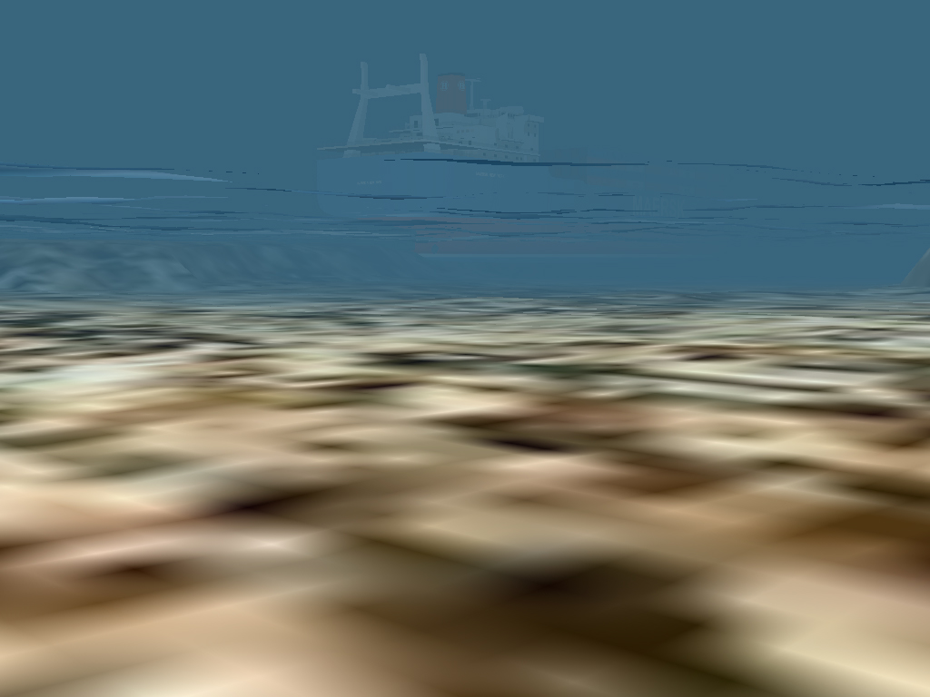

Underwater Scene with LIDAR generated Port Channel

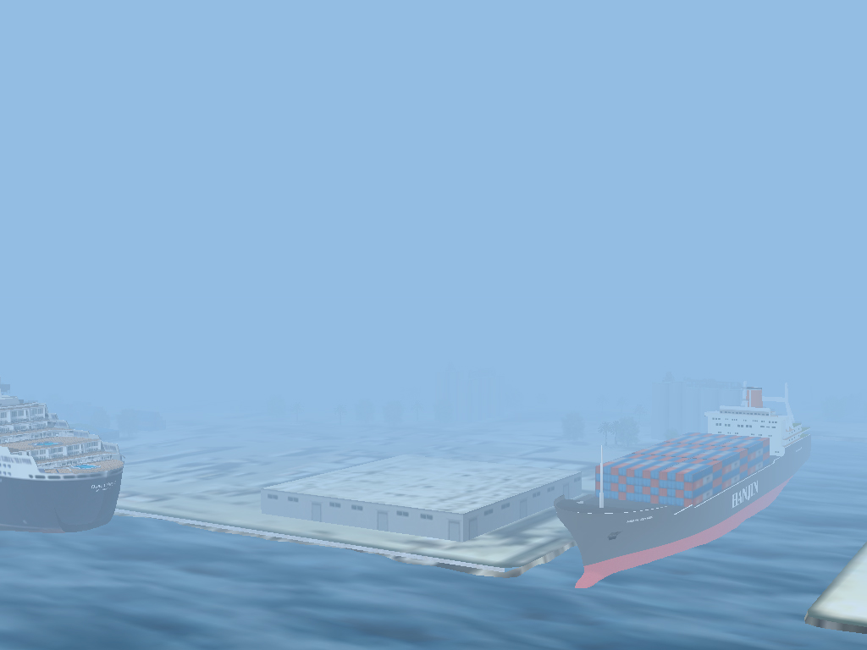

Fog Simulation

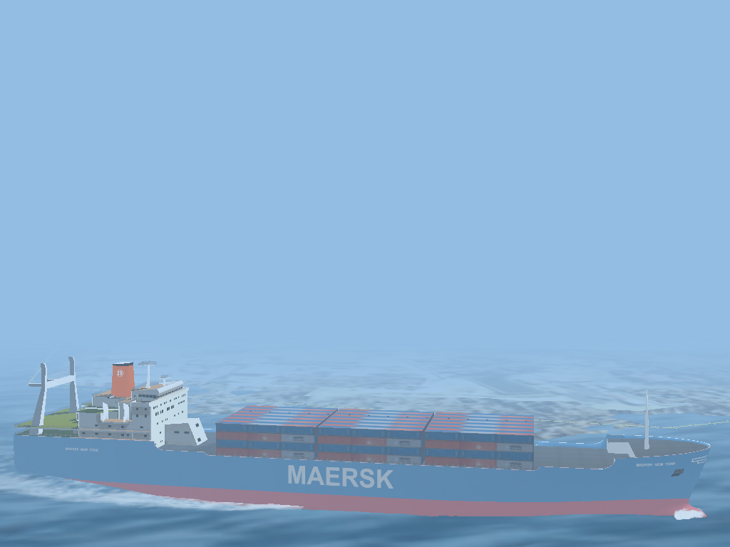

Fog Simulation

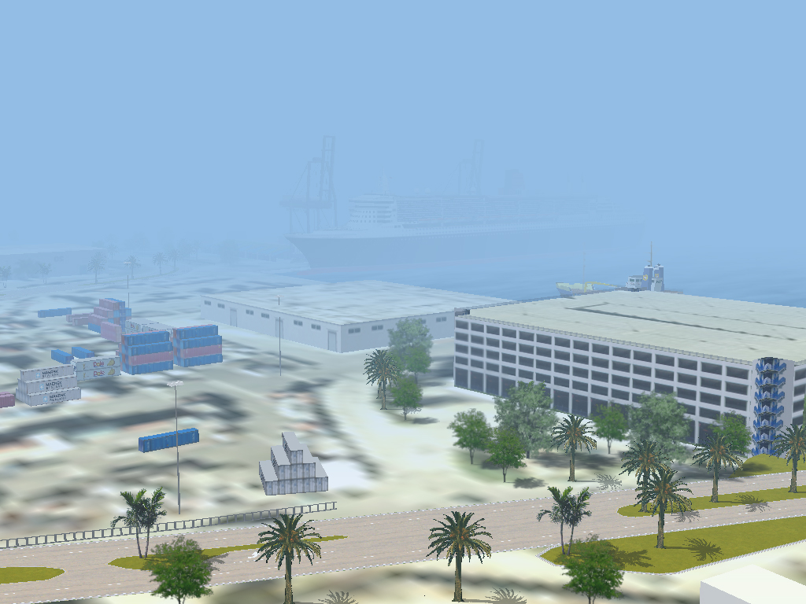

Fog Simulation

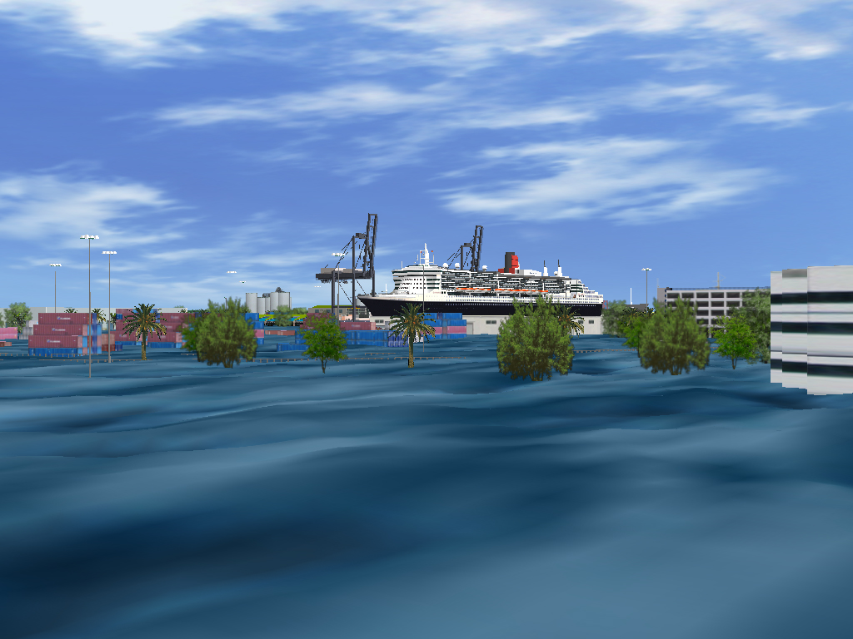

Flooding Scenario

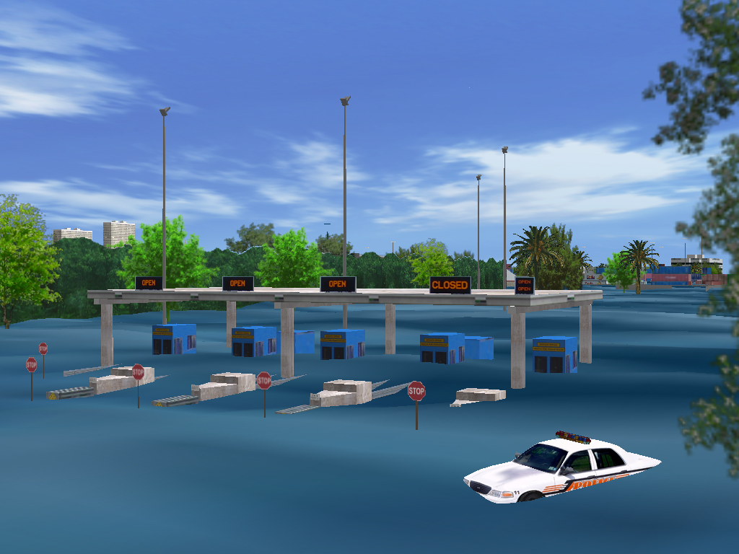

Flooding Scenario

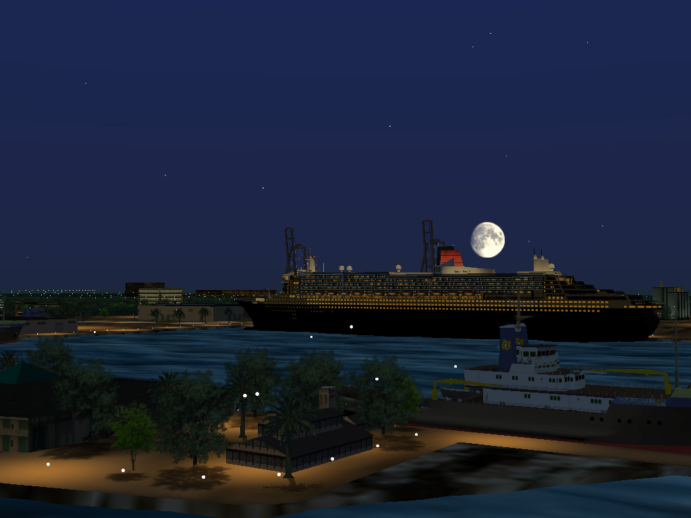

Night Time Port View

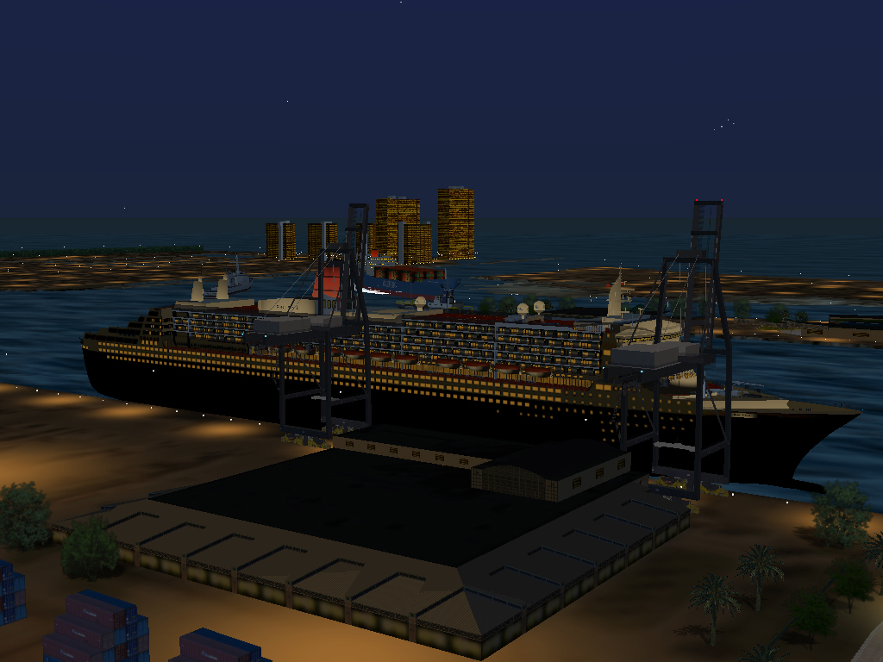

Night Time Port View

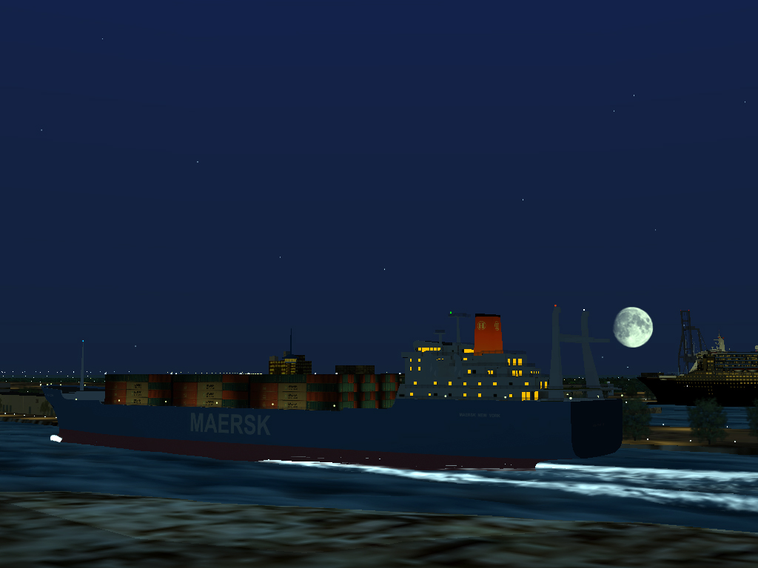

Cargo Ship Entering Port at Night

