2.0 The Remotely Piloted, Unmanned, Untethered, Underwater Vehicle (RPUUV)

2.1 Background

Currently unmanned underwater vehicles fall into two distinct classes: (1) Remotely operated vehicles that are tethered to a topside operator. These devices are usually cage like and are designed to have a hovering capability for close up inspection of a site. They are limited by the necessity to drag a tether with them and so are rarely used for large area rapid surveys. (2) Autonomous Underwater Vehicles that are untethered and used extensively to carry out large area surveys for MCM applications. These vehicles are given a pre specified set of tasks, and have an on board navigation and object recognition capability. They are limited because currently they do not provide real time video or sonar images to the topside operator and rely on either on board intelligence or post deployment analysis to detect and evaluate targets. The autonomous capability requires sophisticated on board sensors that drive up the cost.

An alternative approach, which is not currently available, combines the remotely piloted features of an ROV with the advantages of the untethered AUV. To achieve this requires a high speed wireless underwater communications capability that is only just beginning to become available. It was proposed to develop this type of vehicle and the enabling technology as part of this program and the details of the vehicle development will be described in section 2.2.

At the present time underwater wireless communication is carried out acoustically by use of an acoustic modem. Florida Atlantic University has had a strong program on acoustic modem research for the past ten years, and has developed a number of acoustic communication devices that are used on fully operational AUVs. However to achieve remotely piloted vehicle operation it was not clear at the beginning of this project that acoustic devices will be able to provide the communication rates needed, especially in a shallow water harbor environment. Progress on the development of this technology is described in section 2.3.

To develop the on board sensor systems required, the topside console, and understand the data rate issues for an RPUUV, it is planned as a first step to demonstrate a vehicle using a short tether to a surface float with an RF antenna. The antenna has allowed for real time underwater video, navigation and sonar data to be transmitted back to the topside console in real time. In water testing of this system is described in section 2.2.

For an RPUUV to achieve it’s full potential an on board suite of sensors will be required which include side scan sonars, integrated obstacle avoidance sonars, chemical sensors, and an on board navigation capability. In the first year of this program we have initiated studies on each of these sensor packages, with the intent of integrating them into an RPUUV in years two and three. These systems are described in section 2.5, 2.8 and 2.9. In addition clean hydrodynamics is required for lower power consumption and maneuverability and research in these areas are described in sections 2.6 and 2.7.

The operation of the communication system and other sensors will also depend on the details of the Port environment including speed of sound profiles, turbidity profiles and the currents which can be expected. A study to investigate these features in Port Everglades is described in section 2.4.

2.2 Development of a Remotely Piloted Unmanned Underwater Vehicle
PI: Dr. Stewart Glegg, Project Manager: Robert Coulson

2.2.1 Summary

The development of the Remotely Piloted Unmanned Underwater Vehicle is described in Section 2.2. The objective of year one of this program was to develop a vehicle that communicated with a topside console through an RF link, and to test this vehicle in different environments with simple sensors such as an underwater video and a commercial available sonar system. The vehicle that has been developed features a vectored thruster with a 80 deg angular range, which allows the vehicle to maneuver in tight spaces. The weight of the vehicle is approximately 35 lbs and is easily launched and recovered by a single operator from the side of a small vessel. The vehicle includes an on board computer which processes the sonar data, the underwater video and the output from an onboard compass, pitch and roll sensor. The data from these systems is relayed though a wireless RF link on the tow float to the topside console using a remote desktop capability, which is described in section 2.3. The vehicle is controlled through the RF link using a commercially available remote control device developed for model aircraft.

A complete description of the component layout in the vehicle, the thruster and control system, the onboard power supplies and sensor systems is described in this section. Also included is a description of the in water test which were carried out in May 2006 and recommendations for future development based on the results of those tests.

2.2.2 Introduction

The main objective of this task is to develop the platform that will support the sensors being developed in the other parts of the project. During the first year a vehicle has been developed which will enable future developments of sensors and communication systems. The plan for year one was to develop a vehicle that was attached to a tow float with an RF antenna through which the vehicle can communicate with a topside console. This system is providing valuable information on the operational requirements for this type of vehicle deployment, and has been tested in both an open ocean and a port environment. Following this series of tests, and the studies on hydrodynamics carried out in year one, it is our objective to develop a second generation vehicle in year two.

In the following sections the system concept, the overall system layout and the details of all components will be described. Finally section 2.2.10 will describe the results of the initial water testing carried out in May 2006.

2.2.3 System Concept

The Remotely Piloted Unmanned Underwater Vehicle (RPUUV) is a small submersible platform designed to perform survey and inspection tasks in near shore and port environments. The vehicle is sufficiently small and light that it can be hand launched and piloted by a single operator either from shore or from a small boat. The operator issues control commands to the RPUUV via a traditional Radio Control (RC) handset, and receives feedback data from the vehicle’s sensors, relayed real time to a top-side laptop computer, via a wireless Ethernet bridge. Since electromagnetic waves do not adequately penetrate the air-water interface, a small surface float is towed by the RPUUV that houses the RC receiver and the wireless Ethernet gateway. This tow-float is then connected to the RPUUV via a standard communications cable with waterproof connectors.

The RPUUV is also equipped with acoustic modems and Ultra Short Base-Line (USBL) sonar, and it is anticipated that this acoustic communication channel can be refined to allow real-time control and sensor feedback independently from the electromagnetic channel, allowing for the elimination of the tow-float if necessary in future versions.
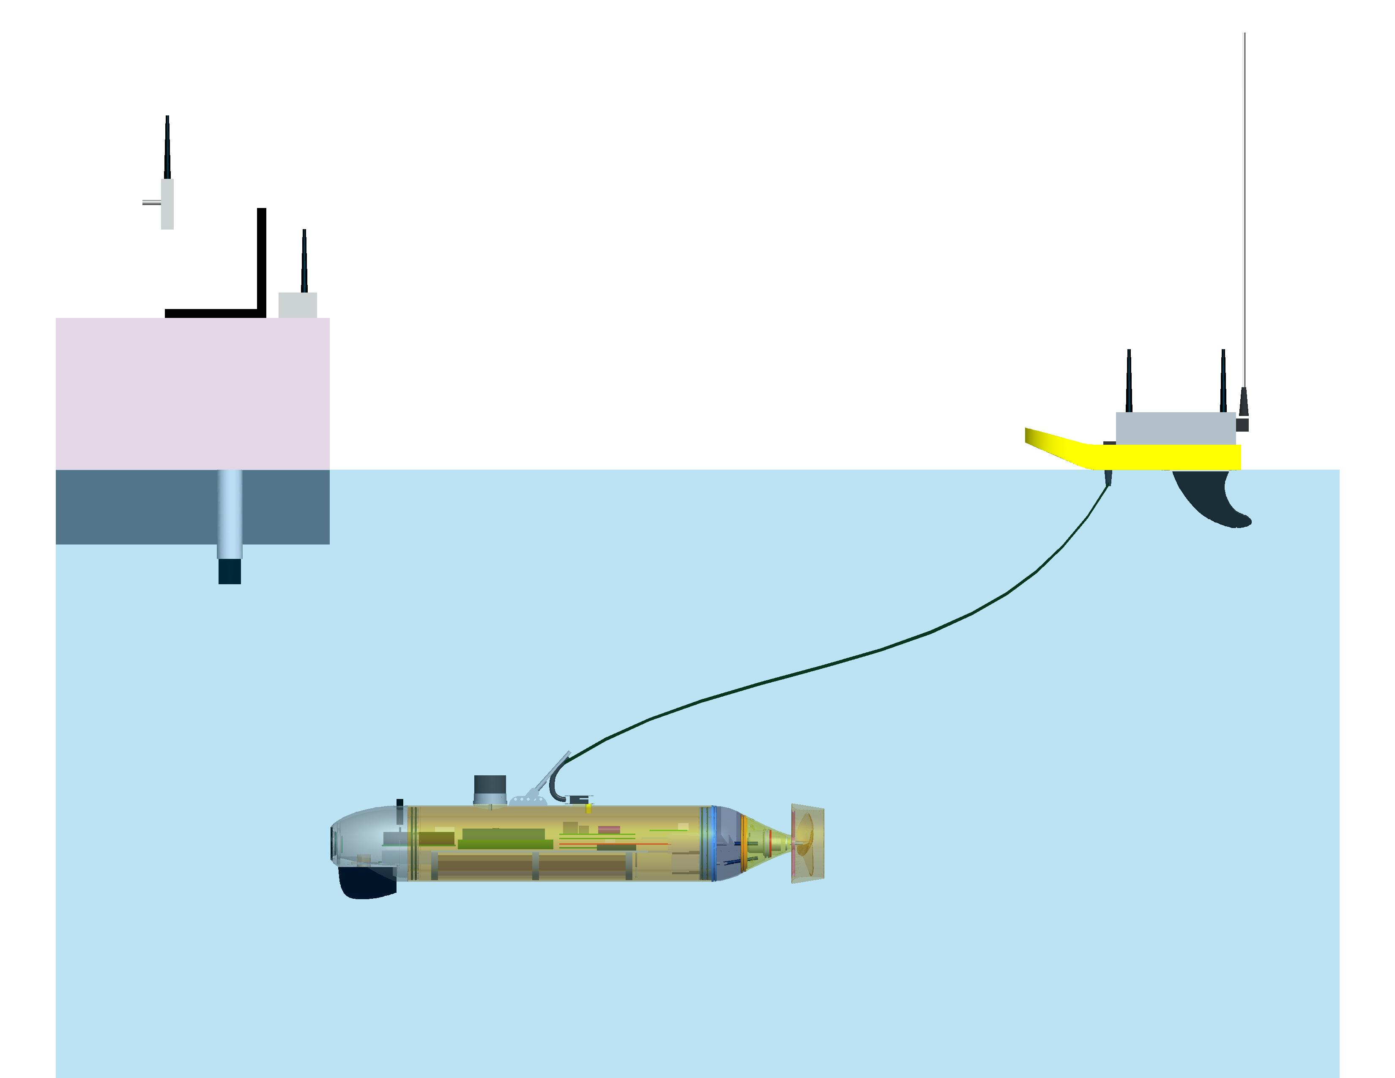
Acoustic Modem
Communications
RC Receiver
Wireless Ethernet
Wireless Ethernet
Radio Control
Sonar
Boat/Dock
Tow-Float
RPUUV
Figure 2.2.1: Communications Channels between Operator & RPUUV

2.2.4 Overall Vehicle Design

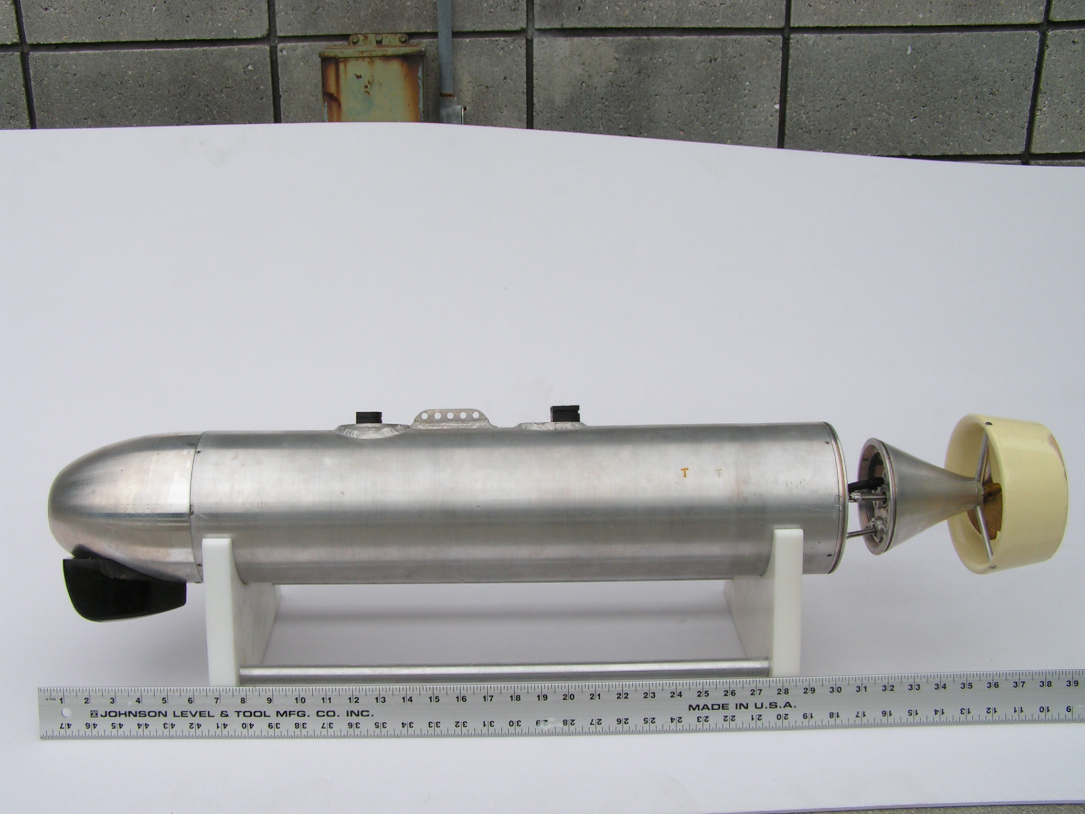
The RPUUV has a nominal diameter of 6”, is approximately 39” long, and weighs about 35lbs. A photograph of the assembled vehicle can be seen in figure 2.2.2.
Figure 2.2.2: Photograph of the RPUUV

The physical make-up of the RPUUV can be separated into three main components: A nose section, a parallel mid-body, and a tail section. These three sections can be seen in figure 2.2.3 and will be described in more detail in following sections.

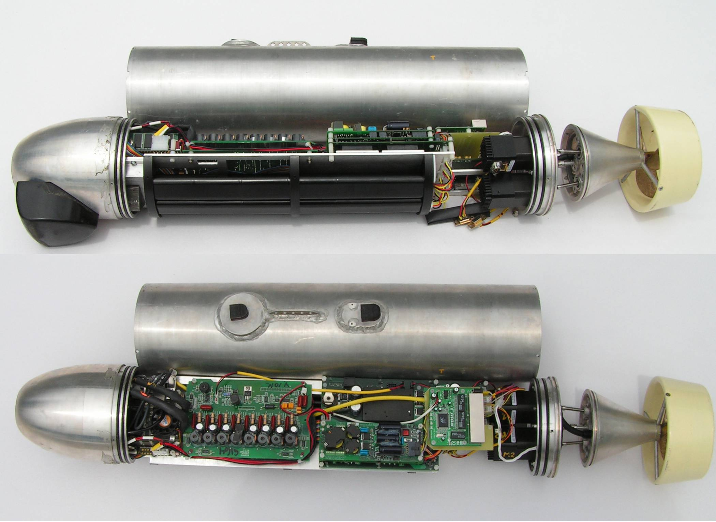
Nose
Mid-body
Tail
Figure 2.2.3: The RPUUV Components
The mid-body is capped on the front end by the nose section and at the rear by the tail-supporting end-cap to create a single watertight pressure vessel that contains all the vehicle electronics, sensors, and battery power packs.

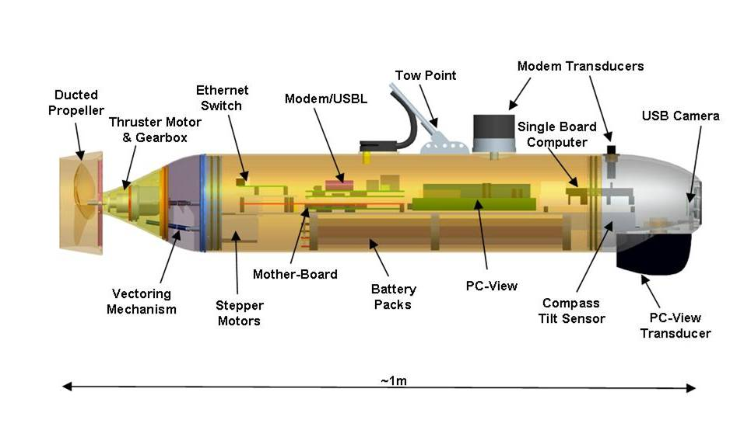
Figure 2.2.4: The RPUUV Component Layout
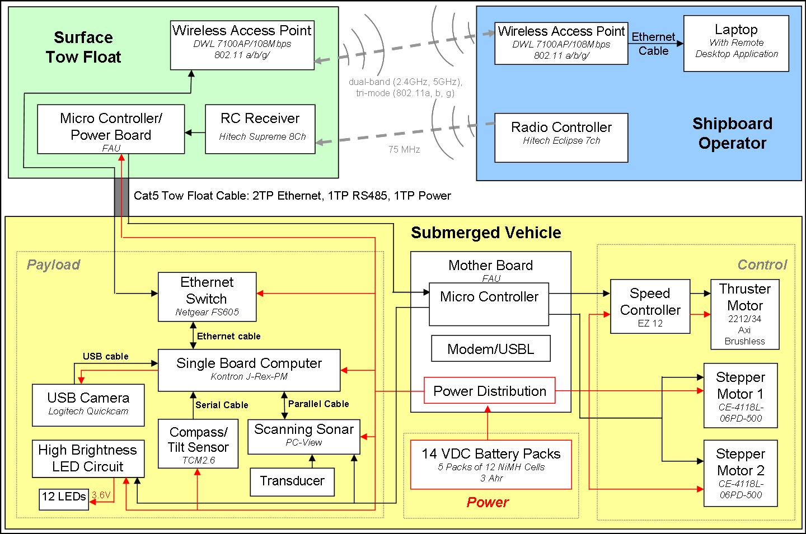
The tail section contains an additional small water-tight vessel that houses the thruster motor and gearbox, and is wired to the main vessel via a waterproof cable and connectors. The nose, mid-section and tail are fabricated from 6061-T6 Aluminum and are rated to a depth of 100ft.
Figure 2.2.5: RPUUV Component Connectivity Flowchart

The component layout can be seen in figure 2.2.4, and a flowchart of the connectivity of displayed in figure 2.2.5.

The vehicle is powered by 5 Nickel Metal Hydride battery packs that provide a nominal 14VDC bus voltage. This power is distributed throughout the vehicle, at a variety of voltages, via power control and distribution circuitry on a custom motherboard. This motherboard also hosts the acoustic modem and USBL power amplifier circuitry with direct plug-in for the Modem DSP board. The motherboard also incorporates a microcontroller that is used to control the stepper motors that actuate the vectored tail section, and the brushless DC thruster motor. Additionally, the microcontroller provides the capability for turning on/off the whole vehicle (via magnetic relays), the payload sensors, and the thruster motor. It also provides for leak detection capability and signaling of the vehicle status or problem reporting through a series of flashing patterns of the front LEDs.

Referring to figure 2.2.5, the sensor payload is centered around a single board Pentium computer that allows for direct plug-in of a USB camera, a compass/tilt sensor and a forward scanning sonar. The application software for these sensors run directly on this embedded computer and can be viewed and controlled via a topside Laptop and a Remote Desktop application through a wireless Ethernet connection. The wireless access point is mounted on the surface tow float and connected to the vehicle via a Cat5 cable and waterproof connectors. This Cat5 cable contains 4 twisted pairs of conductors, and only 2 pairs are required for the Ethernet connection. One of the remaining pairs is used to send power to the tow float from the vehicle so that the float does not need to carry its own battery power supply. The remaining pair provides an RS485 serial connection between an additional microcontroller mounted in the tow float and the microcontroller mounted on the vehicle motherboard. The tow float microcontroller converts the Pulse Width Modulated (PWM) analogue signals from the RC receiver into digital RS485 Serial commands that can then be sent down a single twisted pair in the cable from the tow float to the vehicle. The vehicle microcontroller then either forwards these commands to the stepper motors that can receive Serial commands directly, or converts the thruster command back to a PWM signal to drive the thruster motor controller. The RC receiver has a total of seven channels and only 3 are used for the stepper motors and thruster. This leaves 4 channels available for turning on and off sensors or for the addition of payload features.

By keeping only digital communication channels between the tow float and the vehicle, this arrangement lends itself to the eventual replacement of the tow float link with a High Speed Acoustic Modem (HSAM) for the sensor data transmission and a Dual Purpose Acoustic Modem (DPAM) for vehicle control and USBL functions.

    - Nose Section

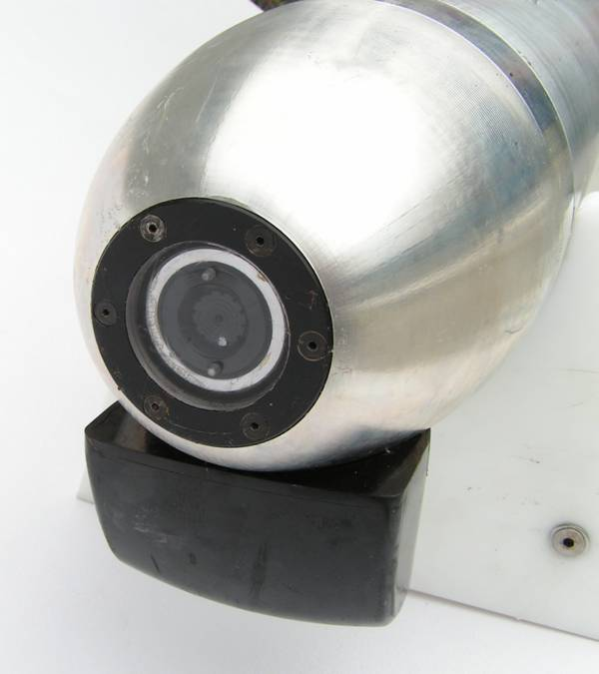
The nose section of the RPUUV can be seen in figure 2.2.6 and the Pro Engineering (ProE) Model is displayed in figure 2.2.7.
Figure 2.2.6: RPUUV Nose

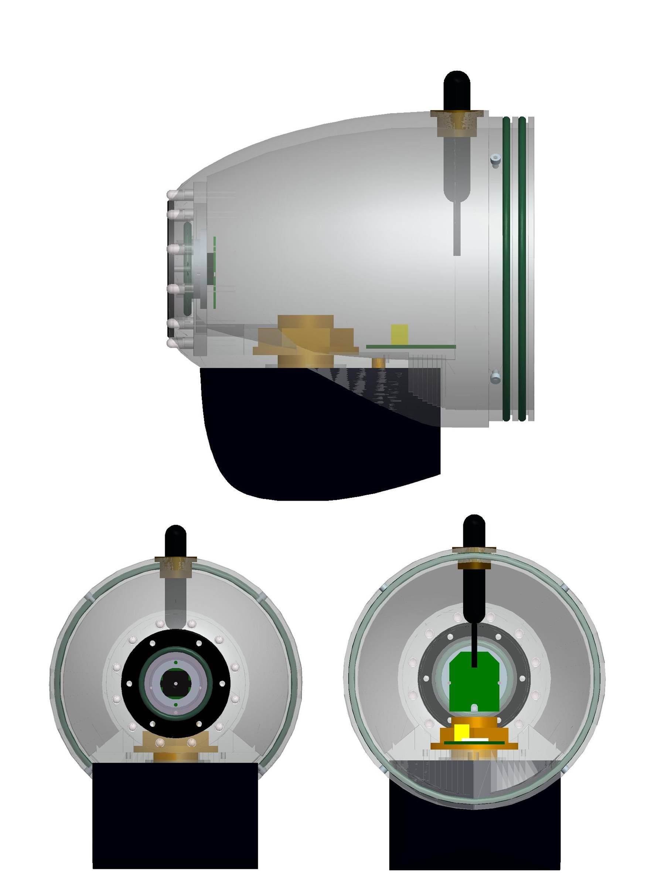
PC-View
Transducer
USB Camera
Acoustic Modem
Transducer
LEDs
Compass/Tilt
Sensor
Figure 2.2.7: Nose Section Components

The nose section has a built in polycarbonate view port behind which is mounted a USB web camera. Surrounding this viewport are 12 high brightness Light Emitting Diodes (LEDs) that provide additional lighting of the camera and coded signaling of the various vehicle states and error modes. The PC-View scanning sonar transducer array is mounted on the underside of the nose. This through-hull transducer is mounted on a milled flat section that contains a face o-ring seal providing a waterproof penetration for the transducer cables. Similarly, the HSAM ITC1089 transducer is mounted on the top of the nose section to facilitate future acoustic communications.

The machined flat area inside the nose section provides a fixed reference frame to the vehicle axes and thus provides an ideal location for mounting the TCM2.6 compass tilt sensor. The nose section is joined to the parallel mid-body by 4 small socket head cap screws and a waterproof connection is provided by two radial o-ring seals.

    - Mid Section

The mid section of the RPUUV consists of a 6” diameter cylindrical section of aluminum tubing. A photograph can be seen in figure 2.2.8 along with the ProE model. Labeled components can also be seen in figure 2.2.4. This section houses the chassis that supports the vehicle electronics, the battery packs and the stepper motors that drive the vectored tail section. The electrical chassis consists of an aluminum plate that is mounted on top of 3 semi-circular bulkheads that carry the battery packs. The single board computer, PC-View sonar boards, motherboard with modems, and the Ethernet switch are all mounted on top of this plate. The chassis is then connected to the nose section via a mounting plate that is secured by the same nut that holds the PC-View transducer to the nose. The nose section, with the chassis attached, can then be removed from the tube as a complete assembly by disconnecting the stepper motor cables and the cabling to the tow float bulkhead connector once the tail section end-cap is removed. Also seen in figure 2.2.8 are 3 welded appendages on the outside of the mid section tube. The forward circular mount is to accommodate the DPAM transducer, then there is a plate for attaching the tow float cable, and toward the stern there is a plate to accommodate the waterproof bulkhead connector for the tow float cable assembly.

By placing the heavy battery packs on the very bottom of the mid section and keeping all the chassis mounted electronics as low as possible, the center of gravity of the RPUUV is sufficiently below its centerline and the center of buoyancy that there vehicle has a good righting moment providing a counter-torque to the thruster.

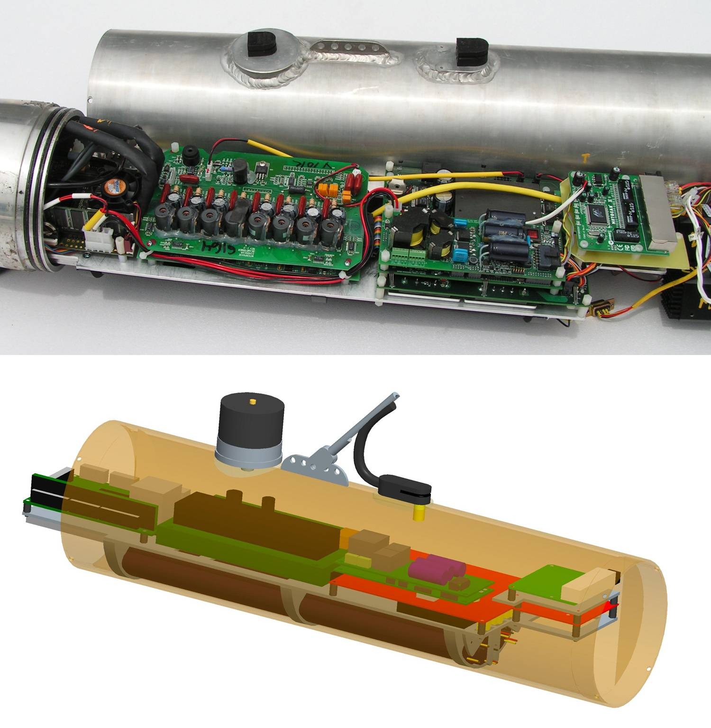
Figure 2.2.8: The RPUUV Mid-Section
    - Tail Section

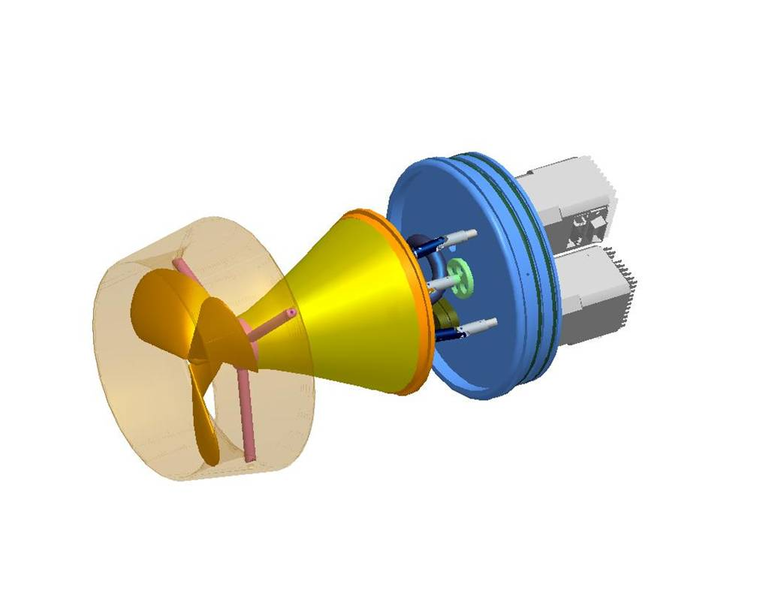
The tail section of the RPUUV provides the directional control and thrust for the vehicle. A ProE model of the assembly is shown in figure 2.2.9 and a photograph is provided in figure 2.2.10.
Figure 2.2.9: CAD Model of the Tail Section

Thrust is provided by a shrouded propeller attached to a DC brushless motor and planetary gearbox assembly. This whole assembly is attached to the RPUUV via a universal joint and a vectoring mechanism, so that the tail can be articulated +/- 40 degrees in both the left to right direction, to provide turning moments, and the up and down direction for diving moments. The articulation is achieved using two stepper motors attached to Acme screws that run through gimbaled nuts on the thruster housing. An exploded view of the components can be seen in figure 2.2.11.

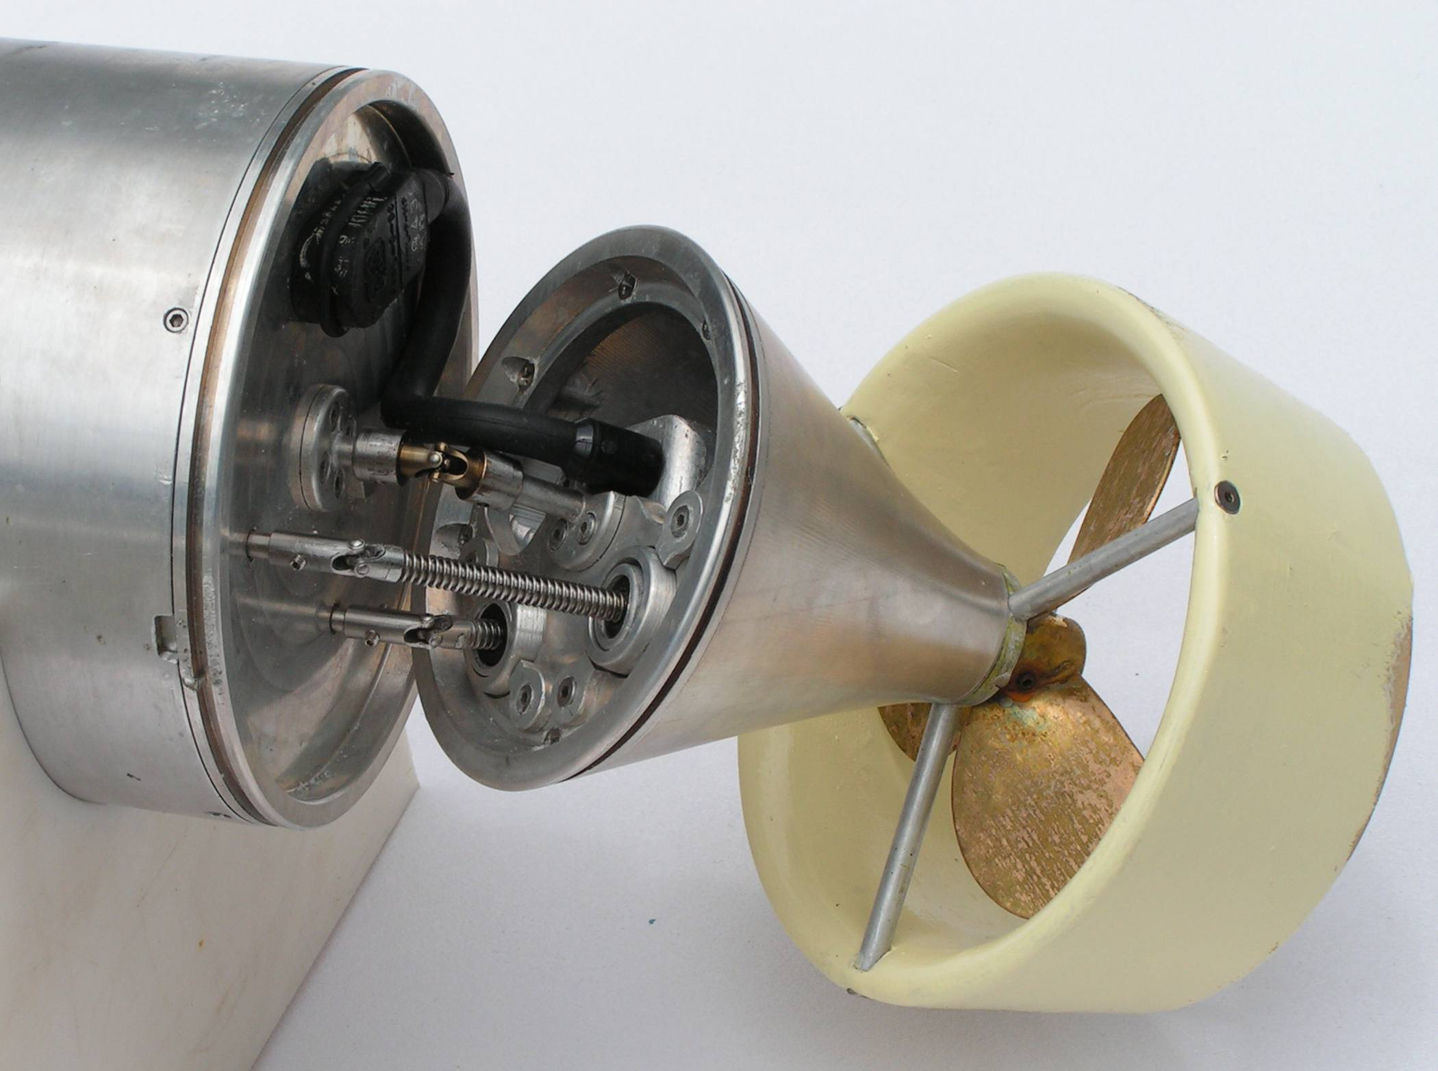
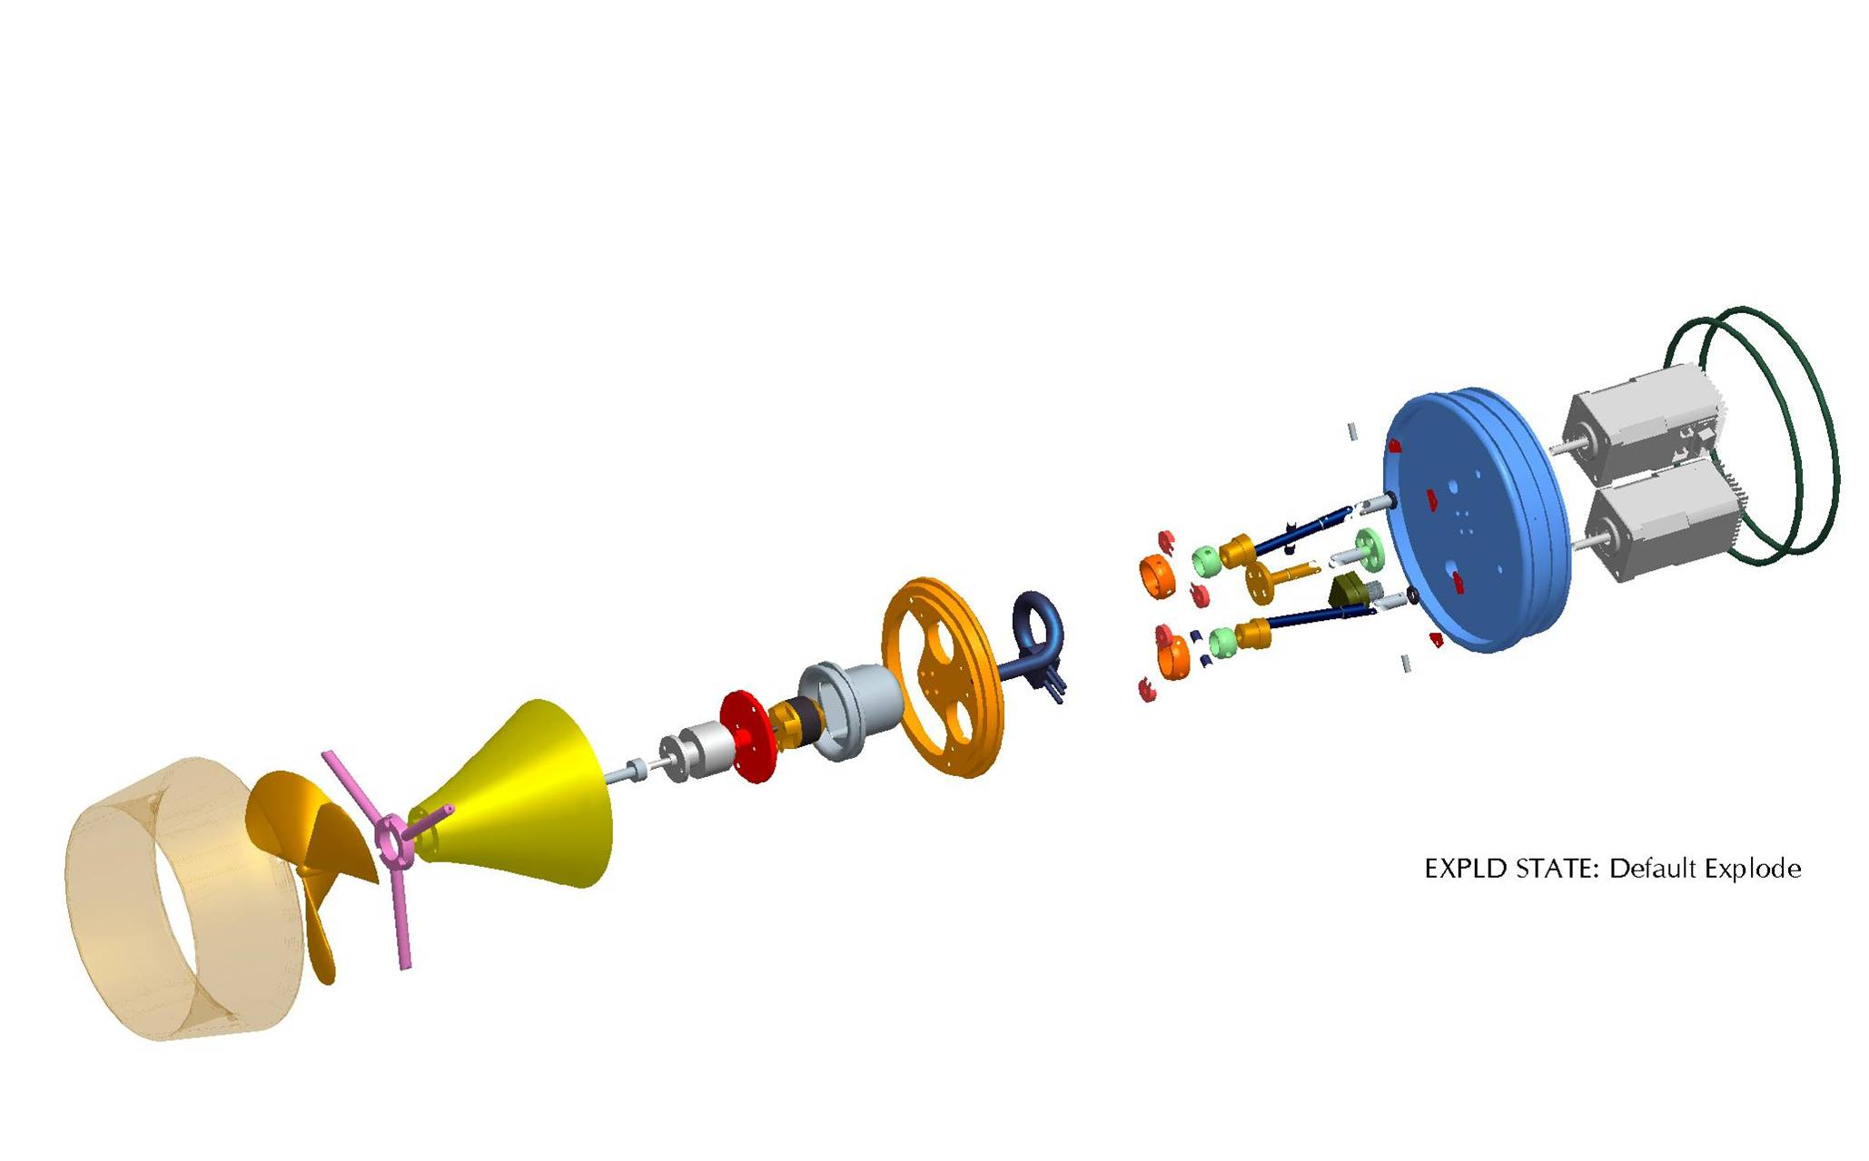
Figure 2.2.10: Close-Up Photograph of RPUUV Tail Section
Figure 2.2.11: Exploded View of the Tail Section Components
Stepper
Motors
Endcap
Propeller
Shroud
Motor/gearbox housing
Acme Screws
Gimbaled
Acme Nuts
Waterproof Cable
& Connectors
Planatery gearbox
Thruster
Motor
Motor Housing
Endcap

A flexible rubber membrane (not shown) is stretched over the vectoring mechanism between the end cap and the thruster motor housing to provide protection against contaminants that may bind the screws and to better streamline the vehicle.

The engineering characteristics of the thruster motor and propeller combination will be discussed in section 2.6 and their effect on the vehicle dynamics will be presented in section 2.7.

    - Electronic Components

The electronic components of the RPUUV are predominantly Commercial Off The Shelf (COTS) products that have been removed from their cases and repackaged to fit in the constraints of the vehicle. There are two custom made printed circuit boards however, one is the vehicle motherboard and the other is the tow float board.

Vehicle Motherboard:

The vehicle motherboard serves many functions. Firstly it distributes power at various voltages to the variety of components that make up the vehicle. The board therefore incorporates DC-DC converters to step up or down the 14VDC bus voltage. The motherboard also provides magnetic hall sensors for switching on the main bus and enabling the thruster etc.. Secondly, the motherboard incorporates a PIC microcontroller to send control signals to the actuators and thruster motors. In addition the motherboard incorporates the power amplification circuitry for the acoustic modems and USBL and a direct plug-in for the modem DSP card. A top level wiring diagram is shown in figure 2.2.12.

The RPUUV Mother Board software’s primary function is to convert the received RS485 data, from the Tow Float, to the necessary format to control the RPUUV. The Micro uses a hardware timer to convert one channel back to a pulse width for the thruster motor controller. It uses two channels to control the vector thruster stepper motors. A 2nd independent RS485 bus is used to communicate to the stepper motors. This 2nd bus enables the optimum performance for the stepper motors.

The RPUUV Mother Board Micro has magnet sensor (Hall) inputs for power control. One sensor turns the RPUUV on (Standby State) and a second enables the thruster (Run State). It also has analog inputs for monitoring battery voltage, temperature and leak error. If any analog input exceeds it limit all power is turned off (Error State). A third magnet sensor must be used in conjunction with the on magnet sensor to clear the error. The 4 Headlight LED are used to indicate the type of error.

The software flow diagram and the state diagram for the RPUUV motherboard are shown respectively in figures 2.2.13 and 2.2.14.

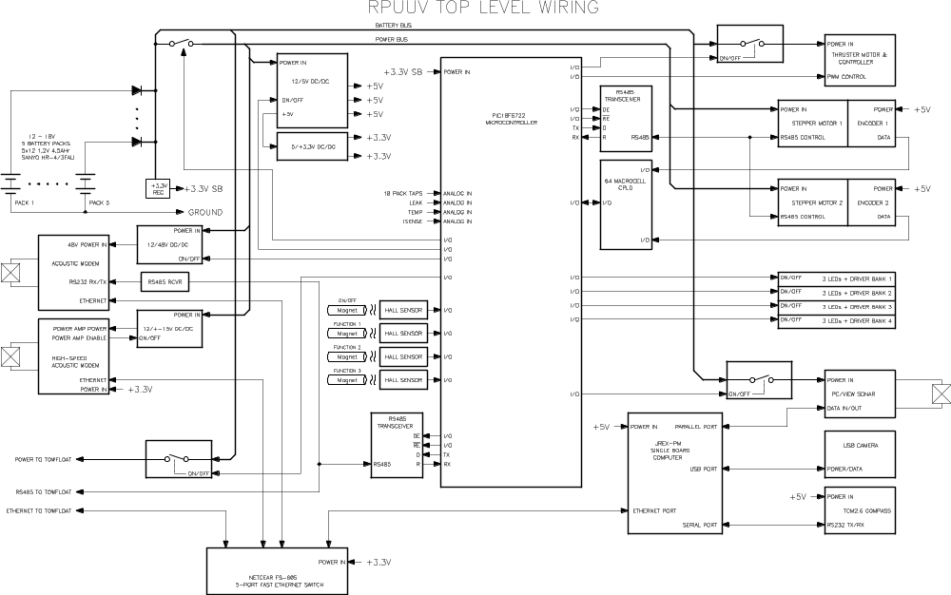
Figure 2.2.12: RPUUV Top Level Wiring Diagram

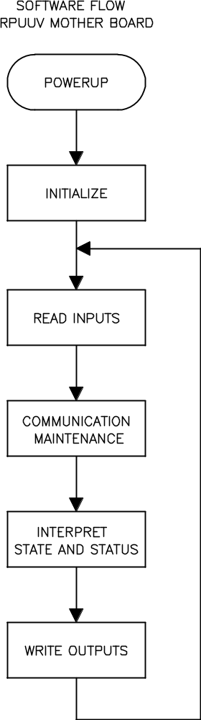
Figure 2.2.13: Software Flow Diagram for the RPUUV Motherboard

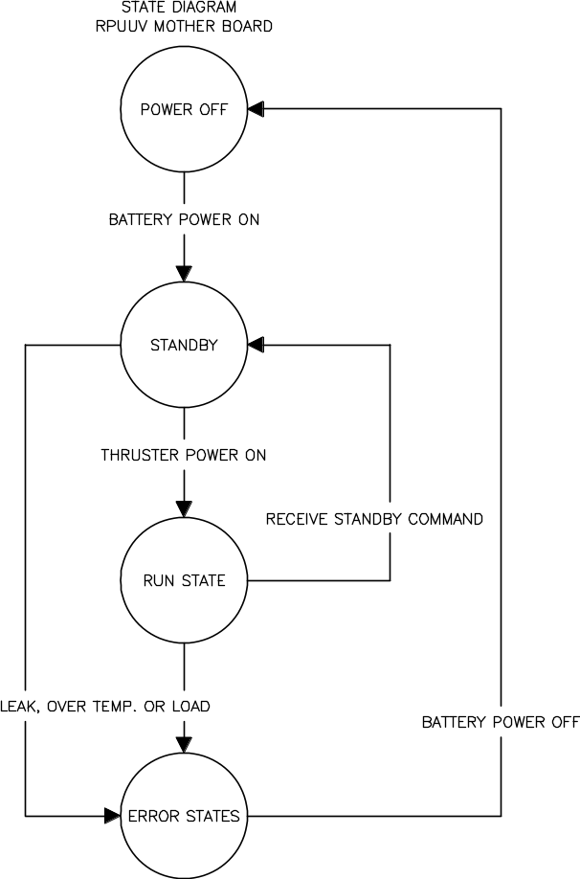
Figure 2.2.14: State Diagram for the RPUUV Motherboard

Tow Float Control Board

The custom tow float board has a DC-DC converter to step down the 14VDC vehicle bus voltage to 5VDC which is required by the RC receiver and the wireless access point that reside in the tow float electronics box. This board also incorporates a PIC microcontroller and the wiring diagram is shown in figure 2.2.15.

The RPUUV Tow Float software’s primary function is to convert pulse width signals, from a Hitec FM receiver, to a RS485 serial data stream and send them down to the RPUUV Mother Board. After initializing the Micro hardware peripheral’s the Micro uses a hardware timer to convert the pulse width of the 7 HiTec channels to a digital value. The Micro then receives control and system status via a RS485 Bus from the RPUUV Mother Board. The system status is displayed by 4 green LED on the Tow Float Board. The Micro’s last step is to convert the pulse width data to ASCII values and transmit it to the RPUUV mother board via the RS485 Bus. The Tow Float to RPUUV RS485 Bus is a simple half duplex configuration running at 57.6K baud. The bus is designed for future expansion by just connecting other devices to it. The bus data flow is controlled by the first 3 characters is each message. The first character is the message the source, the second is the message destination and the third is the type of message. A flow diagram for the tow float control board is presented in figure 2.2.16

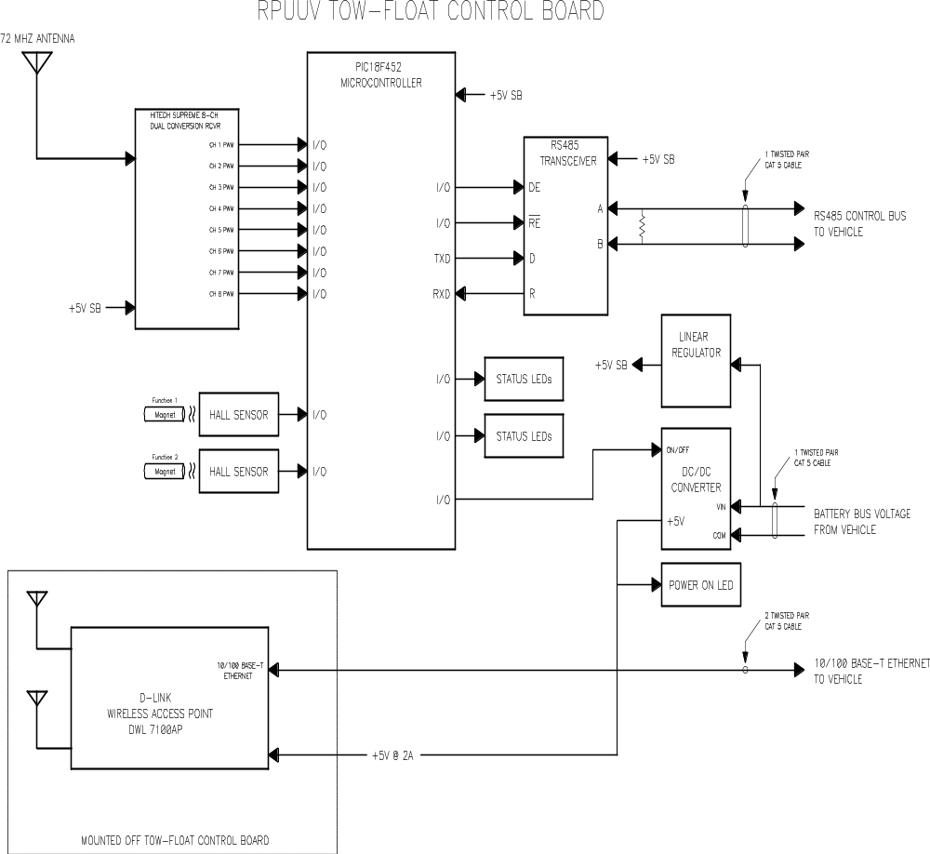
Figure 2.2.15: RPUUV Tow Float Control Board Wiring Diagram

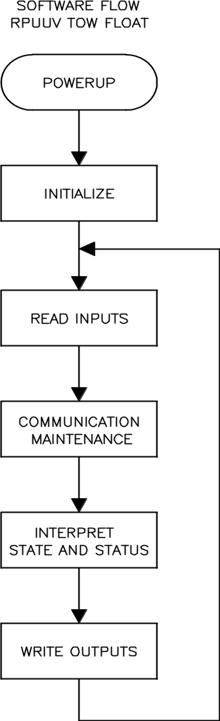
Figure 2.2.16: RPUUV Tow Float Software Flow Diagram

Control and Communication Timing:

Control Frequency – 22.5 Hz typical when RF control data received
- 21.3 Hz maximum when RF control data is lost
RF Good Detection - Channel 1 Interval 21.22 mSec to 23.22 mSec (5 consecutive times)
Communication Time – Alternating 22.22 mSec on/off
Communication Master – Motherboad
Communication Slave – Tow Float

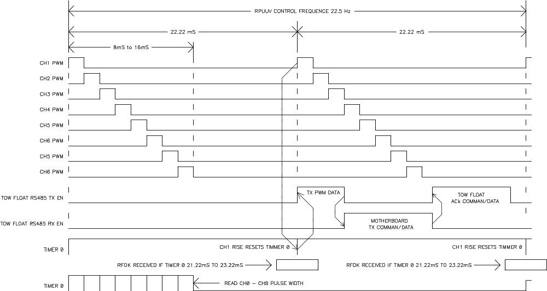

Tow Float to RPUUV Bus:

Bus Type – RS485
Bus Master – Tow Float
Bus Configuration:
Bit Pre Second – 57.6K
Data Bits – 8
Parity – none
Stop bits – 1
Flow control – none
Data Type – ASCII
Line Terminator – Line End with Line Feed

Communication Format:
XYZ,dddddddddddd.……\r\n
X = Source, T = Tow Float, M= Motherboard, A=Acoustic Modem
Y = Destination , T = Tow Float, M= Motherboard, A=Acoustic Modem
Z = Type of data, P=Pulse Width Data, S= ACK Status, s = Request Status
Vehicle Control String, 8 Pulse width channels, 0000uSec to 2777uSec
TMP,aaaa,bbbb,cccc,dddd,eeee,ffff,gggg,hhhh\r\n
aaaa = Channel 1 pulse in uSec
: : : :
hhhh = Channel 8 pulse in uSec

MTS,ddd\r\n = Motherboard to Tow Float message, d is the operational state of the Mother Board (0 to 127)
MTs\r\n = Motherboard to Tow Float message requesting Tow Float Status
TMS,ddd\r\n = Tow Float to Motherboard message, d is the Tower Float Status (0 to 127)

Tow Float LED Indications: LED# 4/3/2/1

Tow Float Battery power off – off/off/off/off (0x00)
Dead Battery – off/off/off/off (0x00)
Leak Error - off/off/on/off (0x02)
Over Load - off/off/on/on (0x03)
Over Temp. - off/on/off/off (0x04)
Standby State - off/on/on/on (0x0E)
Run State - on/on/on/on (0x0F)

Channel Pulse Width Versus Trim Setting: divide

Control Resolution – 0.1% (1uSec resolution for a typical 1mS to 2mS pulse width range)

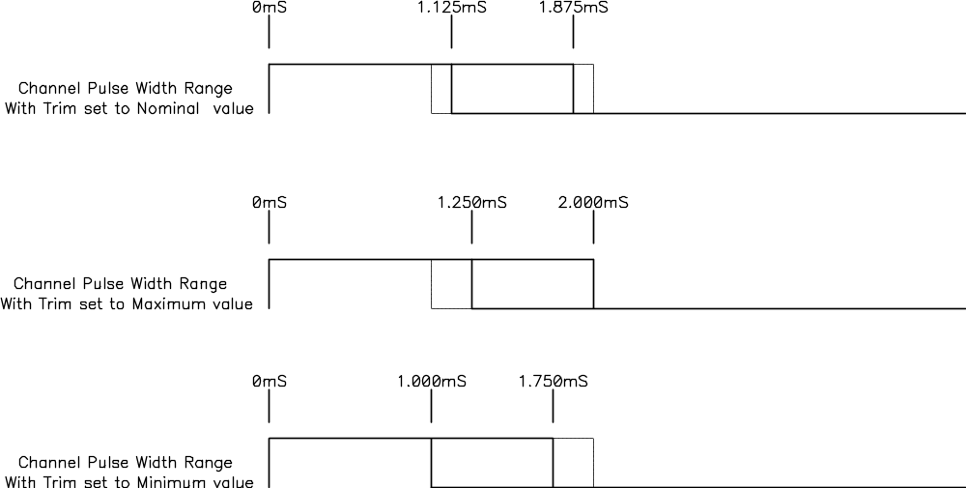

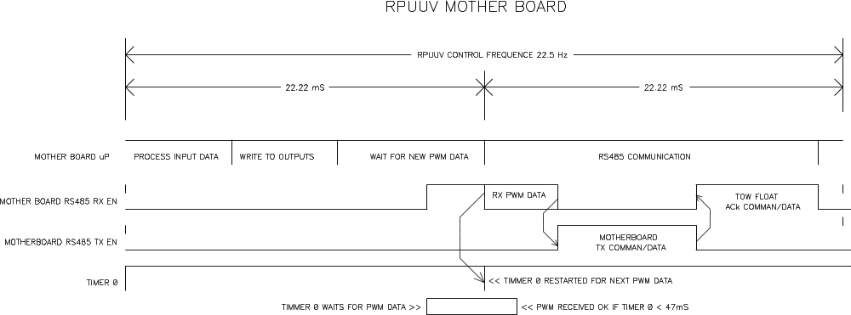

Number | STATES | Power Bus | 5 Volts | 48 Volts | Sonar Power | TowFloat Power | Thruster Power |  | LED 1 | LED 2 | LED 3 | LED 4
0x00 | Dead Battery |  |  |  |  |  |  |  | off | off | off | off
0x01 | Power Off |  |  |  |  |  |  |  | off | off | off | off
0x02 | Leak Error |  |  |  |  |  |  |  | off | off | off | off
0x03 | Over Load Error |  |  |  |  |  |  |  | off | off | off | off
0x04 | Over Temperature Error |  |  |  |  |  |  |  | off | off | off | off
0x14 | Standby Mode | on | on | on | on | on | off |  | off | off | off | off
0x15 | Run Mode | on | on | on | on | on | on |  | on | on | on | on
 | Power up sequence > | 1 st | 2 nd | 5 th | 4 th | 3 rd | 6 th

    - Tow Float

The surface tow float, shown in figure 2.2.17 provides the communications link between the operator and the RPUUV. It is constructed from closed cell syntactic foam and has a small watertight electronics box attached. Contained in this box are the RC receiver, the custom tow float control board and one half of the wireless Ethernet gateway. The RC receiver whip antenna and the two wireless Ethernet gateway antennas are mounted on the outside of the box via waterproof grommets.
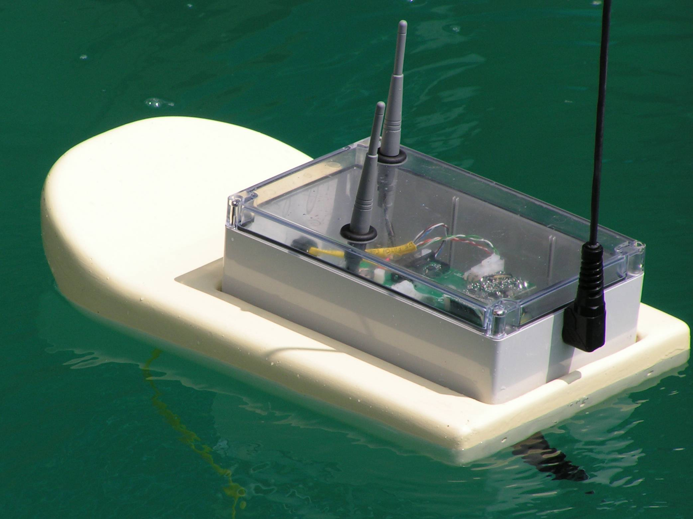
Figure 2.2.17: RPUUV Surface Tow Float

    - In Water Test Results

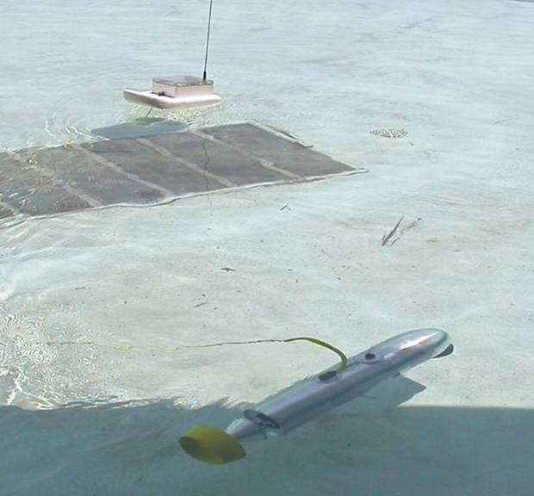
The RPUUV was first tested in a shallow pool at Florida Atlantic University’s Seatech campus. A picture taken from these tests is shown in figure 2.2.18.
Figure 2.2.18: Initial Testing in a Shallow Pool

The test allowed the vehicle to be trimmed and ballasted to sit horizontally in the water with a small amount of positive buoyancy. The first observation from these tests was that the vehicle was much more reactive than anticipated both in speed and maneuverability, making it difficult to control in a confined environment. Consequently future versions of the control software will include more fine control increments and perhaps a non-linear relationship between the RC handset joystick deviation and the commanded turning and diving vectors and throttle positions.

For these initial tests the vehicle main pressure vessel was pressurized slightly so that any leaking around the stepper motor shafts would be evident as bubbles. It was found that positive pressure in the main vessel could have an adverse effect on the operation of the hard drive of the single board computer causing the system to crash and corrupt the boot sector on the drive. This problem was overcome by removing the positive pressure in the main vessel and the plan for future versions will have an embedded version of Windows XP installed on a flash drive instead of the hard disk drive in an effort to make the system more robust and lower the overhead of the operating system on the processor.

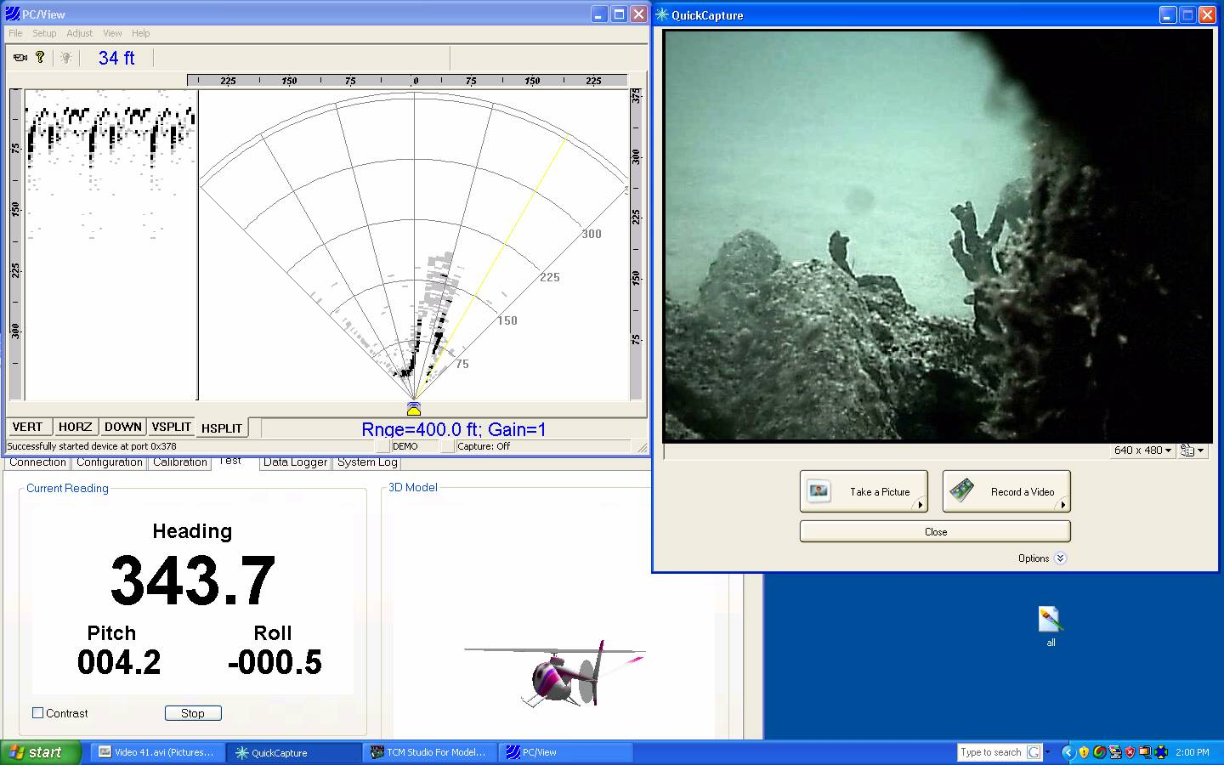
Figure 2.2.19: Screen Dump from Remote Desktop Application on Topside Laptop
To test the forward looking scanning sonar and the vehicle controllability once underwater and out of sight of the operator, a second set of tests were performed at sea in about 15ft of seawater. Once underwater the operator has to control the vehicle using only the feedback from the onboard camera, sonar and compass tilt sensor. Figure 2.2.19 shows a typical screen captured from the Laptop during a dive. The PC-View scanning sonar screen is displayed in the top left of the screen, and the heading with pitch and roll are displayed on the bottom left. The video from the USB camera is displayed on the right.

The first thing that these tests revealed was that the image obtained from the sonar appeared to be just noise. (The screen dump shown in figure 2.2.19 has the sonar in demo mode and is not real data.) There was no discernable bottom reflection or reflection from obstacles the vehicle encountered.

The second observation was that very little could be seen through the camera unless the vehicle was within a few feet of the bottom. Without the benefit of the sonar bottom tracking, it was impossible to determine when the vehicle was approaching the bottom, and by the time it came into view there was not sufficient time to correct and the vehicle ran into the bottom. One conclusion from this experiment is that the camera needs to be pointed at a downward facing angle so that the operator has more time to see the bottom approaching and make control and evasive maneuvers.

Like the pool tests, the at-sea tests also showed that the RPUUV was very difficult to control. Part of this uncontrollability can be attributed to the vehicle being too fast, and the reaction of the pilot too slow, but it was also difficult to make the vehicle dive at slow speed and stay submerged because of the time delay between issuing a command and it being executed by the vectored tail. One reason for this is that the present set-up has no feedback from the stepper motors, so in order for the controller to keep track of the position of the motors, one command has to completely execute before the next is issued. This means that there is a long reaction to control inputs and the operator must wait for his last input to execute before a corrective input is sent. Some of this problem can be removed by desensitizing the controls as discussed to allow for finer control inputs, but much more controllability would result from incorporating the encoder feedback from the stepper motors into the control loop, allowing commands to be interrupted before they are finished and hence cut down the time lag between when the command is given and executed.

It is interesting to note that these trials indicated an inherent problem of the vehicle to move at slow speeds with any controllability and that this observation may be supported by the findings from the hydrodynamic modeling and testing reported in section 2.6 which predict unsteady flow into the propeller at low vehicle speeds. These findings obviously warrant further investigation.

A final conclusion that was apparent from the sea trials is that the human interface needs to be refined. As it stands there is significant operator overload in trying to mentally incorporate all the data from the vehicle sensors from individual windows on the laptop screen and create a mental map of the vehicle’s environment. It would therefore be beneficial to create a single “heads-up” display where all the data is incorporated into a single intuitive screen with a horizon line and indication of the vehicles position relative to the seafloor and surface.

These improvements will be addressed in year two of the CCST Program.

2.3 Acoustic and RF Communications
PI: Dr. P. Beaujean

2.3.1 Summary

The main objective of this portion of the project is to achieve communications for the purpose of transmitting and receiving information wirelessly between a user and the Remotely Piloted Underwater Vehicle (RPUV). Transmitted information is used to pilot the RPUV and relay its position. Information received from the RPUV combine acoustic images of the environment and status report of the vehicle. To achieve such goals, radio wave (WiFi) communication is achieved using a tow-float. Whenever the tow-float solution becomes impractical, a slower but fully wireless acoustic modem is to be used. The communication design must consider the issues associated with acoustic communications in port at high data rates, using a high-frequency acoustic modem, and the piloting and tracking of the RPUV, using a command-and-control acoustic modem.

Dr. Beaujean is responsible for this communication project. Two graduate students have been supported to evaluate the performance of the RF and acoustic communication devices used. The deliverable consisted in a report presenting the design and testing of a dual RF and acoustic wireless communication system to control and retrieve data from the RPUV.

2.3.2 Introduction

Operational criteria:
The objective of this research is to be capable of piloting an underwater vehicle remotely using either radio frequencies or sound. This vehicle is to perform search missions, principally in ports and very shallow waters, to find potentially dangerous or illegal objects such as explosive or narcotics. Note that this vehicle can also perform scientific missions. In its initial configuration, the vehicle is equipped with:
- An imaging sonar system, a camera and an optional chemical sensor for threat detection.
- A tilt sensor and compass, and an Ultra-Short Baseline acoustic positioning system.
- An embedded processor, a motherboard and Ni-Mh batteries.
- A tow-float with a WiFi access point (802-11g, 2.4 GHz) for image and data transmission and Radio Frequency (72 MHz) control unit for piloting.

In a second, fully untethered configuration, the vehicle is equipped with the acoustic communication package:
- A low-speed acoustic modem for remote piloting and positioning (surface to vehicle)
- A high-speed acoustic modem for image transmission (vehicle to surface).

Electro-magnetic wave piloting and feedback:
The criteria retained for the piloting and positioning of the RPUV are as follow:
- Transmission of control (piloting commands) and reception of vehicle sensor information via a tow-float.
- The information is to be relayed from a small USB camera (28 frames-per-second), a PC-View forward-look sonar (5 updates-per-second) and a TCM2 tilt sensor (pitch, roll and heading updated 8 times per second).
- Commands and sensor data are updated 10 times per seconds, or at the fastest update rate of the sensor in question.
- Maximum operating range is 100 m.

Acoustic remote piloting and positioning:
The criteria retained for the piloting and positioning of the RPUV are as follow:
- The vehicle is to operate for approximately 2 hours in approximately 10’ to 50’ of water, in the proximity of walls, pilings and underneath ships.
- The vehicle is moving at a top-speed of 2 knots, at a maximum range of 300 m.
- The vehicle is assumed to remain at least 0.25 m from the surface during operations.
- The peak power consumption of the modem receiver unit in the vehicle is to be kept to a minimum (0.5 W) and use as few transducers as possible (one ITC-3460).
- At the surface, the source level is limited to 168 dB re 1μPa//1m averaged over time, due to environmental requirements, and must not interfere with the imaging sonar nor the USBL.
- The remote piloting modem must operate so that it can easily replace the remote piloting unit initially used for piloting.
- The pitch, yaw and thrust of the vector thruster unit must be updated at least 3 times a second, with 64 positions for pitch and yaw, and 16 levels of thrust. Information space must be reserved for a minimum of 2 module activations.

High-speed acoustic communications:
The criteria retained for high-speed acoustic communication system, used to transfer video and sonar information, are as follow:
- A maximum achievable data rate of 100,000 bits per second at fairly close range (150 meters and less) in harbors and in very shallow water.
- small, low-power and inexpensive device, well suited for modern untethered underwater vehicles operating in very shallow water and ports.
- Compressed video or high-resolution sonar images should be relayed to a topside unit in real-time.

2.3.3 Remote piloting and Control using Electro-Magnetic Waves:

The RPUV can be controlled and piloted using either electro-magnetic waves or sound. In the first case, a tow-float relays the information from the surface to the underwater vehicle, as electro-magnetic waves are severely attenuated in the water. Figures 2.3.1 and 2.3.2 provide an overview of the RPUV equipped with a tow-float.
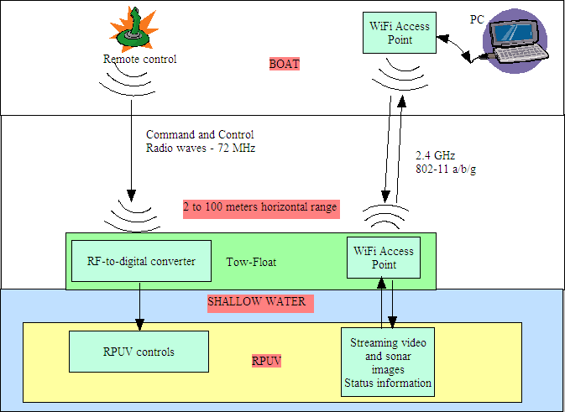

Figure 2.3.1. Overview of the RPUV control using a tow-float and electro-magnetic waves.

PC/View Acoustic
Interface Unit
Submerged
Vessel
Transducer
60 ft Ethernet Power and RS485 Cable
Parallel Cable

USB cable
Ethernet Hub/Switch
Ethernet cable
High Brightness LED Circuit
LEDs
Binary decoder for FM Receiver
Thruster Motor

Speed Controller

Stepper
Motor 1

12V Battery
Power Board
Integrated DC-DCs
5, 9, 12, 48 Vdc

Relays for LEDs
& PC/View
Payload
Power
Control
Surface
Tow Float
FM Receiver
Hitech Supreme 7 Ch
72MHz
Binary encoding module
Wireless Access Point
DWL 7100AP/108Mbps
802.11 a/b/g/
Antenna
High Gain
System Diagram
Tow-Float Configuration
Laptop
With Remote Desktop Application
Radio Transmitter
Joystick Control
Hitech Eclipse 7ch

Wireless Access Point
DWL 7100AP/108Mbps
802.11 a/b/g/
Shipboard
Operator
Ethernet Cable

Ethernet extender
d-link wireless
Antenna
High Gain
Single Board Computer
72 MHz
dual-band (2.4GHz, 5GHz),
tri-mode (802.11a, b, g)
USB Camera
Stepper
Motor 2

Stepper Controller

Figure 2.3.2. Detailed diagram of the RPUV control using a tow-float and electro-magnetic waves.

In the current configuration, the remote piloting is accomplished using a “Hitech Eclipse 7” remote control transmitting radio waves transmitted at 72 MHz to a tow-float, described in Figure 2.3.3. The tow-float is connected to the RPUV with a communication cable. The radio waves are digitized and transformed into numeric commands, transmitted to the vehicle using an RS-485 bus. The following communication format is used:

XYZ,dddddddddddd.……\r\n
X = Source, T = Tow Float, M= Motherboard, A=Acoustic Modem
Y = Destination , T = Tow Float, M= Motherboard, A=Acoustic Modem
Z = Type of data, P=Pulse Width Data, S= ACK Status, s = Request Status
Vehicle Control String, 8 Pulse width channels, 0000uSec to 2777uSec
TMP,aaaa,bbbb,cccc,dddd,eeee,ffff,gggg,hhhh\r\n
aaaa = Channel 1 pulse in uSec
:::::::::::::::::::::::::::::::::::::::::::::
hhhh = Channel 8 pulse in uSec

Note that this configuration format includes future communications using the remote piloting acoustic modem. At the RPUV end on the connection, the binary commands are transformed back to analog commands (thrust, pitch, yaw, activation …) using dedicated micro-controllers.

Figure 2.3.3. Functional diagram of the tow-float.

The navigation information from the vehicle is transferred to the user using a D-link DWL7100AP-108 Mbps 2.4 GHz point-to-point WiFi bridge, supporting the 802.11a, b, and g standards. In the current configuration, the embedded Kontron JREX PC installed in the vehicle is controlled from a topside laptop using “remote desktop”, a built-in feature of Windows XP. The embedded PC runs Windows XP off a 2.5” hard drive at the present time. This operating system will very shortly be replaced with Windows Embedded XP running on a flash disk, a significantly more robust solution.
Using “remote desktop”, the user can observe the streaming video, Interphase PC-view sonar measurement and TCM2 data (pitch, roll, compass heading) in real-time. The time delay in relaying the information from the vehicle to the user is of the order of 0.1 second when all the applications are running and a 320x200 image is displayed (at a rate of 28 frames-per-second).
Experimental measurements have shown that both remote control and WiFi communication systems operate reliably at a range of 100 meters. Further range has not been tested at this time. The units have been tested in the intra-coastal marina facing the FAU SeaTech building (Dania Beach, Florida), and in the South turning basin of Port Everglades, Florida (Figure 2.3.13).

2.3.4 Acoustic remote piloting and positioning:

The second option is to pilot the vehicle using sound. In this case, the RPUV does not use a tow-float any longer. Instead, two acoustic communication units are used for piloting and navigation, and to relay video and images. An overview of the acoustically-piloted RPUV is shown in Figures 2.3.4 and 5. Figure 2.3.6 shows the various components of the RPUV used for communications and piloting.
The piloting and positioning unit uses an FAU-Dual Purpose Acoustic Modem (DPAM) [1], which transmits remote-piloting commands from the topside to the underwater vehicle and receives position information back from the vehicle periodically. The topside unit is equipped with an ITC-3460 reciprocal transducer for piloting. Acoustic positioning takes place using a top-side FAU Ultra-Short Baseline (USBL) array [2]. The high-level communication and navigation algorithms for both topside and vehicle modem units are shown in Figures 2.3.7 and 8. A picture of the FAU DPAM electronics and of the FAU USBL array is shown in Figure 2.3.9.
At present, the remote piloting unit is capable of transmitting up to 4 piloting messages per second, while the vehicle position is updated once every 2 seconds approximately. Although it has not been tested in the water yet, the expected range is 500 meters. The electronic units are built, and the RPUV is already equipped with an FAU DPAM electronic DSP card and amplifier, and an ITC-3460 transducer. The FAU USBL unit has also been assembled. The topside software for the remote piloting is at a point of development where streaming piloting commands can now be transmitted to the vehicle. The real-time positioning software is still under development, as well as the real-time software to receive the piloting commands in the vehicle.

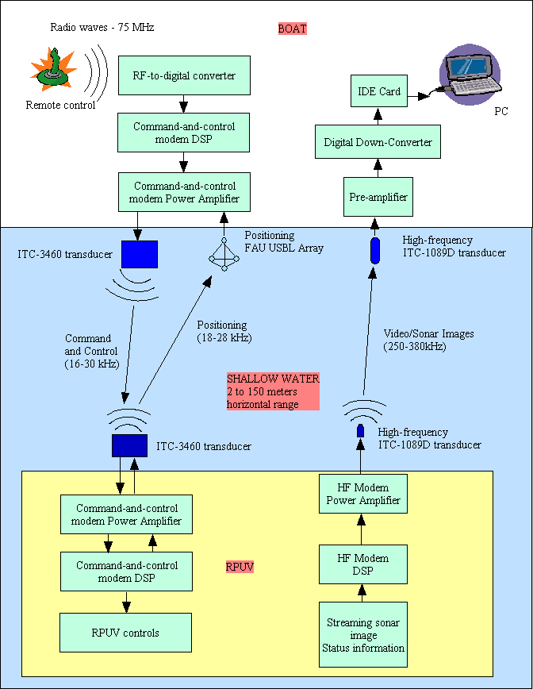

Figure 2.3.4. Overview of the RPUV control using a tow-float and acoustic waves.

PC/View Acoustic
Interface Unit
Submerged
Vessel
Transducer
60 ft Ethernet Power and RS485 Cable
Parallel Cable

USB cable
Ethernet Hub/Switch
Ethernet cable
High Brightness LED Circuit
LEDs
Binary decoder for FM Receiver
Thruster Motor

Speed Controller

Stepper
Motor 1

12V Battery
Power Board
Integrated DC-DCs
5, 9, 12, 48 Vdc

Relays for LEDs
& PC/View
Payload
Power
Control
System Diagram
Acoustic Configuration
Laptop
With Remote Desktop Application
Radio Transmitter
Joystick Control
Hitech Eclipse 7ch

Shipboard
Operator
Ethernet Cable
Single Board Computer
High-speed acomms (260-380 kHz, 100000 bps)
Low-speed acomms
(15-30 kHz, 70 bps)
USB Camera
Stepper
Motor 2

Stepper Controller

Low-speed modem
and USBL
High-speed modem source
High-speed modem receiver
FM Receiver
Hitech Supreme 8 Ch
4.8-6 V, 75MHz
Current Drain 19mA +/-3.0mA
690-Meter Range
Binary encoding module
Serial Cable
72 MHz

Figure 2.3.5. Detailed diagram of the RPUV control using acoustic waves.

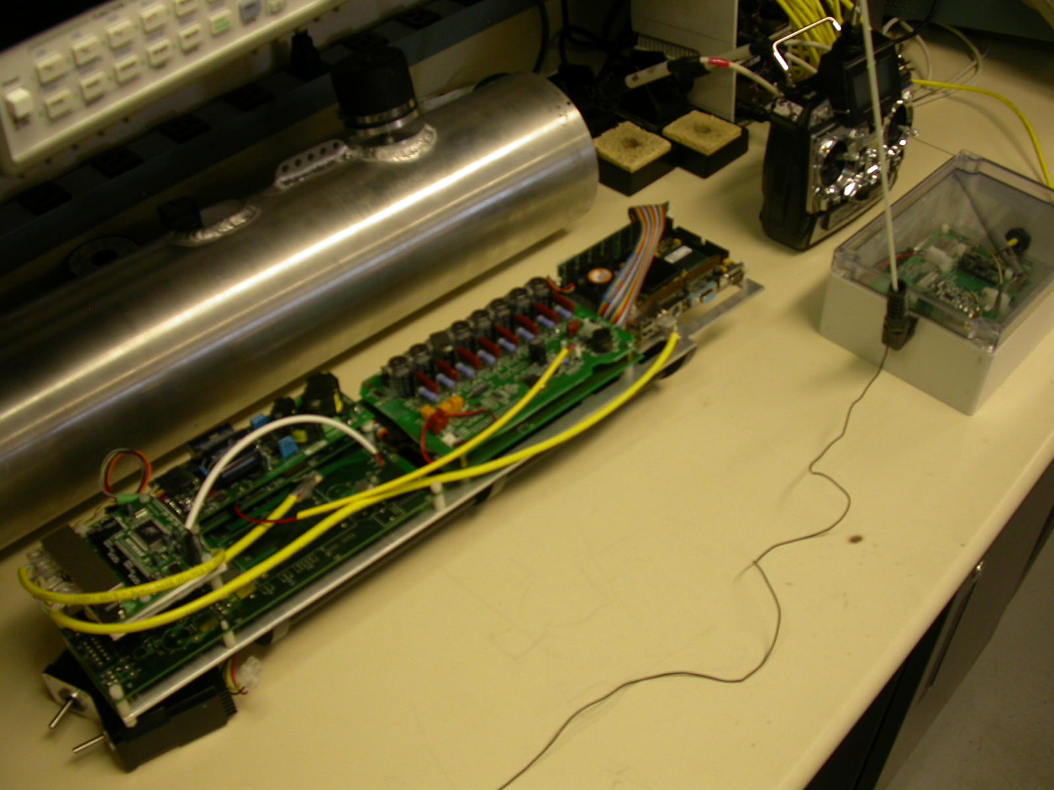
Vehicle embedded PC
Piloting modem
transducer
Tow-float electronics
with RF receiver and
WiFi access point
Pressure vessel
Remote control
Acoustic modem electronics
PC-view electronics

Figure 2.3.6. The remote control components of the RPUV.

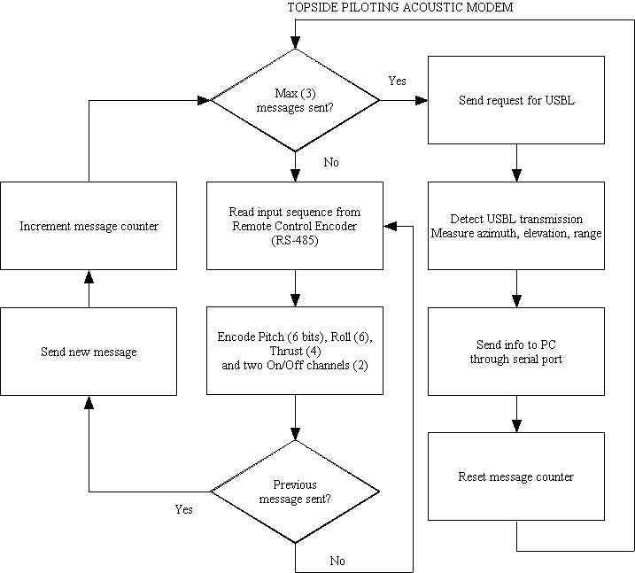
Figure 2.3.7. High-level flow chart of the acoustic piloting and positioning at the user end.

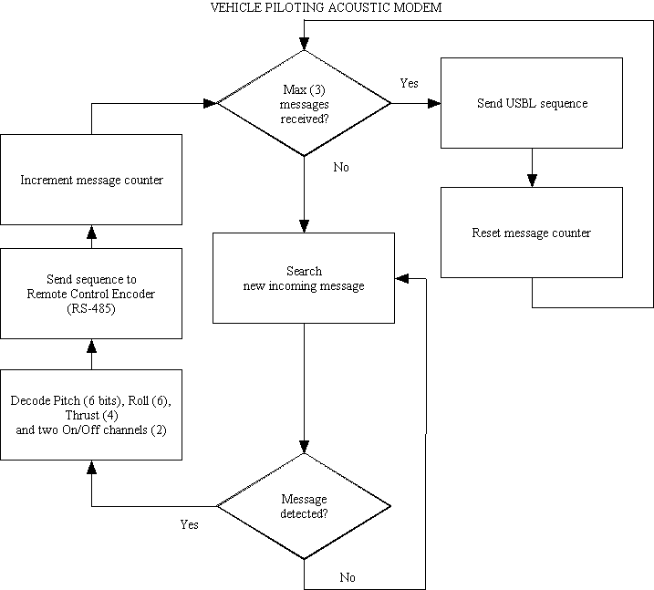

Figure 2.3.8. High-level flow chart of the acoustic piloting and positioning at the RPUV end.

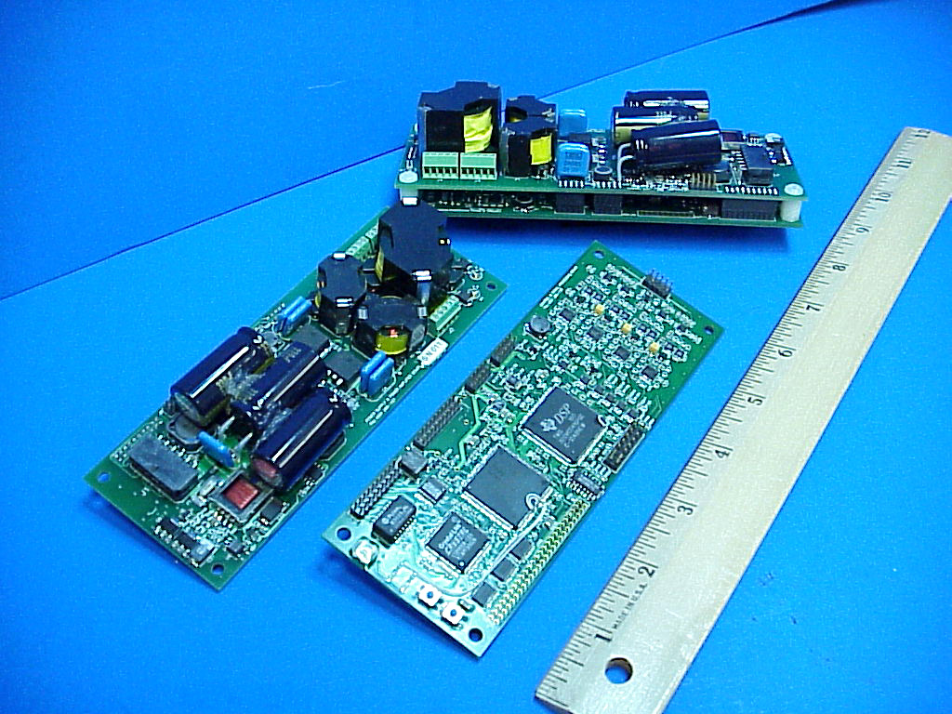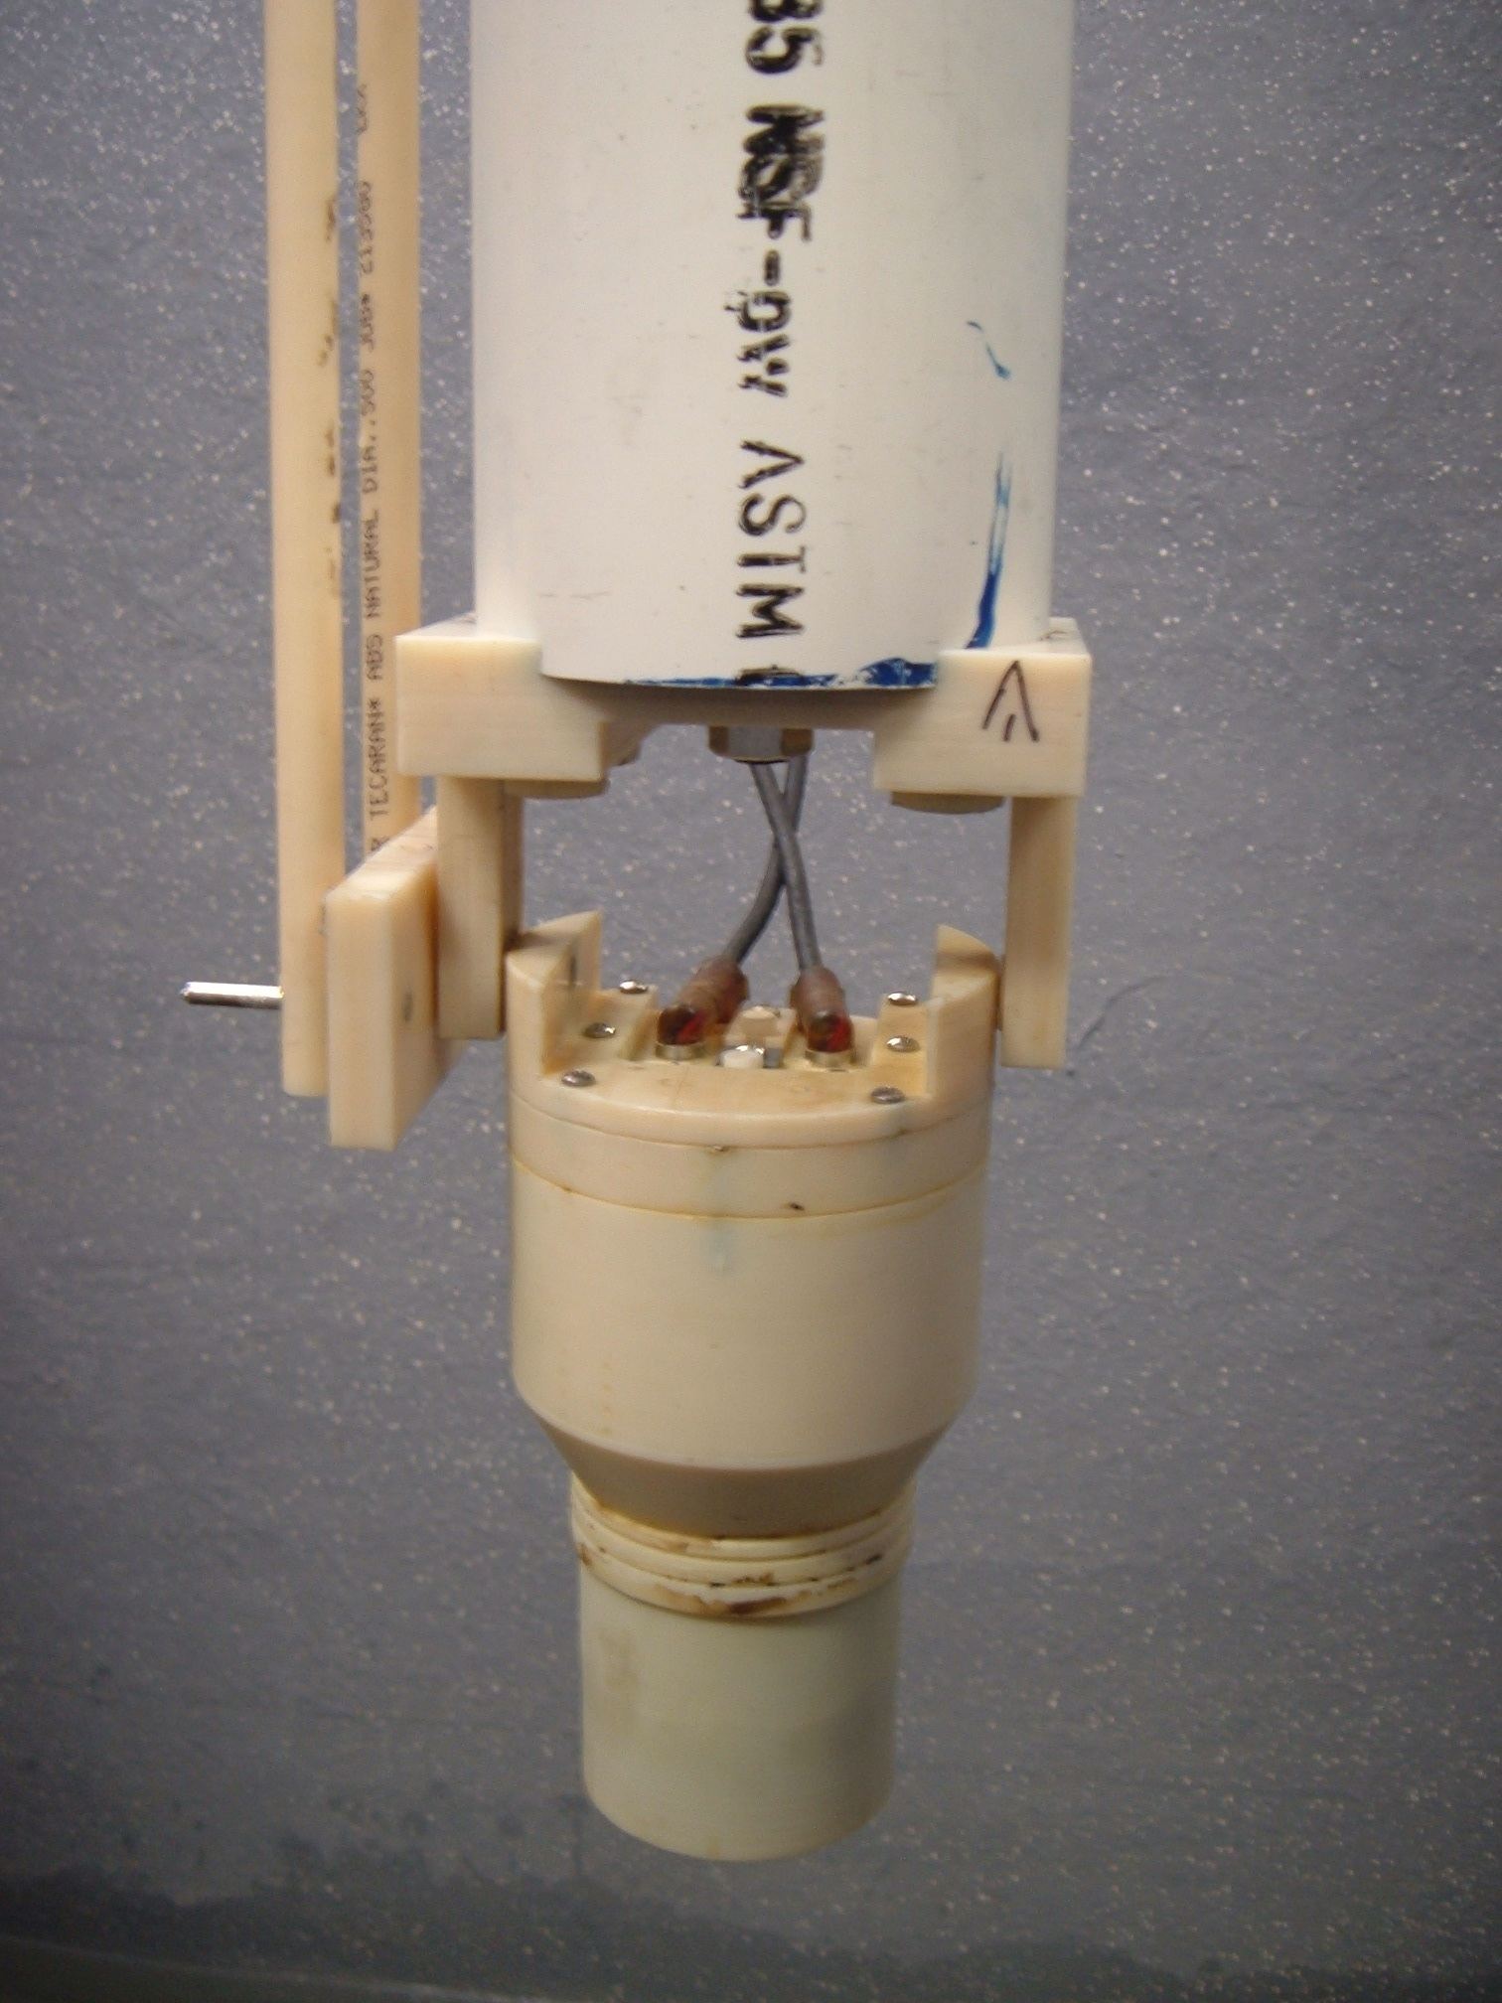
Figure 2.3.9. Acoustic remote piloting electronics (left) and positioning array (right).

2.3.5 High-speed acoustic communications:

The high-speed acoustic communication technology is presented in details in a series of ONR reports and presentations [3-7]. The system is known as the FAU High-Speed High-Frequency Acoustic Modem (HS-HAM). The implementation and testing of the algorithm for high-speed high-frequency acoustic communications is based on technology and equipment already available at FAU and EdgeTech. Figure 2.3.10 summarizes the experimental setup.
An experimental approach is chosen to prove that the HS-HFAM concept is feasible and that adequate performance can be achieved. The acoustic source transmits a known sequence of messages at various speeds, based on the modulation (BPSK and QPSK) and bandwidth (13 µs to 40 µs). Examples of transmitted images are shown in Figure 2.3.11. The source and receiver location and speed are known, as well as the transect bathymetry between the source and the receiver. Both source and receiver use calibrated ITC-1089D transducers. The source level is known (173 dB re 1µPa at 1m). The receiver unit provides the following real-time information regarding the system and the environment:
- Impulse response on a message packet basis (every 10 ms at best), estimated between 262.5 kHz and 337.5 kHz.
- Doppler shift and spread through an auto-regressive PSD estimate of a continuously transmitted tone (375 kHz).
- Noise PSD between 225 kHz and 375 kHz.
- SNR in the 262.5 kHz and 337.5 kHz band.
- Bit error rate associated with each packet and message.
Experiments took place in the FAU SeaTech Marina (Figure 2.3.12) and at the South turning basin of Port Everglades (Figures 2.3.13 and 14). Figure 2.3.15 depicts the deployment of the HS-HFAM test unit during a set of measurement in the turning basin.

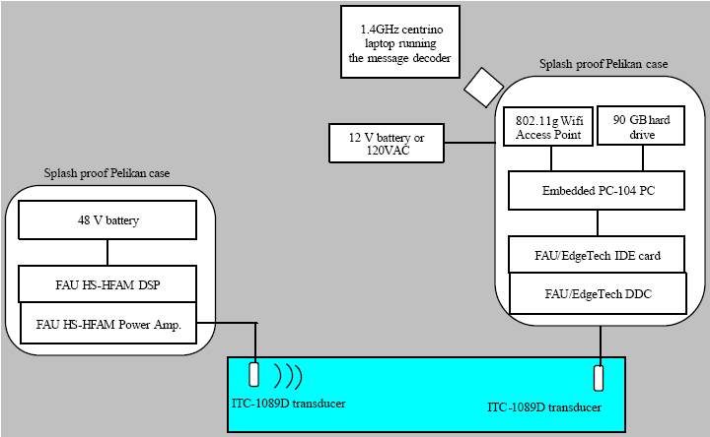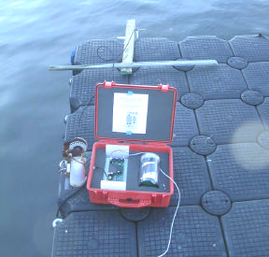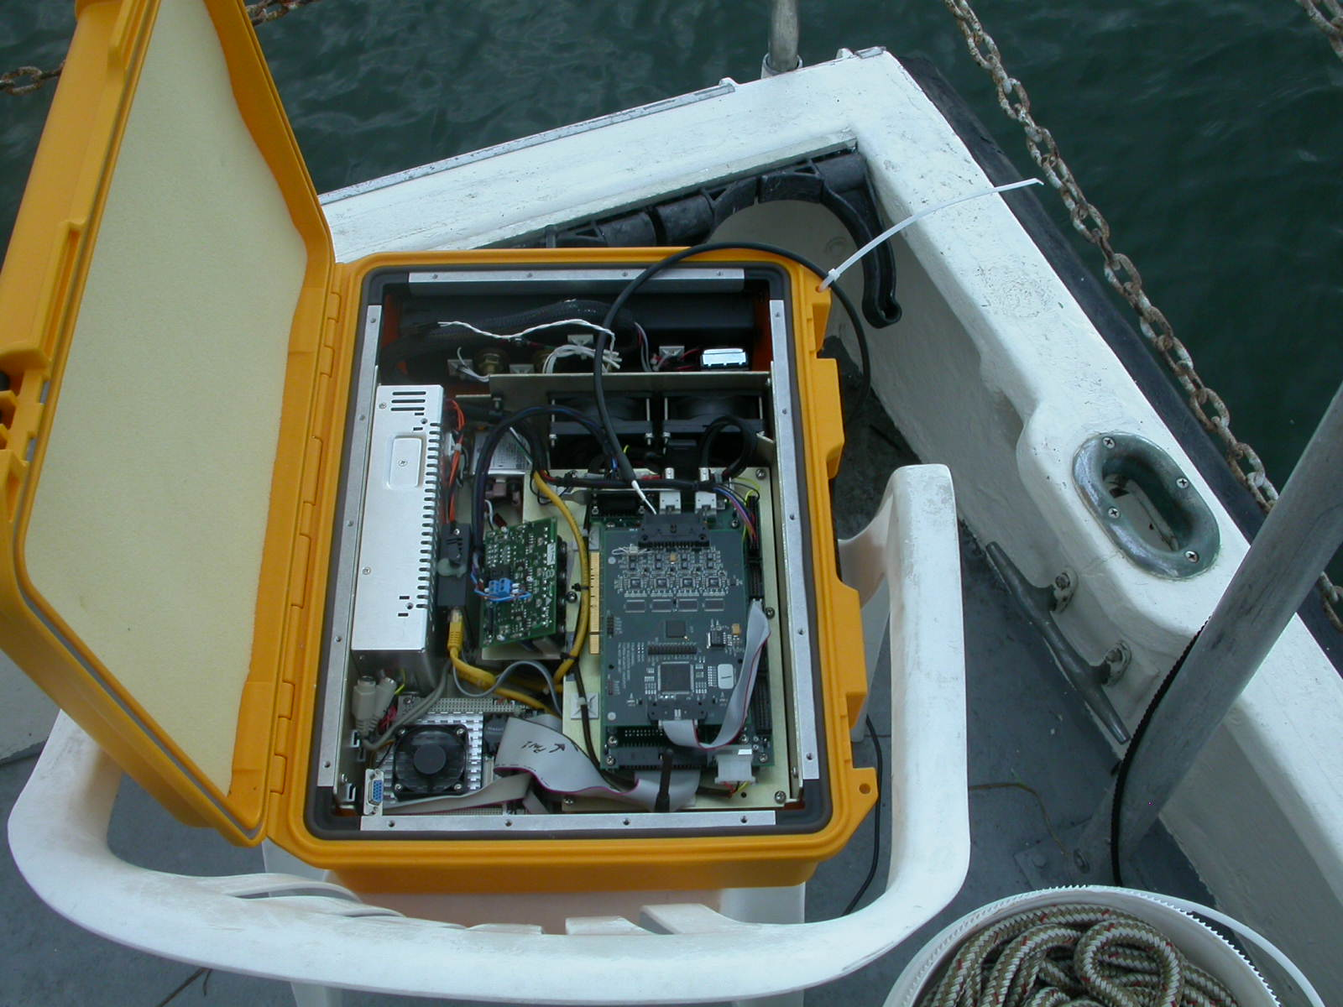

Figure 2.3.10. High-speed high-frequency acoustic modem setup.

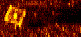

Figure 2.3.11. 43008-bit jpg image and 8192-bit pgm image transmitted during tests in the intra-coastal waterway.

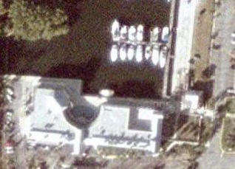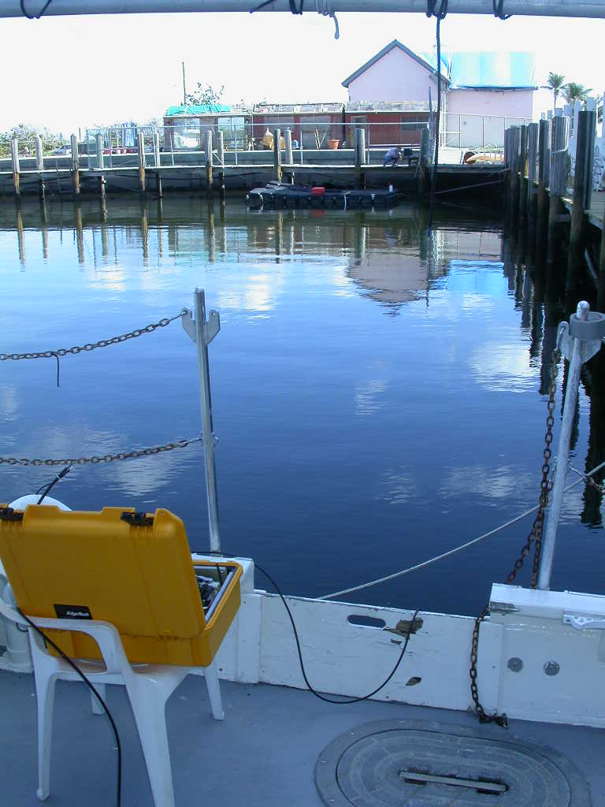
Source
Receiver
40m
Source
25m
50m
Source
Figure 2.3.12. Set of experiments performed at the FAU SeaTech Marina (Dania Beach, Florida).

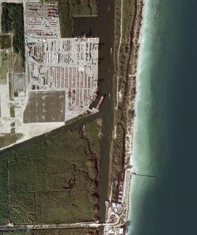
SeaTech
Marina
Turning Basin
Figure 2.3.13. Sky view of the south turning basin of Port Everglades and FAU SeaTech marina.

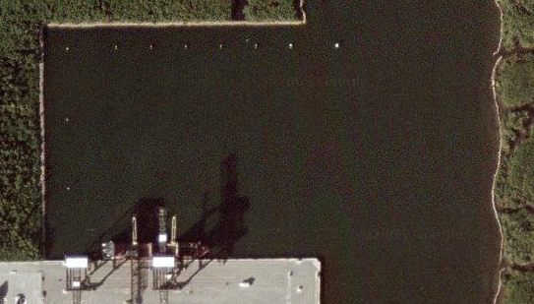
Receiver
Source
10m
25m
50m
75m
10m
Figure 2.3.14. Sky view of the south turning basin of Port Everglades, indicating the source and receiver locations (25, 50 and 75 m ranges) and the scope of the source (10 m watch circle) during a series of experiments.

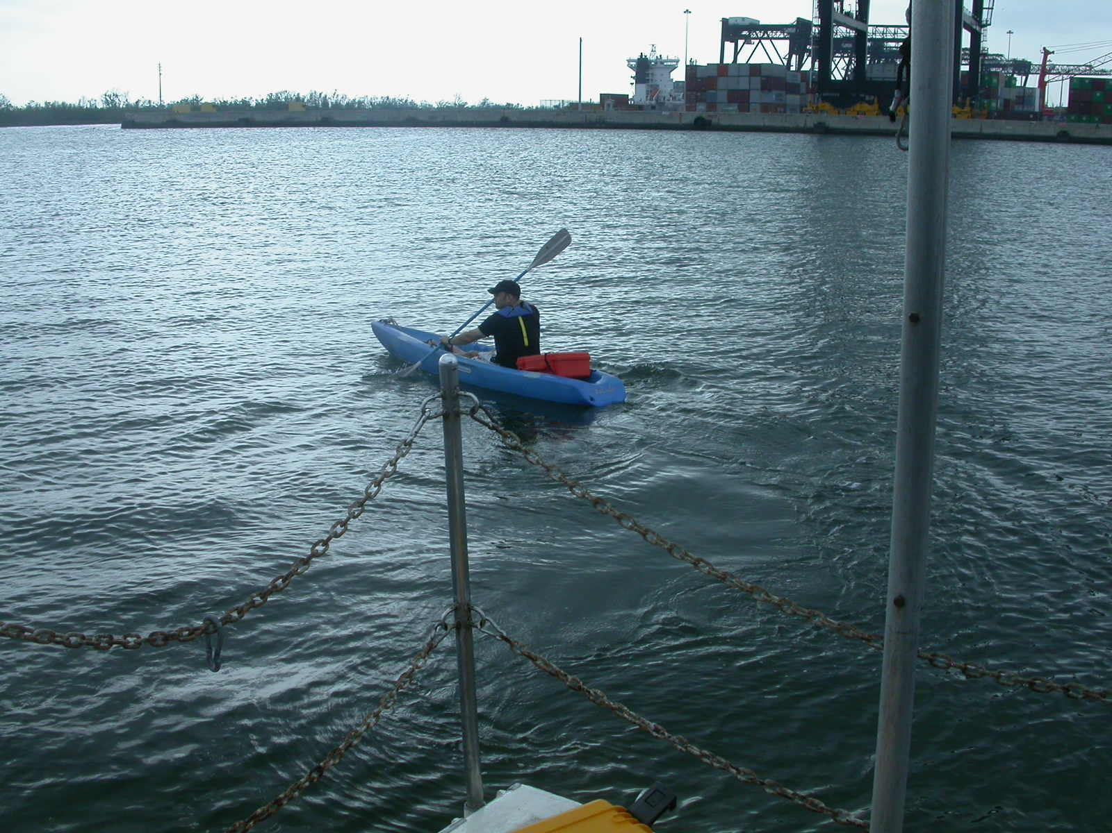
HS-HFAM
source
Receiver
Figure 2.3.15. Boat view of the south turning basin of Port Everglades, indicating the source and receiver locations during the experiments of January 2006.

Acoustic communications were made possible at a rate up to 150,000 bps (coded) at a range of 50 m. At 75 m, acoustic communications was still possible up to 50,000 bps (coded), due to limitations of the source power amplifier. Accurate Doppler correction is required to perform broadband underwater acoustic communications at high-frequencies, along with a sufficient SNR. However, results observed at 75 m under adverse conditions in terms of Doppler and SNR (4 dB) indicate that the BPSK modulation still provides acceptable results using 20 µs and 40 µs symbols.
The results were obtained using an omni-directional source of 173 dB (0.63 W of acoustic power), which set a limit on the range of the HS-HFAM in its current configuration. This shows, however, that the HS-HFAM is remarkably power efficient. The energy efficiency of the fastest transmission modes is 93,121 bits/J at 100,000 coded bps and 130,692 bits/J at 150,000 coded bps. The HS-HFAM is very highly energy efficient and very well suited for small unmanned underwater vehicles and divers with little battery energy to spare. This should be put in perspective with state-of-the-art spread-spectrum MFSK acoustic modems, whose bit efficiency is traditionally of the order of 10 bits/J at best.

References

- P.P.J. Beaujean and E.P. Bernault, “A New Multi-Channel Spatial Diversity Technique for Long Range Acoustic Communications in Shallow Water”, MTS/IEEE Oceans’03 Proc., San Diego, CA, Sept. 2003.
- P.P.J. Beaujean, A.I. Mohamed and R. Warin, “Maximum Likelihood Estimates of a Spread-Spectrum Source Position using a Tetrahedral Ultra-Short Baseline Array”, Proceedings of OES/IEEE Oceans’05 Europe, June 2005, Brest, France.
- P.P. Beaujean, T. Nguyen, " High-Speed, High-Frequency Acoustic Modem (HS-HFAM) coupled with a Wavelet-Based Embedded Compression", ONR Joint Review of Unmanned Systems Technology Development, Panama City, Florida, Feb. 2006.
- P.P. Beaujean, , "High Data Rate, Short Range Communications", ONR Joint
Review of Unmanned Systems Technology Development, Panama City, Florida,
Feb. 2005.
- J. Spruance, P.P. Beaujean, “A High-Speed High-Frequency Broadband Acoustic Modem for Short-to-Medium Range Data Transmission in Ports, Very Shallow Waters and Deep Waters using Spread-Spectrum Modulation and Decision Feedback Equalizing”, Phase-I STTR, final report, March 2006.
- J. Spruance, P.P. Beaujean, “A High-Speed High-Frequency Broadband Acoustic Modem for Short-to-Medium Range Data Transmission in Ports, Very Shallow Waters and Deep Waters using Spread-Spectrum Modulation and Decision Feedback Equalizing”, Phase-I STTR, 2nd status report, December 2005.
- J. Spruance, P.P. Beaujean, “A High-Speed High-Frequency Broadband Acoustic Modem for Short-to-Medium Range Data Transmission in Ports, Very Shallow Waters and Deep Waters using Spread-Spectrum Modulation and Decision Feedback Equalizing”, Phase-I STTR, 1st status report, September 2005.

2.4 Environmental Assessment and Modeling
PI: Dr. George V. Frisk
Daniel H. Sheahan and Dustin E. Whipple (Graduate Students)

Summary

The goal of this project is to characterize Port Everglades both acoustically and optically as these properties relate to the operation of the Remotely Piloted Unmanned Underwater Vehicle (RPUUV) technology being developed for the Center for Coastline Security Technology (CCST). Once the relation of these properties to the functionality of the RPUUV sonar and video systems is adequately understood, this approach can be applied to other port environments in which a similar surveillance system may be employed.

This report is one of the Year 1 Deliverables to the CCST project, and provides the results of a literature search on the current state of knowledge of the Port Everglades environment. Although there are many measurements of these properties in the surrounding areas offshore, there are none actually made within the Port itself. The archival information providing the best insight is an Environmental Impact Statement (EIS) prepared in 2004 that included both Port Everglades and Palm Beach Harbor [1]. However all of these measurements were made offshore and are therefore primarily of interest as points of comparison with data obtained within the Port itself. Due to the lack of existing data, a sampling strategy was developed for acquiring new information about the Port, and an ambitious measurement program was initiated in Year 1 (one year ahead of schedule). This work was accomplished using the FAU research vessels to conduct 15 at-sea trips in which more than 175 profiles were measured using a Falmouth Scientific CTD (conductivity-temperature-depth) and Seapoint turbidity meter. This report presents a quick look at these data sets, with subsequent detailed analysis to take place in Years 2 and 3 of the CCST project.

Introduction

The overall research objective was to characterize the acoustical and optical environment of Port Everglades, since these properties play a key role in the effective operation of new technologies being deployed for port security. Important parameters addressed in Year 1 include temperature, salinity, sound velocity, and turbidity. Once completed for Port Everglades, this methodology can be extended to other ports and harbors [2].

The initial goal was to complete a survey of existing information about the environmental characteristics of Port Everglades. This required research into archival data sets acquired by a variety of agencies, including the Navy, Coast Guard, and NOAA, as well as interaction with physical oceanographers at local universities, such as Nova Southeastern and the University of Miami. One of the key objectives was to identify gaps in the existing database of environmental information. In addition, an appropriate methodology was to be developed for organizing and displaying the known information about the temporal and spatial variability of the port environment.

A second objective was to focus on the principal parameters that are critical to the successful of operation of the RPUUV sonar and optical systems. Turbidity (sediment flux) plays a key role in limiting the effectiveness of optical and acoustical imaging systems in harbor environments. Turbidity levels are affected by a variety of natural and human forces, including tidal currents, wind, waves, commercial shipping, dredging, and drilling.
The acoustical properties, specifically the highly variable sound velocity profile, will influence the performance of the acoustic communication system as well as the hull surveying and collision avoidance sonar. Furthermore, understanding the acoustical properties of the port will provide insights into the optimal locations for the transducers under various environmental conditions.

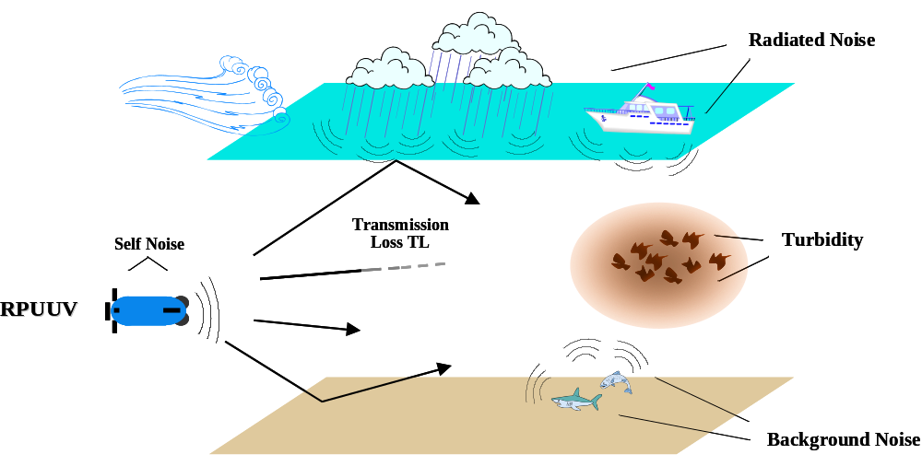

Figure 2.4.2 – Depiction of Effect of Environmental Characteristics within the Port Environment

2.4.3 Known Information

Sources of Information

The most useful information obtained was from the U.S. Environmental Protection Agency; Region 4; Wetlands, Coastal, and Water Quality Branch. [1] Further sources utilized were the U.S. Army Corps of Engineers, and the Naval Surface Warfare Center, South Florida Test Facility. While they didn’t yield any specific results within the port itself, they were useful in providing insight into ways of formatting and depicting the data that is to be collected during years 2 and 3 of the CCST project, along with knowledge about the different sampling strategies that have previously been employed. The following are the three main sources of information; further details about each are given in the reference section.

Summary of Existing Information

The environmental characteristics of Port Everglades have not been previously explored to the extent needed for this project. The most detailed document found during a literature review was an Environmental Impact Statement (EIS) for Ocean Dredged Material Disposal Sites (ODMDSs), with Port Everglades being one of the proposed sites. The EIS detailed a number of properties at each of the three sites within the Port Everglades location:

- Hydrography
- Temperature
- Transmissivity
- Salinity
- Turbidity & Suspended Solids
- Water Chemistry
- Sediment Chemistry

The experiments conducted were similar to those proposed for the CCST project in characterizing the port environment. However, the EIS covers sites that were offshore from Port Everglades; no experiments were completed within the port location. The research completed was done so at a 7-mile site, 4-mile site, and a 2-mile site offshore. The following graph is from the EIS and shows the exact locations were these measurements were taken.

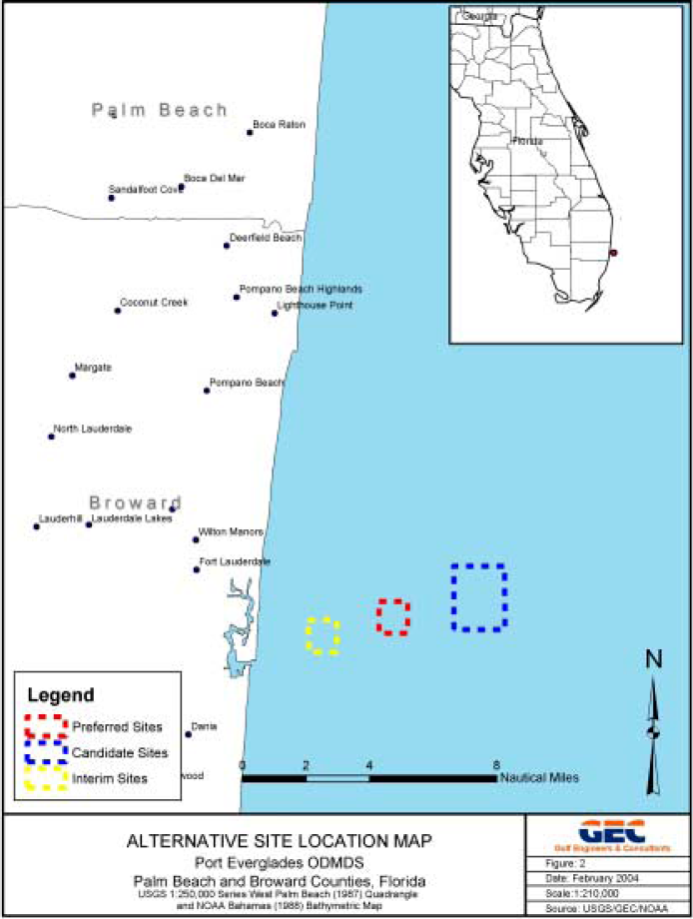

Figure 2.4.3 – Site Locations for EIS Taken by Environmental Protection Agency

Temperature

Water temperatures for the survey ranged from a high of 31°C to a low of 7°C at the bottom (300m). Surface temperatures ranged from 25°C to 31°C, and bottom temperature ranged from 7°C to 11°C. In general, offshore stations were warmer than the near-shore stations. Thermoclines were observed between 20m and 50m at most stations. The average temperature profiles for the sites are shown in figure 2.4.1, with the Interim site profiled in red and blue.

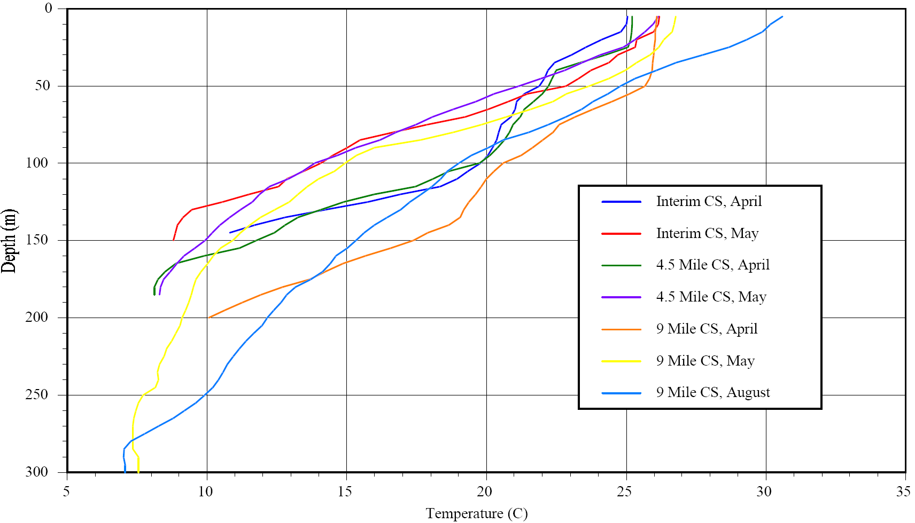
Figure 2.4.4 – Average Temperature Profile from CTD Stations at Port Everglades; Supplied by U.S. Environmental Protection Agency, Region 4, Wetlands, Coastal, and Water Quality Branch

Salinity

The salinity in the surveyed areas ranged from a maximum of 36.4ppt to a minimum of 34.8ppt. There is no obvious trend between the measurements taken and the distance from the shore. All the sites show a halocline between the depths of 100m and 150m, with the salinity leveling off at about 34.7ppt to 34.8ppt below this depth.

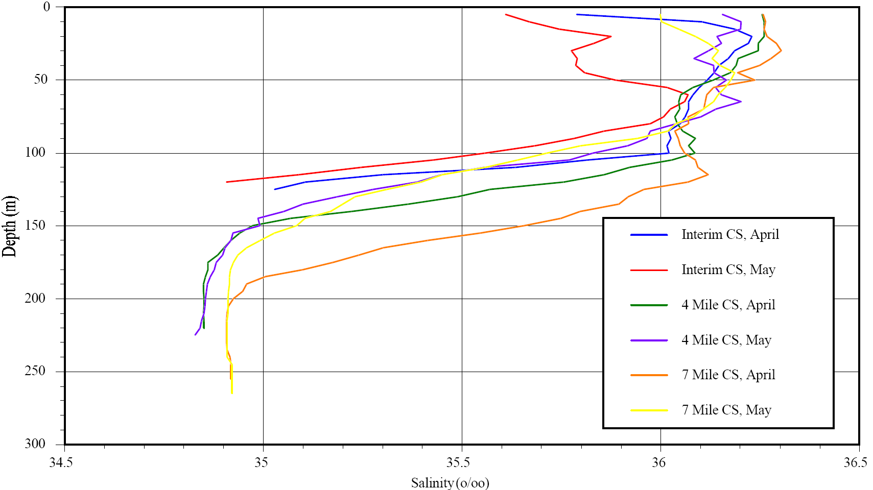

Figure 2.4.5 – Average Salinity Profiles from CTD stations at the Port Everglades; Supplied by U.S. Environmental Protection Agency, Region 4, Wetlands, Coastal, and Water Quality Branch

Turbidity

The following box plot was generated from the Port Everglades sample sites by the U.S. Environmental Protection Agency [1]. The minimum value observed is represented as the end of the blue line to the left of each box. The vertical lines from left to right give the 25%, 50%, and 75% values of the data. The end of the blue line on the right side of each box represents the maximum value observed. Finally the blue square shown inside each box is the median value.

This plot shows that the turbidity values ranged from 0.75 to 1.80 Nephelometric Turbidity Units (NTU), with the medians ranging from 1 to 1.2 NTU. In general the turbidity is higher at the bottom than at the surface, which is possibly due to loose sediment being stirred up in the lower regions. The thermocline shows the largest variance in the data, with the highest value approximately 1.8 NTU. It is possible that the rapid change in temperature at the thermocline traps loose particles, which may account for these high maximum values. However, if the temperature change is not significant enough for this trapping to occur then the turbidity should closely match the surrounding water. This explains why the median value at the thermocline is not too dissimilar from the surface and mid-bottom.
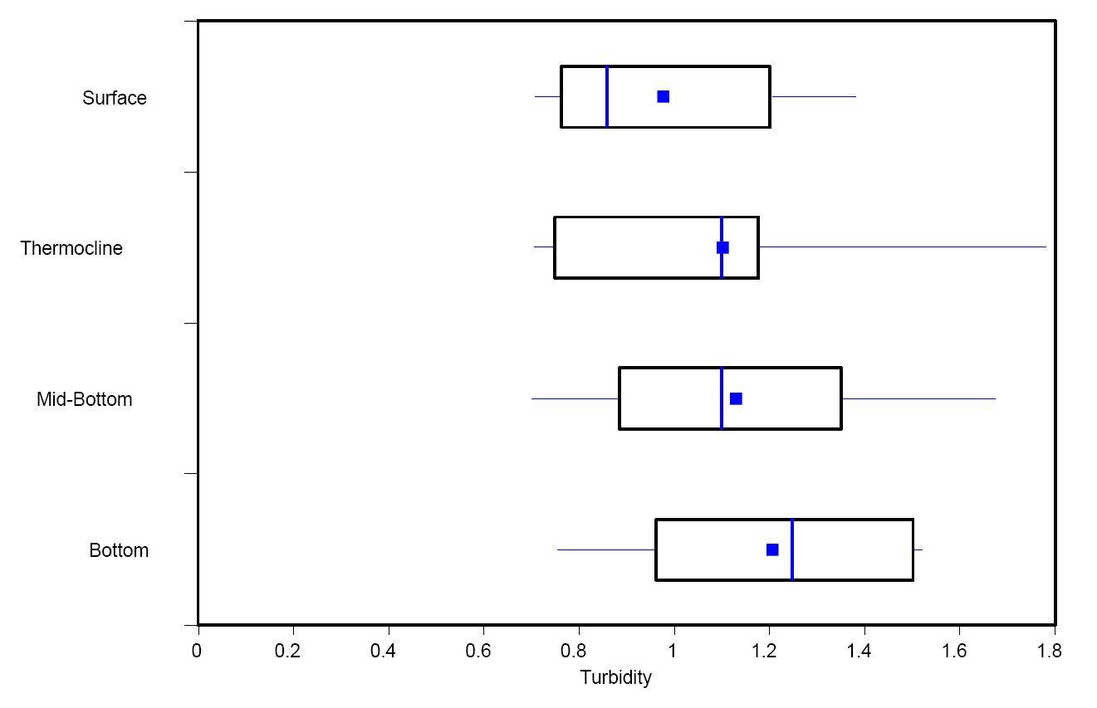
Figure 2.4.6 – Box Plot of Turbidity Concentrations from Port Everglades; Supplied by U.S. Environmental Protection Agency, Region 4, Wetlands, Coastal, and Water Quality Branch

Proposed Measurement Program:

It is unfortunate that no measurements were conducted within the port during the Environmental Assessment, but as the research and literature review matured it became apparent that this was a common occurrence. Data concerning offshore Port Everglades is readily available, in detail, but experiments and data within the harbor environment are rare. Since there is no archival information on these characteristics within the port a proposed measurement program was created.

To begin understanding the acoustic properties of port everglades it is required that measurements of both the sound propagation characteristics as well as the background noise be taken. The Sound Velocity as a function of position and depth through out the port will offer significant insight into the sound propagation. The Ambient noise can be measured using a transducer placed at various positions though out the port at different times. Also, it will be useful to understand the effects of various noise sources on the sound field within the port.

The optical operability of the RPUUV will depend upon the turbidity of the water. This is the property relating to operations that is the most susceptible to quick changes depending on factors such as time & date, shipping activity and biological activity. Therefore it would be beneficial to complete measurements of this property whilst varying largely the time and port activity.

Sampling Strategy

A CTD is to be employed with an attached Turbiditymeter that allows the sound speed and turbidity measurements to be completed simultaneously. The strategy is to firstly complete these measurements as a function of depth recorded over a grid pattern covering Port Everglades. The equipment used is:

- Falmouth Scientific Instruments (FSI) NXIC CTD ADC.
- Seapoint Sensors Inc. Turbiditymeter.
- R/V Oceaneer operated by Florida Atlantic University (FAU).
- R/V Stephan operated by F.A.U.

At each test location the CTD is to be cast at a constant rate until reaching the bottom surface, after which the CTD is then raised at the same constant rate. Once the CTD has reached the surface of the water then that is classed as one cast with the CTD. For each location a total of two CTD casts are completed to ensure accuracy of results. The sampling frequency of the CTD is set at 4 Hz; that is the CTD takes 4 measurements of within the environment for every second that it is acquiring data.

Initial Schedule:

At present 15 half-days of ship time have been dedicated to data gathering, where each half-day consists of 6 hours. It is estimated that a complete CTD and turbiditymeter cast, and then to relocate to the next site takes approximately 15 minutes.

Measurements were to be carried out on the following dates:
- March 28th;
- April 5th, 7th, 12th , 21st, and 26th;
- May 3rd - May 5th, May 8th – 11th, May 17th – May 18th;

Results To Date

For the purposes of this report and for future analysis it was convenient to split the port into 4 main regions, which can be observed below in Figure 2.4.7. Region 1 encompasses the southern part of Port Everglades as well as the Dania Cutoff Canal; Region 2 represents the secure region of the port, with access being granted through the local Port Authority; Region 3 includes the eastern side of the port, along with the inlet leading out to the edge of the port; finally Region 4 represents the northern most section of the port, and generally is much shallower than the previous regions.

In order to display a representative profile of the turbidity and sound speed within each of these regions the following specific locations were profiled.

- Region 1 – N 26° 04.704 W 080° 06.848
- Region 2 – N 26° 05.330 W 080° 07.059
- Region 3 – N 26° 05.459 W 080° 06.927
- Region 4 – N 26° 06.071 W 080° 07.074

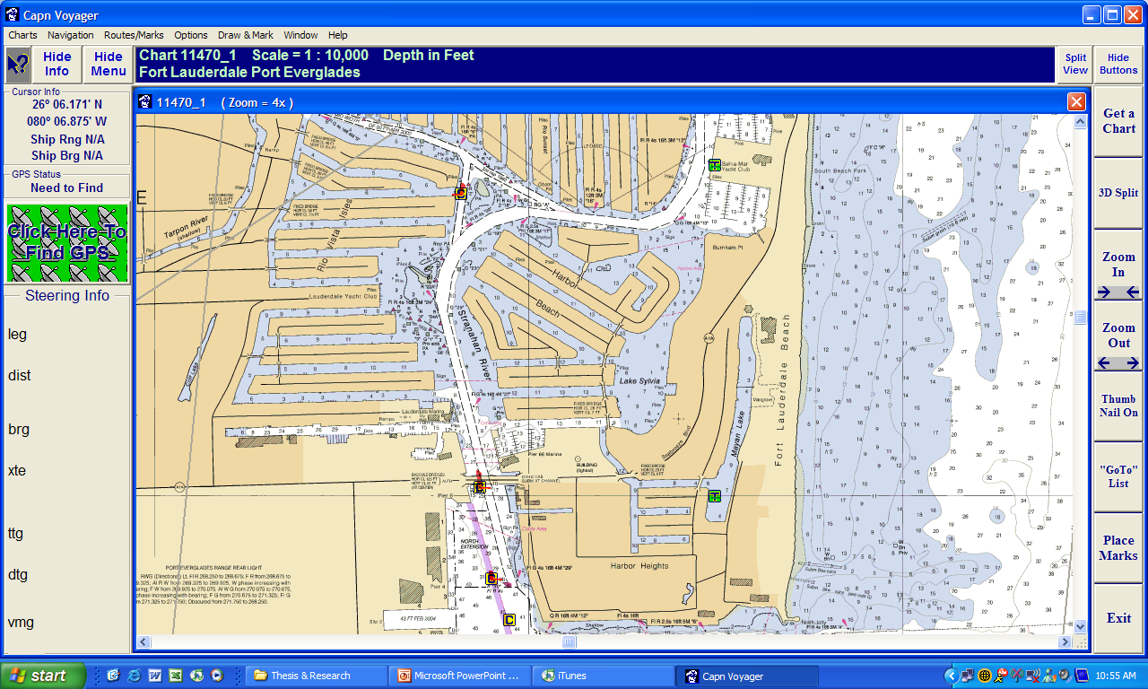
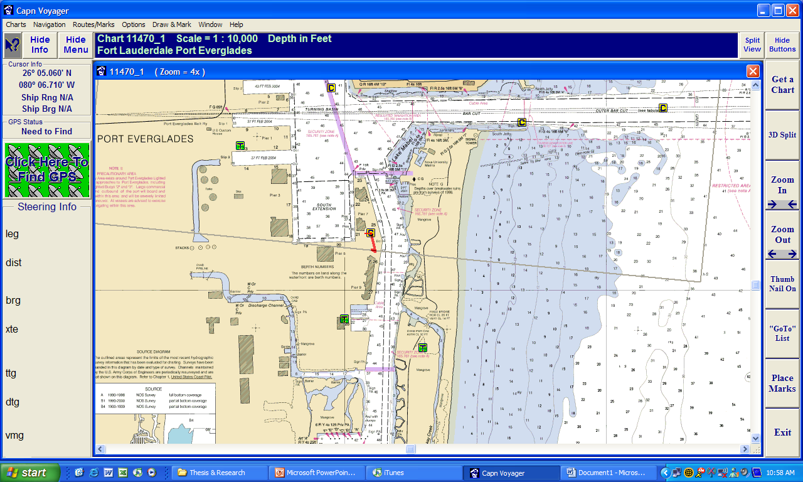
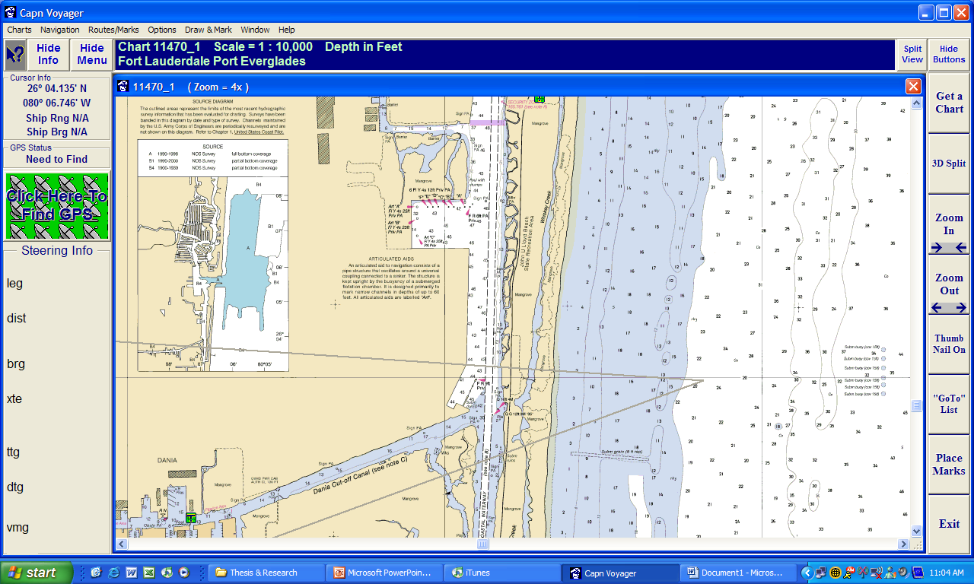
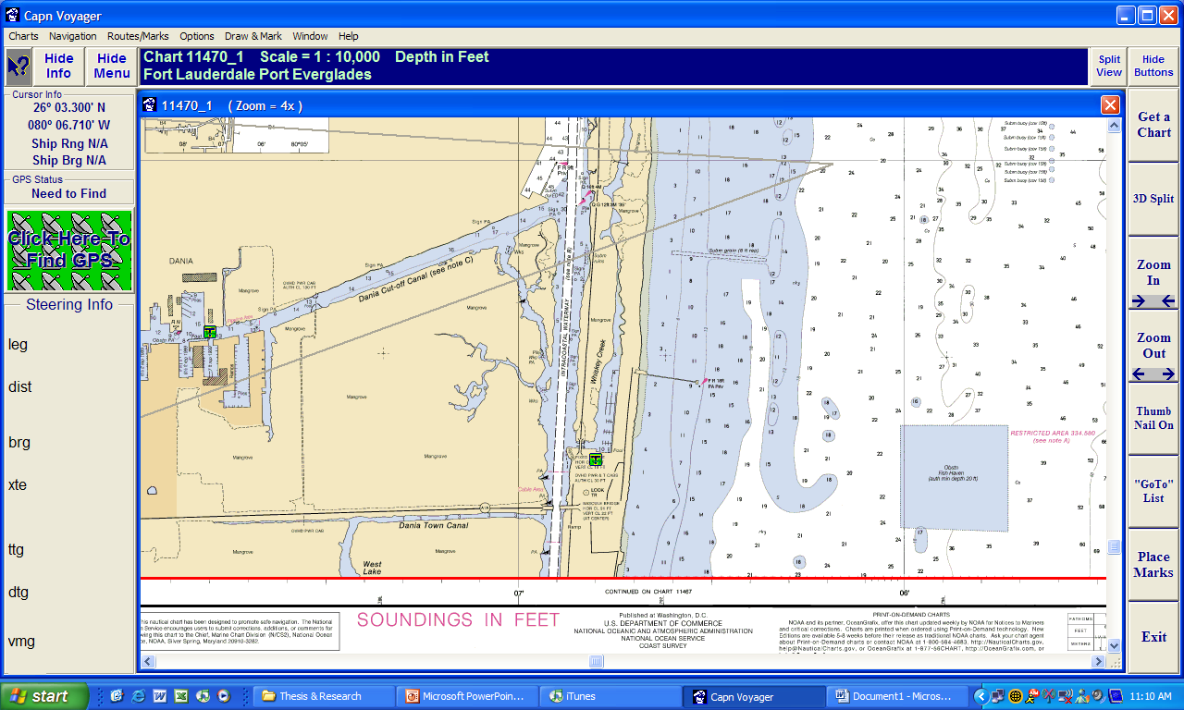
1

5
5
6
7
12
17
35
29
36
47
45
24
41
30
33
12
41
47
45
45
45
46
47
47
40
29
43
40
45
45
45
44
42
45
44
45
41
39
39
38
38
39
35
45
47
45
47
44
41
47
40
46
27
45
46
41
43
41
43
44
46
32
12
14
15
33
36
45
44
43
42
32
43
40
47
45
46
43
44
45
47
43
47
43
44
45
43
41
44
16
14
17
11
15
15
13
14
4
13
14
11
5
5
5
5
3

Figure 2.4.8 – Chart of Port Everglades Representing the Four Regions

Turbidity Profile Measurements

The chart below indicates the Turbidity Profile for each location discussed previously. The turbidity chart uses Formazin Turbidity Units (FTU), which are approximately equal to the more commonly used Nephlometric Turbidity Units (NTU). A suitable conversion to understand the visibility conditions within the port is a NTU value less then 10 corresponds to a visibility of greater then 21.6 inches.

A more specific conversion from FTU to inches within our ranges of measurement will need to be found experimentally for the next part of this project.

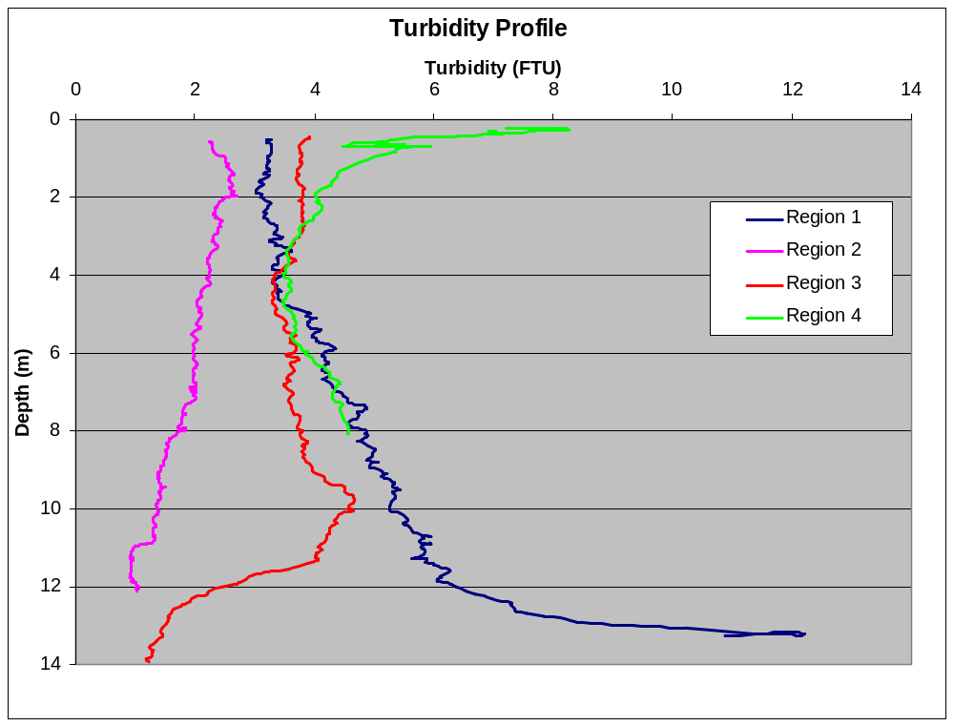

Figure 2.4.9 – Turbidity Profiles at 4 representative locations within Port Everglades.

As can be seen, most of the turbidity values range from 1FTU to 6 FTU. There is a dramatic increase in the turbidity in region 1 near the sea bottom, possibly caused by the agitation of loose sediment.

It can be noted that there is an increased level of turbidity at the surface for Region 4. The northern region of the port is much shallower than the others; as a result it is possible that the port traffic has a greater effect on the level of turbidity within that region. Particularly at the surface it can be noted that the turbidity values are substantially higher. Further investigation into the causes of this is to be completed through subsequent years in the CCST project.

Sound Speed Profile Measurements

In a similar fashion the same locations used previously were used to profile the Sound Velocity profiles within each of the regions. This can be observed below in Figure 2.4.6.

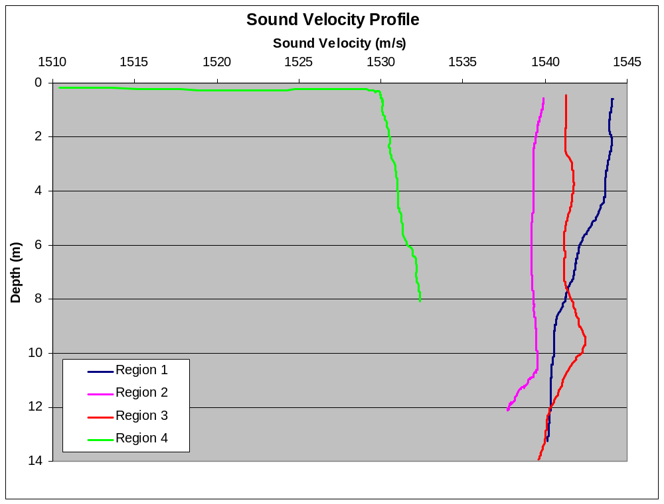

Figure 2.4.10 – Sound Speed Profiles at 4 representative locations within Port Everglades

Excluding region 4 the sound speed stays between 1537m/s and 1544 m/s at all depths. It should be noted that Region 4 is different to the other regions in terms of both depth and turbidity.

The port environment is a highly variable one, and in particular for Region 4 there is a large mixing of fresh water and salt water. Specifically for Port Everglades there is a large influx of fresh water from the Fort Lauderdale River, which feeds into the northern portion of the port. This may explain the reason for the values being dramatically different to those of Regions 1-3, particularly at the surface of the water.

Conclusion / Discussion

The search for archived data on the sound speed and turbidity values within Port Everglades was not as fruitful as was initially expected. It seems that any previous interest within the port is for offshore locations only. The only genuine value that the various reports offered was to allow for offshore comparisons with the environment within the port.

The lack of existing data prompted the beginning of characterizing the port environment substantially earlier than what was previously decided. At present approximately 175 different locations within Port Everglades have been successfully profiled using the CTD. The data received from these tests has only begun to be analyzed, and the next step will be to fully examine the acquired data, and possibly conduct further measurements to ensure that seasonal variability is accounted for.

Preliminary review of the data indicates that there is much variability between the northern and southern regions of the port, and also a large change in values within the inlet to the port. This is what is expected since the inlet to the port has a far higher level of mixing with the sea water. A point for further investigation is to understand the effect of tides on both the sound velocity and the turbidity, and to acquire current data for the port. This will be useful within the CCST project since it may highlight optimal conditions for the RPUUV to operate.

Future work for this project will involve continuing to sample and analyze the Port Everglades environment. Measurements of the sound speed and turbidity profiles will need to be completed at various intervals over the coming year to gain a temporal understanding of these properties. This data will then have to be analyzed to see exactly how the combination of all these elements will affect the functionality of the RPUUV for different times and locations. Also, the data collection and analysis procedures will need to be generalized so as to allow them to be applied to any port environment that might use the RPUUV technology in the future.

References

- Environmental Protection Agency (EPA). Final Environmental Impact Statement (FEIS) for Designation of the Palm Beach Harbor Ocean Dredged Material Disposal Site and the Port Everglades Harbor Ocean Dredged Material Disposal Site, July 2004, U.S. EPA Region 4 61 Forsyth Street, SW Atlanta, GA 30303.
- S. Glegg, W. Glenn, B. Furht, C. Bragdon, S. Schock, P. Beaujean, G. Frisk, K. von Ellenrieder, R. Granata, P. Ananthakrishnan, and E. An, Center for Coastline Security Technology, ONR Contract, 8 June 2005 - 8 June 2006.
- Falmouth Scientific Instruments Inc. 2” Micro-CTD User Manual, Cataumet, MA (2002).
- Stijn Claeys, Guido Dumon, Jean Lanckneus, Keon Trouw. Mobile Turbidity Measurement as a Tool for Determining Future Volumes of Dredged Material in Access Channels to Estuarine Ports, Terra et Aqua, Number 84, September 2001.
- William S. Burdic. Underwater Acoustic System Analysis, 2nd Edition, Prentice Hall, Englewood Cliffs, New Jersey (1991).
- Lawrence E. Kinsler, Austin R. Frey. Fundamentals of Acoustics, 4th Edition, John Wiley & Sons Inc. (2000).
- http://www.epa.gov/safewater/mdbp/pdf/turbidity/chap_03.pdf
- http://clean-water.uwex.edu/wav/monitoring/turbidity/
- http://www.seapoint.com/stm.htm
- http://www.falmouth.com/

2.5 Collision Avoidance Sonar
PI: Dr. Steven Schock

2.5.1 Summary

A low cost collision avoidance sonar was designed to fit into small UUVs. The sonar provides the user with the ability to position transceivers along the nose and hull of the UUV and to configure the electronics package so it can be deployed with a wide variety of nose payloads. A compact transceiver with a circular piston was designed to mount flush to the skin of the UUV. The sonar has a processor that can be programmed to perform tasks such as notifying the UUV of obstacles in its path or the distance to a ship’s hull as the UUV conducts an underwater hull survey. A sea test in the Gulf of Mexico was conducted to verify the performance of the collision avoidance sonar electronics package.

Deliverables

Acoustic Projector Model

An equivalent circuit model was used to model the PZT disk vibrator shown in Figure 2.5.1 to determine the best acoustic termination for the back side of the projector. Air gap, cork, tail mass configurations were examined to determine the effect of the backing material and dimensions on the absolute sensitivity, source level and front to back sensitivity of the projector at disk resonance. The circuit model of the projector shown in Figure 2.5.2 is based on the Mason equivalent circuit model of piezoelectric vibrators. The modeling showed that a 1/4” cork backing provided a front to back ratio of greater than 60 dB. The modeling also showed that a steel plate was not necessary to improve sensitivity and the air gap was not necessary to improve the front to back ratio. Cork was used instead of the steel plate.

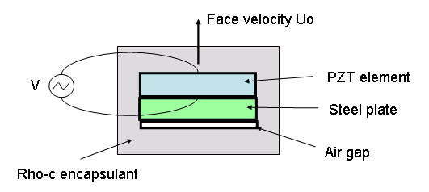
Figure 2.5.1. Model of PZT disk transducer.

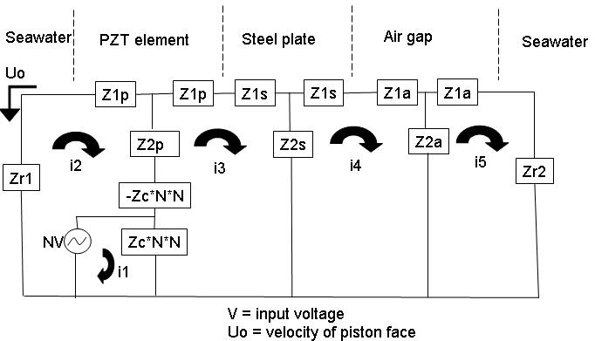

Figure 2.5.2. Equivalent circuit of PZT transducer.

The diameter of the disk was designed to provide a 2 way beamwidth of 60 degrees measured at the -6dB points. The diameter was calculated using the theoretical directional factor for a piston source in a baffle which is given by
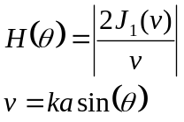
where 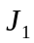is the Bessel function of the first kind and order 1, is the acoustic wavenumber and is the radius of the disk. The analysis showed that a PZT disk resonating at 175 kHz with a diameter of 12.7 mm would meet the beamwidth specification and would not have any notches with 90 degrees of the acoustic axis. The beam pattern of the PZT disk measured in the FAU acoustic test tank is shown in Figure 2.5.3.

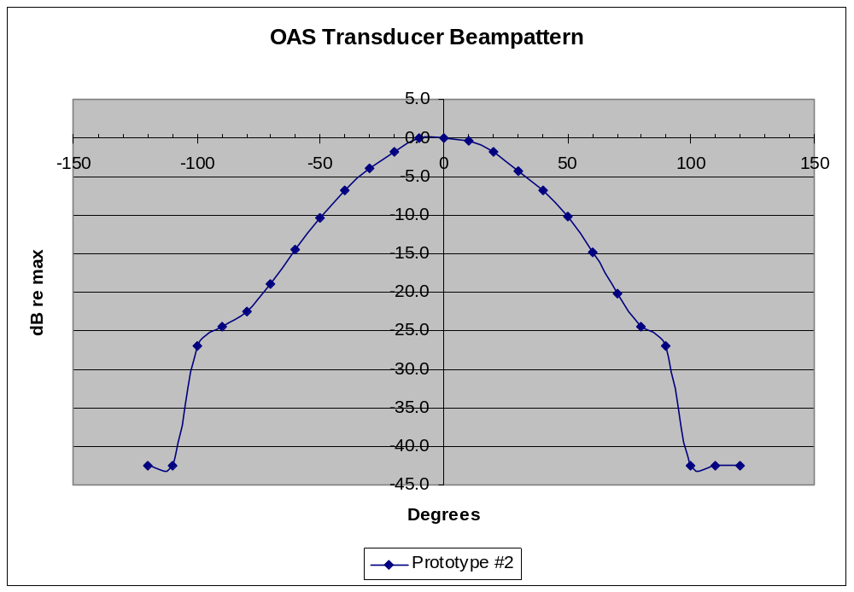
Figure 2.5.3. One way beampattern of circular disk transceiver showing a one way -3dB beamwidth of 60 degree, a beampattern without null within 90 degrees of the acoustic axis and a front to back rejection ratio exceeding 40 dB.

Sonar Design

The collision avoidance sonar is designed to be a reconfigurable system to handle a wide range of UUV payload configurations and applications. An example of a potential collision avoidance configuration is shown in Figure 2.5.4 which contains a drawing of an UUV payload section containing a 4 channel collision avoidance sonar. Note the transceivers are mounted flush to the skin of the UUV. The sonar processor digitizes the acoustic data from each of the channels and detects the first arrival and reports the amplitude and range of the first arrival to the UUV host. A unique feature of the sonar is that it is programmable to frequencies up to 1 MHz and the user can mount the transceivers at locations under the vehicle skin as determined by mission requirements. The sonar can process up to 8 channels.
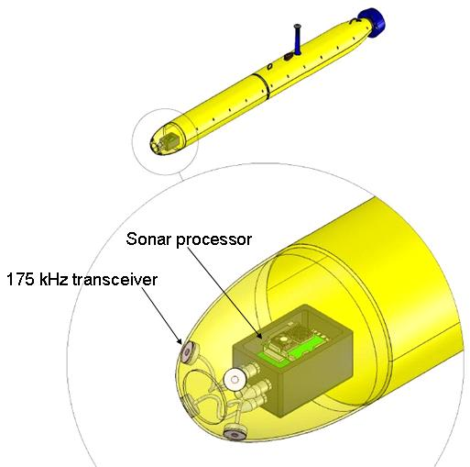
Figure 2.5.4. An example of a sensor configuration for the collision avoidance application and a flooded payload section.

The transceivers, which are mounted flush to the skin of the UUV, consist of a power amplifier, matching transformer, pzt vibrator, a T/R switch and pre-amp electronics. A drawing of a transceiver is given in Figure 2.5.5.

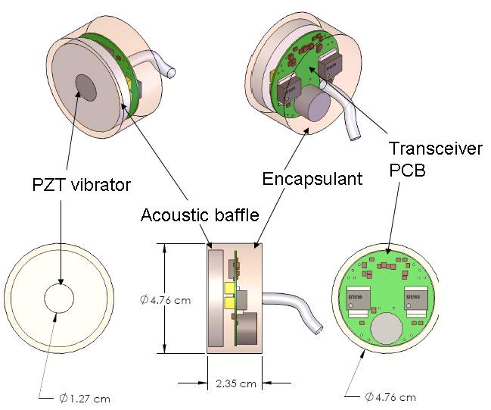

Figure 2.5.5. Transceiver that generates acoustic signals and measures acoustic returns for the collision avoidance sonar. The transceiver consists of a PZT vibrator in a cork baffle and a PCB containing a power amplifier, matching transformer, T/R switch and pre-amp electronics. The transceiver is compact with a diameter of 4.8 cm and a thickness of 2.4 cm.

The sonar processor is relatively compact so it can be encapsulated in a 20.3 x 12.7 by 10.2 cm block if the payload section is flooded. The sonar processor for the case of an eight channel collision avoidance sonar consists of a five card stack as show in Figure 2.5.6. Six DACs on the IDE interface card are available to generate six unique transmission signals which may be important for some applications to eliminate channel crosstalk. Those signals (usually FM pulses) are sent to the 8 transceivers via 4 underwater connectors and cables(2 transceivers per connector). The input signal is amplified using a 10 Watt power amplifier and a matching transformer to drive the PZT disk. A preamp measures the output of the PZT element via a T/R switch and generates the amplified signal which is sent to the DDC card which contains a 14 bit ADC and a digital down converter for baseband conversion. The digital basebanded signal is transferred to the PC104 processor via the IDE interface card. The basebanded signal is processed by the PC104 card which executes a digital matched filter and envelope detection. The detection ranges and amplitudes are relayed to the UUV host via a serial or Ethernet interface.
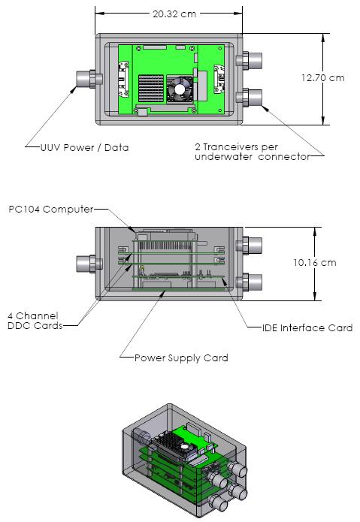
Figure 2.5.6. Encapsulated electronics package for 8 channel collision avoidance sonar system.

Power requirements of the collision avoidance sonar:
Supply voltage: 9 to 72 VDC.
Total Power Requirements:
25 Watts – one 10 Watt transceiver channel
26 Watts – four 10 Watt transceiver channels
31 Watts – eight 10 Watt transceiver channels
The above power requirement calculation assumes a 10 Watt pulse with a 2% duty cycle (e.g., 1 msec pulse every 50 msec) and is based on the following power loads:

1) PC104 processor card 20W
2) IDE Interface card - 1.5W
3) DDC Card - 2.5W ea 5W
4) Transmitter/receiver module (up to 8) - 0.25W ea => 2W quiescent
The power amp can provide up to 10W of electrical power to the projector depending on range requirements. Assuming a duty cycle of 2%, power requirement for each channel is 0.45 Watts.

2.5.2.3 Test Results

The test results consist of the disk transceiver beampattern measurement given in Figure 2.5.3 and imagery generated during seatrials of the sonar in a sidescan configuration. Previous discussions described connecting the instrumentation package to a transceiver with an embedded PZT disk vibrator. The sonar can also be used to generate sidescan images using a line array instead of a circular disk projector. A platform of opportunity was available to sea test the card stack shown in Figure 2.5.6 during an ONR Buried Mine Hunting program experiment conducted in May 2006. The sonar processor was connected to two 750 kHz line arrays mounted on the side of a towed vehicle developed for the buried mine hunting program. A sonar data set at a target field set up by NSWC-Panama City off the Florida panhandle was collected in May 2006 using the board stack shown in Figure 2.5.6 and sidescan line arrays. The data was post-processed to generate the image in Figure 2.5.7. The image shows a mine-like target resting on the seafloor. This experiment showed that the collision avoidance sonar can be easily reconfigured for various applications and the dynamic range and SNR of the sonar meet expectations.

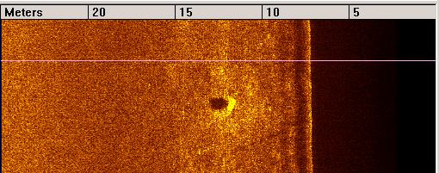

Figure 2.5.7. Image of mine-like target resting on seabed. Image was generated using the collision avoidance sonar operating in a sidescan mode at 750 kHz.

Conclusions

The collision avoidance sonar design is flexible and suitable for a wide range of applications including collision avoidance, wall following and generating sidescan imagery. The sonar is easily configurable with a programmable operating frequency within the range of 20 kHz to 1 MHz. Future plans for this design involve fabricating a collision avoidance sonar and integrating the sonar into the RPUUV developed by Dr. Glegg. The deliverables are contained above in section 2.5.2.
2.6. Hydrodynamic design and integration of RPUUV hull-form and control surfaces
PI: Dr. K. D. von Ellenrieder

2.6.1 Summary

The objective of the research was to contribute to the design and efficient performance of the RPUUV developed at Florida Atlantic University for port and underwater ship-hull surveys. The report describes the selection of propeller and propeller duct design, design and fabrication of experimental models and model mounts, results, findings, and recommendations.

Given a required propeller thrust estimates of 2.5 [N] and an optimum motor operating condition of about 1500 [RPM]/8 [oz-in] torque, a suitable propeller and propeller duct design was selected (Wangeningen Model 19A duct profile with Roboesch 5.2 [inch] diameter, 4-bladed model propeller).

A hydrodynamic model of the RPUUV, as well as a model mounting system, which permits the model to be mounted in any pitch/yaw angle of up to ±60º, in increments of 1º, were designed and constructed. Particle image velocity experiments were conducted to study the velocity field at the stern of the vehicle. The experiments reveal that there is some slight flow separation upstream of the propeller inflow, which can likely be alleviated with simple modification of the aft section.

The findings and contributions of this research to the design and development of the RPUUV are discussed.

2.6.2. Introduction

The following tasks were carried out during Year 1:

[a] selection of propeller and propeller duct design for main thruster,

[b] design and fabrication of RPUUV model sting and towing carriage modifications,

[c] design and fabrication of RPUUV hydrodynamic model, and

[d] particle image velocimetry measurements of the RPUUV aft section flow.

It was decided that the RPUUV would use a vectored thruster propulsion system. The basic design of the system was performed using readily available experimental data on ducted propellers. Experimental models and apparatus have been constructed to validate the capabilities of the propulsion system, to further characterize the force output of the system when turning and to measure the hydrodynamic forces on the vehicle. Initial experimental tests have been conducted using particle image velocimetry (PIV).
2.6.3. Propeller and rotor duct design

As the details of the RPUUV design evolved, several changes were made to the control surfaces and propulsion system. Initial plans for the vehicle involved the use of bow and stern planes with a fixed propeller. After some discussion, it was decided that the overarching design goal from a hydrodynamic standpoint would be to minimize the amount of hydrodynamically-induced flow noise seen by the side-scanning sonar system. To this end, it was decided that an attempt would be made to limit the number of control surfaces in the areas near the sonar system by using a vector-thruster design. Thus, the overall hydrodynamic vehicle design consists of 1) a nose section that has a parabolic profile with a blunt leading edge (to reduce distortion on forward-looking camera), 2) a cylindrical main section and 3) an aft section which tapers to the inlet of a ducted propeller. The ducted propeller and part of the aft section are mounted on a gimbaled system so that the tail section of the RPUUV is effectively the only control surface. An added advantage of this approach is that there are fewer control surfaces protruding from the vehicle, thus reducing the possibility that the vehicle might get snagged by some of the common features of a cluttered port environment (such as chains or cables).

The propeller and rotor duct design presented here were developed using both the vehicle thrust requirements estimated by Dr. P. I. Ananthakrishnan’s group and the propeller motor torque and speed specifications, which were experimentally determined by Dr. S. Glegg’s group. The propeller design goals were effectively set so that the motor could operate near its optimal speed-torque capability while the propulsion system could provide the needed thrust to overcome hydrodynamic drag at the desired operating speed.

Table 2.6.2-1 RPUUV propulsion system design criteria
Motor speed | 1500 RPM (25 Hz)
Motor torque | 8 oz-in
Forward speed of RPUUV | 2 knots (~1 m/s)
Estimated Taylor wake fraction | 10%
Required Thrust | 2.5 N

2.6.2-1. Estimation of propeller thrust and torque

There are few references available, which give design data for the development of a vectored thruster system. Conventional ducted thruster propeller design rules generally assume a uniform inflow, whereas the flow in a vectored thruster is significantly more complicated. The rotor duct acts as both a normal propeller and a hydrofoil as the vehicle turns making the direction and magnitude of the thrust output difficult to estimate. The initial design attempt used followed the approach taken by [1] in which the cross-sectional profile of the duct is assumed to be straight and the thrust generated by the propeller is modeled using a modified blade-element theory approach. A short code was written in Matlab, which would iteratively select the appropriate propeller diameter and pitch to achieve the requirements given in Table 2.6.2-1. However, one of the design goals was to operate the vectored thruster at sharp angles of up to 45º from the center line of the vehicle. At such sharp angle there will most likely be a high-degree of separation upstream of the propeller on one side of the vehicle, making the inflow very non-uniform. While there has been some computational work on open propellers in non-viscous flows [4], no data could be found for vehicles operating in the same mode as the RPUUV, so it was decided that a robust conventional form of propeller and duct profile should be selected. Thus, the initial design models used for the RPUUV assume that the propeller delivers constant thrust throughout a turning maneuver. Initial sea-trials of the vehicle demonstrate that with the current design it can perform very rapid turning maneuvers so that a more thorough analysis of the turning capability is not required at this point.

As shown in [2], the Wageningen Model 19A duct profile exhibits a number desirable design features, including the fact that its relatively rounded trailing edge exhibits less separation than other duct designs when the propeller operates in reverse (as may happen often when using an underwater vehicle in a port environment). Additionally, it is relatively easy to fabricate. Based on these characteristics and the readily available design data, it was decided to use the Model 19A duct in combination with a propeller similar to the Ka 4-70, a four-bladed propeller. Raboesch, a manufacturer of model marine vehicles, produces propellers similar in design to the Ka 4-70. The final propeller design was selected by iteratively calculating the thrust and torque generated by available model sizes at the required design speed (see Table 2.6.2-1); a Taylor wake fraction of 10% was assumed in these estimates.

2.6.3-2. Recommendations of propeller and duct profile

Baseline design: Wageningen (MARIN) Duct profile 19A with Ka 4-70 propeller. Near match given by Raboesch model propeller no. 176-37/38 with 19A duct fabricated in-house.

Table 2.6.2-1 Expected ducted propeller operating characteristics for straight-line motion:
J (advance ratio) | 0.7
P/D (pitch-diameter ratio) | 1.02
D (propeller diameter) | 5.2 inches (130 mm)
K_{T} (thrust coefficient) | 0.225
T (thrust) | 8.87 lb_{f} (4.03 N)
K_{Q} (torque coefficient) | 0.0325
Q (torque) | 6 oz-in (0.04 N-m)

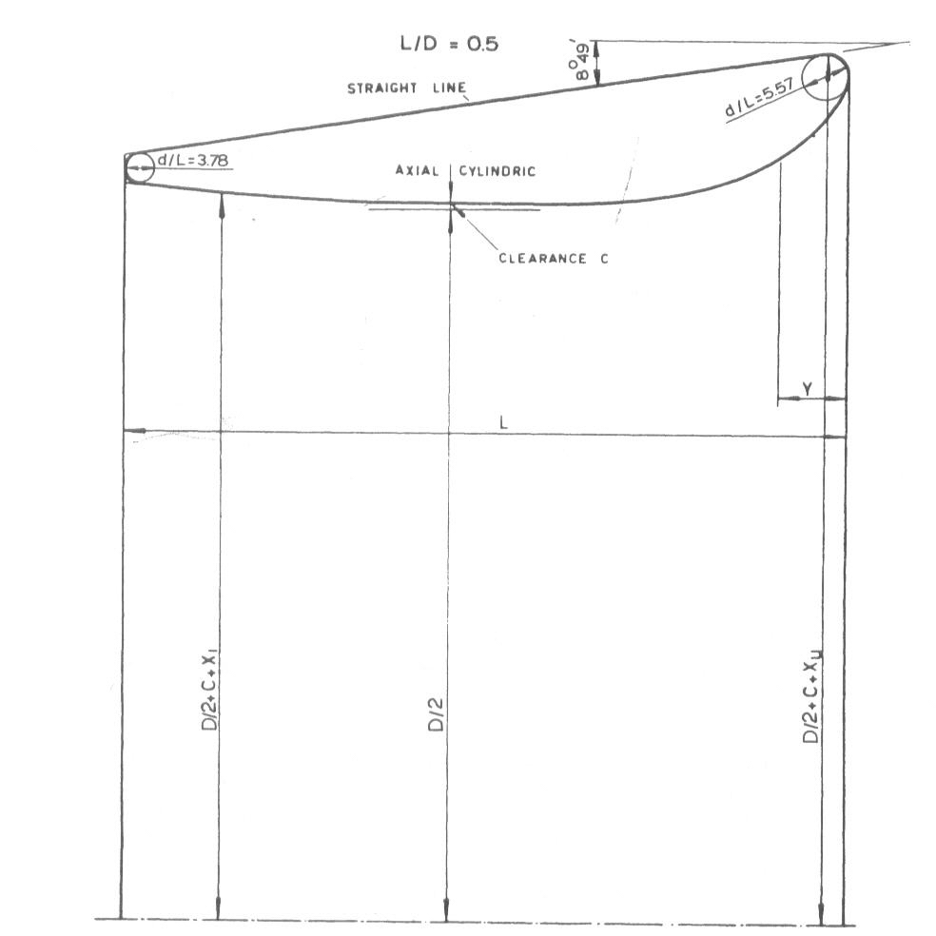
Figure 2.6.1 Wageningen Model 19A duct profile [3].
2.6.4. Experimental Setup

2.6.4-1. Sting

In order to test the RPUUV in the water tunnel, a sting had to be build. In year 2 of the program, the sting will also include a six-axis force transducer to measure the thrust, drag and hydrodynamic moments on the vehicle. The sting is setup on a tow carriage above the water tunnel. It has been designed to hold the RPUUV model, centered between the bottom of the tunnel and the surface of the water, with a hydrodynamic shape, keeping the turbulence created by the structure itself as low as possible. It includes two alignment bearings and a rotation stage in order to pivot the vehicle with respect to the flow. As the roll angle of the vehicle can be changed within the RPUUV holder, measurements can be made at either yaw or pitch angles of up to ±60º in steps of 1º.

2.6.4-2. Towing Carriage
The RPUUV is required to operate within confined environments and in a range of currents from 0 to 3 knots. The motors of the water tunnel can produce a flow with a velocity of up to 0.5 [m/s]. When used in combination with the flow created by the water tunnel pumping system, a tow carriage can be used to approximate this range of currents. The tow carriage has been designed to increase the velocity relative to the RPUUV by roughly 1.0 [m/s]. A computer-controlled stepper motor system running under RTLinux is used to drive the tow carriage. A typical velocity profile of the motor carriage speed is shown in Figure 2.6.3.

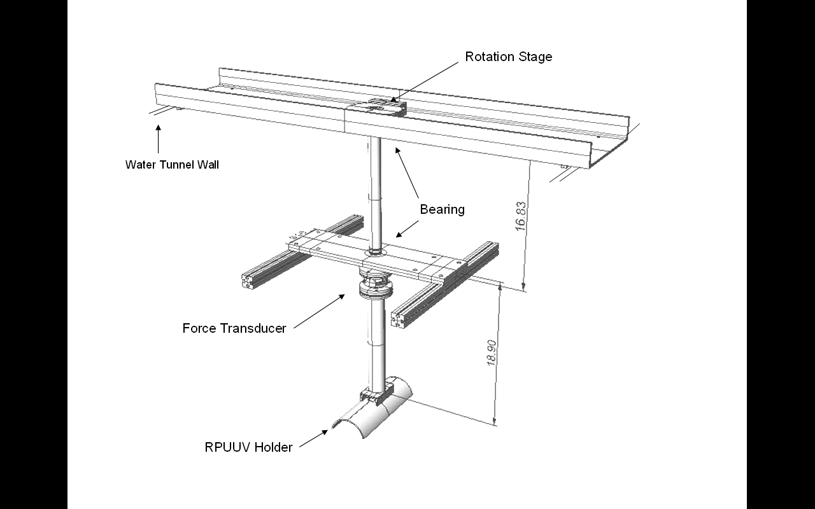 | 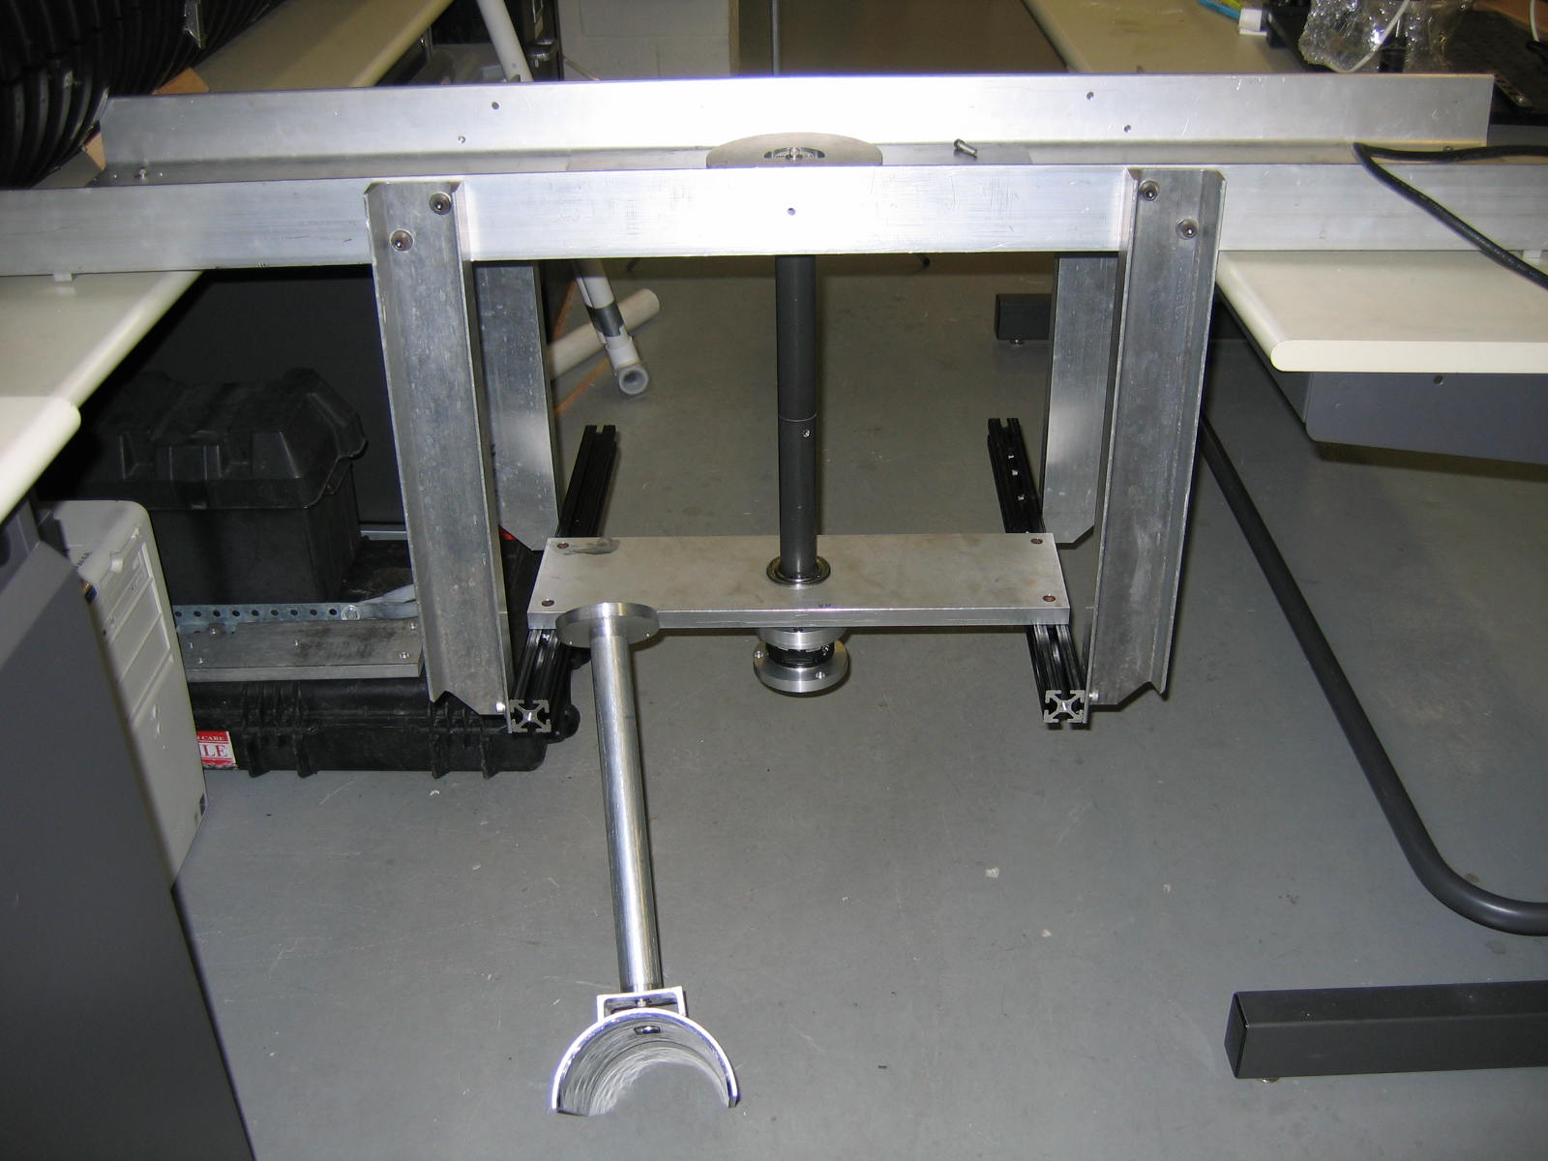
 | 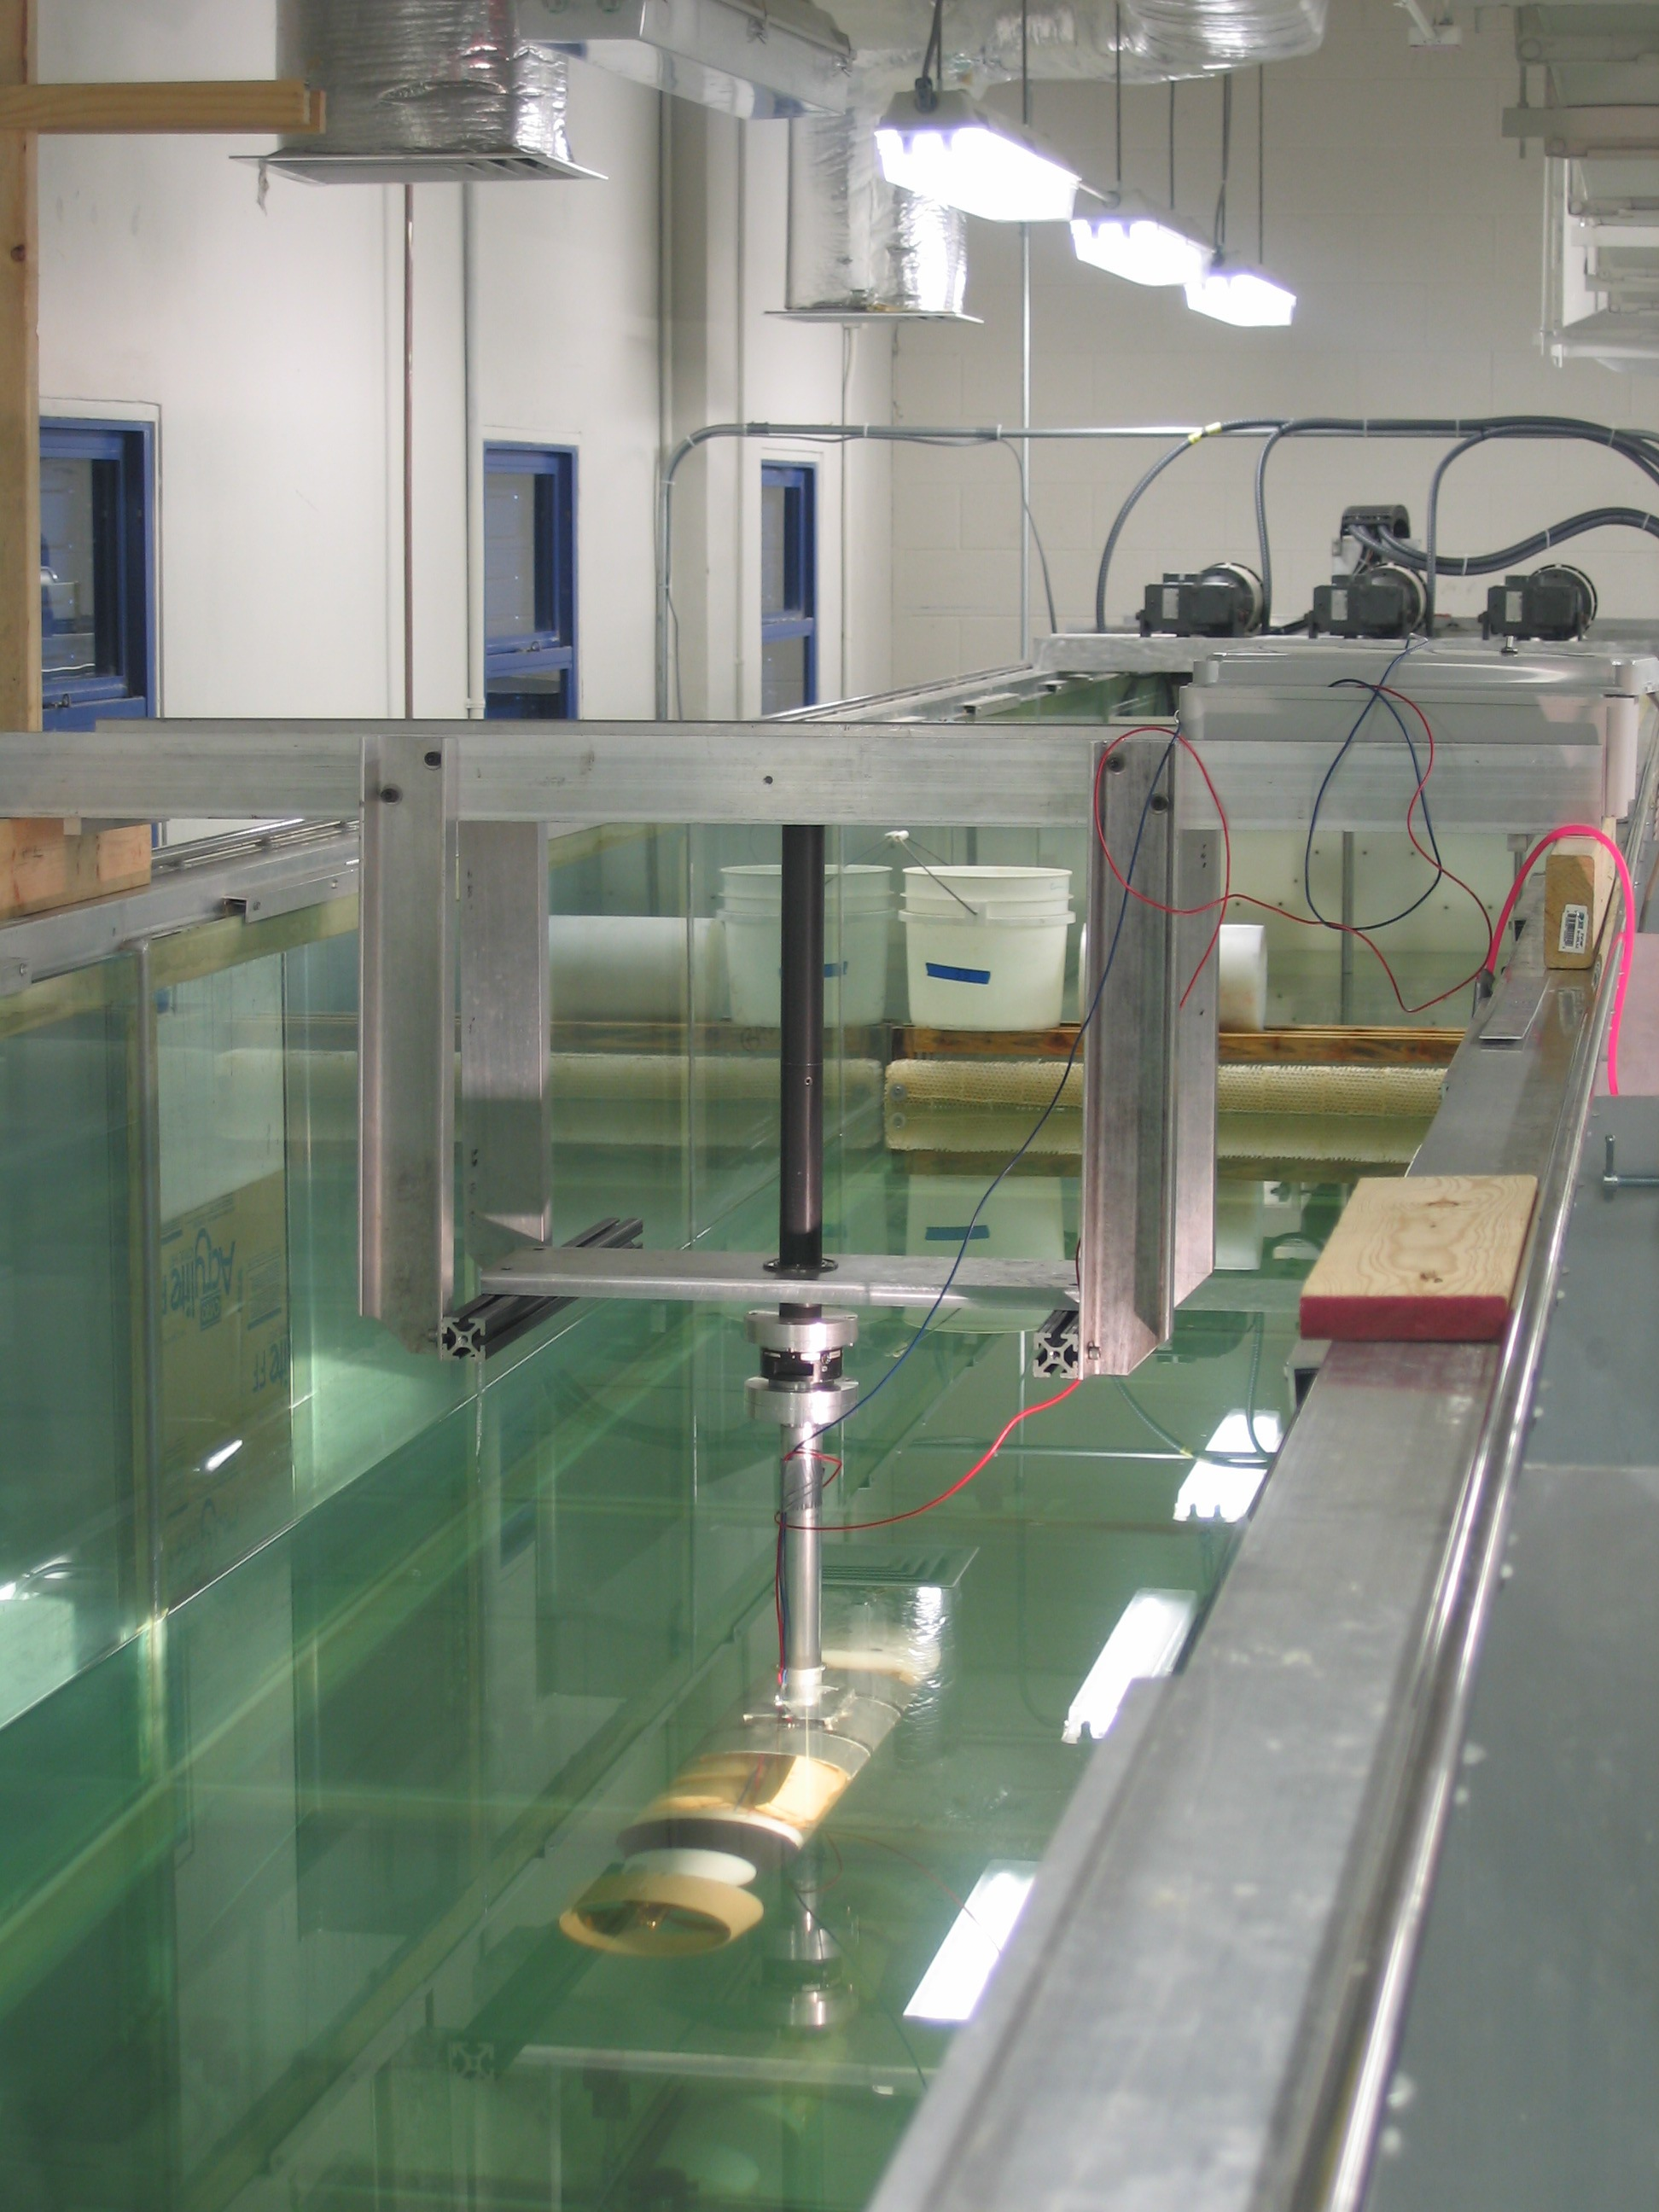
Figure 2.6.2 RPUUV Holder design and assembly.

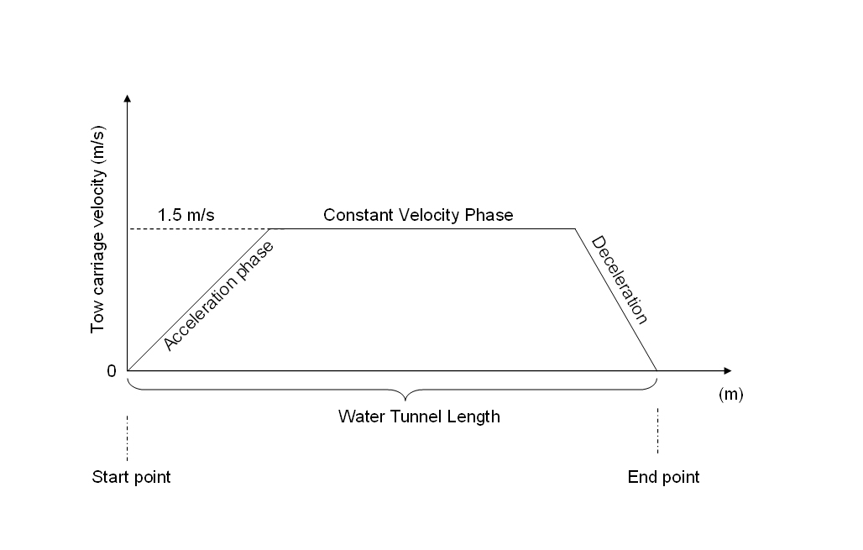
Figure 2.6.3 Tow carriage velocity profile.

The computer used to control the stepper motor will also used to acquire data from the force transducer mounted on the sting.

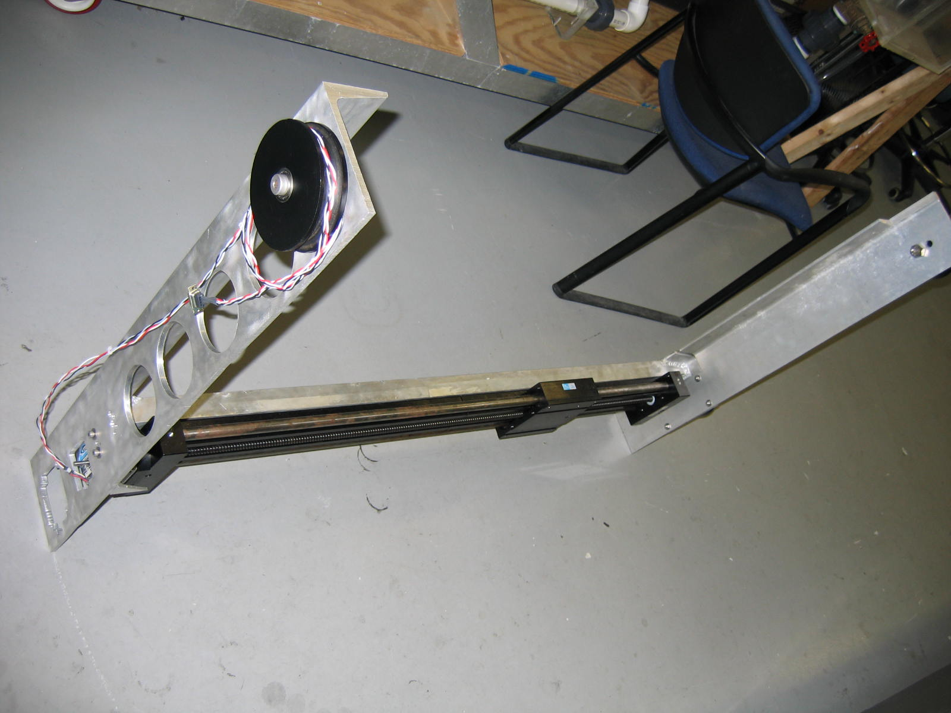 | 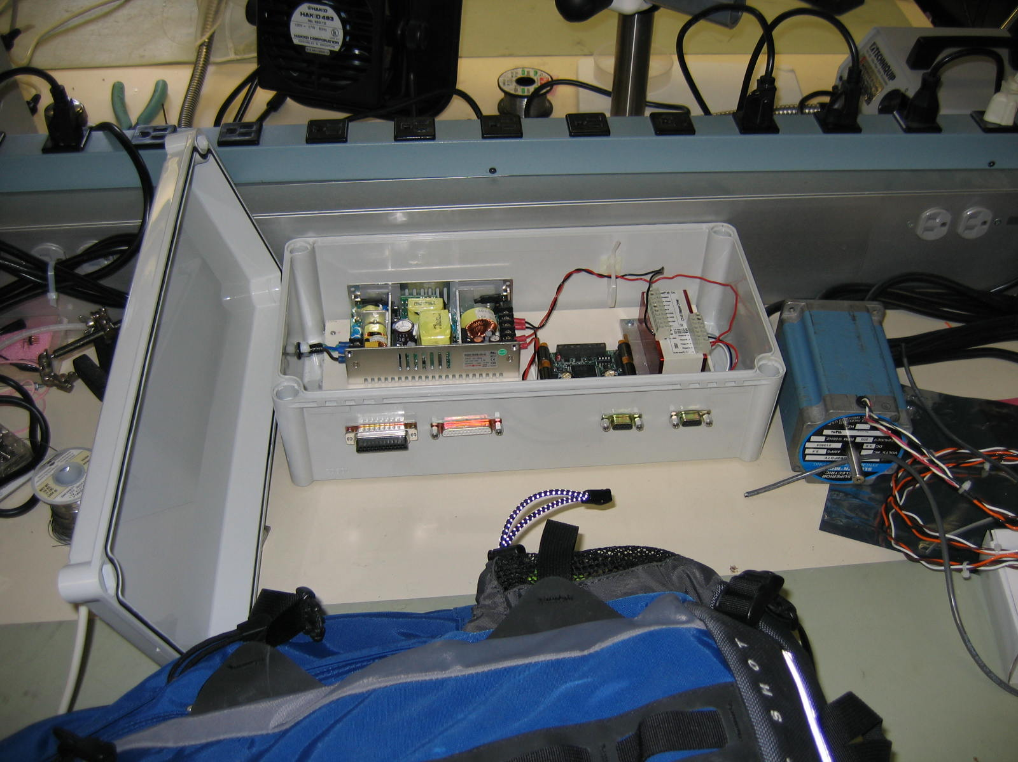
Figure 2.6.4 Tow carriage main assembly and motor controller box.
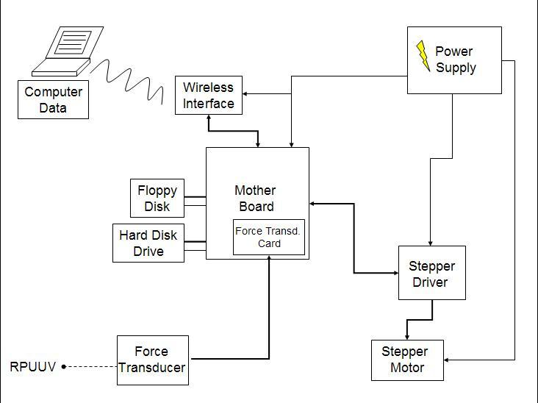
Figure 2.6.5 Schematic of stepper motor controller and force transducer system.

Experiments will be conducted to study the flow at the aft section and to calculate the drag around the underwater vehicle. The hydrodynamic forces acting on the vehicle are specified in terms of hydrodynamic coefficients; state variables of the vehicle motion depending only on the body shape. Those hydrodynamic coefficients depending on the Reynolds number can be computed with the added-mass inertia forces theories, the boundary-integral method, and experimentation: the 6-axis transducer will be used to measure the external forces acting on the RPUUV.

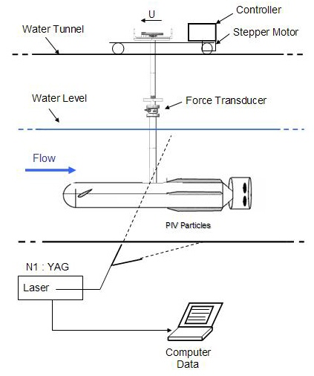
Figure 2.6.6: Overall configuration of experimental setup.

These results of the measured forces will enable one to compute the hydrodynamic coefficients of the vehicle [5].

2.6.4-3. RPUUV Model
The experimental model is replica of the hydrodynamic form of the RPUUV. Using the detailed designs produced by Dr. S. Glegg’s group with ProEngineer, hydrodynamic models of the external sections were created. The nose is shaped from high density polyethylene and the main body is made of acrylic. A motor is mounted in the aft edge of the model in order to simulate the thrust on the vehicle. The motor controller power supply is fixed on the tow carriage. A potentiometer is used to vary the speed of the propeller, which is verified using a strobotach.

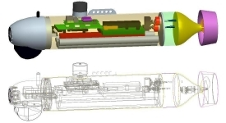
Figure 2.6.7: RPUUV design.

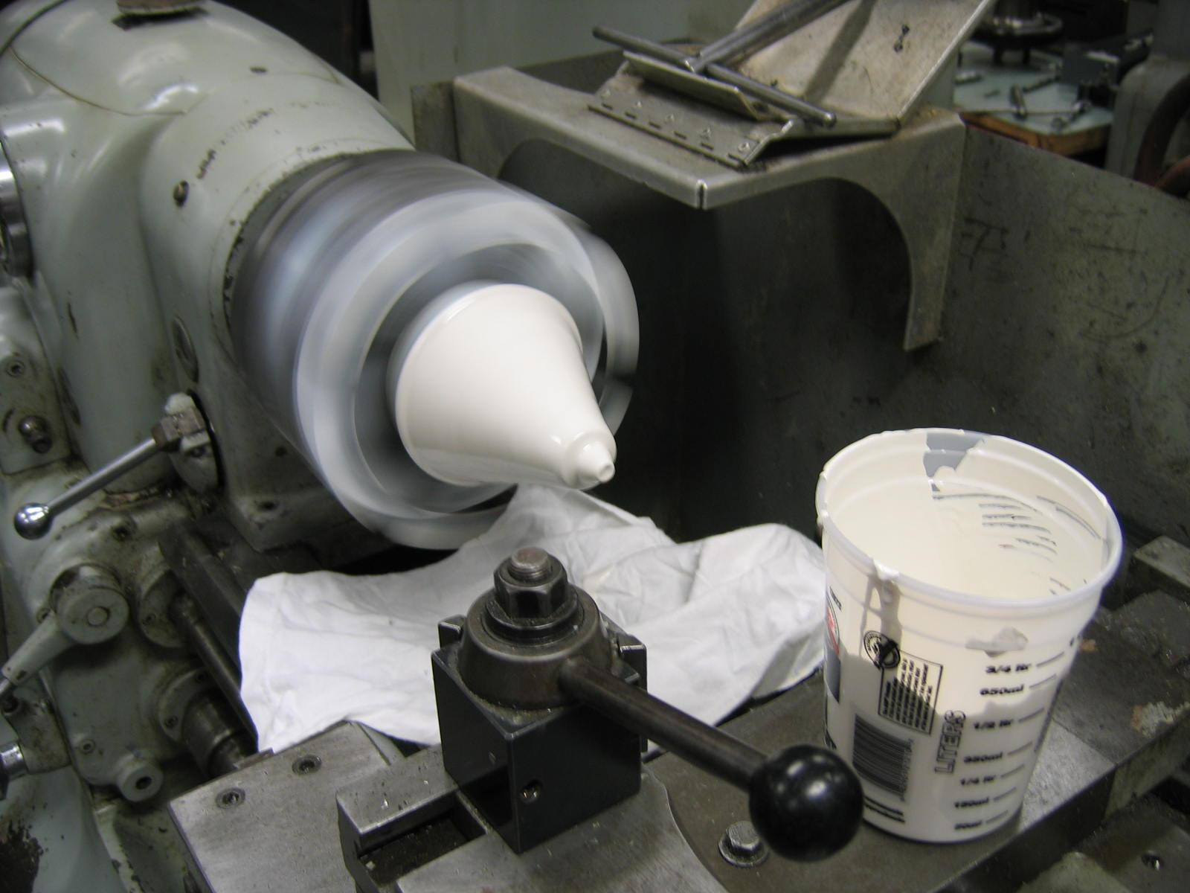 | 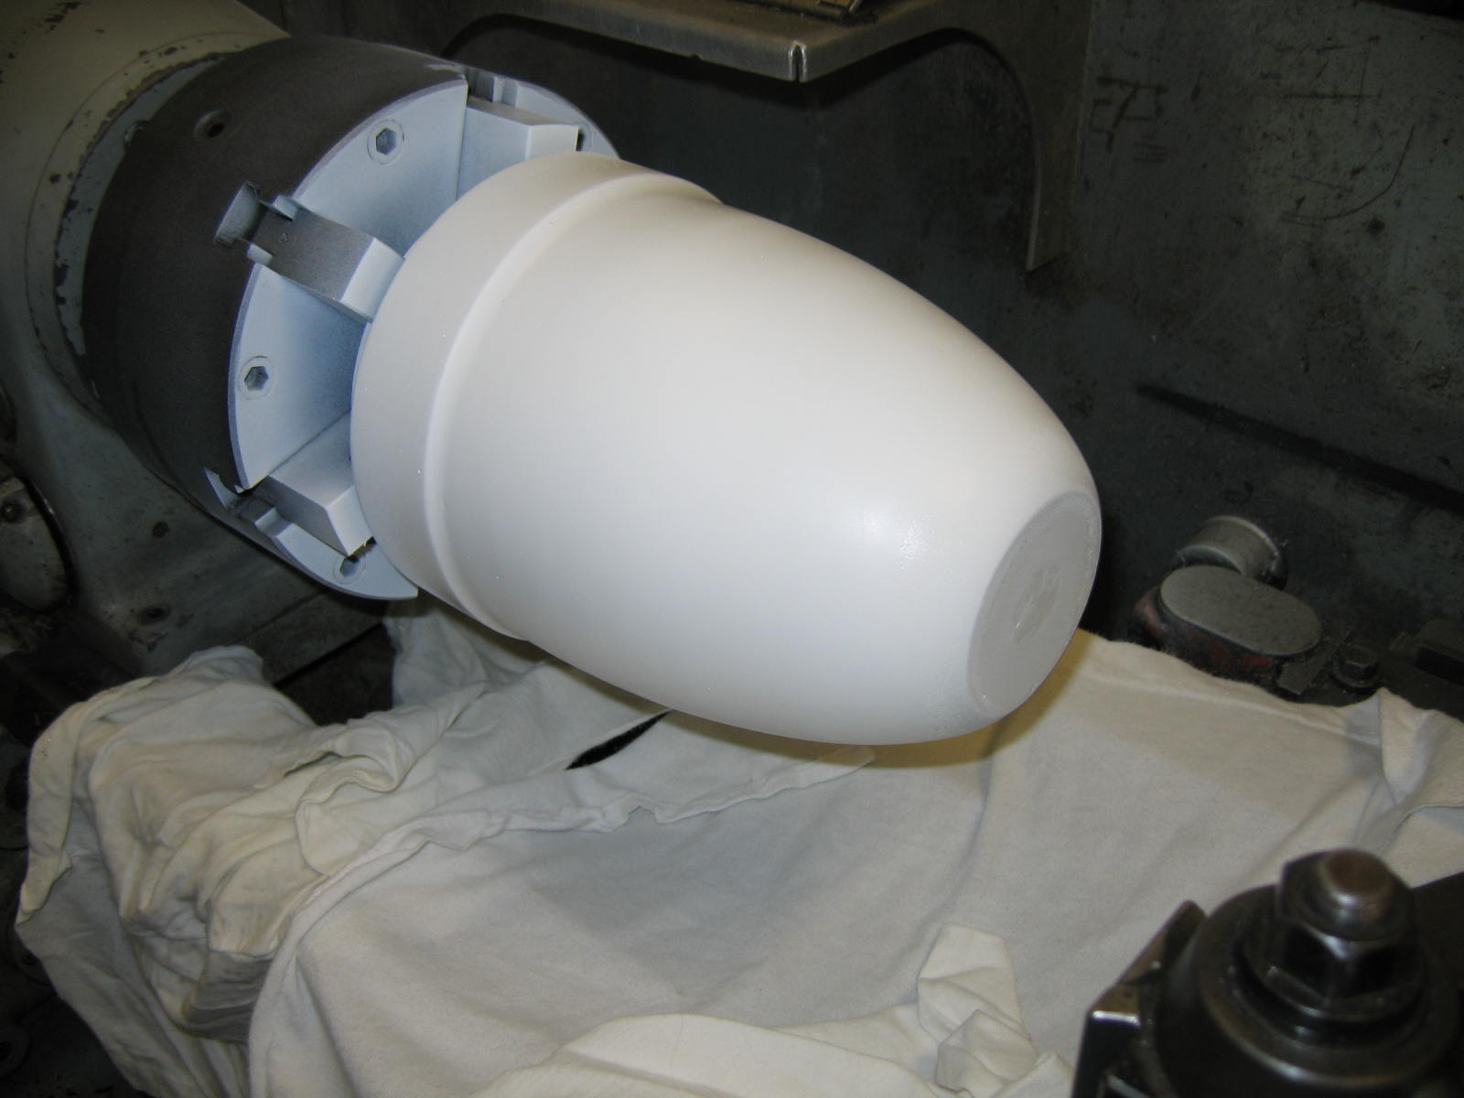
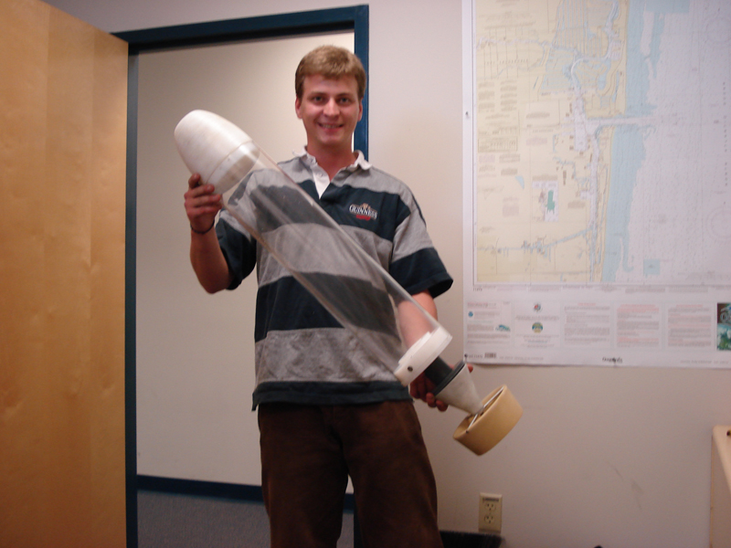
Figure 2.6.8 RPUUV hydrodynamic model construction and assembly: tail section (top left); nose section (top right); partial assembly (bottom).

2.6.4-4. Particle Image Velocimetry Experiment Setup
A particle image velocimetry (PIV) system was used to measure the velocity distribution along the aft surface of the RPUUV model in the longitudinal symmetry plane of the vehicle. The PIV laser light sheet was created using a green laser (532 [nm] Nd:YAG), which operates optimally with a 15 [Hz] repetition rate. The flow was seeded with 11 [μm] hollow glass spheres that follow the flow because they are almost neutrally buoyant (specific gravity of 1.1 [gm/cm³]). PIV image pairs were captured using a TSI PIVCam 10-30 Model 630046 double-shuttered camera with a 60 [mm] lens (set to f/# 16). The camera was located 120 [cm] from the laser light sheet. Image pairs were processing using Insight 3G software. The Hart correlation method together with recursive multigridding was used (64 [px] x 64 [px] sampling window being reduced to 32 [px] x 32 [px]).
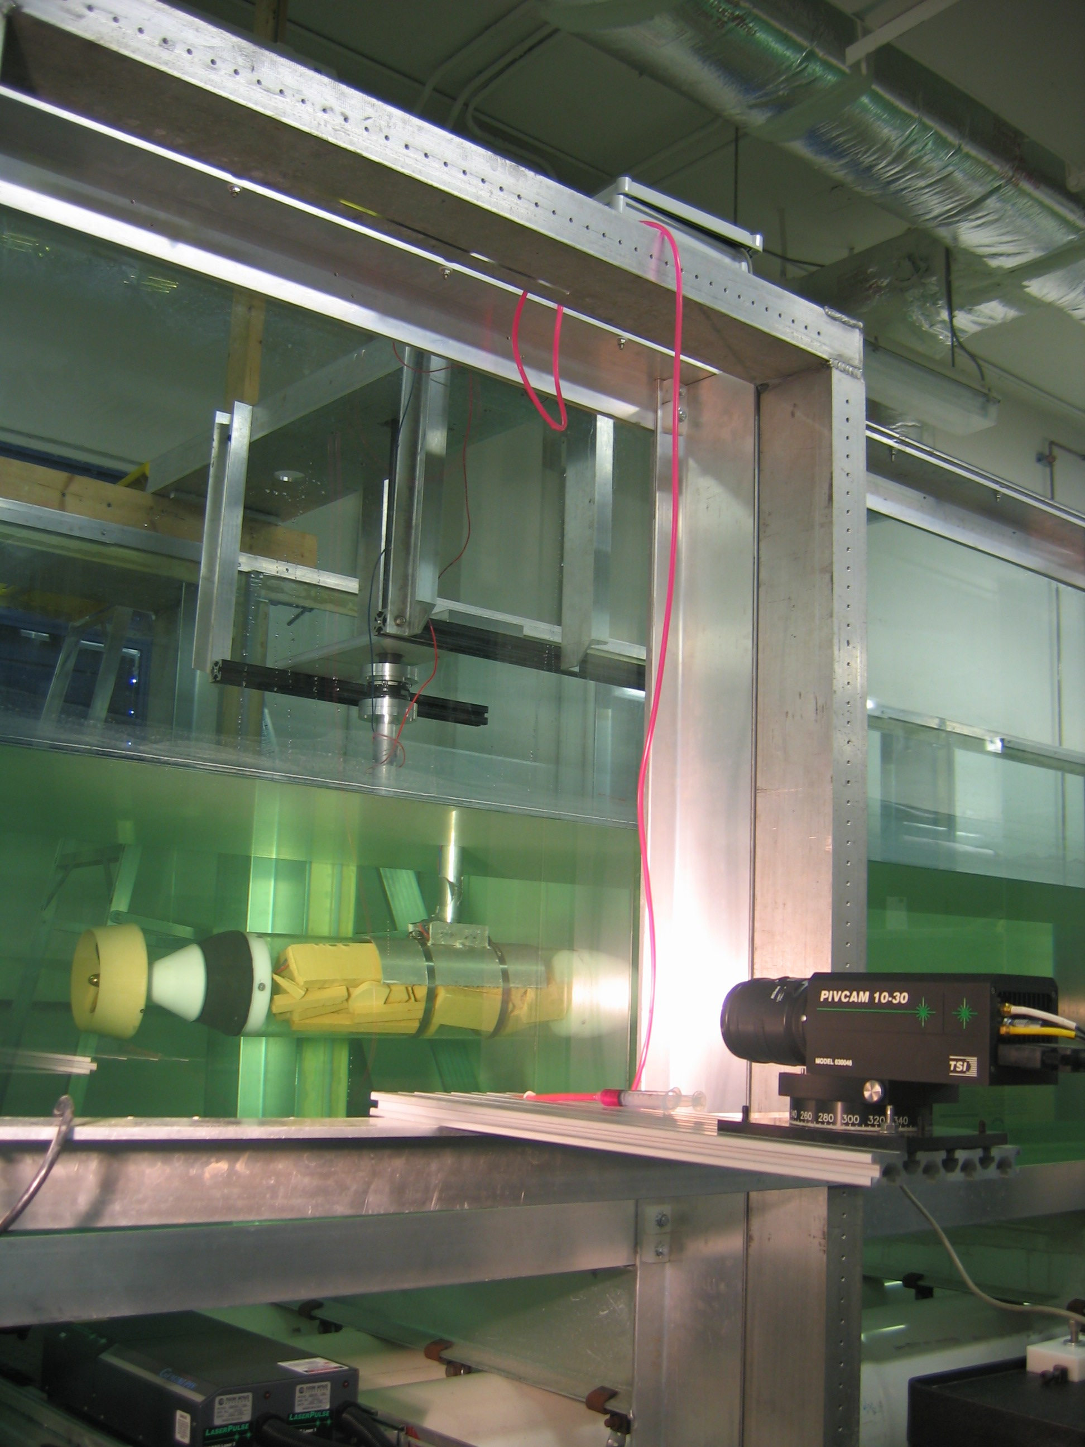
Figure 2.6.9 PIV system setup; hydrodynamic model mounted in test section.

2.6.5 Experimental Results

2.6.5-1. RPUUV Aft Flow
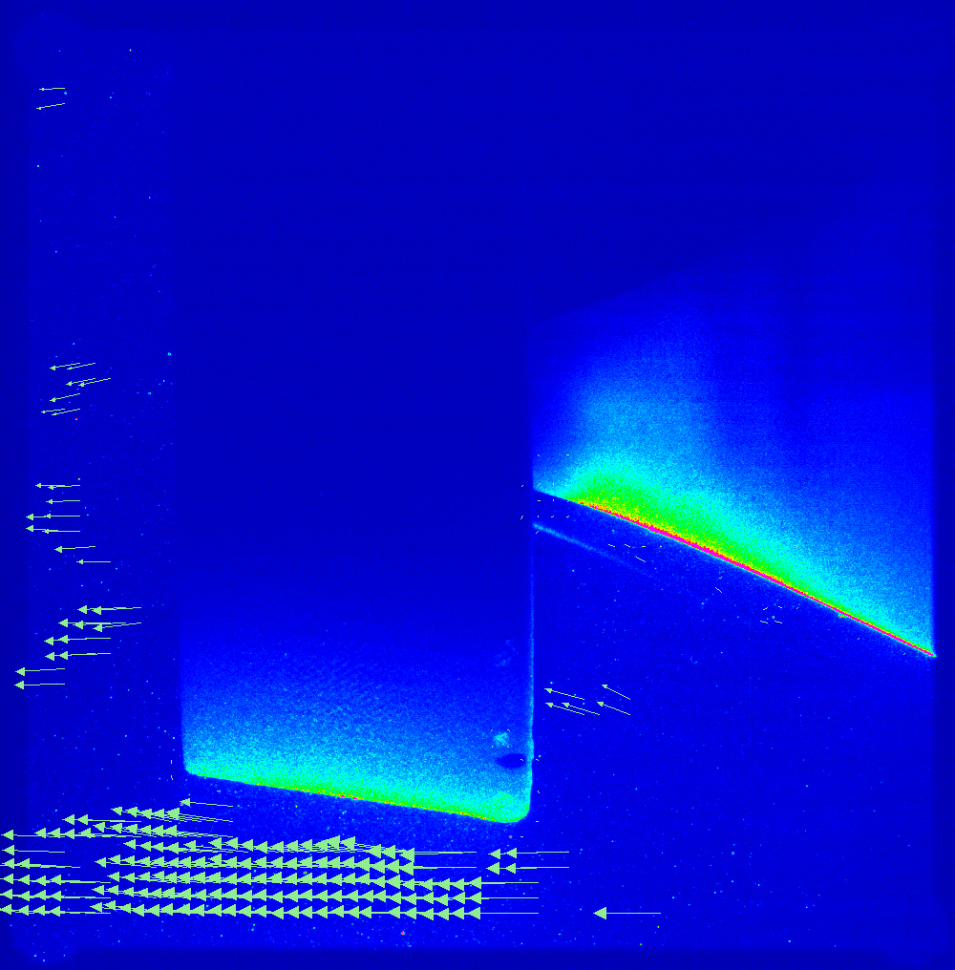
Figure 2.6.10: Velocity field measurements at the aft section of the vehicle with propeller off and the vectored-thruster set to an angle of 0º tilt. Green arrows indicate direction and magnitude of velocity at several points in the flow.

Velocity vector fields (see Figure 2.6.10 for example) have been determined for a variety of flow speeds. With the propeller off, it has been found that at a speed of 0.25 [m/s], a small flow separation region forms upstream of the propeller inflow. With the propeller on, this condition will be worsened. The flow separation will increase the form drag experienced by the RPUUV (reducing the possible range/operation time of the vehicle) and some further design work on the aft section is recommended. Possible improvements include increasing the length of the aft section slightly so that the contraction at the aft end of the vehicle can be made more gradual.

2.6.7. Conclusions

The specific tasks carried out during Year 1, and presented in the report, are
- Selection of propeller and propeller duct design for main thruster.
- Design and fabrication of RPUUV model sting and towing carriage modifications.
- Design and fabrication of RPUUV hydrodynamic model.
- Particle image velocimetry measurements of the RPUUV aft section flow.

Some of the key findings and recommendations of the efforts are
- A Wangeningen Model 19A propeller duct in combination with a Raboesch model propeller no. 176-37/38 should provide the required thrust with the propeller motor operating at near optimal torque and speed.
- Experiments demonstrate that flow separation occurs at low speeds upstream of the propeller inlet. Slight modification of the aft section profile is required to prevent/reduce this.

Year 2 efforts will focus on further hydrodynamic testing and analysis. Force transducer measurements, to be made in Year 2, will permit the hydrodynamic coefficients of the vehicle to be experimentally determined. Further experimentation will be performed to help fine tune the performance of the vehicle built in Year 1.

REFERENCES FOR SECTION 2.6

[1] B. W. McCormick, Aerodynamics of V/STOL Flight, Academic Press, 1967.
[2] J. S. Carlton, Marine Propellers and Propulsion, Butterworth-Heinemann, 1994.
[3] E. V. Lewis (Ed.), Principles of Naval Architecture, Vol. II: Resistance, Propulsion and Vibration, SNAME, 1988.
[4] Z. J. Hua and W. G. Qiang, “Prediction of hydrodynamic performance of ducted controllable pitch propellers”, J. Ship Mechanics, Vol. 6, No. 6, December 2002.
[5] P. Ridley, J. Fontan and P. Corke, ``Submarine dynamic modeling'', Proc. Australian Conf. Robotics & Automation, Brisbane, December 2003.

2.7. Hydrodynamics Analysis and Simulations for Design and Operation of a
Remotely-Piloted Unmanned Underwater Vehicle (RPUUV)
PI: Dr. P. Ananthakrishnan

Summary

The objective of the research was to contribute to the design and efficient performance of the RPUUV developed at Florida Atlantic University for port and underwater ship-hull surveys. The report describes formulations of the hydrodynamic and dynamic problem, solution methodology, specific problems considered, results, findings, and recommendations.

The vehicle drag at the design speed of 1 m/s was determined using empirical formulas including the ITTC formula for skin friction. Using Taylor wake fraction formulas, the thrust and power requirements of the propeller were determined. It was estimated that the vehicle drag at a forward speed of [m/s] is 1.6 [N]. Required propeller thrust was estimated to be 2.5 [N] and delivered power to be 3.3 [W].

The open-loop dynamics of the vehicle was examined by analyzing the equations of motion obtained with respect body-fixed coordinates. The hydrodynamic forces were determined in terms of hydrodynamic coefficients. The dynamic stability and maneuverability of the RPUUV while under horizontal and vertical planes of motion were analyzed for a range of parameters including forward speed, location of the center of gravity and various angles of vector thruster. The analysis confirmed the suitability of a vector thruster for the RPUUV and determined an optimum location on the RPUUV for the connection of the tow float cable.

A viscous-flow solver was also developed to study the stern flow of the vehicle in order to determine an optimum aft profile of the vehicle. The governing incompressible Navier-Stokes equations are solved using a boundary-fitted coordinates method. The operation of the propulsion was modeled using a novel pressure boundary condition. The pressure was determined based on the thrust developed by the propeller.

The findings and contributions of the research to the design and development of the RPUUV are discussed. The source codes developed under this project are included in the appendix section of the report.

2.7.1. Introduction

Dynamical performance of an underwater vehicle, such as the proposed remotely-piloted unmanned underwater vehicle (RPUUV) is greatly affected by the surrounding fluid flow, nearby boundaries and general arrangement of the vehicle. Efficient performance of onboard sensors, in particular sonar, requires slow speed of operation with minimal unsteady oscillations. The efficacy of ship hull survey depends on dynamic agility of the RPUUV. It is also a functional requirement that the vehicle be one-person operable for launch and recovery. All these require the RPUUV to be a dynamically stable and easily maneuverable platform, design of which thus requiring a good knowledge of vehicle dynamics and hydrodynamics.

Various elements of the RPUUV project, including design and development of the vehicle, were carried concurrently. The research was therefore carried out with the understanding that quick estimates and assessment of vehicle dynamics and hydrodynamics characteristics will be used in the initial design and development during Year 1. The present Year 1 report on vehicle dynamics and hydrodynamics presents results of initial dynamics and hydrodynamics analyses of the RPUUV. Further refinement of analyses and the incorporation of the results into design will be carried out in Year 2.

The following tasks were carried out during Year 1:

[a] Estimation of vehicle drag and propulsion at low design speed of 1 [m/s],

[b] Determination of the efficacy of a vector thruster for maneuvering, in particular its ability to achieve a turning radius of 1 [m] or less,

[c] Assessment of dynamic stability with and without fixed fins,

[d] Investigation of tow-connector cable effect on vehicle dynamics, and

[e] Hydrodynamic analysis to determine optimal aft profile of the vehicle.

In Year 1, empirical formulas were used to determine the vehicle drag and propulsion requirements. Only linear hydrodynamic coefficients of the hull were considered for the simulation of vehicle motion. The viscous flow simulation of the aft-flow is still in progress and therefore only the formulation and solution algorithm are presented in the present report. Agreement between simulations and recent at-sea trials has validated, qualitatively for now, the approach and findings of the present research.

2.7.2. Estimation of Vehicle Drag and Propeller Thrust and Power

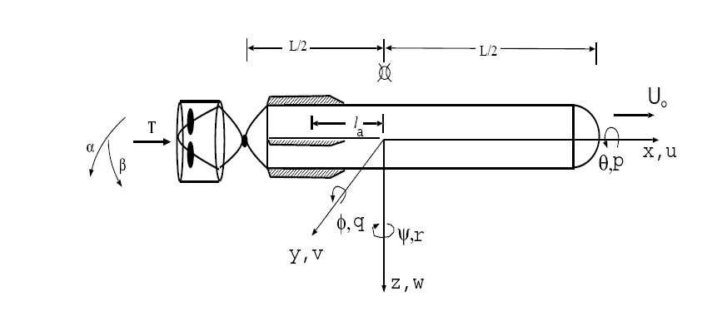
Figure 2.7.2-1 Illustrative sketch of the RPUUV

The first task of the project was to estimate the drag and propulsion requirements for the vehicle, yet to be built. The estimates were made for a vehicle of length 1 [m] and diameter 0.15 [m] and design speed of 1 [m/s]. The vehicle diameter and speed were determined by sonar requirements.

The vehicle drag was determined using the ITTC formula, which is valid for streamlined bodies, and also using experimentally-determined drag coefficient value. Per ITTC formula [4], the frictional resistance coefficient [9] is given by
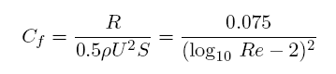
C_{f} denotes the resistance coefficient, R the vehicle resistance, ρ the water density, U the forward speed of the vehicle, S the surface area of the vehicle, Re the Reynold's number defined as
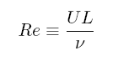
with L corresponding to the vehicle length and ν the coefficient of dynamic viscosity. An estimate of drag was also made in terms of drag coefficient as
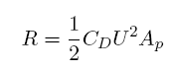
where C_{D} denotes drag coefficient and A the projected area of the vehicle. The drag coefficient for the RPUUV was determined based on experimental results of similar bodies reported in the literature [5]. In estimating the total drag, the induced drag of fixed fins was also included, even though later analysis proved that the fins are not required for maneuvering the present vehicle. Taylor wake formulas [4] were used to account for hull and propeller interaction effects. By this method, the propeller thrust was determined as
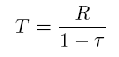
and effective speed of advance of the propeller as
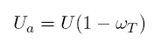
where τ denotes thrust-deduction factor and ω_{T} the Taylor wake fraction. The values of τ and ω_{T} were obtained from empirical results corresponding to underwater vehicles reported in the literature [4].

Assuming a nominal propeller efficiency η_{p} of 60 %, the delivered horsepower P_{D} was estimated. The propeller torque Q at various propeller rpm’s are them determined as
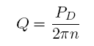
where n denotes revolutions per unit time of the propeller. Allowing 20 % of power for frictional losses, the shaft horsepower of the motor was estimated as
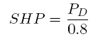
The principal dimensions, parameters of the vehicle, and the drag and propulsion estimates thus made are presented in Table 2.7.2-1. Note that these estimates were made at the start of the project and therefore the contributions of sonar and other sensor packages appended to the RPUUV to resistance were not determined. These will be determined during Year 2 of the project. Further work on the propulsion of RPUUV was carried out by the co-PI of the present project Dr. Karl vonEllenrieder.

Table 2.7.2-1 Principal Dimensions and Propulsion Estimates for the RPUUV
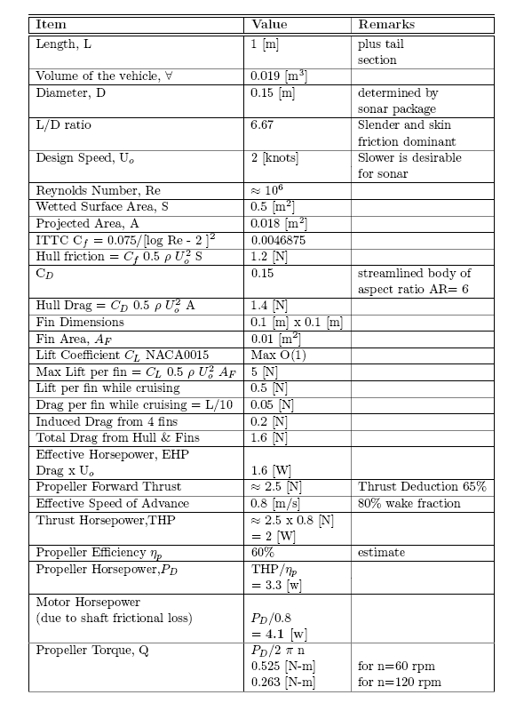

2.7.3. RPUUV Dynamics - Simulation of Horizontal Plane Motion

In order to determine directional stability, viability of vector-thruster for maneuvering, and effect of aft fins on stability and maneuverability, we performed computer simulation of horizontal plane motion. The simulations were carried for a range of parameters such as thrust, vector-thrust angle, fin geometry and location of center of gravity. In this section, we present the formulation of the horizontal plane motion problem using vehicle-fixed coordinate system, determination of hydrodynamic forces, solution method, simulations, representative results and findings.

2.7.3-1. Six Degree of Freedom Rigid Body Motion

The coordinates system and notations used in the formulation of the RPUUV motion problem is shown in Figure 2.7.3-1.

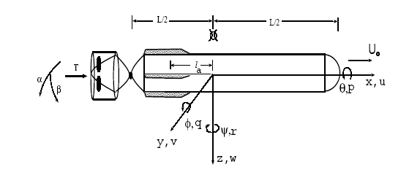
Figure 2.7.3-1. RPUUV motion: coordinate system and notations.

As shown in the above figure, let the coordinate system oxyz be fixed to the vehicle with origin at the intersection of axis of symmetry and the mid-section of the main hull. The x-axis is forward, y axis towards starboard and z axis downward. The body-fixed components of translational velocity are denoted as (u,v,w) and angular velocity as (p,q,r). The Euler angles are denoted as (φ, θ, ψ). Let the inertia tensor components be denoted with subscripts of I and the coordinates of the center of gravity be (x_{G}, y_{G}, z_{G}). The external force acting on the hull is denoted as X = ({X, Y, Z) and its moment as K= (K, M, N). The 6DOF equations of motion with respect to body-fixed coordinates are given by [2]:
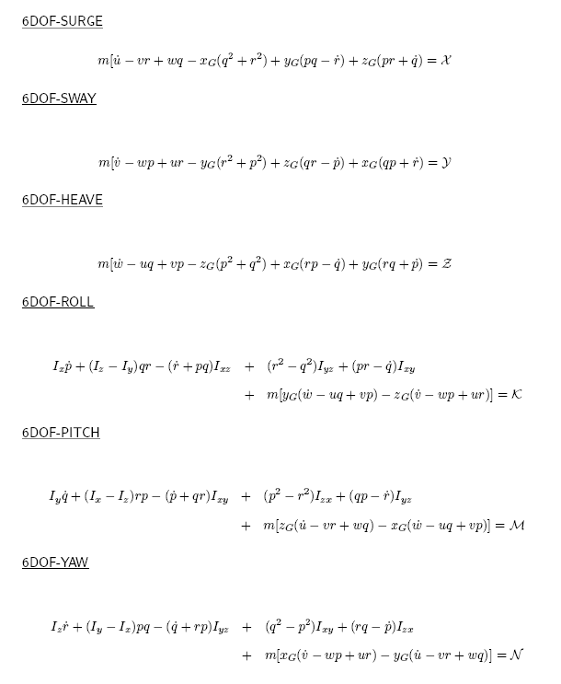

2.7.3-2. Three Degree of Freedom Horizontal Plane Motion.

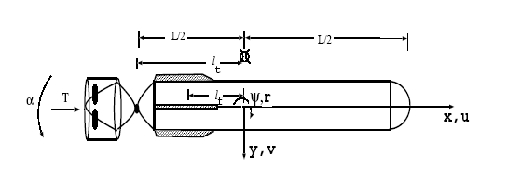

Figure 2.7.3-3 3DOF RPUUV motion in the horizontal plane.

For 3DOF horizontal plane motion, as illustrated in Figure 2.7.3-2, the 6DOF equations presented earlier reduce to [10]:
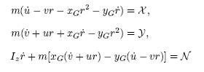

In the case of the plane motion, note that

2.7.3-3. External Force and Moment

The external force and moment appearing in the 3DOF horizontal plane motion equations above can be written as follows:
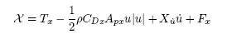
where T_{x} represents forward component of thrust developed by the vector thruster; ie.
T_{x} = T cos α (see Figure 2.7.3-1). The symbol C_{Dx} denotes the drag coefficient for forward motion and X_{u} the added-mass coefficient. Nonlinear (higher-order) hydrodynamic coefficients are neglected. The term F_{x} denotes the x-component of aft-fin force (induced drag) if fins were to be attached to the vehicle. The inviscid ``cross'' hydrodynamic coefficients are zero because of vehicle symmetry about the x axis. In the simulations carried out, vector thrust T and thrust angle α $were specified as input. The drag coefficient C_{Dx} was obtained for experimental values of similarly-shaped bodies reported in literature [5]. A boundary-integral method for the solution of hydrodynamic flow equations developed earlier [2] was considered to determine the hydrodynamic coefficient X_{u}.

Similarly the y-component of the external force can be written as
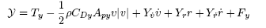
where T_{y} = T sin α (see Figure 2.7.3-1). The lateral flow drag coefficient C_{Dy} was obtained from experimental results found in literature [2]. The hydrodynamic coefficients (denoted by Y’s with subscripts) are obtained from [2,6] corresponding to similar underwater vehicles.

The z component of the external moment is given by
The first term on the right-hand side denotes the yaw moment of the thrust and the second term the moment of the aft fin force (if aft fins were present). The terms l_{T} and l_{f} denote distance to the thruster and to center of fins, respectively, from the origin of the coordinate system. The third term corresponds to the moment of hydrodynamic drag with local velocity v' = v + x r. The remaining terms on the right-hand side denote added (hydrodynamic) moment due to sway and yaw motions.

3-4. Numerical Solution of Equations of Motion

The equations of 3DOF horizontal plane motion with hydrodynamic force and moment expressed in terms of coefficients, as obtained above, are:
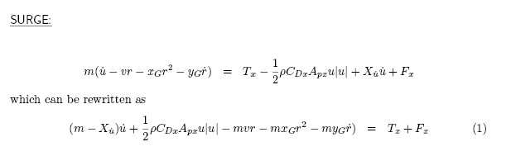
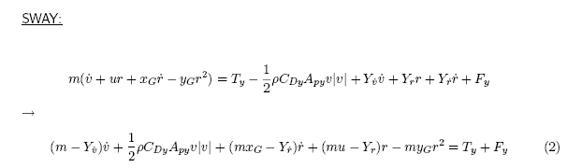

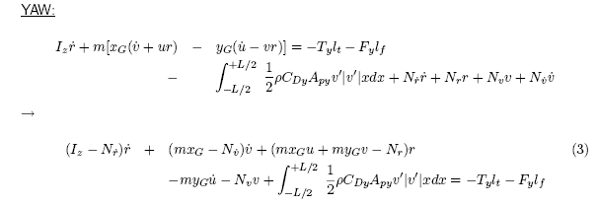

With initial values and thrust forcing specified, the above equations are integrated using an explicit Euler algorithm [2] to advance the solution in time. The integral corresponding to yaw moment of cross-flow drag is evaluated using trapezoidal. At each time step upon determining r, the yaw angular displacement is determined by integrating the following equation:
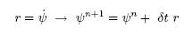

ψ^{n} denotes yaw angle at discrete time n, ψ^{n+1} that at n+1 and δt the time step size. Also, at each time step upon determining instantaneous body-fixed coordinate velocity components u and v, the velocity components with respect to earth-fixed frame of reference OXYZ are obtained by the following transformation [2]:
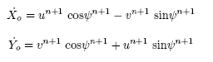
Above equations are integrated to determine vehicle trajectory:
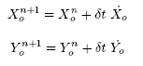
Thus the trajectory and orientation of the vehicle as observed from earth-fixed frame are also determined.

2.7.3-5. Estimation of Hydrodynamic Coefficients

For Year 1 assessment of vehicle dynamics simulations, we have used approximate methods and empirical formulas to determine the hydrodynamic coefficients involved in the equations of motion. More accurate methods, already developed in house [2,7,8] for earlier projects, will be used in Year 2 for further development of the vehicle. The forces and moments associated with viscosity drag are determined in terms of drag coefficient of similarly shaped bodies found in literature [5]. Estimates of added-mass coefficients are obtained from potential-flow results of prolate-spheroids, given in Newman [6], of equivalent aspect ratio and that determined in [2] for similar underwater vehicles. The lift and drag coefficients corresponding to fins are similarly obtained from experimental data reported in literature for NACA sections. For simulations, we took the vehicle to be of length 1 [m] and diameter 0.15 [m] as we did earlier for drag and propulsion estimates. Simple expressions for this particular vehicle, which are easier to program, for hydrodynamic forces and moment involved in the equations of motion are obtained as shown in Table 2.7.3-1:

Table 2.7.3-1: Expressions for hydrodynamic forces and moments
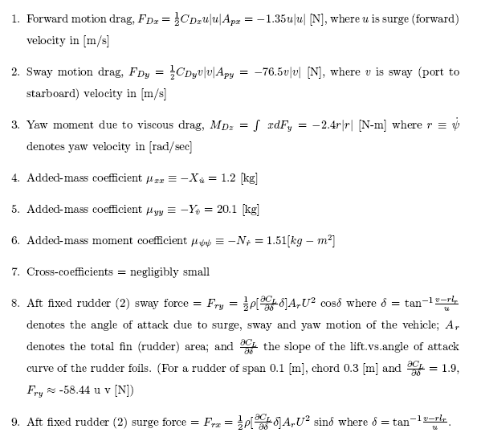
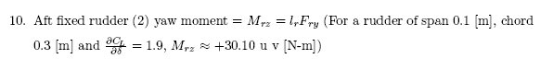

2.7.3-6. Simulations To Determine the Possibility of Vector Thruster for the RPUUV

The solution algorithm developed to simulate horizontal plane motion was used to determine the feasibility of a vector thruster for the RPUUV. It was required that the RPUUV is able to turn within a radius of 1 [m] while advancing at a nominal speed of 1 [m/s].

Computer simulated result for the case of thrust T = 2 [N], vector thrust angle α=10º, center of gravity at x_{G}=-0.1 [m], y_{G} = 0, with no aft fins is shown in Figure 2.7.3-6-i. The figure shows the trajectory of the vehicle. It can be observed that the turning radius is approximately 160 [m]. However when T = 4 [N] and vector thrust angle α=50º (and remaining parameters same), simulation show that the RPUUV can execute a circle of radius less than 1 [m] (refer to Figure 2.7.3-6-ii). Simulations were carried for wide range of parameters and it was found that it is possible to propel the RPUUV with a vector thruster and achieve required turning radius of 1 [m].

Recommendation: Based on the simulations, it was confirmed that a vector thruster will make the vehicle quite efficiently maneuverable, in particular that it will enable the RPUUV achieve a turning radius of 1 [m]. The use of vector thruster was therefore supported.

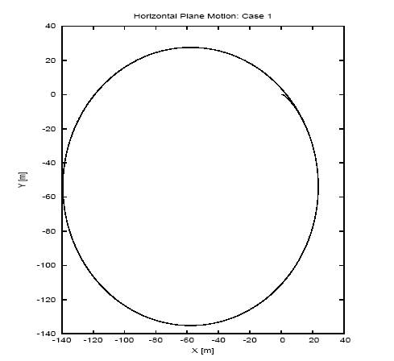

Figure 2.7.3-6-i. T = 2 [N], α=10º, x_{G}=-0.1 [m], y_{G} = 0 and without aft fins.
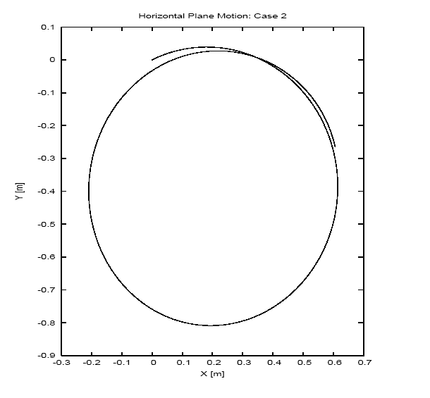

Figure 2.7.3-6-ii. T = 4 [N], α=50º, x_{G}=-0.1 [m], y_{G} = 0 and without aft fins.

2.7.3-7. Simulations to Determine Fixed Aft Fins Requirements for the RPUUV

To determine whether fixed aft fins would be required for the RPUUV to ensure directional stability, the simulations were carried out including fixed fins at aft. Simulations were carried out with and without fins for a range of values of the following parameters

- location of the center of gravity of the vehicle,
- propeller thrust T,
- thrust angle α
- chord length and span
- distance from the mid-vehicle section to the fins
- and with and without introduction of perturbation to motion (to determine dynamic stability)

NACA0015 geometry was chosen for the fin section. Representative results presented here have the following common parameter values:

- Time-step size, δt = 0.1 sec
- Start up = Ramp start up from zero to maximum thrust in 30 sec
- Duration of simulation = 100 sec
- Time perturbation applied (if applied) = 50 sec

The results are presented and discussed below in pairs, one with fins and and one without fins, for a range of other parameters. Results are presented in the form of graphs and tables. Case simulations 1 and 2 presented in Table 2.7.3-7i and Figure 2.7.3-7i, show that fins would make the vehicle less manueverable in that it will make the turning radius large.

Table 2.7.3-7i. Simulations 1 and 2
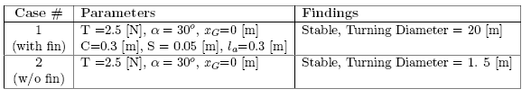
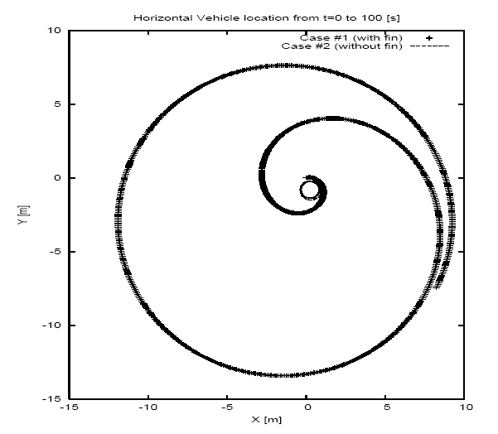
Figure 2.7.3-7i. Simulated vehicle trajectories for Cases 1 and 2}

Results for case studies 3 and 4 are presented in Table 2.7.3-7ii and Figure 2.7.3-7ii.
In these simulations, the dynamic stability of the vehicle was analyzed. A spike in sway velocity
by a magnitude of +0.1 [m/s] was introduced at time t = 50 [s]. Both for the cases with and without fins, as results show, the perturbation vanishes as time progresses.

Table 2.7.3-7ii. Simulations 3 and 4
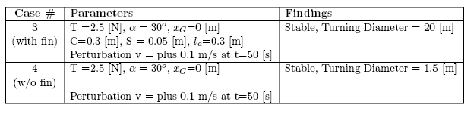

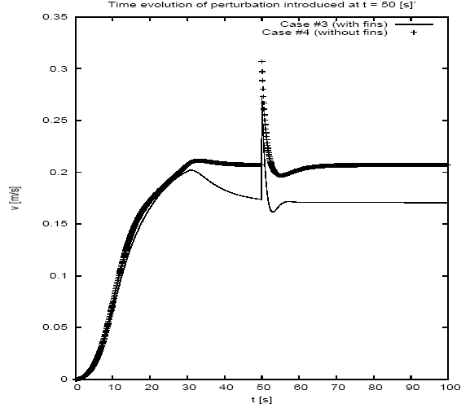

Figure 2.7.3-7ii. Evolution of sway velocity v in time. Note that the spikes correspond to perturbation introduced at t = 50 [s]

Next, effect of moving the center of gravity off the mid section was considered both for the cases of with and without fins. Representative results of this examination for x_{G} = +0.1 [m] are summarized in Table 2.7.3-7iii and shown in Figure 2.7.3-7iii below. The results show that forward location of the center of gravity increases turning radii of the vehicle with or without aft fins.

Table 2.7.3-7iii. Simulations 5 and 6

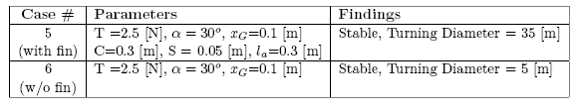
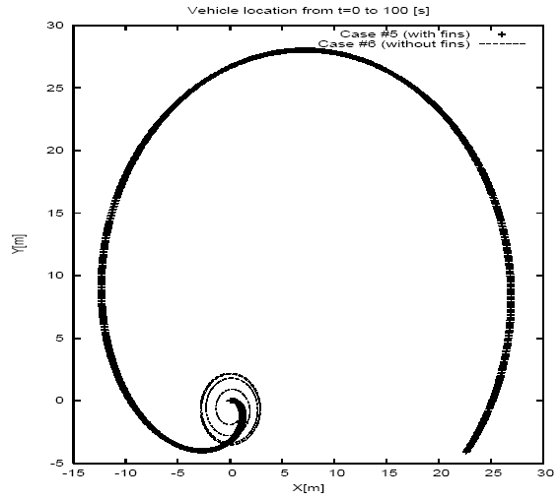
Figure 2.7.3-7iii. Trajectories of the vehicle with and without aft fins for x_{G} = +0.1 [m]

Dynamic stability of the vehicle with and without fins and both with x_{G} = +0.1 is examined in case studies 7 and 8 and results presented in Table 2.7.3-7iv and Figure 2.7.3-7iv. Simulations reveal that the vehicle is stable - in other word, perturbed velocity tends to zero as time advances – both with and without the fins.

Table 2.7.3-7iv. Simulations 7 and 8

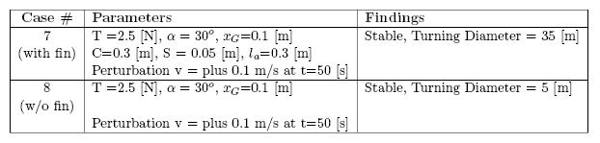

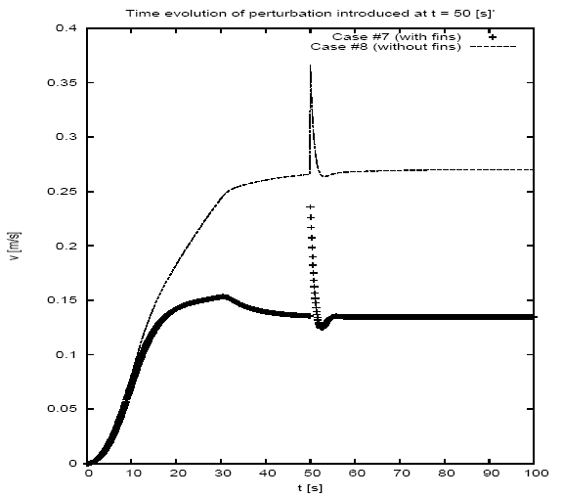
Figure 2.7.3-7iv. Time evolution of sway velocity perturbed at t = 50[s] with and without aft fins and with x_{G} = +0.1

Effect of having the center of gravity aft of the mid-section was considered next. Results for x_{G} = -0.1 [m] with and without aft fins are given in Table 2.7.3-7v and Figure 2.7.3-7v. As found in earlier simulations, fins tend to increase the turning radius. However, having the center of gravity aft of the mid-section enables the vehicle to execute tighter turns.

Table 2.7.3-7v. Simulations 9 and 10

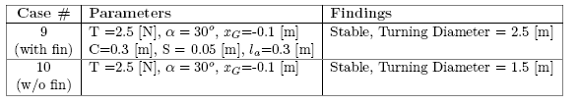

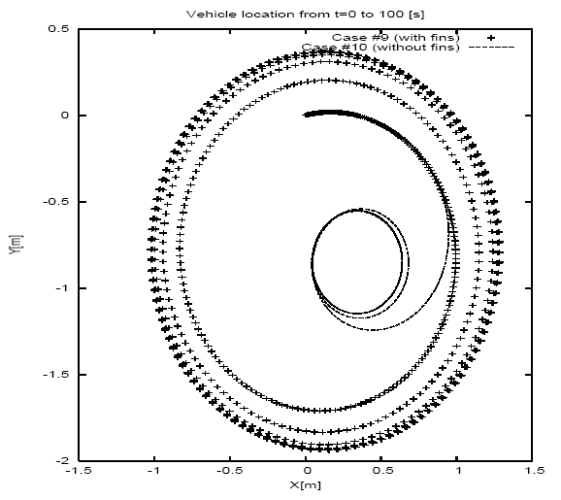

Figure 2.7.3-7v. Trajectories of the vehicle with and without aft fins for x_{G} = -0.1 [m]

Dynamic stability of the vehicle with and without fins and with x_{G} = -0.1 [m] was examined. As shown in Table 2.7.3-7vi and Figure 2.7.3-7vi, the vehicle was found to be stable both with and without aft fins.

Table 2.7.3-7vi. Simulations 11 and 12
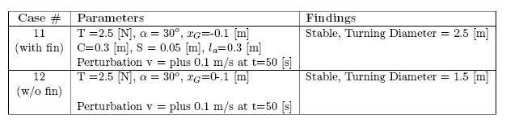
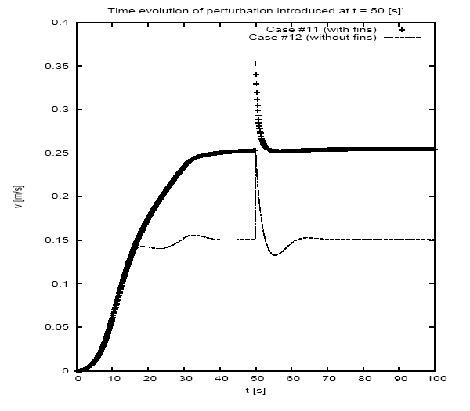
Figure 2.7.3-7vi. Time evolution of sway velocity perturbed at t = 50[s] with and without aft fins and with x_{G} = -0.1 [m].

Plain Forward Motion. Simulations were carried out for plain forward motion also.
Though not shown, results showed that application of thrust T= 2.5 [N] at α = 0º causes the vehicle to move just forward both with and without fins. The vehicle achieves a steady forward speed of 1.35 [m/s] with a forward thrust of 2.5 [N]. When perturbed, the vehicle is stable both with and without fins and for CG locations aft, at and forward of mid-section.

High Speed Motion. Out of interest, a few simulations with thrust = 50 [N] were also carried out. It was found that at α = 0º the vehicle reached forward speed of 6 [m/s]. Findings on the effect of aft fins on vehicle trajectory and stability are similar to what was observed at low speeds.

2.7.3-8 Recommendation on Aft Fin Requirements.

As simulated results presented in this section demonstrate, for the present RPUUV the aft fixed fins do not contribute to improvement of vehicle performance in any significant way. It does suppress perturbation at a faster rate in some cases, but the vehicle by itself (ie., without fins) was also found to be stable. In fact the presence of fixed fins was found to make the vehicle less steerable, in that they tend to increase turning radius. The fins could suppress unsteady motions as for example induced by surface waves; the subject of RPUUV-Wave Interactions will be taken up during the second year of the project. For mid-water applications, it was thus suggested that fins are not required for the RPUUV.

2.7.4 RPUUV Dynamics - Simulation of Vertical Plane Motion

Next, by considering heave, pitch and surge modes we examined the dynamic behavior of the vehicle. The analysis was carried to determine stability and maneuverability of the RPUUV in the vertical plane. Simulations were carried out for a range of values of parameters such as location of the center of gravity, thrust, and thrust angle. Simulations were also carried out to determine the optimum location on the RPUUV for connecting the cable to the tow float.

2.7.4-1. Formulation of Vertical Plane Motion

The coordinates system and notations used in the formulation of the RPUUV motion problem is shown again in Figure 2.7.4-1 below.

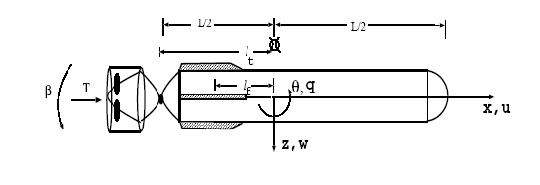

Figure 2.7.4-1. RPUUV motion in the vertical oxz plane.

From the 6DOF equations of motion, presented in the earlier Section 2.7.3, one can obtain the following equation for the vertical motion by setting all velocity components, except that of surge u, heave w and pitch q, to zero. The resulting equations are given by
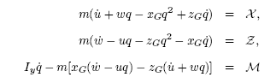

where X and Z denote the x and z components of the external force, respectively, M the y component of the force moment which includes righting moment also.

2.7.4-2. External Force and Moment

The external force and moment appearing in the above vertical plane motion equations above can
be written as follows:
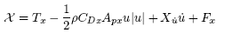
where T_{x} represents forward component of thrust developed by the vector thruster; ie.
T_{x} =T cos β (see Figure 2.7.4-1). C_{Dx} denotes the drag coefficient for forward motion and X_{u} the added-mass coefficient. Nonlinear (higher-order) hydrodynamic coefficients are neglected. The term F_{x} denotes the x-component of aft-fin force (induced drag) were fins attached to the vehicle. The ``cross'' hydrodynamic coefficients are zero because of vehicle symmetry about the x axis.

Similarly the Z-component of the external force can be written as
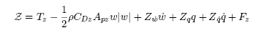

where T_{z} denotes the vertical component of the vector thrust, C_{Dz} the drag coefficient associated with the cross flow and Z’s with subscripts the hydrodynamic added-mass coefficients.

The pitch moment can be written as
where T_{z} and F_{z} denote the z component of the thrust and fin forces, respectively, C_{Dz} the drag coefficient of the cross flow, and the M's the hydrodynamic coefficients. The last term
on the right hand side denotes the righting moment with Δ representing the vehicle displacement
(weight), GM the metacentric height (ie., the distance of separation between the centers of
buoyancy and gravity, taken to be positive when center of gravity is below the center of buoyancy) and θ the Euler angle about the y axis. Note that in the case of plane motion,

The hydrodynamic coefficients are determined from potential-flow theory calculations [6] and the drag coefficient from experimental data of similarly-shaped bodies found in literature [5]. The thrust, thrust angle, coordinate of the the center of gravity etc are specified as input.

2.7.4-3. Solution Method

An explicit Euler algorithm is then used to integrate the above equations and to advance the solution in time. At each time step, having determined the pitch velocity at time instant n+1, the Euler pitch angular displacement is found as
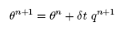
Having advanced the body-fixed coordinate velocity components at discrete time n+1,
the earth-fixed coordinate velocity components are determined using the following transformation relation:
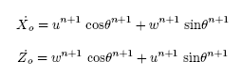
Above equations are then integrated to determine the vehicle coordinates at time n+1:
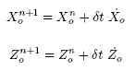

2.7.4-4. Simulations of Vertical Plane Motion - Without Aft Fins

Results were obtained for a range of parameters for the motion of the RPUUV in the vertical oxz plane. Representative results are given in Figures 2.7.4-4i and 2.7.4-4ii. Note that as the center of buoyancy is on the axis of symmetry of the vehicle, the metacentric height is simply the z (downward positive) coordinate of the center of gravity.

Results corresponding to T = 3 [N], β=10º, x_{G}=+0.01 [m], z_{G} =+0.03 [m] given in Figure 2.7.4-4i show that vehicle dives to a depth of 25 [m] while covering a horizontal distance of 500 [m] during the period of simulation which is 400 [s].
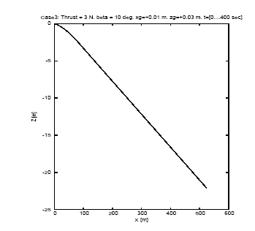

Figure 2.7.4-4i. Motion in the vertical plane for T = 3 [N], β=10º, x_{G} =+0.01 [m], z_{G} =+0.03 [m] and t=(0,400 [s].

Results corresponding to thrust T = 5 [N], thrust angle β=50º, x_{G} =0 [m], z_{G} =+0.03 [m] and time t=(0,300 [s]) are given below in Figure 2.7.4-4ii. Here, the vehicle reaches a depth of 60 [m] in a duration of 5 minutes. The results confirm that the RPUUV is quite stable in vertical plane motion also, even without the addition of fixed fins at aft.
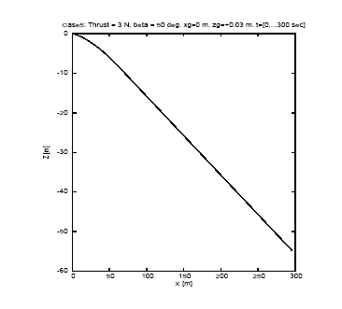

Figure 2.7.4-4ii. T = 5 [N], β=50º, x_{G} =0 [m], z_{G} =+0.03 [m] , and t=(0,300 [s])

2.7.4-5. Simulations to Determine Optimum Location for Tow Float Connector

Next, simulations in the vertical plane were carried to determine the optimum location on the RPUUV for connecting the cable to the tow float. As the tension in the cable depends on various parameters such as motion of the tow float, drag force on the cable etc, determination of which
is not a trivial task, simulations were performed for a range of cable tension forces τ and cable angles δ (see Figure 2.7.4-5i). The equations governing the motion are same as that presented in the previous section, except for the addition of τ cos δ to x component of the external force, τ sin δ to the z component of the external force and x_{tow .}τ sin δ (where x_{tow} denotes the x coordinate of the point of connection) to the external pitch moment.

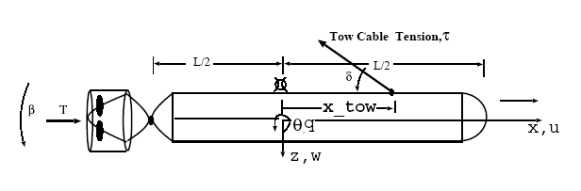
Figure 2.7.4-5i. RPUUV motion in the vertical plane include tow-float cable force.

Simulations were carried out for a range of parameters and representative results are given.
Representative results corresponding to range of forward thrusts (ie., β = 0), tow-cable tensions τ, connector coordinates x_{tow} and locations of center of gravity are given in Figures 2.7.4-5ii to 2.7.4-5iv. Trajectory of the vehicle corresponding to forward Thrust = 2.5 [N], β=0, x_{G}=0, metacentric height z_{G}= 0.01 [m], tow tension = 0.5 [N], tow cable angle = δ = 45 degrees and for various locations of x_{tow} (= -0.3, 0 and +0.3 [m]) is shown in Figure 2.7.4-5ii. For all three cases, the vehicle motion is quite stable. Because of upward tension and forward thrust, the vehicle ascends as it translates forward. Time histories of the corresponding pitch angular displacements, shown in the next figure 2.7.4-5iii, reveal that angular motion is large when the connection is farther away from the mid-section, a finding which is somewhat intuitively obvious also.
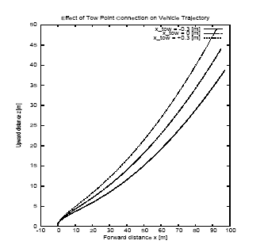
Figure 2.7.4-5ii Vehicle trajectory corresponding to T = 2.5 [N], β=0, x_{G}=0, z_{G}= 0.01 [m], τ =0.5 [N], δ = 45ºand for values of x_{tow} = -0.3, 0 and +0.3 [m].

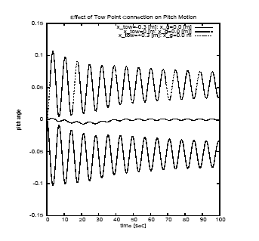

Figure 2.7.4-5iii. Time evolution of pitch displacement (in radians) corresponding to T = 2.5 [N], β=0, x_{G}=0, z_{G}= 0.01 [m], τ =0.5 [N], δ = 45ºand for values of x_{tow} = -0.3, 0 and +0.3 [m].

Similar results were obtained even for forward location of the center of gravity x_{G}. Results
corresponding to thrust = 2.5 [N], β=0, x_{G}=0.1 [m], z_{G}= 0.01 [m], τ =0.5 [N], δ = 45ºand for values of x_{tow} = -0.3, 0 and +0.3 [m] shown in Figure 2.7.4-5iv also confirm that farther the tow-float connector from the mid-section the larger will be angular motions.

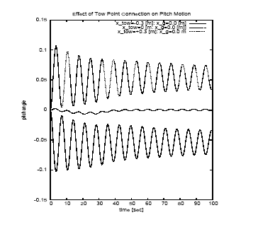

Figure 2.7.4-5iv. Time evolution of pitch displacement (in radians) corresponding to
Thrust = 2.5 [N], β=0, x_{G}=0.1 [m], z_{G}= 0.01 [m], τ =0.5 [N], δ = 45ºand for values of x_{tow} = -0.3, 0 and +0.3 [m].

Based on the simulations, it was recommended that the tow-float cable be connected (taking into consideration other restrictions of general arrangement and sensor locations) as close to the mid-section of the RPUUV as possible.

2.7.5. RPUUV Hydrodynamics – Simulation of Stern Flow Including Propulsion Effect

Our first year effort also included modeling and analysis of the hydrodynamic flow about the aft section of the RPUUV with the objective of determining the effect of RPUUV geometry on the flow and an optimum aft profile for maximum flow into the propeller.
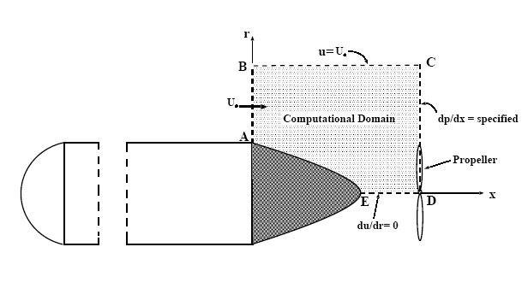

Figure 2.7.5-1. Modeling of the Aft Flow

2.7.5-1. Formulation of the Viscous Flow Problem.

We consider viscous flow past the RPUUV as shown in Figure 5-1. The particular region of focus is ABCDE. The governing incompressible axi-symmetric Navier-Stokes equations are given by [1]:
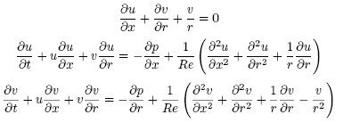
where u and v denote non-dimensional axial (x) and radial (r) components of fluid velocity, respectively, p the pressure and Re the Reynolds number defined as
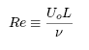
Here Uo is the vehicle's steady forward speed, L the aft-body length and ν the coefficient of kinematic viscosity.

The following boundary conditions are developed for examining the flow in the aft region ABCDE, defined with respect to frame attached to the vehicle as follows. On the upstream surface AB and outer boundary BC, velocity is specified as
On the RPUUV boundary AE, velocity is zero:
On the axis of symmetry,
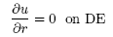
On the downstream boundary, a Dirichlet pressure boundary condition is developed:
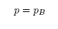
where p_{B} is average pressure on the low-pressure side (back) of the propeller. The specific value of p_{B} is determined approximately based on the knowledge of propeller thrust T and blade area A; in other words,
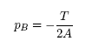
.A few observations of this novel condition are in order: (i) The condition accounts for the effect of propulsion on the aft flow in a straightforward manner without having to resolve the complex flow across propeller blades, (ii) the propulsion induces a favorable pressure gradient on the flow and therefore could delay flow separation.

2.7.5-2. Solution Method.

The above hydrodynamic flow equations are solved using a boundary-fitted coordinates based finite-difference method developed by the PI earlier [1]. In this method the physical space (x,r) is mapped to an uniform rectangular computaional space (ξ, η). The generation of grid is based on a reference-space based variational formulation [1]. The governing equations are also transformed to the uniform computational space using chain rules of partial differentiation. The transformed Navier-Stokes equations are solved in primitive variables using a fractional-step finite-difference method [3]. In this method, an auxiliary velocity field is first determined by integrating the momentum equation without the pressure-gradient terms. The auxiliary field is then decomposed into actual divergence-free velocity and pressure fields. The decomposition involves solution of a pressure Poisson equation. Details of the solution method can be found in earlier articles of the PI [1]. \\
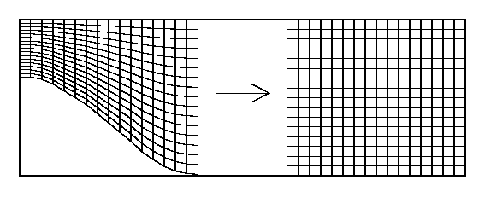
Figure 2.7.5-2. Mapping of physical domain to uniform rectangular computational domain.

2.7.5-3. Results.

At the time of writing the present Year 1 report, modeling and development of the flow algorithm have been completed. Debugging of the code is underway and results are expected during the first quarter of Year 2 of the project.

2.7.6. Conclusion

The specific tasks carried out during Year 1, and presented in the report, are

- Estimation of RPUUV drag and propulsion for forward speed of 1 [m/s]
- Simulation of RPUUV motion in the vertical and horizontal planes
- Determination of efficacy of vector thruster for propulsion and steering
- Determination of aft-fins requirements for stability
- Determination of optimum location for tow-float connection
- Simulation of aft flow including propulsion effects

Some of the key findings and recommendations of the efforts are

- Vector thruster can effectively maneuver the vehicle at low speed. In particular, it is possible to achieve a turning radius of 1 [m] at low forward speed.
- Aft fins are not necessary for ensuring dynamic stability of the RPUUV engaged in mid-water applications.
- Optimum location for tow-float connection is mid-section as connections at forward or aft of mid section will induce unsteady pitch oscillations of significant magnitude.

One important contribution to basic marine hydrodynamics is the development of an algorithm
to model that stern flow of a vehicle including propulsion effect. The propeller effect
is modeled using a novel Dirichlet pressure boundary condition on the downstream open
boundary of the computational domain. The coding and debugging of the algorithm is however not fully complete and results can be expected only in Year 2.

Year 2 efforts will focus on further refinement of hydrodynamic analysis, in particular on determining the hydrodynamic coefficients and flow about the vehicle built in Year 1. Effect of boundaries, ie. sea bottom and surface waves, on vehicle motion will be also investigated.
Results will be used to enhance and fine tune the performance of the vehicle built in Year 1.

REFERENCES FOR SECTION 2.7

[1] P. Ananthakrishnan, ``Radiation hydrodynamics of a floating vertical cylinder in a viscous fluid,'' Journal of Engineering Mechanics, vol. 125, No.7, pp. 836-847, 1999.

[2] P. Ananthakrishnan and S. Decron, ``Dynamics of Small- and Mini-Autonomous Underwater Vehicles: Part I. Analysis and Simulation for Midwater Applications'', Technical Report, 63p,
Department of Ocean Engineering, Florida Atlantic University, July 2000.

[3] A. J. Chorin, ``Numerical Solution of the Navier-Stokes Equations,'' Mathematics of Computing, v.ol. 22, pp. 745-762, 1968

[4] J. P. Comstock (editor), Principles of Naval Architecture, SNAME Publication, 1967

[5] C. T. Crowe, D. F. Elger and J. A. Robserson, Engineering Fluids Mechanics, John Wiley \& Sons Inc., 2005.

[6] J. N. Newman, Marine Hydrodynamics, The MIT Press, 1999.

[7] C. Puaut, ``Hydrodynamic Analysis of an Underwater Vehicle Including Free-Surface Effects'', MS Thesis, Advisor: P. Ananthakrishnan, Department of Ocean Engineering, Florida Atlantic University, 2001.

[8] O. Saout, ``Computation of Hydrodynamic Coefficients and Determination of Dynamic Stability Characteristics of an Underwater Vehicle including Free Surface Effects,'' MS Thesis, Advisor: P. Ananthakrishnan, Department of Ocean Engineering, Florida Atlantic University, 2002.

[9] H. Schlichting, Boundary Layer Theory, McGraw-Hill, New York, 1955.

[10] J. V. Wehausen, Ship Dynamics, Lecture Notes, University of California at Berkeley, Fall 1972.

2.7. Appendix A: Listing of Fortran Code for the Simulation of Horizontal Plane Motion

c
c 3DOF Linear Planar Motion of RPUUV with vector thruster and
c with fixed fins
c
c Quantities are dimensional and Units are SI
c
real mass,length,iz,nvdot,nrdot,lprop
character*72 outfl1,outfl2,fillog
c
write(*,*) '**************************************************'
write(*,*)
write(*,*) '3DOF HORIZONTAL PLANE MOTION OF RPUUV'
write(*,*)
write(*,*) '**************************************************'
write(*,*)
write(11,*) '**************************************************'
write(11,*)
write(11,*) '3DOF HORIZONTAL PLANE MOTION OF RPUUV'
write(11,*)
write(11,*) '**************************************************'
write(11,*)
c
c
pi=4.0*atan(1.0)
alpa=alfa*pi/180.
c
mass=20.0
iz=1.70
c
length=1.0
cdx=0.15
cdy=1.0
dragxco=1.35
dragyco=76.5
drgmomc=2.4
apx=0.017
apy=0.15
rho=1020.0
c
c
xudot=-1.2
yvdot=-20.0
nrdot=-1.5
c
yrdot=+0.0
nvdot=+0.0
c

write(*,*) 'Log file for entered data'
read(*,20) fillog
write(*,*) 'Outfile 1 for time, thrust, u, v, r'
read(*,20) outfl1
write(*,*) 'Outfile 2 for time, x, y, yaw'
read(*,20) outfl2
c
20 format(a72)
c
open(7,file=outfl1,status='new')
open(9,file=outfl2,status='new')
open(11,file=fillog,status='new')

c
write(*,*) 'Enter Case Study / Simulation Number'
read(*,*) icase
write(11,*) 'Case Study / Simulation Number=',icase
write(*,*) 'Enter vector thrust in [N]'
read(*,*) thrust
write(11,*) 'vector thrust in [N] =',thrust
write(*,*) 'Enter vector thruster angle in [deg]'
read(*,*) alfa
write(11,*) 'Vector thruster angle in [deg]=',alfa
write(*,*) 'Enter thruster ramp start-up time in [sec]'
read(*,*) stime
write(11,*) 'Thruster ramp start-up time in [sec]=',stime
write(*,*) 'Enter x-coordinate of cg in [m] from mid-section'
read(*,*) xg
write(11,*) 'x-coordinate of cg in [m] from mid-section=',xg
c
write(*,*) ' *********************** FIN RELATED ********* '
write(11,*) ' *********************** FIN RELATED ********* '
c
c Fixed Aft Rudder
c
c
write(*,*)
write(11,*)
write(*,*) 'Enter aft fixed fin rudder chord in [m]'
read(*,*) rudchd
write(11,*) 'Aft fixed fin rudder chord in [m]', rudchd
write(*,*) 'Enter aft fixed fin rudder span in [m]'
read(*,*) rudspn
write(11,*) 'Aft fixed fin rudder span in [m]', rudspn
c
arudder=2.0*rudchd*rudspn
write(*,*) 'Aft fixed fin two rudders area in [m^2]',arudder
write(11,*) 'Aft fixed fin two rudders area in [m^2]',arudder
c

write(*,*) 'Enter Dcl/Ddelta of rudder'
read(*,*) dclddel
write(11,*) 'Dcl/Ddelta of rudder',dclddel
c
write(*,*) 'Enter aft distance to rudder in [m]'
read(*,*) distrud
write(11,*) 'Aft distance to rudder in [m]', distrud
c
write(*,*) 'Enter aft distance to propeller in [m]'
read(*,*) lprop
write(11,*) 'Aft distance to propeller in [m]', lprop
c
finfy=0.5*rho*dclddel*arudder
finmz=finfy*distrud
write(*,*) 'FinFy and FinMz in [N] and [N-m]',finfy,finmz
write(11,*) 'FinFy and FinMz in [N] and [N-m]',finfy,finmz
c
write(*,*)
write(11,*)
c
write(*,*) '*************************************************'
write(11,*) '*************************************************'
c
write(*,*) 'Enter time-step size dt in [sec]'
read(*,*) dt
write(11,*) 'Time-step size dt in [sec]=',dt
write(*,*) 'Enter maximum duration of simulation'
read(*,*) totime
write(11,*) 'Maximum duration of simulation=',totime
maxt=totime/dt
write(11,*) 'Discete time of simulation=',maxt
write(*,*) 'ie.,Discete time of simulation=',maxt
write(*,*) 'Enter initial forward speed in [m/s]'
read(*,*) uzero
write(11,*) 'Initial forward speed in [m/s]=',uzero
write(*,*) 'Enter Time instant of perturbation in [sec] to study
6 stability; otherwise give a large number'
read(*,*) pertime
write(11,*) 'Time instant of perturbation in [sec]=',pertime
write(*,*) 'Enter perturbation velocity in [m/s]'
read(*,*) vpert
write(*,*) 'Perturbation velocity in [m/s]=',vpert

33 continue
c

c Initialize the variables
c
u=uzero
up=uzero
v=0.0
vp=0.0
r=0.0
rp=0.0
x=0.0
xp=0.0
y=0.0
yp=0.0
yaw=0.0
yawp=0.0
udot=0.0
vdot=0.0
rdot=0.0

c
do 100 i=1,maxt,1
write(*,*) 'time i=',i
c
time=dt*i
if (time.le.stime) then
thruss=thrust*time/stime
else
thruss=thrust
endif
c
fthrust=thruss*cos(alpa)
sthrust=thruss*sin(alpa)
thmom=-sthrust*lprop
c
del1=vp-(rp*distrud)
c
c
if (up.eq.0.0) then
delta=0.0
else
delta=atan(del1/up)
endif
c
velmag=sqrt((del1*del1)+(up*up))
c
c
sur1=fthrust
sur2=-dragxco*up*abs(up)
sur3=mass-xudot
sur4=mass*vp*rp
sur5=mass*xg*rp*rp

sur6=finfy*delta*velmag*velmag*sin(delta)
u=up+(dt*(sur1+sur2+sur4+sur5+sur6)/sur3)

c
c
swy0=-dragyco*vp*abs(vp)
swy1=sthrust
swy2=-mass*up*rp
swy3=-mass*xg*rdot
swy4=mass-yvdot
swy5=-finfy*delta*velmag*velmag*cos(delta)
c
if (time.eq.pertime) then
vp=vp+vpert
else
vp=vp
endif
c

v=vp+(dt*(swy0+swy1+swy2+swy3+swy5)/swy4)
c

yaw0=-drgmomc*rp*abs(rp)
yaw1=thmom
yaw2=-mass*xg*up*rp
yaw3=-mass*xg*vdot
yaw5=iz-nrdot
yaw6=-swy5*distrud
c
c

r=rp+(dt*(yaw0+yaw1+yaw2+yaw3+yaw6)/yaw5)
c
yaw = yawp + (dt*r)
c
xdoto=(u*cos(yaw))-(v*sin(yaw))
ydoto=(u*sin(yaw))+(v*cos(yaw))
c
x = xp + (xdoto*dt)
y = yp + (ydoto*dt)
c
write(7,200) time,thruss,u,v,r
write(9,300) time,x,y,yaw
c

c Update
c
udot=(u-up)/dt
vdot=(v-vp)/dt
rdot=(r-rp)/dt
up=u
vp=v
rp=r
xp=x
yp=y
yawp=yaw
c
100 continue
200 format(5f12.5)
300 format(4f12.5)
close(7)
close(9)
close(11)
stop
end

c

2.7. Appendix B: Listing of Fortran Code for the Simulation of Vertical Plane Motion Including Tow Cable Tension Force

c
c 3DOF Linear Planar Motion of RPUUV with vector thruster and w/o fixed fins
c
c Quantities are dimensional and Units are SI
c
real mass,length,iy,mwdot,mqdot
character*72 outfl1,outfl2,fillog
c
write(*,*) '**************************************************'
write(*,*)
write(*,*) '3DOF VERTICAL PLANE MOTION OF RPUUV'
write(*,*)
write(*,*) '**************************************************'
write(*,*)
write(11,*) '**************************************************'
write(11,*)
write(11,*) '3DOF VERTICAL PLANE MOTION OF RPUUV'
write(11,*)
write(11,*) '**************************************************'
write(11,*)
c
pi=4.0*atan(1.0)
write(*,*) 'Log file for entered data'
read(*,20) fillog
write(*,*) 'Outfile 1 for time, thrust, u, v, r'
read(*,20) outfl1
write(*,*) 'Outfile 2 for time, x, y, yaw'
read(*,20) outfl2
c
20 format(a72)
c
open(7,file=outfl1,status='new')
open(9,file=outfl2,status='new')
open(11,file=fillog,status='new')

c
c
c write(*,*) 'Enter Case Study / Simulation Number'
c read(*,*) caseno
c write(11,*) 'Case Study / Simulation Number=',caseno
c
write(*,*) 'Enter vector thrust in [N]'
read(*,*) thrust

write(11,*) 'vector thrust in [N] =',thrust
write(*,*) 'Enter vector thruster angle in [deg]'
read(*,*) beta
write(11,*) 'Vector thruster angle in [deg]=',beta
write(*,*) 'Enter thruster ramp start-up time in [sec]'
read(*,*) stime
write(11,*) 'Thruster ramp start-up time in [sec]=',stime
write(*,*) 'Enter x-coordinate of cg in [m] from mid-section'
read(*,*) xg
write(11,*) 'x-coordinate of cg in [m] from mid-section=',xg
write(*,*) 'Enter z-coordinate of cg in [m] from mid-section'
read(*,*) zg
write(11,*) 'z-coordinate of cg in [m] from mid-section=',zg
write(*,*) 'Enter aft fixed fin (2 sternplns) area in [m^2]'
read(*,*) astern
write(11,*) 'Aft fixed fin (2 rudders) area in [m^2]=',astern
write(*,*) 'Enter time-step size dt in [sec]'
read(*,*) dt
write(11,*) 'Time-step size dt in [sec]=',dt
write(*,*) 'Enter maximum duration of simulation'
read(*,*) totime
write(11,*) 'Maximum duration of simulation=',totime
maxt=totime/dt
write(11,*) 'Discete time of simulation=',maxt
write(*,*) 'ie.,Discete time of simulation=',maxt
write(*,*) 'Enter initial forward speed in [m/s]'
read(*,*) uzero
write(11,*) 'Initial forward speed in [m/s]=',uzero
write(*,*) 'Enter Time instant of perturbation in [sec] to study
6 stability; otherwise give a large number'
read(*,*) pertime
write(11,*) 'Time instant of perturbation in [sec]=',pertime
write(*,*) 'Enter perturbation velocity in [m/s]'
read(*,*) wpert
write(*,*) 'Perturbation velocity in [m/s]=',wpert

33 continue
c
c
write(*,*) '*************************************************'
write(11,*)'*************************************************'
c
write(*,*) 'Tension from Tow Cable'
read(*,*) towten
write(11,*) 'Tension from Tow Cable=',towten
write(*,*) 'Angle between tow cable and RPUUV stern side'
read(*,*) towan
towang=towan*pi/180.0

write(11,*) 'Angle between tow cable and RPUUV stern',towan
write(*,*) 'Distance from mid section of tow point'
read(*,*) towdist
write(11,*) 'Distance from mid section of tow point',towdist
c
write(*,*) '*************************************************'
write(11,*)'*************************************************'
c
alpa=alfa*pi/180.
betar=beta*pi/180.
C
mass=20.0
iz=1.70
gravity=9.81
weight=mass*gravity
c
length=1.0
cdx=0.15
cdz=1.0
dragxco=1.35
dragzco=76.5
drgmomc=2.4
apx=0.017
apz=0.15
rho=1020.0
c
c
xudot=-1.2
zwdot=-20.0
mqdot=-1.5
c
zqdot=+0.0
mwfot=+0.0
c
c Fixed Aft Rudder
c
diststn=0.30
dclddel=1.91
c
c finfz=58.44
c finmy=17.5
c
c NO FINS
c
finfz=0.0
finmy=0.0
c
c

c Initialize
c
u=uzero
up=uzero
w=0.0
wp=0.0
q=0.0
qp=0.0
x=0.0
xp=0.0
z=0.0
zp=0.0
pit=0.0
pitp=0.0
udot=0.0
wdot=0.0
qdot=0.0
c
do 100 i=1,maxt,1
write(*,*) 'time i=',i
c
time=dt*i
if (time.le.stime) then
thruss=thrust*time/stime
else
thruss=thrust
endif
c
fthrust=thruss*cos(betar)
vthrust=thruss*sin(betar)
thmom=+vthrust*length/2.0
c
dels=wp+(qp*diststn)
c
c
if (up.eq.0.0) then
delta=0.0
else
delta=atan(dels/up)
endif
c
sur1=fthrust
surtow=-towten*cos(towang)
sur2=-dragxco*up*abs(up)
sur3=mass-xudot
sur4=-mass*wp*qp
sur5=mass*xg*qp*qp
sur6=-mass*zg*qdot
u=up+(dt*(surtow+sur1+sur2+sur4+sur5+sur6)/sur3)
c

c
hevtow=-towten*sin(towang)
hev0=-dragzco*vp*abs(vp)
hev1=vthrust
hev2=+mass*up*qp
hev3=+mass*xg*qdot
hev3b=+mass*zg*qp*qp
hev4=mass-zwdot
hev5=-finfz*up*wp
c
if (time.eq.pertime) then
wp=wp+wpert
else
wp=wp
endif
c

w=wp+(dt*(hevtow+hev0+hev1+hev2+hev3+hev3b++hev5)/hev4)
c
pittow=-towdist*hevtow
pit0=-drgmomc*qp*abs(qp)
pit1=thmom
pit2=-mass*xg*up*qp
pit3=+mass*xg*wdot
pit5=iz-mqdot
pit6=-finmy*up*wp
pit7=-mass*zg*udot
pit8=-mass*zg*wp*qp
c
c righting moment
c
pit9=-weight*sin(pitp)*zg
c
q=qp+(dt*(pittow+pit0+pit1+pit2+pit3+pit6+pit7+pit8+pit9)
6 /pit5)
c
pit = pitp + (dt*q)
c
xdoto=(+u*cos(pit))+(w*sin(pit))
zdoto=(-u*sin(pit))+(w*cos(pit))
c
c xdoto=(u*cos(pit))-(w*sin(pit))
c zdoto=(u*sin(pit))+(w*cos(pit))
c
x = xp + (xdoto*dt)
z = zp + (zdoto*dt)
c
c Note Z is positive downwards!
C

write(7,200) time,thruss,u,w,q
c
zup=-z
write(9,300) time,x,zup,pit
c
c Update
c
udot=(u-up)/dt
wdot=(w-wp)/dt
qdot=(q-qp)/dt
up=u
wp=w
qp=q
xp=x
zp=z
pitp=pit
c
100 continue
200 format(5f12.5)
300 format(4f12.5)
close(7)
close(9)
close(11)
stop
end

2.8 RP UUV Navigation and Control
PI: Dr. Edgar An

2.8.1 Summary

Response time to a threat or incident for coastline security is an area needing improvement. Currently, the U.S. Coast Guard or local law enforcement is tasked with monitoring and responding to threats in coastal and port environments using boats, planes, and SCUBA divers. This can significantly hinder the response time due to the uncertainty in the threat or incident’s location. One solution to this problem is to use autonomous underwater vehicles (AUVs) to continuously monitor a port or to be launched in response to an incident or attack. The AUV must be able to navigate the environment without colliding into objects for it to operate effectively. Therefore, an obstacle avoidance system (OAS) is essential to the activity of the AUV. This report describes a systematic approach to characterize the OAS performance in terms of environments, obstacles, SONAR configuration and signal processing methods via modeling and simulation. A fuzzy logic based OAS is designed using a simulation created in Matlab. Subsequent testing of the OAS demonstrates its effectiveness in unknown environments.

2.8.2 Introduction

One major concern with coastline security is the response time to a threat or disaster. This consideration is based not only on providing safety and security to a situation, but also on economic factors. Currently, U.S. Coast Guard and local enforcement agencies monitor these areas either by boats or by planes. However, very little monitoring activity has taken place underwater. Any potential underwater threats will have to be detected and inspected by scuba divers. Thus, the response time can be extensive due to the uncertainty in location of the threats. One solution to addressing this issue is to deploy an autonomous underwater vehicle (AUV) to continuously monitor a port or to be launched in response to a specific incident. In either case, the AUV must be able to navigate in a port without colliding with any obstacle, seawalls, or bottom. This is especially challenging in a port environment because obstacles generally do not have static positions. Therefore a reliable obstacle avoidance capability is needed on an AUV that can dynamically update its path to provide safe navigation.

An obstacle avoidance system (OAS) is essential to ensure the survivability of an autonomous underwater vehicle (AUV). Conventional underwater avoidance systems use scanning SONAR for sensing the environment. These systems are able to give high-resolution information about a vehicle's surroundings. However, the resolution of a SONAR system increases proportionally with its complexity. Scanning SONAR systems require a considerable amount of power and space from the vehicle on which it is installed. Smaller underwater vehicles offer less space for acoustic arrays, less room for electronics, and require that the SONAR use less power [1]. Using a scanning SONAR system on a small, low power AUV may not always be feasible. The computational time needed to process data is also problematic for reactive avoidance. A scanning SONAR system will collect a sizeable amount of data about the environment. This data must be processed in order to extract useful features in the vehicle's surroundings. Generating real-time information from the raw SONAR data is difficult to accomplish. Reactive avoidance maneuvers may not be accomplished without compressing the SONAR data or decreasing the resolution.

Power, size, and time constraints can be met by decreasing the complexity of a SONAR system. Single, separated transducers can be utilized instead of arrays of transducers. This, however, will significantly decrease the amount of data that can be gathered about the environment. Additional processing or the use of an intelligent logic system will be needed to keep the system robust.

Much obstacle avoidance research is based on the assumption that the environment and obstacles are known beforehand. As such, the vehicle path is then planned based on 1) globally optimizing the energy consumption of the vehicle in a mission while not hitting any obstacle, or 2) local maneuvering around any obstacles that are detected. In contrast, only very limited obstacle avoidance fieldwork has been reported for an AUV in an unknown environment. It is the author's opinion that much work needs to be done in this scenario to attain the level of reliability needed in AUV missions.

The objective of this research is to create an obstacle avoidance system that uses circular piston transducers for sensing an unknown port environment. These transducers have low power and size requirements. Results of this research will be used towards an underwater vehicle for coastline security. The OAS will be evaluated in terms of the survivability it brings to the underwater vehicle. Therefore, conservative avoidance maneuvers are more desired than optimal paths.

In order to accomplish this objective, a 3-dimensional SONAR simulator was first developed. In the simulator, obstacles can be defined in terms of a combination of spheres, cylinders, and planes, and their geometrical attributes, such as position and orientation and target strengths can be adjusted. The environment consists of bottom and surface boundaries. In terms of vehicle motion, basic kinematics attributes, such as turning rate, position, velocity and orientation can be programmed. The acoustic model is based on simple circular piston transducers. These transducers can be placed at an arbitrary location on the vehicle's hull. The simulator was then used to develop a fuzzy logic based obstacle avoidance system. The main benefits to a fuzzy system include: 1) simplicity, 2) understandability, 3) extensibility, and 4) reduced hardware cost. A fuzzy system is able to handle the uncertainties associated with unknown environments and inaccurate sensors. The fuzzy OAS consists of unique behaviors that govern the control commands to the vehicle. Each behavior has a degree of priority based on the SONAR sensor inputs. For instance, in a certain scenario, an emergency behavior may take precedence and command the vehicle into an evasive maneuver. In another scenario, a following behavior may command the vehicle to follow a wall at a certain distance. It is the combination of these behaviors that allows the OAS to function well in an unstructured environment.

The main contributions of the presented work are to first design a fuzzy logic based obstacle avoidance system using a SONAR simulator. Then use the simulator to help better design the avoidance strategy needed for a specific scenario.

2.8.3 Methods, Assumptions, and Procedures

To facilitate the development of the obstacle avoidance system, a SONAR simulator was first created in Matlab. This simulator acoustically mimics the operation of circular piston transducers. The simulator can be broken down into four main models, environmental, vehicle, ray tracing, and acoustic.

2.8.3.1 Environment

Simple geometric objects are used to create the environmental model. The simulation allows the placement of planar, spherical, and cylindrical objects. These components can be used to build more complex environments for the vehicle to operate. Sample environments created in the simulation can be seen in Figure 2.8.1. In Figure 2.8.1(a), four planes and a cylinder are used to model a reef or ocean ridge. The channel in Figure 2.8.1(b) uses the dimensions of the entrance channel of Port Everglades. The ship, modeled in Figure 2.8.1(c), is prevalent in a port environment. The group of pilings in Figure 2.8.1(d) is created from cylinders. All these environments contain a sea surface and sandy bottom.
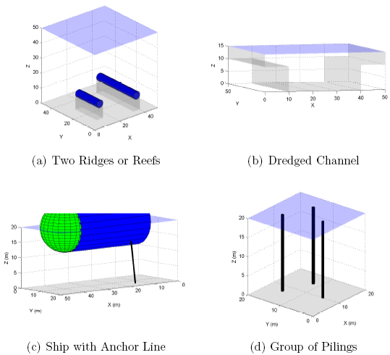
Figure 2.8.11 Example environments created in the simulator

2.8.3.2 Vehicle

A simplified kinematic model is used for vehicle motion within the simulation. Only changes in the vehicle's heading and pitch are considered for the control commands. The effects of roll have not been investigated. The steering and diving models of the vehicle are found in equations 1 and 2. In equation 1, ψ is the new yaw angle, ψ_{o} is the original yaw angle, ψ_{c} is the commanded heading, Δt is the simulation time-step, and 1/β₁ is the time constant of the closed-loop heading dynamics. The diving model is defined similarly in equation 2 with 1/β₂ being the time constant of the closed-loop pitching dynamics.

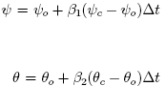
(1)

(2)

2.8.3.3 Ray-tracing

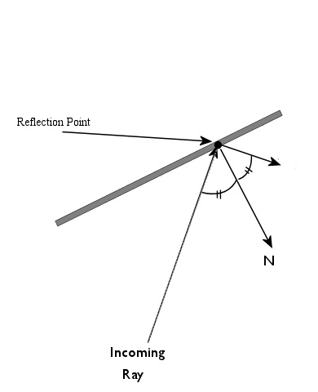
The ray-tracing aspect of the simulation goes through the process of transmitting an acoustic wave from the transducer, reflecting that wave off of planar, spherical, and cylindrical surfaces, and receiving the reflected acoustic wave. The ray tracing algorithms are based on the principle that an incoming ray and the reflected ray will for the same angle with a normal vector placed at the point of reflection. This concept is illustrated in Figure 2.8.2. The reflection point, found from ray tracing, is then passed onto the acoustic model.

Figure 2.8.12 The basic principle behind the ray tracing algorithms

2.8.3.4 Acoustics

The reflection point is the last piece of information necessary to formulate the acoustic values of the transducer's ping. The range, seen in equation 3, is computed from the reflection point to the current transducer position. The directivity is based on the angle the reflected ray makes with the axis of the transducer. Figure 2.8.3 illustrates which angle is used for directivity. This angle is used with the Bessel function of the first kind of order 1 to determine the directivity function, H(θ) [2]. The formulation of H(θ) is found in equation 4 where ‘k’ is the wave number of the transmitted sound wave, and ‘a’ is the radius of the transducer.

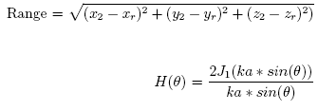
(3)

(4)

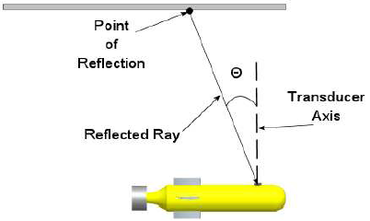

Figure 2.8.13 The angle of reception of a reflected ray is measured from the axis of the transducer. This value is used to determine the directivity function that is applied to the signal.

2.8.3.5 Pressure Wave Calculations

The acoustic model for this simulation is based on a simple circular piston source. The range and angular information will be processed into pressure levels felt on each transducer. First, the effective pressure, Pe, of the transmitted wave will need to be found. The SONAR system used in the simulation is assumed to have a source level of 180 dB relative to 1 μPa. Back computations led to finding an effective pressure level of 10⁹ μPa using a reference pressure of 1 μPa. This computation can be seen in equation 5.
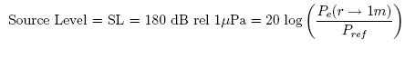
(5)

The axial pressure found 1 meter from the transducer is then computed as in equation 6. Px is computed for t greater than zero to less than 1/bandwidth. The bandwidth is found as in equation 7, where f_{c} is the operating frequency of the SONAR system. In addition, the axial pressure uses a peak acoustic pressure, P, instead of the effective pressure, Pe. The effective pressure was converted to its peak value in equation 8.

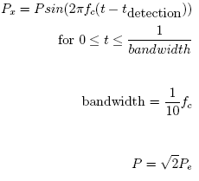
(6)

(7)

(8)

The axial pressure contains no directivity or range information about the incoming signal. Additionally, the reflected pressure wave will be affected by the object's geometry and material. Planar objects use a reflection coefficient to account for different materials. Spherical and cylindrical objects use target strength to account for their geometry. Therefore, the received pressure from an object is found by combining the axial pressure, directivity, range, and the object's properties. Equation 3.53 is used to compute the pressure from a planar reflection where ‘r’ is the range to an object and H(θ) is the directivity found in equation 4. R, in equation 9, is the reflection coefficient for a specific material. This coefficient is defined in equation 10, where z₁ is the impedance of salt water and z₂ is the impedance of the object's material. The characteristic impedance is simply the density of the material multiplied by the speed of sound in that material [2].

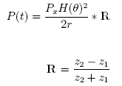
(9)

(10)

Spherical and cylindrical objects are both found using equation 11. TS, in equation 11, is the target strength for the object. Equation 12 gives the formula used to compute the target strength of a sphere, where ‘a’ is the radius of that sphere in yards. Likewise, equation 13 shows the formula used as the target strength of a cylinder where ‘a’ is the radius in yards and ‘r’ is the range to that cylinder [3].

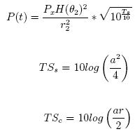
(11)

(12)

(13)

Pressures found using equations 9 or 11 can be added linearly. Therefore, pressures from detections that occur at a similar time can either constructively or destructively interfere with the total pressure. A time variable gain is then applied to the combined pressures. This is an option, used in practical SONAR systems, by which the amplification of the signal is increased with time to compensate for the reduction of received signal intensity caused by the spreading and absorption losses due to the system [4]. The model used in this simulation is shown in equation 14, where P is the original pressure value, Pa is the amplified pressure, t_{t} is the transmit time, t_{r} is the reception time, and c_{sw} is the speed of sound in salt water.

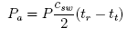
(14)

Basic signal processing is applied to the final pressure signal in order to extract useful information for the obstacle avoidance system to use. This includes applying a dynamic threshold filter to eliminate small amplitude echoes and peak detection to determine the strength of the return signal. The analysis yields first return range and pressure amplitude information that is passed onto the obstacle avoidance system. These two pieces of information from each transducer are the only information available to the OAS.

2.8.3.6 Obstacle Avoidance System (OAS)

The obstacle avoidance system is broken into multiple fuzzy systems [5] that are activated based on the status of the vehicle and the environment. This modular design allows for different systems, or behaviors, to be plugged in without the need for major code revision. In addition, system can then be thought of as a black box that output information on the vehicle’s maneuver.

The base level behavior is the Emergency Reverse. This behavior will command the vehicle to stop and reverse its direction depending on the sensor inputs. The distance used to activate this behavior depends on the turning radius of the vehicle. If the vehicle needed to make an 180º turn, it would need room in the front greater than the turning radius of the vehicle. In addition, the space to the left or right of the vehicle would need to be greater that twice the turning radius of the vehicle. The Emergency Reverse behavior allows the vehicle to back out of situations in which it cannot turn around. Once activated, the Emergency Reverse will back the vehicle to a predetermined distance, and then command the vehicle to turn around whichever obstacle was initiated the emergency behavior. A scenario that would invoke the Emergency Reverse behavior is shown in figure 2.8.4.
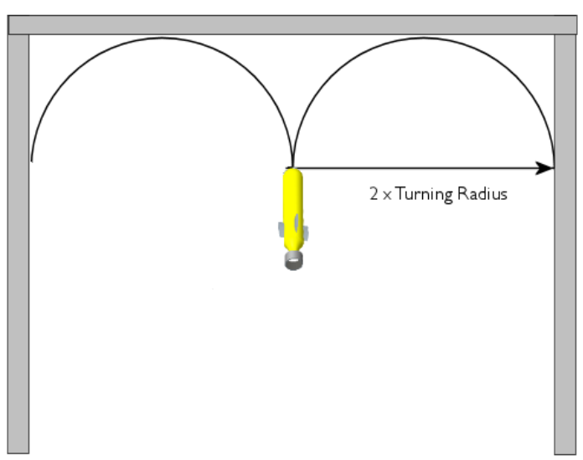

Figure 2.8.14 A situation that would invoke the Emergency Reverse behavior

The Disallowed Direction is the next layer in the OAS. This behavior takes sensor inputs and translates them into restricted heading angles that the vehicle should not travel. The distance and pressure amplitude information from the acoustic analysis are used as the inputs to this fuzzy system. A close distance or large pressure amplitude results in greatly disallowing the direction in which that return emanated. This behavior only gives half of the information needed to generate a vehicle command. A desired direction from either the Emergency Turn or Goal Finding behaviors is needed.

The inputs membership functions for the Disallowed Direction fuzzy system are shown in figure 2.8.5. These inputs are combined using the ‘MIN’ fuzzy conjunction operator. Combined degree of matching of the input functions are used in the fuzzy implication process on the output membership functions.

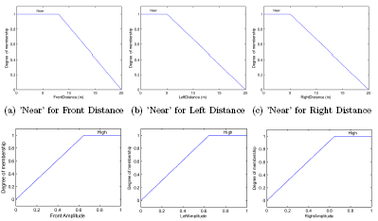

Figure 2.8.5: Disallowed Direction input membership functions.

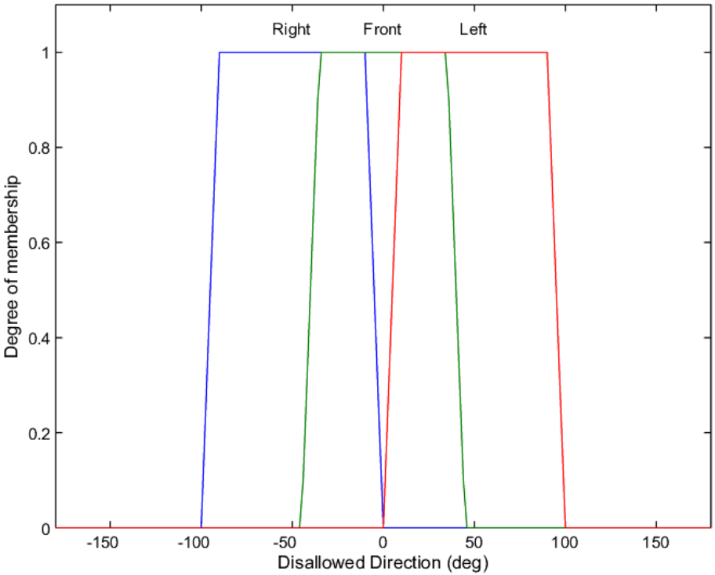

Figure 2.8.6: Disallowed Direction output membership functions.

The output membership functions for Disallowed Direction are shown in figure 2.8.6. A simple clipping method is used for the implication operations. The final output membership functions are combined using the ‘MAX’ aggregation operator. The final result is a membership function that describes restricted heading commands for the vehicle. A flow chart of the Disallowed Direction behavior can be seen in figure 2.8.7

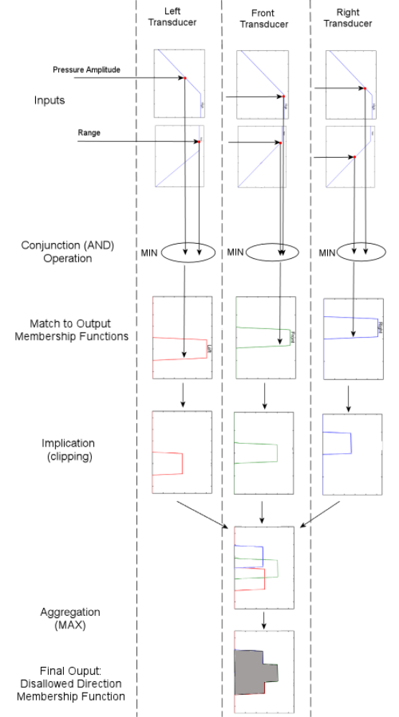

Figure 2.8.7: Flow chart for the Disallowed Direction fuzzy system.

The fuzzy rules used to carry out the implication process for Disallowed Direction can be found in the appendix. The Disallowed Direction fuzzy system only supplies half of the information needed to generate a maneuver for the vehicle to follow. A desired direction is also needed for a command to be given. The Emergency Turn or Goal Finding behaviors can supply a desired direction to the fuzzy OAS.

The Emergency Turn behavior commands a ±90º heading change depending on the results of Disallowed Direction. The heading that is less disallowed will be the commanded turn. This behavior is activated depending on the range estimates from the front of the vehicle. If a range estimate is close to the turning radius of the vehicle, then the Emergency Turn behavior is activated. This ensures that the vehicle has enough room to turn and avoid whichever obstacle is located in front. The Emergency Turn behavior is based on providing survivability to the vehicle motion.

Unlike the previous fuzzy system, the Emergency Turn behavior is composed of binary membership functions. Therefore, the Emergency Turn is either active or inactive. The input membership functions for this behavior can be seen in figure 2.8.8.

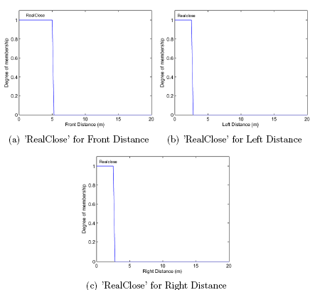

Figure 2.8.8: Input membership functions for the Emergency Turn behavior.

The Emergency Turn fuzzy system follows the same process that was described for the Disallowed Direction fuzzy system. The fuzzy rules used for implication for Emergency Turn can be found in the appendix. The outputs to this fuzzy system are shown in figure 2.8.9. Notice that the two peaks are centered at ±90^{o.}
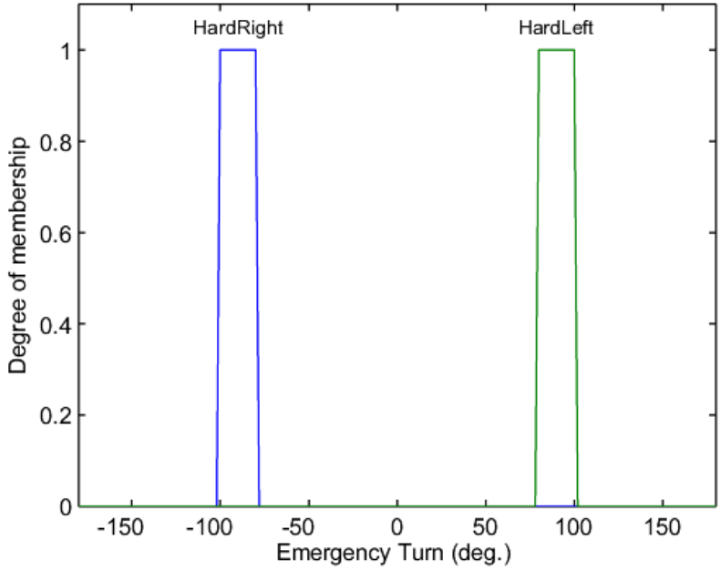

Figure 2.8.9: Output membership functions for Emergency Turn

A Goal Finding behavior is another system that can provide a desired direction to be combined with the Disallowed Direction output. This behavior is activated if and only if Emergency Turn is inactive. Goal Finding outputs a range of desired heading angles for the vehicle to take in order to reach the goal point. This allows for greater flexibility in the vehicle's maneuvering. The input to this system is the bearing to a given goal or waypoint. The input membership functions for Goal Finding are shown in figure 2.8.10.

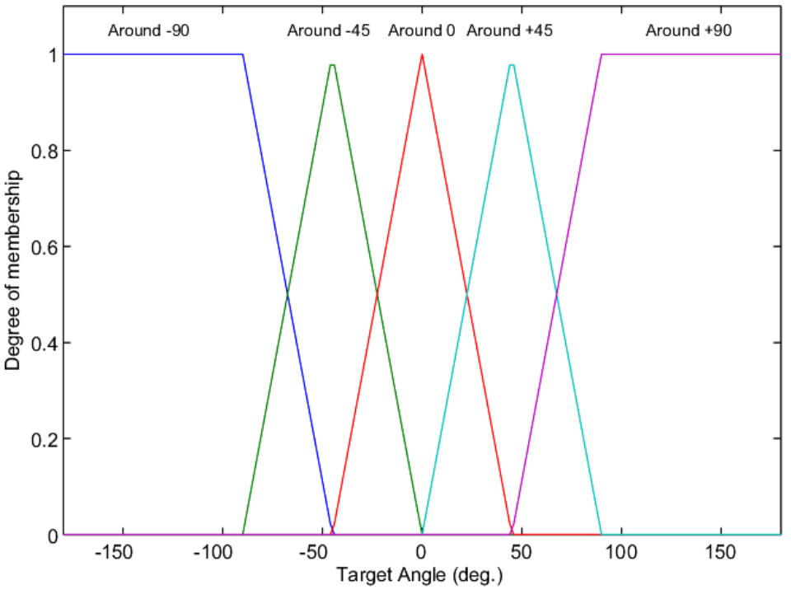

Figure 2.8.10: Input membership function for Goal Finding

Like the previous two behaviors, the Goal Finding behavior follows the same series of operations. The fuzzy rules used for implication for this behavior can be found in the appendix. The output membership function for the Goal Finding behavior can be seen in figure 2.8.11.

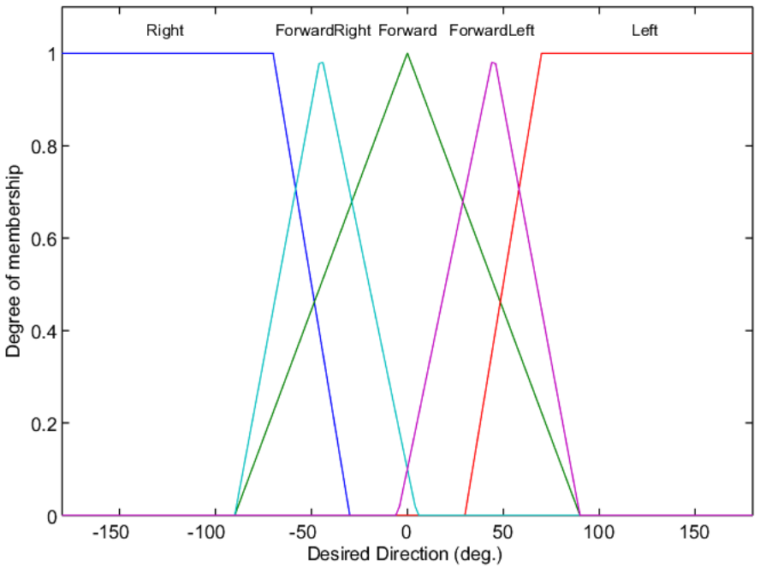

Figure 2.8.11: Output membership function for Goal Finding

The desired direction from either Goal Finding or Emergency Turn must be combined with the Disallowed Direction output. To illustrate, say for example that the output from the Disallowed Direction behavior is given in figure 2.8.12. Additionally, say that the output from the Goal Finding behavior is given in figure 2.8.13. The two functions are combined using the MIN operator. In addition, the Disallowed Direction output is inverted before combination. This insures that the final heading command is desired and not disallowed.

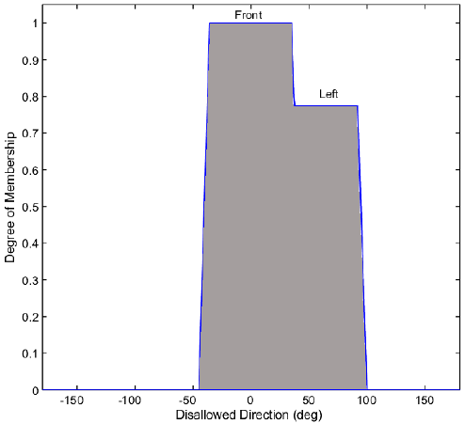

Figure 2.8.12: An example Disallowed Direction output
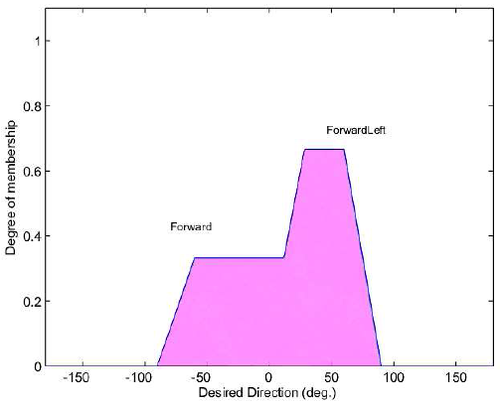

Figure 2.8.13: An example Goal Finding output

The combination of the desired and not disallowed fuzzy outputs is shown in figure 2.8.14. The output is now ready to be defuzzified to yield a crisp command heading.

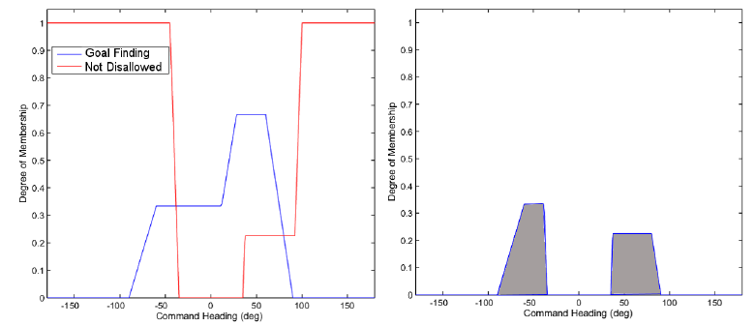
Figure 2.8.14: The combination of a desired direction and a not disallowed direction.

Defuzzification is the process in which a crisp, single command is extracted from the combined output membership function. Center of Largest Area (CLA)[6] defuzzification method is implemented. The CLA method first calculates the largest area of the output membership function. If there are no separate peaks, then the entire membership function is used. Next, the centroid of the chosen area is used as the command heading. This method guarantees that the command heading will lie within a peak of the output membership function. The CLA method, applied to the example in figure 2.8.14, is shown in figure 2.8.15.

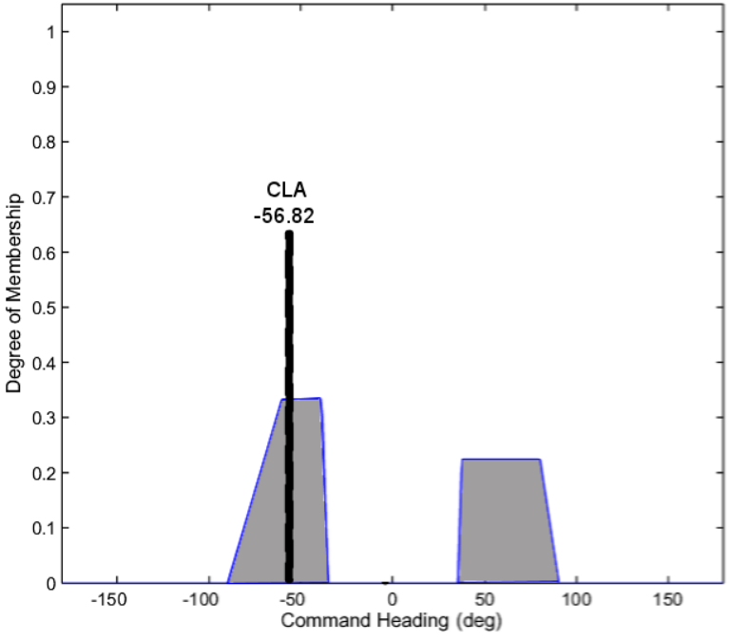

Figure 2.8.15: CLA defuzzification of an output membership function to arrive at a heading command for the vehicle

The Wall Following behavior is an extension to the basic obstacle avoidance system. Wall Following is initiated if and Emergency Turn is commanded. The vehicle will then attempt to follow whichever objected invoked the Emergency Turn behavior. Wall Following is primarily used as an escape strategy for trap obstacles. In such a case, the vehicle will follow the walls of the trap until the vehicle is free and can safely proceed towards the goal. The Wall Following behavior is written as a classic fuzzy logic control system. The behavior tries to maintain a set distance away from whichever object it is trying to follow. The two main inputs into this system are ‘Distance Error’ and ‘Distance Error Rate’. A positive ‘Distance Error’ corresponds to the vehicle being too close to the wall, while a negative value corresponds to the exact opposite. A positive ‘Distance Error Rate’ corresponds to the vehicle moving towards the wall, while a negative value corresponds to the exact opposite. The output of the Wall Following behavior is a heading command for the vehicle. A positive heading command corresponds to commanding the vehicle away from the wall, while the opposite is true for a negative heading command. The interaction of inputs and outputs of this system can be visualized with a surface shown in figure 2.8.16.

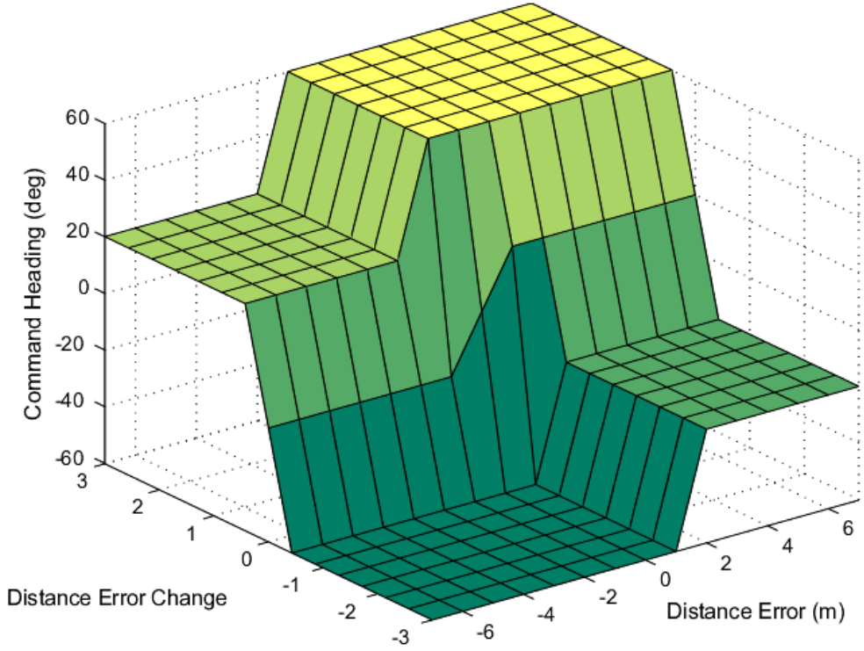

Figure 2.8.16: Surface describing the interaction of inputs and outputs in the Wall Following behavior.

The hierarchical combination of the fuzzy avoidance behaviors described in this section can be seen in figure 2.8.17 where the basic avoidance system is boxed in red.

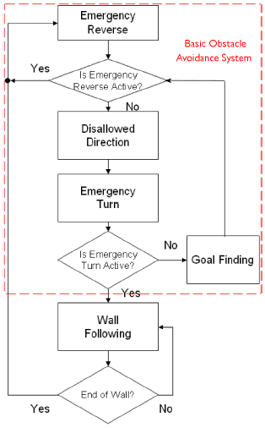

Figure 2.8.17: Flow chart illustrating the interactions of behaviors in the OAS.

2.8.4 Results and Discussion

The performance of an obstacle avoidance system can be measured in terms of optimality. In this case, performance is judged in terms of run time, energy expended, or deviation from the initial vehicle path. An OAS can also be evaluated on safety, or how much survivability it can bring to the vehicle. The fuzzy OAS developed in this research is written conservatively. Therefore, its performance should be based on the safety it provides to the vehicle. This chapter will show the results of the fuzzy OAS when operating in a variety of environments. The simplest environments tested consist of isolated geometric shapes. Later, more objects are added to create complex environments that can represent aspects of a port. Throughout the tests, the vehicle may not be commanded to an optimal path through the given environment. This, however, is not of any concern since survivability is more important. The results will be performed using the vehicle, SONAR, and simulation parameters shown in Table 2.8.1. The transducers are placed orthogonal to each other on the nose of the vehicle. This is shown in Figure 2.8.18. These properties are kept constant throughout the results chapter for consistency purposes. As stated before, the OAS is not provided with any prior knowledge about the environment. Only range and pressure amplitudes are used for the basis of obstacle avoidance.

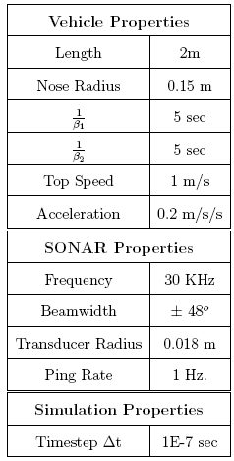
Table 2.8.1: Parameters used to generate the maneuvers in the results
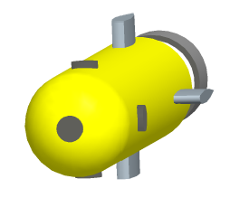
Figure 2.8.18: Transducer placement on the vehicle used for the results

Each result will show the vehicle's path as a blue line. A red sphere will represent the goal point used in the Goal Finding behavior. Additionally, the starting point and direction will be shown if necessary. When applicable, the two-dimensional avoidance behavior will first be shown. The vehicle's two-dimensional maneuver is easier to illustrate in a static figure. There are also some restrictions placed on the vehicle's pitching capability. Traditional underwater vehicles are not as maneuverable in the pitching plane as they are in the yaw plane. Therefore, ±90º pitching is possible and was limited to ±30º. It is important to note that some of the figures may give the appearance of the vehicle pitching to a greater degree. This is associated with attempting to representing a three dimensional motion in a two dimension figure. The vehicle motion does not exceed the ±30º restriction.

2.8.4.1 Simple Cylinder

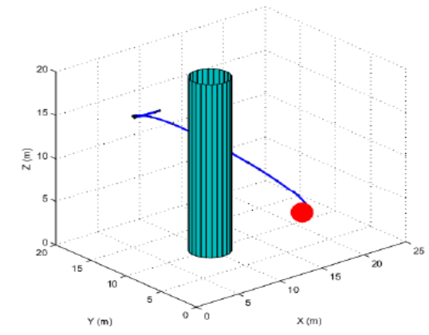
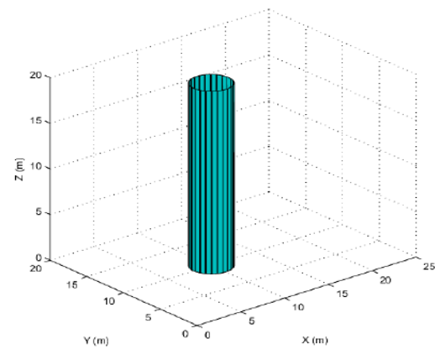
The first results have come from testing the fuzzy OAS in simple environments created in (a) (b)
Figure 2.8.19: Basic test results of the fuzzy OAS using a simple isolated cylinder.

the simulator. As an example, the simple, isolated cylinder shown in figure 2.8.19(a) was first used to test the basic capabilities of the OAS. The results of the test are shown in figure19(b). This result illustrates the fuzzy avoidance system’s ability to concurrently command yaw and pitch changes for the vehicle.

The two dimensional avoidance performance of a short wall is shown in figure 2.8.20. In the figure, the wall is directly in the path of the vehicle. The vehicle will deviate only slightly from its original path. The vehicle does not make a large effort to turn away from the wall due to the Goal Finding behavior's desire to go toward it. The vehicle does not safely navigate away from the wall until the Emergency Turn behavior is activated. After the emergency turn, the vehicle will travel along the wall until it is safe to turn towards the goal.
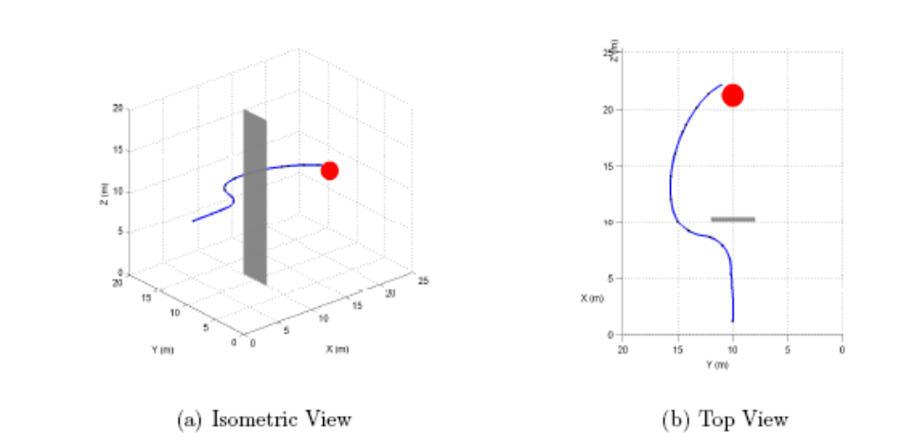

Figure 2.8.20: Obstacle avoidance result using a short, flat wall.
2.8.4.2 Test-Tank Following

This environment consists of four planar surfaces representing the tank walls, one planar surface for the tank bottom, and one planar surface for the air water interface. A larger sized tank was created in order to better demonstrate the Wall Following behavior.

No goal was set for this environment. Therefore, the OAS does not use the Goal Finding behavior. Instead, the vehicle will wander around the tank reacting to commands given when Emergency Turn is activated. Once an emergency turn is commanded, the Wall Following behavior is automatically activated. This is due to the hierarchy of the avoidance system explained in the previous chapter. The performance of the OAS in a tank environment can be seen in figure 2.8.21. A bright green sphere is used to mark the starting position of the vehicle during the tank analysis. The vehicle is able to make a complete loop around the tank avoiding the walls. The maneuver stops due to a set runtime of the simulation.

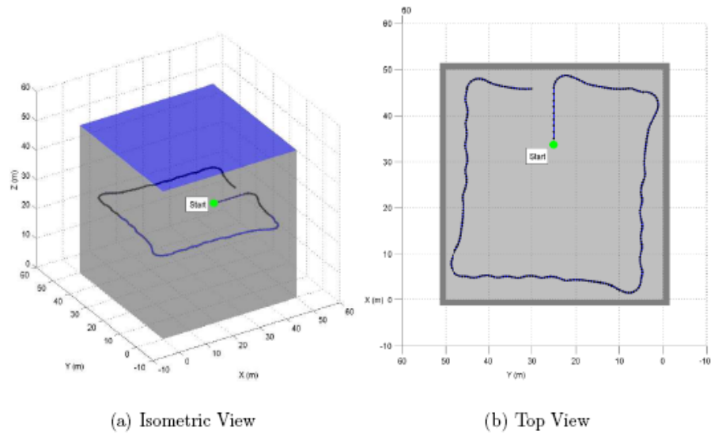

Figure 2.8.21: Wall following behavior in a test tank.

2.8.4.3 Half Moon Canyon

A common trap environment consists of the half moon canyon shown in figure 2.8.22. This object is particularly troubling for the commonly used potential field method of avoidance, resulting in the vehicle trapped in a local minimum indefinitely. The problem of looping inside the trap is also present in the proposed fuzzy OAS if Wall Following is not used.

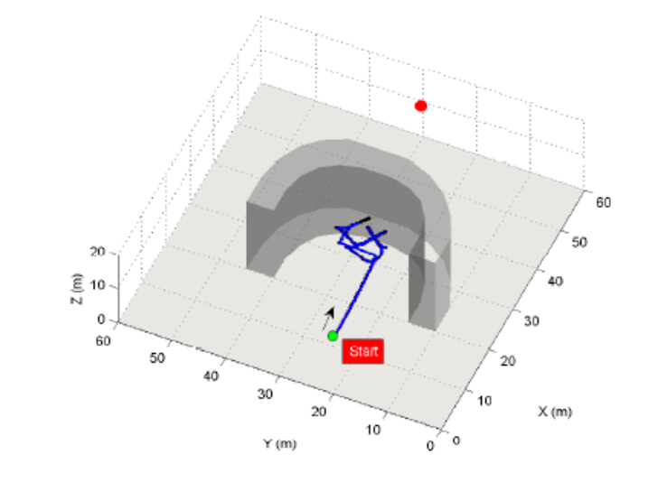

Figure 2.8.22: The vehicle fails to escape the canyon if the Wall Following behavior is not activated.

The vehicle must use the same escape strategy as before. Once a wall of the canyon is encountered, the vehicle will use Wall Following to follow it outside of the trap. The vehicle will continue on this course until the path to the goal is clear. The vehicle can be seen successfully escaping the half moon canyon in figure 2.8.23.
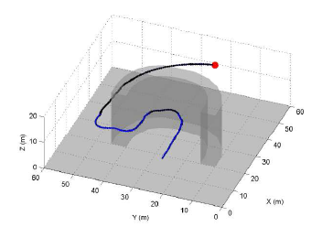
Figure 2.8.23: The vehicle successfully reaches the goal point if the Wall Following behavior is activated.

2.8.5 Conclusion

This research was undertaken to develop an obstacle avoidance system for small underwater vehicles with limited sensor resources. Previous research in avoidance systems for underwater vehicles revealed that scanning SONAR systems are primarily used for gathering information about the environment. Scanning systems usually dictate the size and powering of the vehicle within which it is installed. Therefore, obstacle avoidance systems based on scanning SONAR inputs were not feasible for the problem at hand. Instead, a system was developed using small, low power, circular piston transducers to sense the environment. Such a system limits the amount of information about the environment available to the avoidance system. A fuzzy logic system was therefore used as the basis for the creation of the OAS. This configuration can account for the insufficient amount of data about the environment collected by the sensors.

The obstacle avoidance system was developed using a SONAR simulator in Matlab. The simulator was necessary since the physical system was not available. The acoustic model used in the simulator was based on circular piston transducers. These transducers were operated as time-of-flight systems. This provided the fuzzy OAS with range and amplitude information about the objects in the environment. The information was limited as such in order to ensure that the OAS could operate effectively in an unknown environment.

The fuzzy logic obstacle avoidance system is composed of different behaviors that dictate how the vehicle will react to different situations. The Emergency Reverse and Emergency Turn are conservative behaviors that are primarily concerned about the survivability of the vehicle. Survivability was a main goal in developing the OAS. In all of the tested scenarios, the vehicle did not hit any obstacles. The vehicle may not have made it to the goal on an optimal path, or at all. This is an acceptable.result, as the vehicle's safety was still ensured by the OAS.

The Goal Finding and Wall Following are more goal-oriented behavior of the OAS. These behaviors have a lower precedence and are only active after the conservative behaviors have been evaluated. The Goal Finding behavior will attempt to steer the vehicle towards a waypoint in the absence of obstacles. The Wall Following behavior commands the vehicle to follow a wall at a set distance. This behavior is used as an escape strategy when a trap situation is encountered.

A progression of testing was performed on the fuzzy OAS using the simulation in Matlab. At a basic level, isolated generic shapes were used to determine the initial capabilities of the avoidance system. If problems arose from such a simple environment, then there would be little hope for the system's performance in more complicated environments. After successful maneuvering at the basic level, the avoidance system was tested in more complex environments created by combining the simple geometric shapes. The Wall Following behavior was evaluated extensively during this stage of testing. It was found that this behavior can account for planar surfaces with varying orientations. The Wall Following behavior can also overcome complications due to inside and outside 90o wall corners. Trap-like obstacles were also created to determine the effectiveness of the escape strategies used in the avoidance system. Finally, port environments were recreated and tested in the simulation. Vehicle performing port security operations will frequently encounter objects, such as pilings and sea walls. The OAS was able to successfully maneuver the vehicle through the port environments.

As a conclusion, the goal of simulating an obstacle avoidance system for a small, low power underwater vehicle has been reached. The OAS has been developed in a simulated environment, but can be migrated to a physical system with some tuning of its parameters. This is a credit to the fuzzy logic base of the OAS.

2.8.6 Recommendations

The obstacle avoidance system was written in the Matlab programming language. This is not an embedded language, or the language currently used on the vehicle within which the OAS will be integrated. Therefore, the avoidance algorithms will need to be translated into the proper coding language. In addition, the OAS must be made to fit the software architecture of the vehicle. This should not be a problem since the OAS was written as a black box with SONAR inputs and pitch and yaw command outputs.

As this simulated system migrates to the physical hardware, the parameters of the fuzzy system will need to be tuned. Currently, the OAS uses idealized specular SONAR returns as its inputs. A physical system will have backscatter returns, system, and environmental noises. The size and shape of the membership functions in the fuzzy system should be altered depending on tests of the physical SONAR. The hardware side of this obstacle avoidance system still needs to be optimized. SONAR parameters that were used to generate the results were chosen to give a large beamwidth value. The parameters, such as operating frequency and transducer size, can be changed in the simulation. Different configurations should be tested in order to determine the effect on the system's performance. In this way, an optimal combination of hardware and software can be found.

The simulation has only been used to test static objects within an environment. However, port environments inherently have dynamic obstacles such as ships and sea life. The simulation has the capability to update the obstacle's positions at each time step. However, due to time constraints, this part of the simulation was not tested. Further work is needed on evaluating the avoidance system's performance with dynamic obstacles.

2.8.7 References

1. A.M Chiang, S.R. Broadstone, J.M. Impagliazzo, “A Low Power Imaging and Obstacle Avoidance Sonar for Small UUVs”, Proceedings of OCEANS 2003, Vol.4, pp1875-1881, Sept 2003.

2. Alan Coppens, James Sanders, Lawrence Kinsler, Austin Frey. Fundamentals of Acoustics, John Wiley & Sons, Inc., 4th edition, 2000.

3. Robert J. Urick, Principles of Underwater Sound. Peninsula Publishing, 3rd edition, 1983.

4. Roman Kuc, “Forward Model for Sonar Maps Produced with the Polaroid Ranging Module”, IEEE Transactions on Robotics and Automation, Vol.19, No.2, pp358-362, April 2003.

5. John Yen, Reza Langari, Fuzzy Logic - Intelligence, Control, and Information. Prentice Hall, Upper Saddle River, New Jersey 07458, 19999.

6. John Yen, Nathan Pfluger, “A Fuzzy Logic Based Extension to Payton and Rosenblatt's Command Fusion Method for Mobile Robot Navigation”, IEEE Transactions on Systems, Man, and Cybernetics, Vol. 25, No. 6, pp971-978, June 1995.

Fuzzy Rules for Disallowed Direction

1. If (Front Distance is NEAR) and (Front Amplitude is HIGH) then (Disallowed is Front)
2. If (Left Distance is NEAR) and (Left Amplitude is HIGH) then (Disallowed is Left)
3. If (Right Distance is NEAR) and (Right Amplitude is HIGH) then (Disallowed is Right)

Fuzzy Rules for Emergency Turn

1. If (Front Distance is REALCLOSE) then (Emergency Turn is ACTIVATED)
2. If (Left Distance is REALCLOSE) then (Emergency Turn is ACTIVATED)
3. If (Right Distance is REALCLOSE) then (Emergency Turn is ACTIVATED)

Fuzzy Rules for Goal Finding

1. If (Target Angle is AROUND 0) then (Desired Direction is FORWARD)
2. If (Target Angle is AROUND -45) then (Desired Direction is FORWARD RIGHT)
3. If (Target Angle is AROUND +45) then (Desired Direction is FORWARD LEFT)
4. If (Target Angle is AROUND -90) then (Desired Direction is RIGHT)
5. If (Target Angle is AROUND +90) then (Desired Direction is LEFT)

Fuzzy Rules for Wall Following

1. If (Distance Error is LN) and (Distance Error Change is LP) and
(Forward Distance is not Turn) then (Command Heading is P)
2. If (Distance Error is LN) and (Distance Error Change is Z) and
(Forward Distance is not Turn) then (Command Heading is N)
3. If (Distance Error is LN) and (Distance Error Change is LN) and
(Forward Distance is not Turn) then (Command Heading is LN)
4. If (Distance Error is LN) and (Distance Error Change is N) and
(Forward Distance is not Turn) then (Command Heading is LN)
5. If (Distance Error is LN) and (Distance Error Change is P) and
(Forward Distance is not Turn) then (Command Heading is N)
6. If (Distance Error is Zero) and (Distance Error Change is LP) and
(Forward Distance is not Turn) then (Command Heading is LP)
7. If (Distance Error is Zero) and (Distance Error Change is Z) and
(Forward Distance is not Turn) then (Command Heading is Z)
8. If (Distance Error is Zero) and (Distance Error Change is LN) and
(Forward Distance is not Turn) then (Command Heading is LN)
9. If (Distance Error is Zero) and (Distance Error Change is N) and
(Forward Distance is not Turn) then (Command Heading is N)
10. If (Distance Error is Zero) and (Distance Error Change is P) and
(Forward Distance is not Turn) then (Command Heading is P)
11. If (Distance Error is LP) and (Distance Error Change is LP) and
(Forward Distance is not Turn) then (Command Heading is LP)
12. If (Distance Error is LP) and (Distance Error Change is Z) and
(Forward Distance is not Turn) then (Command Heading is P)
13. If (Distance Error is LP) and (Distance Error Change is LN) and
(Forward Distance is not Turn) then (Command Heading is N)
14. If (Distance Error is LP) and (Distance Error Change is N) and
(Forward Distance is not Turn) then (Command Heading is P)
15. If (Distance Error is LP) and (Distance Error Change is P) and
(Forward Distance is not Turn) then (Command Heading is LP)
16. If (Distance Error is N) and (Distance Error Change is LP) and
(Forward Distance is not Turn) then (Command Heading is LP)
17. If (Distance Error is N) and (Distance Error Change is Z) and
(Forward Distance is not Turn) then (Command Heading is N)
18. If (Distance Error is N) and (Distance Error Change is LN) and
(Forward Distance is not Turn) then (Command Heading is LN)
19. If (Distance Error is N) and (Distance Error Change is N) and
(Forward Distance is not Turn) then (Command Heading is LN)
20. If (Distance Error is N) and (Distance Error Change is P) and
(Forward Distance is not Turn) then (Command Heading is Z)
21. If (Distance Error is P) and (Distance Error Change is LP) and
(Forward Distance is not Turn) then (Command Heading is LP)
22. If (Distance Error is P) and (Distance Error Change is Z) and
(Forward Distance is not Turn) then (Command Heading is P)
23. If (Distance Error is P) and (Distance Error Change is LN) and
(Forward Distance is not Turn) then (Command Heading is LN)
24. If (Distance Error is P) and (Distance Error Change is N) and
(Forward Distance is not Turn) then (Command Heading is Z)
25. If (Distance Error is P) and (Distance Error Change is P) and
(Forward Distance is not Turn) then (Command Heading is LP)
26. If (Forward Distance is Turn) then (Command Heading is Turn)

2.9 Chemical Sensors
PI: Dr. Richard Granata

2.9.1 Summary

This section describes the formulation of a chemical method to detect underwater trace explosives, as well as the design of a field-deployable device to implement the chemical method. The research goals are identified, the primary test materials, equipment and experiments are described and the results are discussed. The chemical compound, europium thenoyltrifluoroacetone, has been identified as an integral part of a viable underwater chemical detection method for underwater explosive traces.

2.9.2 Introduction

The ultimate purpose of this UUV component is to detect underwater explosives and provide a signal so that action can be taken. This process breaks down to three basic steps: (1) Obtain an underwater sample for testing (2) Analyze the obtained sample and (3) Provide feedback of the results so that appropriate action can be taken.

Several methods exist to analyze a water sample for explosive traces [1], but practicality in UUV application dictates several limitations, such as size, cost, autonomy and processing speed. Consequently, these limitations in conjunction with the unique seawater environment eliminate most existing explosive detection methods. The research contained herein focuses on the formulation and testing of a detection method based on fluorescent tagging and the development of a field-deployable device to detect waterborne explosive traces with this method. Attention has been given to UUV parameters such as size, cost, power consumption, autonomy, analysis speed and sensitivity.

The research goals have been identified as follows:

- Evaluate the feasibility of developing a photoluminescent method of detecting underwater explosive traces.
- Examine different fluorescent compounds, looking for optimal combinations of the chosen fluorescer (europium) and sensitizing ligands to achieve both fluorescent loss in water (quenching) and maintained fluorescence in response to explosive compounds. Different combinations, concentrations and mixing orders of the chemicals are evaluated. Other factors that influence the performance of the compounds are also evaluated, such as the amount of solvent required and/or used to deliver the chemicals into the seawater solution.
- Characterize the excitation and emission frequencies of the sensitized compounds.
- Evaluate the hypothesis that europium complexes will preferentially bond with explosive compounds over water molecules in an aqueous environment. Continue this experiment to include a seawater environment.
- Identify, purchase and set up a working underwater explosive detection device and develop a test plan. This includes concentration studies.
- Explain some potential fluorescence quenching issues of seawater that may cause the detection method to perform differently in seawater than in distilled fresh water.

2.9.3 Methods, Assumptions, and Procedures

2.9.3.1 Primary Test Materials

The primary test materials include the explosive sample and the chemicals involved. Medical nitroglycerin tablets are used for the explosive sample. Europium is used for the fluorescer and two compounds were evaluated as sensitizing ligands: Thenoyltrifluoroacetone (TTA), (C₈H₅F₃O₂S) and 1,10 Phenanthroline Monohydrate (OP), (C₁₂H₈N₂•H₂O).

2.9.3.2 Primary Test Equipment

For the first stage of laboratory testing, the primary test equipment consisted of a handheld UV light (approximately 370 nm) and a Perkin-Elmer LS50B luminescence spectrometer. The handheld UV light was used to execute preliminary evaluations of different chemical mixtures under different conditions. This provided a quick, efficient method of testing the design path, without performing tedious, exact experiments for all possibilities. The luminescence spectrometer was used to precisely evaluate certain mixtures for fluorescence and quenching. The luminescence spectrometer can either record the light output of a compound with a given excitation wavelength, or it can scan for the best excitation wavelength to produce the maximum intensity of a given emission wavelength.

For the second stage of testing, the focus is on a working field detector design. The core of the design is a compact, underwater fluorometer (Figure 2.9.1). The fluorometer used in this experiment is a WETStar model, made by Wet Labs, Inc., that has been specially modified to provide 370nm excitation and record 613nm emission. Due to the low velocity, laminar flow that is fed into the fluorometer, an in-line static mixer is also utilized to assure proper mixing of the seawater and reagent solutions.

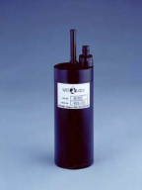

Figure 2.9.1 – WETStar Fluorometer.

2.9.3.3 Experiments

The luminescence spectrometer was used to evaluate the appropriate excitation and emission wavelengths for the chosen fluorescent compounds. Special attention was given in determining the excitation wavelength so that it corresponded to a standard, commercially available, LED light source. This consideration was included so that an LED light source could be used in the field-deployable device. Background fluorescence analyses were conducted for several solutions to provide additional insight into the real fluorescence change between explosive-laden and explosive-absent solutions. Several fluorescent compounds were compared to determine the best choice of sensitizing ligands, concentrations and mixing orders. The effect of the solvent that was used to deliver the chemicals into the solution was evaluated for its effect on the explosive detecting ability. The detection limit of nitroglycerin in the luminescence spectrometer of the chosen compound was evaluated. Finally, the performance difference between seawater and fresh water was evaluated to determine if the additional constituents of seawater affect the detection method.

2.9.4 Results and Discussion

The optimum excitation wavelength was found to be 382 nm (Figure 2.9.2). Through comparison experiments, it was judged that this was close enough to the standard LED wavelength of 370 nm to use 370 nm for the excitation wavelength. The emission wavelength of the compounds used corresponded to that of europium alone (613 nm) and varied an insignificant amount with the addition of sensitizing ligands and nitroglycerin. Refer to Figures 2.9.3, 4 and5.

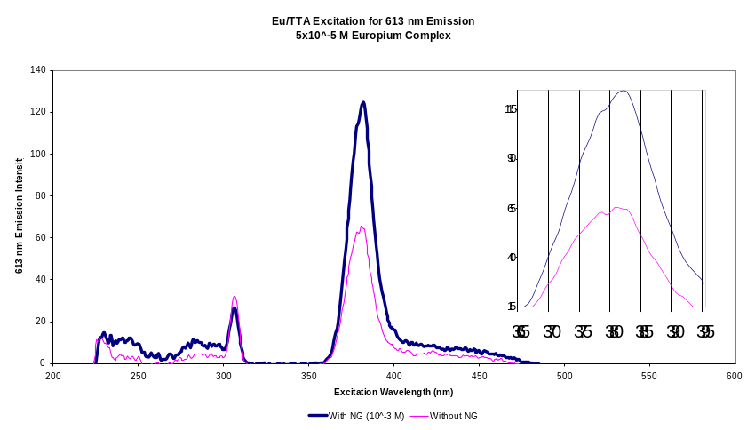

Figure 2.9.2 – Eu/TTA peak excitation when scanning for 613 nm emission, with and without nitroglycerin.

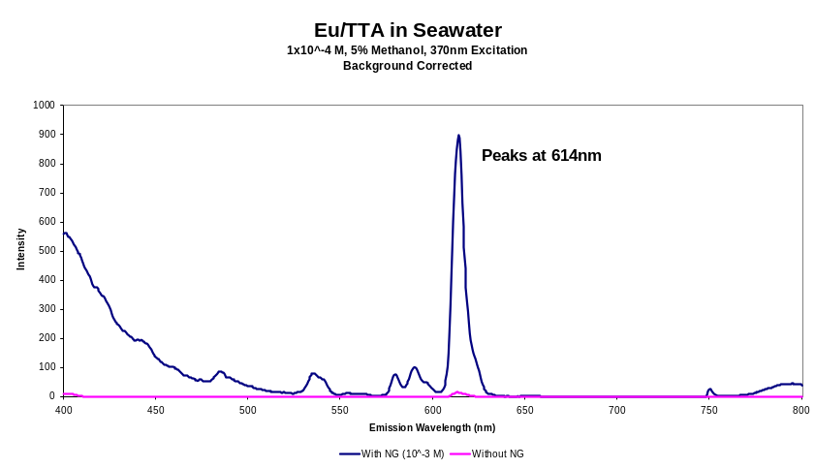

Figure 2.9.3 – Eu/TTA emission in seawater, excited at 370 nm.

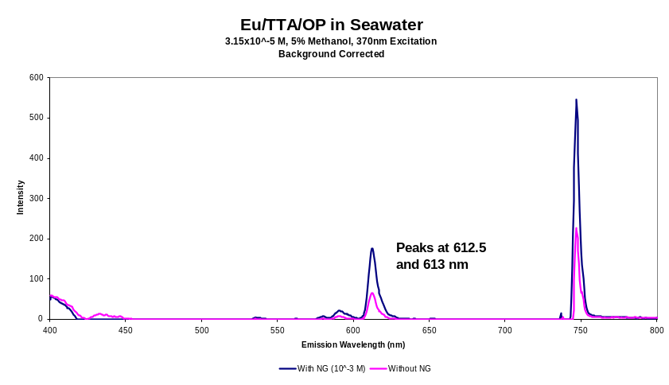

Figure 2.9.4 – Eu/TTA/OP emission in seawater, excited at 370 nm.

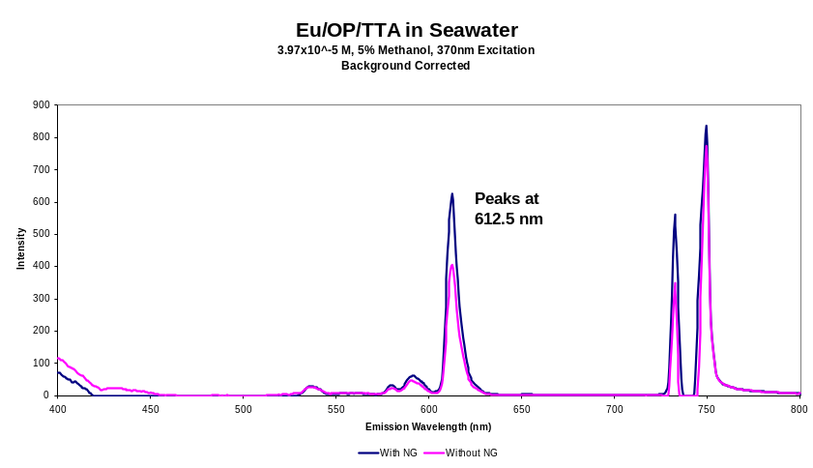

Figure 2.9.5 – Eu/OP/TTA emission in seawater, excited at 370 nm

Although compounds with OP fluoresced at lower concentrations, TTA alone was found to be the best sensitizing ligand choice. OP sensitizes the europium very little when excited at 370 nm, because it absorbs primarily at a lower wavelength (approximately 305-310 nm). Additionally, OP inhibits the ability for water to quench the europium fluorescence when explosive traces are not present. When both OP and TTA were used, the mixing order affected the compound performance. Refer to Figure 2.9..6.

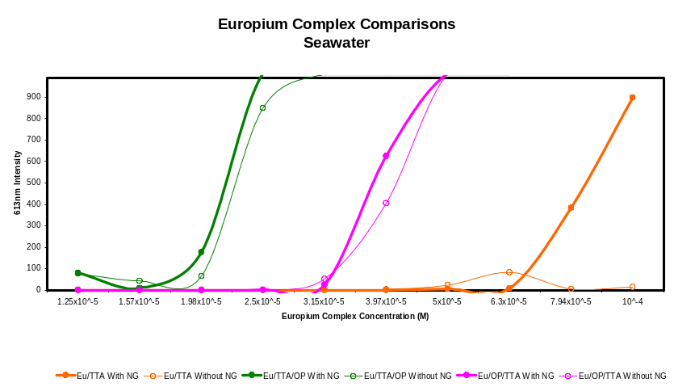

Figure 2.9.6 – Response of all three europium compounds in seawater, with and without nitroglycerin, excited at 370 nm

At high volume fractions, the chemical solvent used (methanol) adversely affects the performance of the detection method. Thus, it is better to keep the methanol percent to a minimum. Refer to Figure 2.9.7.

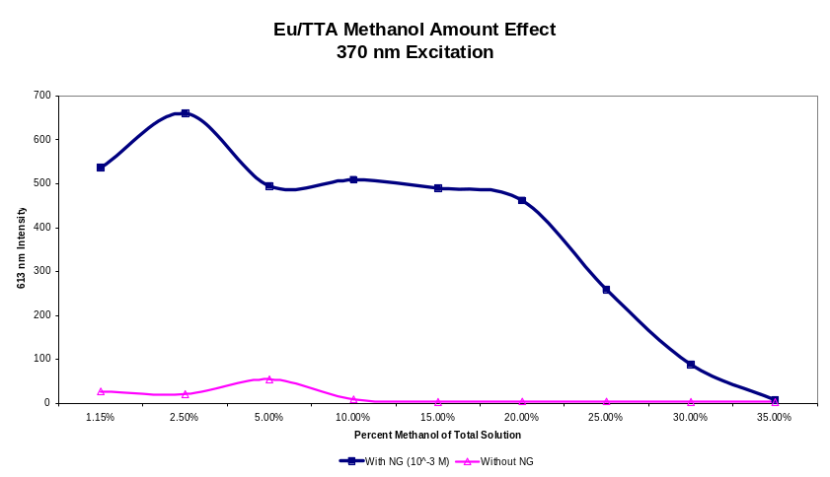

Figure 2.9.7 – 613 nm fluorescence intensity as a function of solution methanol percentage.

In the luminescence spectrometer, this method was capable of identifying nitroglycerin traces in solutions as diluted as approximately 1x10⁻⁶ M. Refer to Figure 2.9.8.

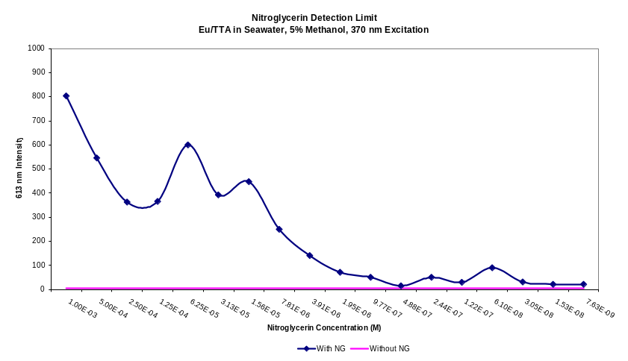

Figure 2.9.8 – 613 nm fluorescence intensity as a function of solution methanol percentage.

The detection method performs better in distilled water solutions than in seawater solutions. It was found that this is likely due to the presence of ions that are able to exchange with the europium ion in the fluorescent compounds, such as calcium, sodium and magnesium. It was also found that acidic conditions adversely affect the detection method.

2.9.5 Conclusions and Recommendations

From this work, it was determined that the use of a lanthanide element to fluorescently tag explosive traces is a viable underwater trace explosive detection method. Europium was used as the lanthanide element. While water quenches (shortens) the europium compound’s fluorescence, water-borne nitroglycerin enhances (prolongs) its fluorescence.

To capture the fluorescent properties of a lanthanide ion, radiation absorbent ligands must be attached to absorb and transfer energy to it [2]. The type of ligand is important, as well as mixing order if multiple ligands are used. Thenoyltrifluoroacetone (TTA) is a good ligand to use with europium for this purpose. Ortho-phenanthroline (OP) is not recommended because its absorption range does not coincide with that attainable with LED light sources and it appears to prevent fluorescence quenching when explosive traces are not present.

The combination of europium and TTA is recommended as a compound to detect underwater explosive traces. It is also recommended to limit the amount of chemical solvent (methanol) to as low a percentage as practicable, definitely not to exceed 20%.

Experiments have been completed to allow selection of final chemical detection method. Also, a sensor module has been identified, modifications specified, the UUV operable hardware ordered and received. Testing is now underway for the next phase of the work which is laboratory and field testing of the chemical sensor module.

References for Section 2.9 - Chemical Detector
- J. Yinon, S. Zitrin, Modern Methods and Applications in Analysis of Explosives, John Wiley & Sons Ltd., 1993.

- E. Menzel, K. Bouldin, R. Murdock, Trace Explosives Detection by Photoluminescence, TheScientificWorld JOURNAL (2004) 4, 55–66 ISSN 1537-744X; DOI 10.1100/tsw.2004.7.

