5.0 VIRTUAL PORT SIMULATION-PORT EVERGLADES ENVIRONS
PI: Dr. Cliff Bragdon and Dr. Carl Berkowitz

5.1 Summary

The US maritime ports are vital multi-use facilities both for commercial and military transportation activities and their safety and security is essential to the nation’s economic well-being; it is, therefore, critical to have the ability to conduct comprehensive safety and security analysis of all seaports. A key analysis tool for port safety and security is advanced simulation technology that depicts the air-land-seaport access and potential vulnerabilities in a virtual real-time format. This technology can examine port vulnerabilities from containers, docking berths, gantry operations to intermodal connections by using virtual simulation to address the uncontrolled access that can result in breaches of safety and security.

This virtual simulation is able to replicate the entire infrastructure and transportation activity (moving people and goods) through a photo-realistic computer digitally based real-time presentation of both existing conditions and alternative future conditions in a port. Through this simulation process, the port will be able to identify vulnerabilities, create realistic scenes for examination, view elevations at various multi eye-points, and evaluate advanced technologies. This technology, also, allows for the development of surface and underwater scenes in order to evaluate incident response training, conduct tabletop exercises, train management personnel and more effectively develop transportation security systems.

This report discusses the methodology used to build the Port Everglades virtual simulation model, including: data acquisition, using GIS information, inputting CAD files, overlaying intermodal traffic, converting information into a digitized data base, volumetric development and massing of infrastructure, texturing of fixed and mobile objects, visualization of climatic conditions, depicting time of day, presenting seasons and sun/moon angles, and development of runtime model (motion-based) in real-time.

5.2 Introduction

Since September 11, 2001, the nation’s maritime ports have been increasingly viewed as potential targets for future terrorist attacks. Security experts are very concerned that the ports can be a gateway for the smuggling of weapons and other dangerous materials into the USA and cargo and cruise ships could present potentially desirable terrorist targets as well. The ports are not only gateways for the movement of people and goods, but are also industrial hubs and are very close to population centers, presenting additional opportunities for terrorists. A coordinated port security is critical to protecting the American people.

There are many stakeholders involved in port security including law enforcement agencies and other government agencies, vessel owners and operators, railroads and trucking companies, port authorities, support services, factories and other businesses, as well as people who work at the port or live nearby.

Currently, port security efforts are focused on using radar, sonar, cameras, and direct observations to track vessels, trucks, containers, and people entering or leaving the facility. Three-D simulation overlays these traditional techniques is the next major step in the planning, designing and managing the safety and security of America’s marine ports. It is an important tool that can provide guidance to prevent threats and dangerous conditions at the port. Through virtual simulation, an analytical framework is developed that will enhance the understanding of a complex environment and provide guidance to facilitate security policies and practices, including: access and control, operations and management, preventing cargo theft, training personnel, evaluating regulations, risk assessment and contingency planning.

There are 361 marine ports that receive 8,000 foreign flag vessels, 9 million containers of cargo and approximately 200 million passengers from cruise ship and ferry boat every year. This simulation will provide a baseline structure to evaluate complex situations by focusing on important policies and by providing guidance for prioritizing future actions.

5.3 Methods, Assumptions, and Procedures

Data collected from Port Everglades Personel was gathered including aerial photographs, building footprints as well as elevation data of the buildings and intercoastal channel depth. This data was used with several software packages including Multigen Creator, Creator Terrain Studio and Vega Prime to construct the Visual Simulation Model.

Creator Terrain Studio Software addresses the challenges of constructing open, reusable and layered terrain databases. This software provides a unique workflow process, geospatial data management infrastructure and user interface which allows the modeler to deliver large-area terrain databases that satisfy varying simulation and training requirements (see Figure 1 and 4).

Creator Software builds high fidelity real-time 3-D simulation content for use in visual simulation and the integrated and extensible toolset puts more interactive real-time 3-D modeling power in the modeler’s hand. Creator simulates real-time rendering techniques for true WYSIWYG (what you see is what you get) interactive modeling and changes appear in real-time. Creator, also, offers the flexibility of modeling from multiple points of view (see Figure 2 and 4).

Vega Prime Software creates visual simulations, general visualization applications and delivers the infrastructure needed to rapidly develop and deploy accurate real-time 3-D software applications; modules FX deliver the functionality required to simulate a wide variety of special effects in real-time 3-D applications. Effects can be predefined and adjusted by a number of visual attributes to customize the display, timing, triggering and performance characteristics of the effects within scenes. The marine module utilizing water surfaces such as the ocean for real-time simulation and provides the capability to easily add realistic and dynamic water surfaces. Marine also combines the realism of accurately synthesizing a dynamic ocean surface (as required for a maritime simulation), with the performance required for interactive real-time simulation and training (see Figure 3 and 4).

5.4 Results and Discussion

The tasks associated with the virtual port simulation for Port Everglades and its immediate environmental setting has been completed for the project. These tasks have been performed under the auspices of the Center for Intermodal Transportation Safety and Security.

Task: Creation of a 4D Port Simulation
The result of this task was the creation of a computer based four dimensional real-time virtual simulation of a selected segment of Port Everglades that accurately defines both waterside and landside features and infrastructure necessary for developing potential maritime scenarios (i.e., threats) impacting safety and security of the Port. The Port Simulation is capable of showing varying weather conditions, sea states as well as the sun/moon positions during different times of the day.

Task: Development of both Naval and Civilian Ship Renderings
In this task representative Navy (two classes) and civilian (passenger and cargo) that may potentially navigate the harbor of Port Everglades were rendered for use in realistic four-dimensional visualization and simulation. These included a Ticonderoga Class Ship, Los Angeles Class Submarine, the Queen Mary 2, as well as a Cargo Container Vessel. (See Appendix)

Task: Establishment of selected Port Everglade Scenarios
The final phase of the project involved the virtual reality flooding of Port Everglades due to a natural disaster. The project has concluded with both a working model of Port Everglades in all weather conditions and a DVD presentation showing the Port succumbing to real time wind/water flood conditions.

5.5 Conclusions

The need to apply practical solutions for assuring safe and secure seaports in the United States is based on both social and economic well-being, as well as regulatory requirements. Our deepwater ports in the U.S. account for approximately 90% of the value of all goods transported, consequently, the maritime system is a vital economic transportation link in the supply chain. Furthermore both national and international regulations (e.g., IMO, SOLAS/ISPS) now require that safety and security standards, programs and implementation strategies be in place at all ports involved in commercial trade; and require the establishment of Port Security Plans reviewed and approved by the Department of Homeland Security-U.S. Coast Guard, it is also applicable to all Port Facility, Company Security and Ship Security Officers.

The advanced simulation technology previously described has many applications that make it an indispensable tool for all maritime facilities. These practical approaches include:

Scenario Development - The financial cost and logistical requirements for conducting live exercises to play out potential safety and security scenarios involving all the role players in a port environment places severe constraints on this approach. Electronic table top exercises that can be modified and replicated for training and certification purposes are very compatible with this advanced simulation 3-D real-time technology. This computer based simulation approach is becoming increasingly popular since all variables of weather, time-of-day, location, port activity; methods of terrorism and prevention are possible in a timely and efficient manner. Changes and modifications can be easily facilitated, including the introduction of “wild cards” or unanticipated events to examine personnel responses, related to emergency or incident response scenarios (see Figure 5).

Logistical Optimization - All ports are in a competitive environment with the goal of optimizing their logistical operation to maximize their revenue potential, while also addressing safety and security. The ability to accurately visualize the entire operation of the port assists the management to optimize critical logistical issues such as queuing, headways, dwell times, passenger and commodity flows, port scheduling, docking and berth assignments, and access and control much of which is coordinated by the Harbor Master and the Port Command Center. Timing, safety and security is of the essence where for example on Saturdays at Port Everglades five cruise ships must dock discharge passengers, crew, luggage and supplies (25,000+), clean, maintenance and restock, board and prepare for another five departures (another 25,000+), all within a 6-12 hour window.

Planning and Engineering - Both port planning and engineering activities are enhanced by the utilization of simulation. Site planning and design must be carefully executed to maintain the safe and efficient flow of people, goods and services utilizing all the transport modes and infrastructure. Properly designed and operated gates handling nearly 50,000 vehicle movements a day required the Port Everglades Director to examine alternative designs for a port gate security system. Methods of primary and secondary inspection of all trucks entering and leaving the Port were simulated and designed using 3-D simulation. Master planning for a maritime facility requires a new approach that departs from physical printed documents and maps that are framed and positioned on walls, with master plan reports filed away. The desirable alternative is now electronic interactive visual plans that allow all parties to fly-through the scenes, and venues thereby making modifications and producing a consensus-based virtual approach.

Environmental - Ports need to be continuously evaluated in terms of environmental impact, assessment and control. The interface of air, land and sea based activities require that the ecosystem and the environmental setting be compatible with the local conditions and standards in terms of environmental health, safety and general welfare. Fuel storage, container protection and surveillance, lighting, acoustics, visibility, all must be considered and reviewed continuously. All eye-points, views and perspectives should be environmentally examined on port property as well as at all intermodal connecting points (e.g., roadways, railways, waterways, airports, transit connections, and utility corridors) coupled with safety and security. This environmental perspective involves aerial, surface and subsurface views and assessments employing virtual simulation technology for identifying problems and creating effective solutions.

Technology Applications - Every port is continuously investigating methods and technologies that have the potential for addressing safety and security issues. Virtual simulation is a method whereby some of these potential technologies (e.g., laser scanning, computer activated cameras, geo-fencing, optical arrays, etc.) can be put into the ports digital scene to assess their possible benefit, including line of sight, communications integration, response time.

Port Everglades
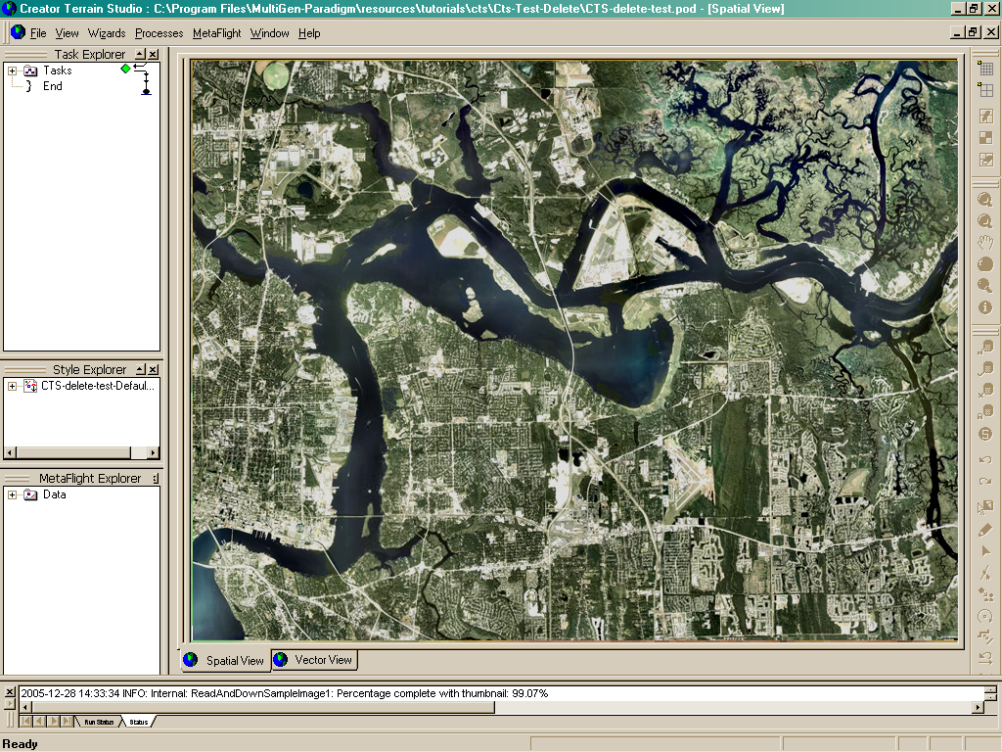
Figure 1
Creator Terrain Studio Software

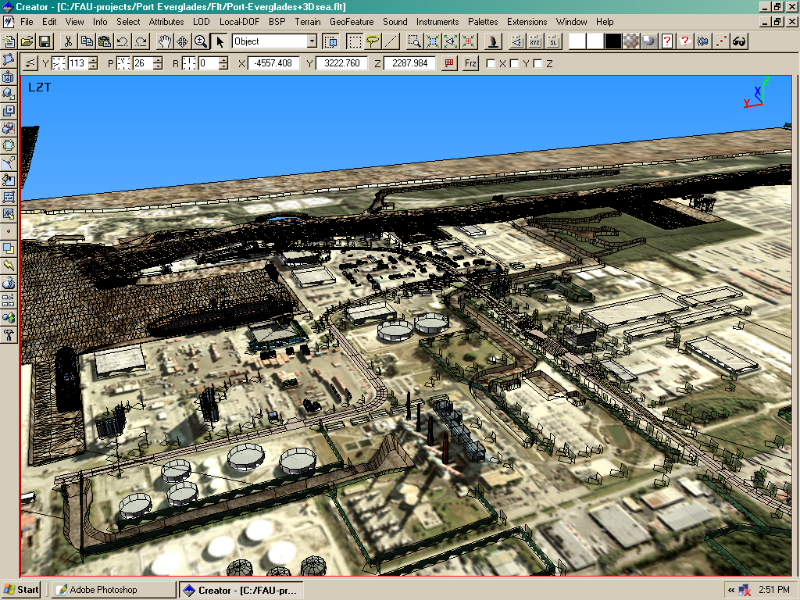
Figure 2
Creator Software

Port Everglades
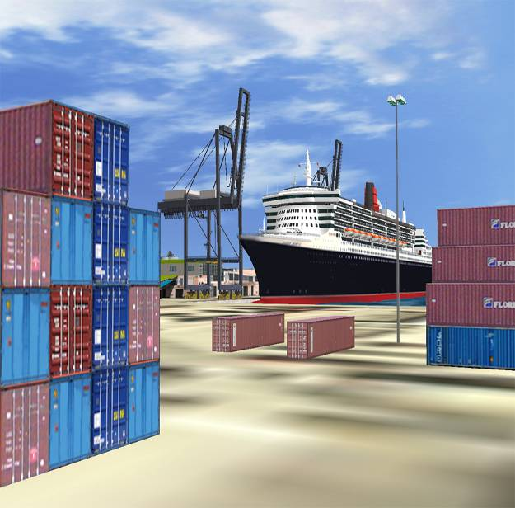 | 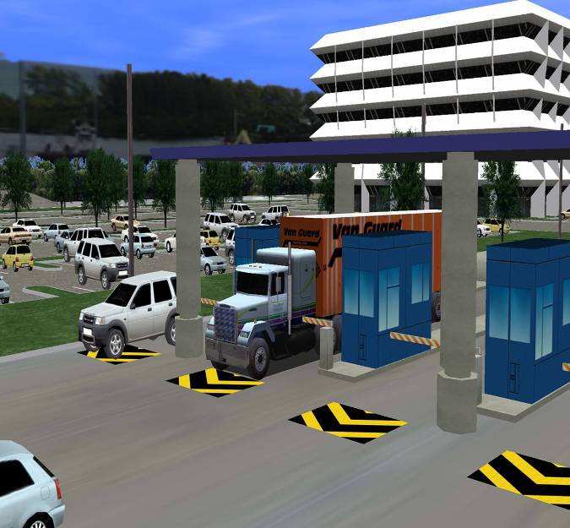
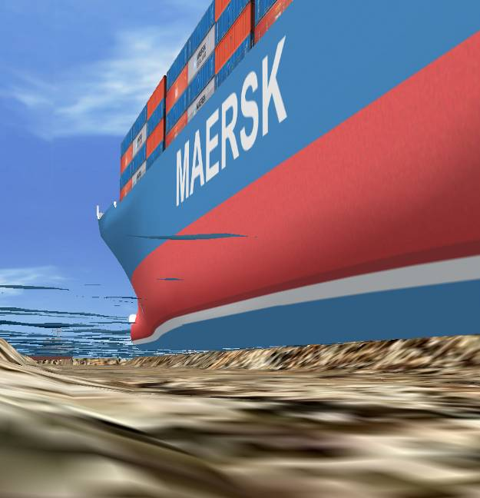 | 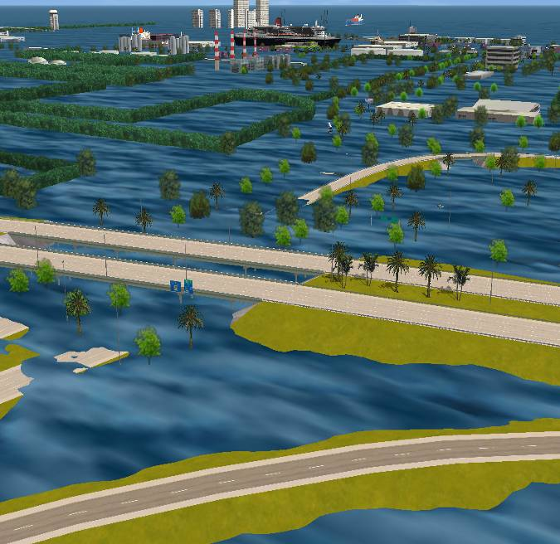
Clockwise: landside, gate area, Figure 3
port flooded, underwater Vega Prime Software

GIS
Data

Creator
Terrain
Studio

Auto-
CAD

Creator

Vega
Prime
Topographical data is obtained from the US Geological Survey (aerial photographs, digital elevation maps, etc.)
Creates accurate large area terrain databases with high-fidelity 3-D culture and imagery. Generates the topography to be used in the virtual reality environment.
A powerful application tool that creates realistic images. Two-dimensional accurate infrastructure drawings in digital format (computer aided drafting)
A highly sophisticated modeling tool for interactively developing real-time 3-D applications. Takes the data from AutoCAD and overlays this data on top of the output from creator terrain studio to generate 3-D models.
Used to create real-time visual and audio simulations, virtual reality and general visualization applications. Software allows running of various simulation environments, changing parameters, run special effects, day or night, weather, etc.
Figure 4
Advanced Virtual Simulation Work Flow

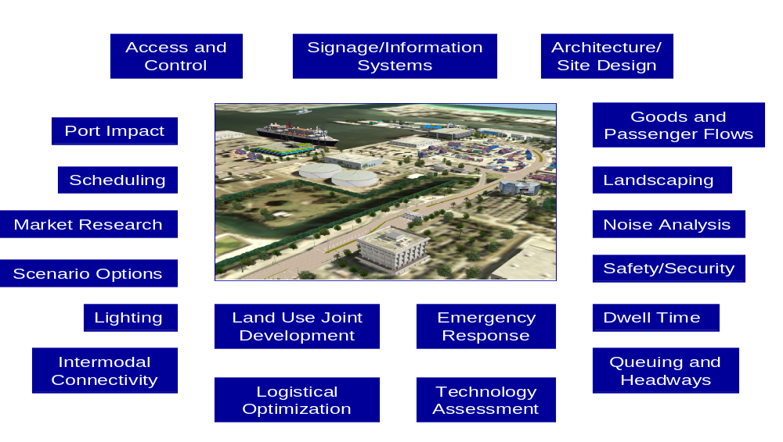
Figure 5
Simulation Scenarios

