____________________A______________________

ACTIVE BUFFER MANAGEMENT FOR PROVISION OF VCR FUNCTIONALITIES
Synonym: Adjusting content of the buffer;

Definition: Active buffer management is used to adjust the contents of the buffer after execution of VCR functions in VoD systems.

The problem of providing VCR functions with the traditional buffering schemes is that the effects of VCR actions in the same direction are cumulative. When consecutive VCR actions in the same direction are performed, the play point will ultimately move to a boundary of the buffer. Thus, the active buffer management (ABM) scheme [1] was developed to use a buffer manager to adjust the contents of the buffer after the VCR functions such that the relative position of the play point can stay in the middle of the buffer. Figure 1 shows the basic operational principle of ABM in a staggered VoD system with no VCR actions. Assuming the buffer can hold 3 segments. At some point, the buffer downloads segments z, z+1, z+2 and the play point is in segment z+1. If there is no VCR action, after a period of time, the play point will be at the start of segment z+2. At this moment, in order to keep the play point in the middle, the client will download segment z+3 and segment z will be discarded.

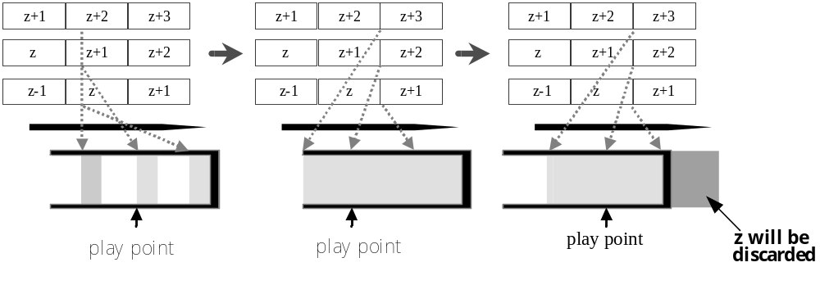
- Active buffer management scheme without VCR action.
For the scenario with an interactive function, it is assumed that the buffer now holds segment z, z+1 and z+2. If a FF action as illustrated in Figure 2 is issued and the play point moves to the end of segment z+2, the buffer manager will select segment z+3 and z+4 to download. The play point will thus be moved back to the middle segment after one segment time. This is segment z+3 in this case.

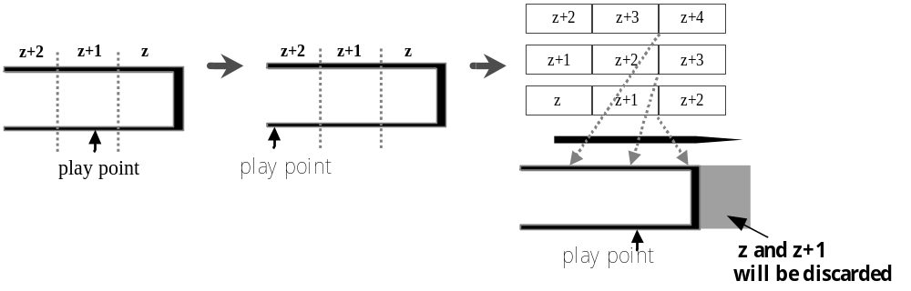 Figure 2. Active buffer management scheme with FF action.

See: Large-Scale Video-on-Demand System

References
- Z. Fei, M.H. Ammar, I. Kamel, and S. Mukherjee, “Providing interactive functions for staggered multicast near video-on-demand,” Proceedings of IEEE International Conference on Multimedia Computing and Systems ’99, 1999, pp. 949-953.

ADAPTIVE EDUCATIONAL HYPERMEDIA SYSTEMS
Synonyms: Open corpus problem; Adaptive functionality

Definition: Adaptive educational hypermedia systems include adaptive functionality based on three components: the document space, observations, and the user model.

To support re-usability and comparability of adaptive educational hypermedia systems, we give a component-based definition of adaptive educational hypermedia systems (AEHS), extending the functionality-oriented definition of adaptive hypermedia given by Brusilovsky in 1996 [1]. AEHS have been developed and tested in various disciplines and have proven their usefulness for improved and goal-oriented learning and teaching. However, these systems normally come along as stand-alone systems - proprietary solutions have been investigated, tested and improved to fulfill specific, often domain-dependent requirements. This phenomenon is known in the literature as the open corpus problem in AEHS [2] which states that normally, adaptive applications work on a fixed set of documents which is defined at the design time of the system, and directly influences the way adaptation is implemented.

The logical definition of adaptive educational hypermedia given here focuses on the components of these systems, and describes which kind of processing information is needed from the underlying hypermedia system (the document space), the runtime information which is required (observations), and the user model characteristics (user model). Adaptive functionality is then described by means of these three components, or more precisely: how the information from these three components, the static data from the document space, the runtime-data from the observations, and the processing-data from the user model, is used to provide adaptive functionality. The given logical definition of adaptive educational hypermedia provides a language for describing adaptive functionality, and allows for the comparison of adaptive functionality in a well- grounded way, enabling the re-use of adaptive functionality in different contexts and systems. The applicability of this formal description has been demonstrated in [3].

An Adaptive Educational Hypermedia System (AEHS) is a Quadruple (DOCS, UM, OBS, AC) with:
DOCS: Document Space: A finite set of first order logic (FOL) sentences with constants for describing documents (and knowledge topics), and predicates for defining relations between these constants.
UM: User Model: A finite set of FOL sentences with constants for describing individual users (user groups), and user characteristics, as well as predicates and rules for expressing whether a characteristic applies to a user.
OBS: Observations: A finite set of FOL sentences with constants for describing observations and predicates for relating users, documents / topics, and observations.
AC: Adaptation Component: A finite set of FOL sentences with rules for describing adaptive functionality.

With the emerging Semantic Web, there is even more the need for comparable, re-usable adaptive functionality. If we consider adaptive functionality as a service on the Semantic Web, we need re-usable adaptive functionality, able to operate on an open corpus, which the Web is.

See: Personalized Educational Hypermedia

References
- P. Brusilovsky, “Methods and techniques of adaptive hypermedia,” User Modeling and User Adapted Interaction, Vol. 6, No. 2-3, 1996, pp. 87-129.
- P. Brusilovsky, “Adaptive Hypermedia,” User Modeling and User-Adapted Interaction, Vol. 11, 2001, pp. 87-110.
- N. Henze and W. Nejdl, “A Logical Characterization of Adaptive Educational Hypermedia,”,New Review of Hypermedia, Vol. 10, No. 1, 2004.

ANALYZING PERSON INFORMATION IN NEWS VIDEO

Shin’ichi Satoh
National Institute of Informatics, Tokyo, Japan

Synonyms: Face detection and recognition; Face-name association;

Definition: Analyzing person information in news video includes the identification of various attributes of a person, such as face detection and recognition, face-name association, and others.

Introduction
Person information analysis for news videos, including face detection and recognition, face-name association, etc., has attracted many researchers in the video indexing field. One reason for this is the importance of person information. In our social interactions, we use face as symbolic information to identify each other. This strengthens the importance of face among many types of visual information, and thus face image processing has been intensively studied for decades by image processing and computer vision researchers. As an outcome, robust face detection and recognition techniques have been proposed. Therefore, face information in news videos is rather more easily accessible compared to the other types of visual information.

In addition, especially in news, person information is the most important; for instance, “who said this?”, “who went there?”, “who did this?”, etc., could be the major information which news provides. Among all such types of person information, “who is this?” information, i.e., face-name association, is the most basic as well as the most important information. Despite its basic nature, face-name association is not an easy task for computers; in some cases, it requires in-depth semantic analysis of videos, which is never achieved yet even by the most advanced technologies. This is another reason why face-name association still attracts many researchers: face-name association is a good touchstone of video analysis technologies.

This article describes about face-name association in news videos. In doing this, we take one of the earliest attempts as an example: Name-It. We briefly describe its mechanism. Then we compare it with corpus-based natural language processing and information retrieval techniques, and show the effectiveness of corpus-based video analysis.

Face-Name Association: Name-It Approach
Typical processing of face-name association is as follows:

- Extracts faces from images (videos)
- Extracts names from speech (closed-caption (CC) text)
- Associates faces and names

This looks very simple. Let’s assume that we have a segment of news video as shown in Figure 1. We don’t feel any difficulty in associating the face and name when we watch this news video segment, i.e., the face corresponds to “Bill Clinton” even though we don’t know the person beforehand. Video information is composed mainly of two streams: visual stream and speech (or CC) stream. Usually each one of these is not direct explanation of another. For instance, if visual information is shown as Figure 1, the corresponding speech will not be: “The person shown here is Mr. Clinton. He is making speech on...,” which is the direct explanation of the visual information. If so the news video could be too redundant and tedious to viewers. Instead they are complementary each other, and thus concise and easy to understand for people. However, it is very hard for computers to analyze news video segments. In order to associate the face and name shown in Figure 1, computers need to understand visual stream so that a person shown is making speech, and to understand text stream that the news is about a speech by Mr. Clinton, and thus to realize the person corresponds to Mr. Clinton. This correspondence is shown only implicitly, which makes the analysis difficult for computers. This requires image/video understanding as well as speech/text understanding, which themselves are still very difficult tasks.
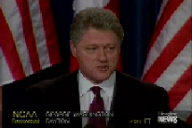
6902 >>> PRESIDENT CLINTON MET
6963 WITH FRENCH PRESIDENT
6993 JACQUES CHIRAC TODAY
7023 AT THE WHITE HOUSE.
7083 MR. CLINTON SAID HE WELCOMED
7113 FRANCE'S DECISION TO END
7143 ITS NUCLEAR TEST PROGRAM
7204 IN THE PACIFIC AND PLEDGED
7234 TO WORK WITH FRANCE TO BAN
7264 FUTURE TESTS.

Figure 1. Example of news video segment.

Name-It [3] is one of the earliest systems tackling the problem of face-name association in news videos. Name-It assumes that image stream processing, i.e., face extraction, as well as text stream processing, i.e., name extraction, are not necessarily perfect. Thus the proper face-name association cannot be realized only from each segment. For example, from the segment shown in Figure 1, it is possible for computers that the face shown here can be associated with “Clinton” or “Chirac,” but the ambiguity between these cannot be resolved. To handle this situation, Name-It takes a corpus-based video analysis approach to obtain sufficiently reliable face-name association from imperfect image/text stream understanding results.

The architecture of Name-It is shown in Figure 2. Since closed-captioned CNN Headline News is used as news video corpus, given news videos are composed of a video portion along with a transcript (closed-caption text) portion. From video images, the system extracts faces of persons who might be mentioned in transcripts. Meanwhile, from transcripts, the system extracts words corresponding to persons who might appear in videos. Since names and faces are both extracted from videos, they furnish additional timing information, i.e., at what time in videos they appear. The association of names and faces is evaluated with a “co-occurrence” factor using their timing information. Co-occurrence of a name and a face expresses how often and how well the name coincides
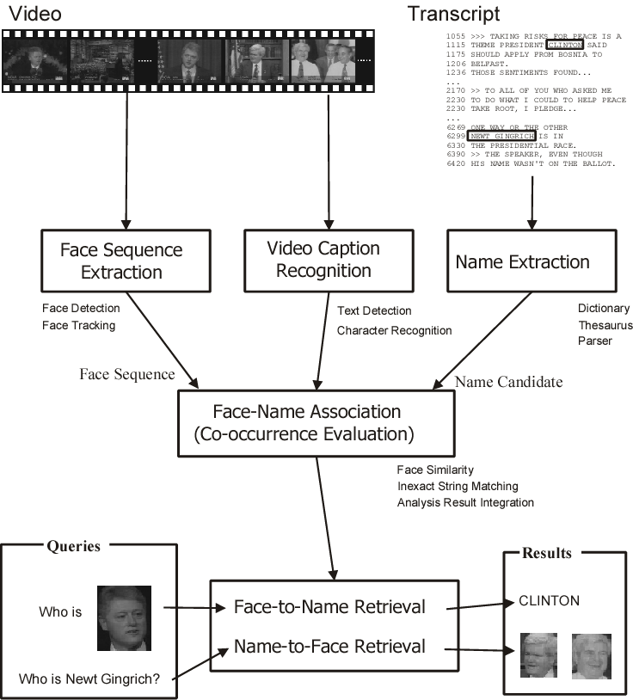

Figure 2. The architecture of Name-It.

with the face in given news video archives. In addition, the system also extracts video captions from video images. Extracted video captions are recognized to obtain text information, and then used to enhance the quality of face-name association. By the co-occurrence, the system collects ambiguous face-name association cues, each of which is obtained from each news video segment, over the entire news video corpus, to obtain sufficiently reliable face-name association results. Figure 3 shows the results of face-name association by using five hours of CNN Headline News videos as corpus.

A key idea of Name-It is to evaluate co-occurrence between a face and name by comparing the occurrence patterns of the face and name in news video corpus. To do so, it is obviously required to locate a face and name in video corpus. It is rather straight forward to locate names in closed-captioned video corpus, since closed-caption text is symbol information. In order to locate faces, a face matching technique is used. In other words, by face matching, face information in news video corpus is symbolized. This enables co-occurrence evaluation between faces and names. Similar techniques can be found in the natural language processing and information retrieval fields. For instance, the vector space model [5] regards that documents are similar when they share similar terms, i.e., have similar occurrence patterns of terms. In Latent Semantic Indexing [6], terms having similar occurrence patterns in documents within corpus compose a latent concept. Similar to these, Name-It finds face-name pairs having similar occurrence patterns in news video corpus as associated face-name pairs. Figure 4 shows occurrence patterns of faces and names. Co-occurrence of a face and name is realized by correlation between occurrence patterns of the face and name. In this example, “MILLER” and F₁, “CLINTON” and F₂, respectively, will be associated because corresponding occurrence patters are similar.

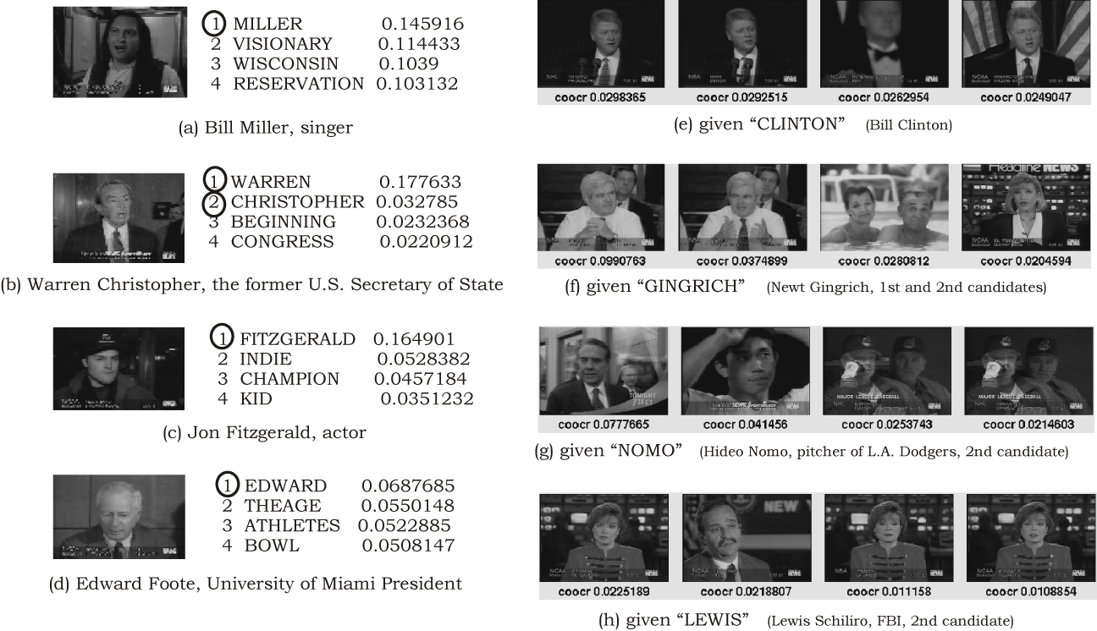

Figure 3. Face and name association results.

Conclusions and Future Directions
This article describes about face-name association in videos, especially Name-It, in order to demonstrate the effectiveness of corpus-based video analysis. There are potential directions to enhance and extend corpus-based face-name association. One possible direction is to elaborate component technologies such as name extraction, face extraction, and face matching. Recent advanced information extraction and natural language processing techniques enable almost perfect name extraction from text. In addition, they can provide further information such as roles of names in sentences and documents, which surely enhances the face-name association performance.

Advanced image processing or computer vision techniques will enhance the quality of symbolization of faces in video corpus. Robust face detection and tracking in videos is still challenging task (such as [7]. In [8] a comprehensive survey of face detection is presented). Robust and accurate face matching will rectify the occurrence patterns of faces (Figure 4), which enhances face-name association. Many research efforts have been made in face recognition, especially for surveillance and biometrics. Face recognition for videos could be the next frontier. In [10] a comprehensive survey for face recognition is presented. In addition to face detection and recognition, behavior analysis is also helpful, especially to associate the behavior with person’s activity described in text.
.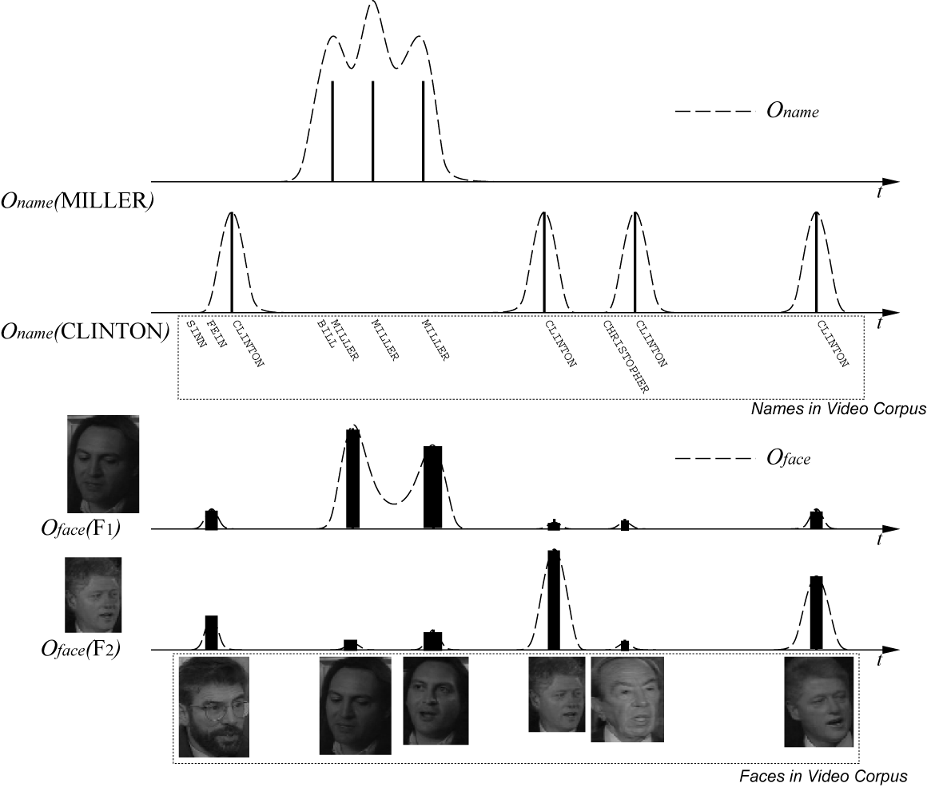

Figure 4. Face and name occurrence patterns.

Usage of the other modalities is also promising. In addition to images, closed-caption text, and video captions, speaker identification provides a powerful cue for face-name association for monologue shots [, 1].

In integrating face and name detection results, Name-It uses co-occurrence, which is based on coincidence. However, as mentioned before, since news videos are concise and easy to understand for people, relationship between corresponding faces and names is not so simple as coincidence, but may yield a kind of video grammar. In order to handle this, the system ultimately needs to “understand” videos as people do. In [2] an attempt to model this relationship as temporal probability distribution is presented. In order to enhance the integration, we need much elaborated video grammar, which intelligently integrate text processing results and image processing results.

It could be beneficial if corpus-based video analysis approach is applied to general objects in addition to faces. However, obviously it is not feasible to realize detection and recognition of many types of objects. Instead, in [9] one of the promising approaches is presented. The method extracts interest points from videos, and then visual features are calculated for each point. These points are then clustered by features into “words,” and then a text retrieval technique is applied for object retrieval for videos. By this, the method symbolizes objects shown in videos as “words,” which could be useful to extend corpus-based video analysis to general objects.

References
- M. Li, D. Li, N. Dimitrova, and I. Sethi, “Audio-Visual Talking Face Detection,” Proceedings of the International Conference on Multimedia and Expo (ICME2003), 2003.
- C. G. M. Snoek and A. G. Haptmann, “Learning to Identify TV News Monologues by Style and Context,” CMU Technical Report, CMU-CS-03-193, 2003.
- J. Yang, M. Chen, and A. Hauptmann, “Finding Person X: Correlating Names with Visual Appearances,” Proceedings of the International Conference on Image and Video Retrieval (CIVR'04), 2004.
- S. Satoh, Y. Nakamura, and T. Kanade, “Name-It: Naming and Detecting Faces in News Videos,” IEEE MultiMedia, Vol. 6, No. 1, January-March (Spring), 1999, pp. 22-35.
- R. Baeza-Yates and B. Ribeiro-Neto, “Modern Information Retrieval,” Addison Wesley, 1999.
- S. Deerwester, S. T. Dumais, G. W. Furnas, T. K. Landauer and R. Harshman, “Indexing by Latent Semantic Analysis,” Journal of the American Society for Information Science, Vol. 41, 1990, pp. 391-407.
- R. C. Verma, C. Schmid, and K. Mikolajcayk, “Face Detection and Tracking in a Video by Propagating Detection Probabilities”, IEEE Transactions on Pattern Analysis and Machine Intelligence, Vol. 25, No. 10, 2003, pp. 1216-1228.
- M.-H. Yang, D. J. Kriegman, and N. Ahuja, “Detecting Faces in Images: A Survey,” IEEE Transactions on Pattern Analysis and Machine Intelligence, Vol. 24, No. 1, 2002, pp. 34-58.
- J. Sivic and A. Zisserman, “Video Google: A Text Retrieval Approach to Object Matching in Videos,” Proceedings of the International Conference on Computer Vision (ICCV2003), 2003.
- W. Zhao, R. Chellappa, P. J. Phillips, and A. Rosenfeld, “Face recognition: A literature survey,” ACM Computing Surveys, Vol. 35, No. 4, 2003, pp. 399-458.

APPLICATIONS OF FACE RECOGNITION And NOVEL TRENDS
Synonyms: Face verification; Face identification

Definition: A number of contemporary civilian and law enforcement applications require reliable recognition of human faces.

Nowadays, machine recognition of human faces is used in a variety of civilian and law enforcement applications that require reliable recognition of humans. Identity verification for physical access control in buildings or security areas is one of the most common face recognition applications. At the access point, an image of someone’s face is captured by a camera and is matched against pre-stored images of the same person. Only if there is a match, access is permitted, e.g. the door opens. For high security areas, a combination with card terminals is possible, so that a double check is performed. Such face recognition systems are installed for example in airports to facilitate the crew and airport staff to pass through different control levels without having to show an ID or passport [1].

To allow secure transactions through the Internet, face verification may be used instead of electronic means like passwords or PIN numbers, which can be easily stolen or forgotten. Such applications include secure transactions in e- & m-commerce and banking, computer network access, and personalized applications like e-health and e-learning. Face identification has also been used in forensic applications for criminal identification (mug-shot matching) and surveillance of public places to detect the presence of criminals or terrorists (for example in airports or in border control). It is also used for government applications like national ID, driver’s license, passport and border control, immigration, etc.

Face recognition is also a crucial component of ubiquitous and pervasive computing, which aims at incorporating intelligence in our living environment and allowing humans to interact with machines in a natural way, just like people interact with each other. For example, a smart home should be able to recognize the owners, their family, friends and guests, remember their preferences (from favorite food and TV program to room temperature), understand what they are saying, where are they looking at, what each gesture, movement or expression means, and according to all these cues to be able to facilitate every-day life. The fact that face recognition is an essential tool for interpreting human actions, human emotions, facial expressions, human behavior and intentions, and is also an extremely natural and non-intrusive technique, makes it an excellent choice for ambient intelligence applications [2].

During the last decade wearable devices were developed to help users in their daily activities. Face recognition is an integral part of wearable systems like memory aids or context-aware systems [2]. A real-world application example is the use of mini-cameras and face recognition software, which are embedded into an Alzheimer's patient’s glasses, to help her remember the person she is looking at [2].

See: Face Recognition

References
- A. Jain, A. Ross, and S. Prabhakar, “An introduction to biometric recognition,” IEEE Transactions on Circuits and Systems for Video Technology, Vol. 14, No. 1, January 2004, pp. 4-20.
- A. Pentland and T. Choudhury, “Personalizing smart environments: face recognition for human interaction,” IEEE Computer Magazine, Vol. 33, No. 2, February 2000, pp. 50-55.

ARCHITECTURE OF COMMERCIAL NEWS SYSTEMS
Synonyms: Modern news networks; News syndication services

Definition: The architecture of commercial news systems is based on a layered approach consisting of the following layers: data layer, content manipulation layer, news services layer, and end user layer.

Multimedia news is presented as content of commercial services by national and international agencies and organizations all over the world. The news community is researching for solutions in different application areas, such as high level semantic analysis, provisioning and management of mixed information, and distribution and presentation of media data to satisfy requirements dictated by business scenarios.

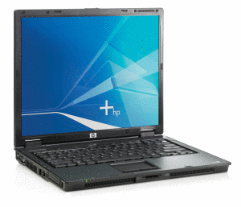

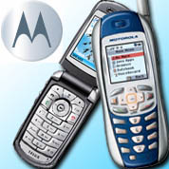
Modern news networks, news syndication services, media observation and international news exchange networks are following the customer needs and provide specific services within the multimedia news application domain. The most-used presentation platform for multimedia news herein is the World Wide Web, providing all facets of news aggregation, manipulation, and dissemination as discussed in “Multimedia news systems”. Appropriate Web applications integrate multimedia services in complex environments [1] and modern web-based content management systems (WCMS) handle all assets of multimedia news data for personalized user-oriented news presentation.
Audio Engineering
Categorization
ImgDB
, JPG
Text/
NewsML
Video, MPEG2
Text/
NewsML
Video, MPEG2
CMS
Aggregation
Authoring
SW
Video
Cutting
Content Presentation
Semantic coupling
News
syndication
News
monitoring
data layer
Content
manipultation layer
News
services layer
End
user layer
Categorization
ImgDB
, JPG
Text/
NewsML
Video, MPEG2
CMS
Aggregation
Authoring
SW
Video
Cutting

Figure 1. Multimedia news systems layering.

Multimedia news systems typically follow a layered architecture approach as shown in Figure 1. The data layer contains multimedia data that are stored in modern appropriate formats like NewsML for texts, modern image formats such as JPG, PNG, etc. and current versions of multimedia encoding (e.g. MPEG versions) for audio- and video files.

The content manipulation layer provides access to the multimedia data via specific tools that provide methods to control and access news contents along the various transitions in the content lifecycle. The news services layer includes gateways that provide structured and standardized access to the contents by end user applications. Within this layer, tools and services of content provider networks take care of the presentation and distribution of multimedia contents. Most providers run multimedia gateways such as streaming servers or web services and sites to present the multimedia contents.

The top layer presents the end user environment, providing access to multimedia news services based on direct access to multimedia gateways or special services of the news services layer such as multi-agency full-text search engines, semantically coupling services or commercially related gateways like billing servers or subscription access gateways.

See: Multimedia News Systems

References
- E. Kirda, M. Jazayeri, C.Kerer, and M. Schranz, “Experiences in Engineering Flexible Web Services,” IEEE Multimedia, Vol. 8, No. 1, January-March 2001, pp. 58-65.

AUDIO COMPRESSION AND CODING TECHNIQUES
Jauvane C. de Oliveira
National Laboratory for Scientific Computation, Petropolis, RJ, Brazil

Definition: Audio compression and coding techniques are used to compress audio signals and can be based on sampling or on signal processing of audio sequences.

Audio is the most important medium to be transmitted in a conference-like application. In order to be able to successfully transmit audio through a low bandwidth network, however, one needs to compress it, so that the required bandwidth is manageable.

Introduction – Audio Properties
Sound is a phenomenon that happens due to the vibration of material. Sound is transmitted through the air, or some other elastic medium, as pressure waves that are formed around the vibrating material. We can consider the example of strings of a guitar, which vibrate when stroked upon. The pressure waves follow a pattern named wave form and occur repeatedly at regular intervals of time. Such intervals are called a period. The amount of periods per second denotes what is known as the frequency of sound, which is measured in Hertz (Hz) or cycles per second (cps) and is denoted by f. Wavelength is the space the wave form travels in one period. It may also be understood as the distance between two crests of the wave. The waveform is denoted by λ. Yet with regard to the wave form, the intensity of the deviation from its mean value denotes the amplitude of the sound. Figure 1 shows an example of an audio signal, where we can observe both its amplitude and period. The velocity of sound is given by c=fλ. At sea level and 20 C (68 F), c=343m/s.

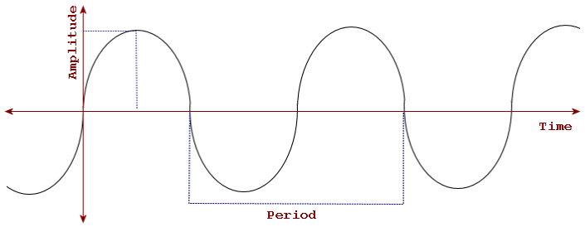

- Sound wave form with its amplitude and period.
A sound wave is an analog signal, as it assumes continuous values throughout the time. Using a mathematical technique called Fourier Analysis one can prove that any analog signal can be decomposed as a, possibly infinite, summation of single-frequency sinusoidal signals (See Figure 2). The range of frequencies which build up a given signal, i.e. the difference between the highest and lowest frequency components, is called signal bandwidth. For a proper transmission of an analog signal in a given medium that must have a bandwidth equal or greater than the signal bandwidth. If the medium bandwidth is lower than the signal bandwidth some of the low and/or high frequency components of the signal will be lost, which degrades its quality of the signal. Such loss of quality is said to be caused by the bandlimiting channel. So, in order to successfully transmit audio in a given medium we need to either select a medium whose bandwidth is at least equal to the audio signal bandwidth or reduce the signal bandwidth so that it fits in the bandwidth of the medium.
A B C
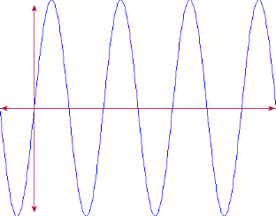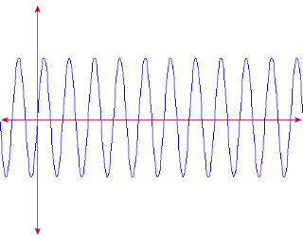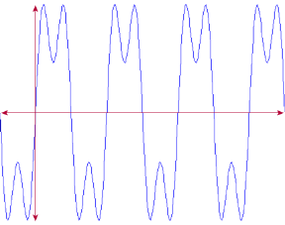

- Two sinusoidal components (A, B) and its resulting summation (C)

Audio Digitization Codec
In order to process audio in a computer, the analog signal needs to be converted into a digital representation. One common digitization technique used is the Pulse Code Modulation (PCM). Basically we’ll set a number of valid values in the amplitude axis and later we will measure the amplitude of the wave a given number of times per second. The measurement at a given rate is often referred to as sampling. The sampled values are later rounded up or down to the closest valid value in the amplitude axis. The rounding of samples is called quantization, and the distance from one value to the next refers to as a quantization interval. Each quantization value has a well-defined digital bitword to represent it. The analog signal is then represented digitally by the sequence of bitwords which are the result of the sampling + quantization. Figure 3 shows this procedure, whose digital representation of the signal is 10100 00000 00010 00010 10010 10101 10101 10011 00011 01000 01001 00111 00010 10011 10011 00001 00100 00101 00101 00110.

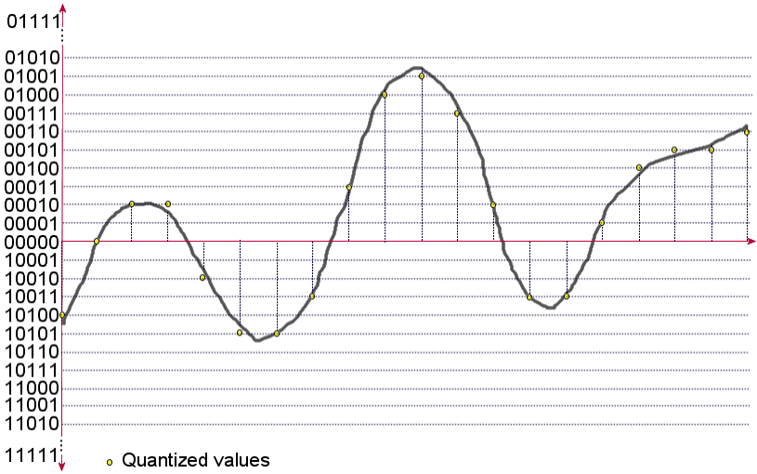

- Digitization: samples (vertical dashed), quantized values (dots)
and bitwords (left).

Harry Nyquist, a physicist who worked at AT&T and Bell Labs, developed in 1927 a study with regard to the optimum sampling rate for a successful digitization of an analog signal. The Nyquist Sampling Theorem states that the sampling frequency must be greater than twice the bandwidth of the input signal in order to allow a successful reconstruction of the original signal out of the sampled version. If the sampling is performed at a frequency lower than the Nyquist Frequency then the number of samples may be insufficient to reconstruct the original signal, leading to a distorted reconstructed signal. This phenomenon is called Aliasing.

One should notice that for each sample we need to round it up or down to the next quantization level, which leads to what is called quantization error. Such procedure actually distorts the original signal. Quantization noise is the analog signal which can be built out of the randomly generated quantization errors.

In order to reconstruct the analog signal using its digital representation we need to interpolate the values of the samples into a continuous time-varying signal. A bandlimiting filter is often employed to perform such procedure.

Figure 4 shows a typical audio encoder. Basically we have a bandlimiting filter followed by an Analog-to-Digital Converter (ADC). Such converter is composed of a circuit which samples the original signal as indicated by a sampling clock and holds the sampled value so that the next component, a quantizer, can receive it. The quantized, in its turn, receives the sampled value and outputs the equivalent bitword for it. The bandlimiting filter is employed to ensure that the ADC filter won’t receive any component whose Nyquist rate could be higher than the sampling clock of the encoder. That is, the bandlimiting filter cuts off frequencies which are higher than half of the sampling clock frequency.

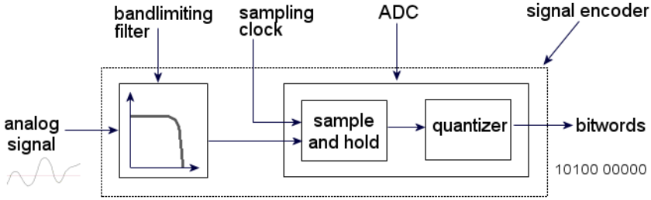

- Signal encoder.

The audio decoder is a simpler device that is composed of a Digital-to-Analog Converter (DAC), which receives the bitwords and generates a signal that maintains the sample value during one sampling interval until the next value gets decoded. Such “square” signal then goes through a low-pass filter, also known as reconstruction filter, which smoothens it out to what would be equivalent to a continuous-time interpolation of the sample values.

The Human Hearing/Vocal Systems and Audio Coding
The human hearing system is capable of detecting by sounds whose components are in the 20 Hz to 20 kHz range. The human voice, in the other hand, can be characterized in the 50 Hz to 10 kHz range. For that reason, when we need to digitize human voice, a 20 ksps (samples per second) sampling rate is sufficient according to the Nyquist Sampling Theorem. More generally, since we can’t hear beyond 20 kHz sinusoidal components, a generic sound such as music can be properly digitized using a 40 ksps sampling rate.

The above-mentioned characteristics of the human audio-oriented senses can be used to classify sound processes as follows:

- Infrasonic: 0 to 20 Hz;
- Audiosonic: 20 Hz to 20 kHz;
- Ultrasonic: 20 kHz to 1 GHz; and
- Hypersonic: 1 GHz to 10 THz.
The human hearing system is not linearly sensible to all frequencies in the audiosonic range. In fact the curve shown in Figure 5 shows the typical hearing sensibility to the various frequencies.

With regard to the quantization levels, using linear quantization intervals, it is usual to use 12 bits per sample for voice encoding and 16 bits per sample for music. For multi-channel music we’d use 16 bits for each channel. We can then find that we would use respectively 240 kbps, 640 kbps and 1280 kbps for digitally encoded voice, mono and stereo music. In practice, however, since we have much lower network bitrate available than those mentioned herein, we’ll most often use a lower sampling rate and number of quantization levels. For telephone-quality audio encoding, for instance, it is common to sample at 8 ksps, obviously cutting off sinusoidal components with frequencies over 4 KHz in order to comply with the Nyquist sampling theorem.

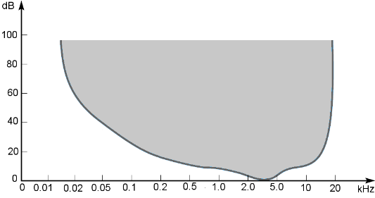

- Human hearing sensibility.

Sampling Based Audio Compression Schemes
There are a number of standard compression schemes, which are based on the samples and that are not specific for any type of audio, being hence useable for both voice and music, with the appropriated adaptations with regard to the frequency range considered.

Pulse Code Modulation (PCM): Pulse Code Modulation, defined in the ITU-T Recommendation G.711 [5], is a standard coding technique defined for voice encoding for transmission over telephone lines. A typical telephone line has a bandwidth limited to the range from 200 Hz to 3.4 KHz. For this rate a 6.8ksps sampling frequency would suffice, but in order to accommodate low quality bandlimiting filters, an 8 ksps sampling frequency is employed. PCM uses 8 bits per sample rather than 12, with a compression/expansion circuit being used to achieve a sound quality equivalent to a normal 12 bits per sample encoding. Basically what the compression/expansion circuit does is to indirectly implement non-linear quantization levels, i.e. the levels are closer together for smaller samples and farther apart for larger ones. That minimizes quantization error for smaller samples, which leads to a better overall audio quality. Instead of really using logarithmic quantization levels, the signal is compressed and later linear quantized. The result is nevertheless equivalent to quantizing with logarithmic distributed quantization levels. There are two standard compression/expansion circuits: u-Law, which is used in the North America and Japan; and A-law, which is used in Europe and other countries. With that a telephone-like audio coded with PCM reaches a total of 64 kbps.

Compact Disc Digital Audio (CD-DA): Music has sinusoidal components with frequencies in the 20 Hz to 20 kHz range. That requires at least a 40 ksps sampling rate. In practice a 44.1ksps is used to accommodate filter discrepancies. Each sample is then ended with 16 bits using linear quantization levels. For stereo recordings there shall be 16 bits for each channel. Such coding scheme reaches a total of 705.6 kbps for mono and 1.411 Mbps for stereo music.

Differential Pulse Code Modulation (DPCM): Further compression is possible in an audio signal through the analysis of typical audio samples. If we analyze a sound wave form, we can see that at the Nyquist sampling rate the wave change from one sample to the next is not very abrupt, i.e. the difference between two consecutive samples is much smaller than the samples themselves. That allows one to naturally use a sample as a prediction to the next one, having to code just the difference to the previous rather than the each sample separately. The difference between two samples can be coded with a smaller number of bits, as its maximum value is smaller than the sample itself. That’s the motto behind Differential PCM, or DPCM. Typical savings are of about 1 bit per sample; hence a 64 kbps voice stream gets compressed to 56 kbps. The problem with this coding scheme is that quantization errors can accumulate if the differences are always positive (or negative). More elaborated schemes may use various previous samples that are mixed together using predictor coefficients, which consists of proportions of each previous sample that is to be used to build the final prediction. Figure 6 shows both the DPCM encoder with a single and three previous values used for prediction.

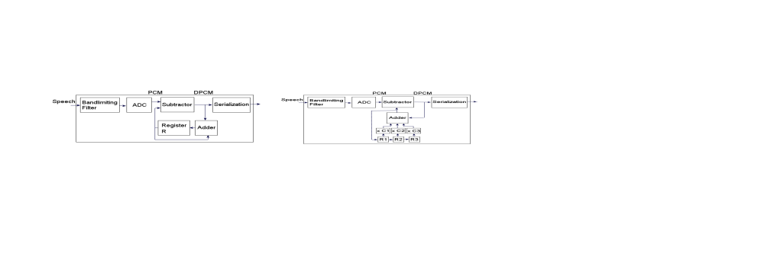

- DPCM encoders with single (left) and third order predictions (right).

Adaptive Differential Pulse Code Modulation (ADPCM). Extra compression can be achieved by varying the number of bits used to encode different signal components, depending on their maximum amplitude. The former ITU-T G.721 Recommendation, now part of the ITU-T G.726 Recommendation [8], uses the same principle as DPCM, but using a eight-order prediction scheme, with either 6 or 5 bits per sample for a total of 32 kbps or 16 kbps. The ITU-T G722 Recommendation [6] adds another technique called subband coding. Such technique consists of extending the speech bandwidth to 50 Hz to 7 kHz (rather than cutting off at 3.4 kHz like in PCM) and passing the signal through two filters: the first allows only frequencies from 50 Hz to 3.5 kHz while the second allows only frequencies from 3.5 kHz to 7 kHz. The two signals are named lower subband and upper subband signals. Each subband signal is then sampled independently, respectively at 8 ksps and 16 ksps, and quantized using specific tables. The bitstreams are finally merged together in a last stage. This standard leads to 64 kbps, 56 kbps or 48 kbps. We should notice that this standard reaches higher voice quality encoding as it also considers higher frequencies in the 3.4 kHz to 7 kHz range. Yet another ADPCM-based standard, ITU-T G.726 Recommendation [8], also uses the subband coding technique described above, but considering only 50 Hz to 3.4 kHz components, with bitstreams at 40, 32, 24 or 16 kbps.

Adaptive Predictive Coding (APC): Further compression can be achieved if we use adaptive coefficient predictors, which is the basis for a compression technique called Adaptive Predictive Coding, where such coefficients change continuously based on characteristics of the audio signal being encoded. An audio sequence is split into small audio segments, each of which is then analyzed aiming at selecting optimum predictive coefficients. Such compression scheme can reach 8kbps with reasonable quality.

Digital Signal Processing Based Audio Compression Schemes
We call psycho-acoustic system what comprises those two systems. The first consists of all electrical/nervous systems linked to the communication from the senses to the brain and vice-versa and the latter comprises the generation/capture of sound which is transmitted through a given medium, such as the air, to/from the other party of the communication. The human speech is generated by components that come from the diaphragm all the way up to the human lips and nose. Through analysis of the human voice and the psycho-acoustic model of the human being, there is a class of compression schemes which makes use of digital signal processing circuits that are inexpensive as of today inexpensive. In this section, we describe a number of those compression schemes.

Linear Predictive Coding (LPC): The Linear Predictive Coding is based on signal processing performed in the source audio aiming at extracting a number of its perceptual features. Those are later quantized and transmitted. At the destination such perceptual features feed a voice synthesizer which generates a sound that can be perceived as the original source audio. Although the sound does sound synthetic, this algorithm reaches very high compression rates, leading to a low resulting bitstream. Typical output bitstreams reach as low as 1.2 kbps.

The perceptual features that are commonly extracted from voice signals are pitch, period, loudness as well as voice tract excitation parameters. Pitch is related to the frequency of the signal, period is the duration of the signal and loudness relates to the power of the signal. The voice tract excitation parameters indicated if a sound is voice or unvoiced. Voiced sounds involve vibrations of the human vocal cords while unvoiced sounds do not. Lastly vocal tract model coefficients are also extracted. Such coefficients indicate probable vocal tract configuration to pronounce a given sound. Such coefficients later feed a basic vocal tract model which is used to synthesize audio at the destination.

Code-excited LPC (CELP): A group of standards which are based on a more elaborate model of the vocal tract is also used. Such model is known as Code Excited Linear Prediction (CELP) model and is one of various models known as enhanced excitation LPC models. This compression scheme achieves better sound quality than LPC. Standards such as ITU-T G.728 [9], G.729 [10], G.723.1 [6] are based in CELP. Those standards achieve respectively 16 kbps, 8 kbps and 5.3 or 6.3 kbps. The price paid for such low final bitrate is the time it takes for the encoding to be performed. Respectively 0.625 ms, 23 ms and 67.5 ms

Perceptual Coding: If we expect to compress generic audio such as music, the previous LPC and CELP are not useable, as those are based on a vocal tract model for audio synthesis. Perceptual Coding is a technique which exploits the human hearing system limitations to achieve compression with not perceived quality loss. Such compression scheme also requires digital signal processing, to analyze the source audio, before it gets compressed. Features explored include: 1) the human hearing sensibility, as shown in Figure 5, where we can cut off signal components whose frequencies have an amplitude which is below the minimum shown, i.e. if a signal component at 100Hz is under 20dB it is not inaudible, 2) frequency masking, which consists of the fact that when we hear a sound that is composed of several waves, if a loud wave is close (frequency-wise) to a low wave, the low wave is not heard because of the sensitivity curve for the human ear, as shown in Figure 5, that gets distorted for frequencies around a given loud wave, much like if the sensitivity levels were pushed up a bit, 3) temporal masking, which consists of the fact that when we hear a loud sound we get deaf for quieter sounds for a short period. When we hear an explosion, for instance, we can’t hear quieter noises for a while. All those inaudible sounds can be fully discarded and go unnoticed.

MPEG-Audio: The Motion Picture Expert Group (MPEG), set by ISO to define a number of standards related to multimedia applications that use video and sound, defined a number of MPEG audio coders based on Perceptual Coding. Basically a source audio is sampled and quantized using PCM with a sampling rate and number of pixels per sample determined by the application. In a next step the bandwidth is split in 32 frequency subbands using analysis filters. Such subbands go through a Discrete Fourier Transform (DFT) filter to convert the samples to the frequency domain. In a further step, using the human hearing limitations some frequencies are cut off. For the remaining audible components, quantization accuracy is selected along with the equivalent number of bits to be used. That way, less quantization (and more bits) can be used for the frequencies for which we are most sensible to, such as the range from 2 kHz to 5 kHz. In the decoder, after dequantizing each of the 32 subband channels, the subbands go through the synthesis filter bank. That component generates PCM samples which are later decoded to generate an analog audio. The ISO Standard 11172-3 [11] defines three levels of processing through layers 1, 2 and 3; the first being the basic mode and the other 2 with increasing level of processing associated, respectively with higher compression or better sound quality if bitrate is kept constant.

Dolby AC-1, AC-2 and AC-3: Other coding schemes based on Perceptual Coding are the Dolby AC-1, AC-2 and AC-3. AC stands for acoustic coder. Dolby AC-1 is basically a standard for satellite FM relays and consists of a compression scheme based in a low-complexity psychoacoustic model where 40 subbands are used at a 32 ksps sampling rate and fixed bit allocation. The fix bit allocation avoids the need to submit the bit allocation information along with the data. Dolby AC-2 is used by various PC sound cards, producing hi-fi audio at 256 kbps. Even tough the encoder uses variable bit allocations, there is no need to send that information along with the data because the decoder also contain the same psychoacoustic model used by the encoder, being able to compute the same bit allocations. In the negative side, if any change is to be made in the model used by the encoder all decoders need to be changed as well. The decoder needs to have the subband samples to feed the psychoacoustic model for its own computation of bit allocations, reason why each frame contains the quantized samples as well as the encoded frequency coefficients from the sampled waveform. That information is known as the encoded spectral envelope and that mode of operation is known as backward adaptive bit allocation mode. Dolby AC-3 uses both backward and forward bit allocation principles, which is known as hybrid backward/forward adaptive bit allocation mode. AC-3 has defined sampling rates at 32 ksps, 44.1 ksps and 48 ksps and uses 512 subband samples per block, of which only 256 subsamples are updated in each new block, since the last 256 subbands of the previous block become the first 256 subbands of the new block.

See: Human Vocal System, Human Hearing System

References
- T. F. Quartieri, “Speech Signal Processing – Principles and Practice,” Prentice Hall, 2001.
- B. Gold and N. Morgan, “Speech and Audio Signal Processing – Processing and Perception of Speech and Music,” John Wiley & Sons, Inc. 2000, ISBN: 0471351547.
- F. Halsall, “Multimedia Communications – Applications, Networks, Protocols and Standards,” Addison Wesley, 2001. ISBN: 0201398194.
- R. Steinmetz and K. Nahrstedt, “Multimedia Fundamentals Volume I – Media Coding and Content Processing,” Prentice Hall, 2002, ISBN: 0130313998.
- ITU-T G.711 Recommendation, "Pulse Code Modulation (PCM) of Voice Frequencies," International Telecommunication Union, Telecommunication Standardization Sector.
- ITU-T G.722 Recommendation, "7kHz Audio-coding Within 64 kbits/s," International Telecommunication Union, Telecommunication Standardization Sector.
- ITU-T G.723.1 Recommendation, "Dual rate speech coder for multimedia communications transmitting at 5.3 and 6.3 kbit/s," International Telecommunication Union, Telecommunication Standardization Sector.
- ITU-T G.726 Recommendation, "40, 32, 24, 16 kbit/s adaptive differential pulse code modulation (ADPCM)," International Telecommunication Union, Telecommu-nication Standardization Sector.
- ITU-T G.728 Recommendation, "Coding of speech at 16 kbit/s using low-delay code excited linear prediction," International Telecommunication Union, Telecommu-nication Standardization Sector.
- ITU-T G.729 Recommendation, "Coding of speech at 8 kbit/s using conjugate-structure algebraic-code-excited linear-prediction (CS-ACELP)", International Telecommunication Union, Telecommunication Standardization Sector.
- ISO/IEC 11172-3 “Information technology – Coding of moving pictures and associated audio for digital storage media at up to about 1,5 Mbit/s – Part 3: Audio,” International Organization for Standardization.

AUDIO CONFERENCING
Definition: Audio conferencing allows participants in a live session to hear each other.

The audio is transmitted over the network between users, live and in real-time. Audio conferencing is one component of teleconferencing; the others are video conferencing, and data conferencing. Since the audio must be encoded, transmitted, and decoded in real-time, special compression and transmission techniques are typically used. In a teleconferencing system that is ITU-T H.323 [1] compliant, the G.711 [2] audio codec, which is basically uncompressed 8-bit PCM signal at 8KHz in either A-Law or μ-Law format, must be supported. This leads to bitrates of 56 or 64kbps, which are relatively high for audio but supported by today’s networks.

Support for other ITU-T audio recommendations and compression is optional, and its implementation specifics depend on the required speech quality, bit rate, computational power, and delay. Provisions for asymmetric operation of audio codecs have also been made; i.e., it is possible to send audio using one codec but receive audio using another codec. If the G.723.1 [3] audio compression standard is provided, the terminal must be able to encode and decode at both the 5.3 kbps and the 6.3 kbps modes. If a terminal is audio only, it should also support the ITU-T G.729 recommendation [4]. Note that if a terminals is known to be on a low-bandwidth network (<64kbps), it does not need to disclose capability to receive G.711 audio since it won’t practically be able to do so.

To transfer the live audio over the network, a protocol such as the RTP (Real-time Transport Protocol) [5], or simple UDP (User Datagram Protocol) is used.

See: Teleconferencing

References
- International Telecommunication Union, Telecommunication Standardization Sector H.323 Recommendation – Packet-based multimedia communications systems, July 2003.
- International Telecommunication Union, Telecommunication Standardization Sector G.711 Recommendation – Pulse code modulation (PCM) of voice frequencies, November 1988.
- International Telecommunication Union, Telecommunication Standardization Sector G.723.1 Recommendation – Dual rate speech coder for multimedia communications transmitting at 5.3 and 6.3 kbit/s, March 1996.
- International Telecommunication Union, Telecommunication Standardization Sector G.729 Recommendation – Coding of speech at 8 kbit/s using conjugate-structure algebraic-code-excited linear-prediction (CS-ACELP), March 1996.
- H. Schulzrinne, S. Casner, R. Frederick, and V. Jacobson, “RTP: A Transport Protocol for Real-Time Applications,” IETF RFC 1889, January 1996.

AUDIO STREAMING
Shervin Shirmohammadi
University of Ottawa, Canada

Jauvane C. de Oliveira

National Laboratory for Scientific Computation, Petropolis, RJ, Brazil

Definition: Audio streaming refers to the transfer of audio across the network such that the audio can be played by the receiver(s) in real-time as it is being transferred.

Introduction
Audio streaming can be for various live media, such as the Internet broadcast of a concert, or for stored media, such as listening to an online jukebox. Real-time transfer and playback are the keys in audio streaming. As such, other approaches, such as downloading an entire file before playing it, are not considered to be streaming. From a high-level perspective, an audio streaming system needs to address three issues: audio compression, dissemination over the network, and playback at the receiver.

Audio Compression
Whether the audio is coming from a pre-stored file, or is captured live, it needs to be compressed to make streaming practical over a network. Uncompressed audio is bulky and most of the time not appropriate for transmission over the network. For example, even a low-quality 8Khz 8-bit speech in the PCM format can take from 56 to 64 kbps; anything with higher quality takes even more bandwidth. Compression is therefore necessary for audio streaming. Table 1 shows a list of several streaming standards, with the typical target bitrate, relative delay and usual target applications.

It should be noted that the delays disclosed in table 1 are based on the algorithm. For example, for PCM at 8 KHz sampling, we have one sample at every 0.125 milliseconds. Sample based compression schemes, such as PCM and ADPCM, are usually much faster than those that achieve compression based on the human vocal system or psychoacoustic human model like MP3, LPC and CELP. So, for delay-conscious applications such as audio streaming, which needs to be in real-time, one may select a sample-based encoding scheme, bandwidth permitting; otherwise one of the latter would be a better choice as they achieve higher compression. For a detailed discussion about the audio compression schemes please see the “Compression and Coding Techniques, Audio” article. In the streaming context, the Real Audio (ra) and Windows Media Audio (wma) formats, from Real Networks and Microsoft Corp. respectively, are also used quite often.

Table 1. Characteristics of Compression Schemes

Standard | Compression | Target Bitrate | Audio Quality | Relative  Delay | Application
G.711 [5] | PCM + compansion | 64 kbps | Good Voice | 0.125ms | PSTN/ISDN telephony
G.722 [6] | ADPCM w/ subband coding | 64 kbps  56/48 kbps | Excellent Voice  Good Voice | Slightly higher than PCM | Audio conferencing
G.723.1 [6] | CELP | 6.3 kbps  5.3 kbps | Good Voice  Fair Voice | 67.5ms | Video and Internet telephony  Videoconferencing
G.726 [8] | ADPCM w/ subband coding | 40/32  24/16  kbps | Good Voice  Fair Voice |  | Telephony at reduced bitrates  Conferencing
G.728 [9] | CELP | 16 kbps | Good Voice | 0.625ms | Low delay/low bitrate telephony
G.729 [10] | CELP | 8 kbps | Good Voice | 25ms | Telephony in celular networks; Simultaneous telephony & data fax
LPC-10 | LPC | 2.4/1.2 kbps | Poor Voice |  | Telephony in military networks
MP3 [11] | Perceptual Coding | 32kbps to  320kbps | Music FM to CD Quality |  | Music Streaming

Dissemination over the Network
Unlike elastic traffic such as email or file transfer, which are not severely affected by delays or irregularities in transmission speed, continuous multimedia data such as audio and video are inelastic. These media have a “natural” flow and are not very flexible. Interruptions in audio while streaming it is undesirable and creates a major problem for the end user because it distorts its real-time nature. It should be pointed out that delay is not always detrimental for audio, as long as the flow is continuous. For example, consider a presentational application where the audio is played back to the user with limited interaction capabilities such as play/pause/open/close. In such a scenario, if the entire audio is delayed by a few seconds, the user’s perception of it is not affected due to lack of a reference point, as long as there are no interruptions. However, for a conversational application such as audio conferencing, where users interact with each other, audio delay must not violate certain thresholds because of the interaction and the existence of reference points between the users.

The transport protocol used for audio streaming must be able to handle the real-time nature of it. One of the most commonly-used real-time protocols for audio streaming is the Real-time Transport protocol (RTP), which is typically used with the Real Time Streaming Protocol (RTSP) for exchanging commands between the player and media server, and sometimes used with the Real -time Transport Control Protocol (RTCP) for Quality of Service (QoS) monitoring and other things. These protocols are briefly discussed next.
Real-time Transport Protocol (RTP)
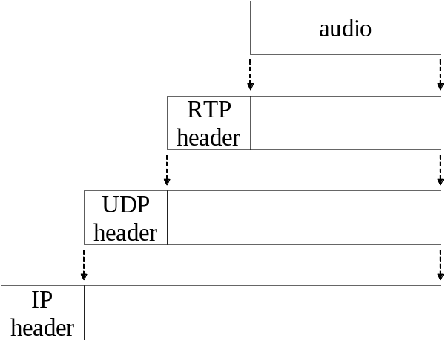To accommodate the inelasticity of audio streaming, there is a need for special networking protocols. The most common such protocol is the Real-time Transport Protocol (RTP) [1]. It is usually implemented as an application-level framing protocol on top of UDP, as shown in Figure 1. It should be noted that RTP is named as such because it is used to carry real-time data; RTP itself does not guarantee real-time delivery of data. Real-time delivery depends on the underlying network; therefore, a transport-layer or an application-layer protocol cannot guaranty real-time delivery because it can’t control the network. What makes RTP suitable for multimedia data, compared to other protocols, are two of its header fields: Payload Type, which indicates what type of data is being transported (Real Audio, MPEG Video, etc.), and Timestamp, which provides the temporal information for the data. Together with the Sequence Number field of the RTP header, these fields enable real-time playing of the audio at the receiver, network permitting. RTP supports multi-point to multi-point communications, including UDP multicasting.

Figure 1. RTP in the TCP/IP protocol suite.

Real-time Transport Control Protocol (RTCP)
RTP is only responsible for transferring the data. For more capabilities, RTP’s companion protocol the Real-time Transport Control Protocol (RTCP) can be used [1]. RTCP is typically used in conjunction with RTP, and it also uses UDP as its delivery mechanism. RTCP provides many capabilities; the most used ones are:

- QoS feedback: the receiver can report the quality of their reception to the sender. This can include number of lost packets or the round-trip delay, among other things. This information can be used by the sender to adapt the source, if possible. Note that RTCP does not specify how the media should be adapted - that functionality is outside of its scope. RTCP’s job is to inform the sender about the QoS conditions currently experienced in the transmission. It is up to the sender to decide what actions to take for a given QoS condition.
- Intermedia synchronization: information that is necessary for the synchronization of sources, such as between audio and video can be provided by RTCP.
- Identification: information such as the e-mail address, phone number, and full name of the participants can also be provided.
- Session Control: participants can send small notes to each other, such as “stepping out of the office”, or indicate they are leaving using the BYE message, for example.

Real Time Streaming Protocol (RTSP)
Unlike RTP which transfers real-time data, the Real Time Streaming Protocol (RTSP) [2] is only concerned with sending commands between a receiver’s audio player and the audio source. These commands include methods such as SETUP, PLAY, PAUSE, and TEARDOWN. Using RTSP, an audio player can setup a session between itself and the audio source. The audio is then transmitted over some other protocol, such as RTP, from the source to the player. Similar to RTP, RTSP is not real-time by itself. Real-time delivery depends on the underlying network.
A Typical Scenario
Figure 2 demonstrates a typical scenario of audio streaming.

client
audio
server
Web
server
GET
pointer to audio
SETUP
HTTP
RTSP
RTP
RTCP
PLAY
audio data
QoS
feedback
TEARDOWN
Figure 2. A typical sequence of events when streaming audio from a Web site.
Here, the client first goes to a web site, where there is a link to the audio. Upon clicking on that link, the webs server sends to the receiver the URL of where the audio can be found. In the case of an RTSP session, the link looks something like rtsp://www.audioserver.com/audio.mp3. Note that the Web server and the audio server do not have to be the same entity; it is quite possible to separate them for better maintenance. After receiving the above link, the client’s player established an RTSP link with the audio server through the SETUP command. The client can then interact with the server by sending PLAY, STOP, PAUSE, and other commands. Once the audio is requested for playing, RTP is used to carry the actual audio data. At the same time, RTCP can be used to send control commands between the client and the server. Finally, the session is finished with the TEARDOWN command of RTSP.
HTTP Streaming
HTTP streaming is an alternative to using RTP. The idea here is that the player simply requests the audio from the web server over HTTP, and plays it as the audio data comes in from the Web server. The disadvantages of this approach are the lack of RTP/RTCP features discussed above, and the fact that HTTP uses TCP which is not considered a real time protocol, especially under less-than ideal network conditions. As such, there can be more interruptions and delay associated with HTTP streaming compared to RTP streaming. However, HTTP streaming is used quite commonly for cases where the receiver has a high-speed Internet connection such as DSL and the audio bandwidth is not very high. In these cases, using HTTP streaming can be justified by its advantages; namely, the fact that HTTP is always allowed to go through firewalls, and that HTTP streaming is easier to implement as one can simply use an existing Web server.
Playback at the Receiver
Although the coding and transmission techniques described above significantly contribute to the audio steaming process, the ultimate factor determining the real-time delivery of audio is the network condition. As mentioned above, delay severely affects audio in conversational applications. But for presentational applications, delay is less detrimental as long as it has a reasonable amount for a given application and is relatively constant. However, even for presentational applications, the variance of delay, known as jitter, has an adverse effect on the presentation. In order to smoothen out the delay, the player at the receiver’s end usually buffers the audio for a certain duration before playing it. This provides a “safety margin” in case the transmission is interrupted for short durations. Note that the buffer cannot be too large, since it makes the user wait for too long before actually hearing the audio, and it cannot be too short since it won’t really mitigate the effect of jitter in that case.

An extension to the above buffering technique is the faster-than-natural transmission of audio data. Depending on the buffer size of the receiver, the sender can transmit the audio faster than its normal playing speed so that if there are transmission interruptions, the player has enough data to playback for the user. This technique would work for stored audio, but it does not apply to live applications where the source produces audio at a natural speed.
Interleaved Audio
Interleaved audio transmission is a technique that is sometimes used to alleviate network loss and act as a packet loss resilience mechanism [3] [4]. The idea is to send alternate audio samples in different packets, as opposed to sending consecutive samples in the same packet. The difference between the two approaches is shown in figure 3. In 3a we see 24 consecutive samples being transmitted in one packet. If this packet is lost, there will be a gap in the audio equal to the duration of the samples. In 3b we see the interleaved approach for the same audio sample in 3a, where alternate samples are being sent in separate packets. This way if one of the packets is lost, we only lose every other sample and the receiver will hear a somewhat distorted audio as opposed to hearing a complete gap for that duration. In case of stereo audio, we can adapt this technique to send the left channel and the right channel in separate packets, so that if the packet for one of the channels is lost, the receiver still hears the other channel.
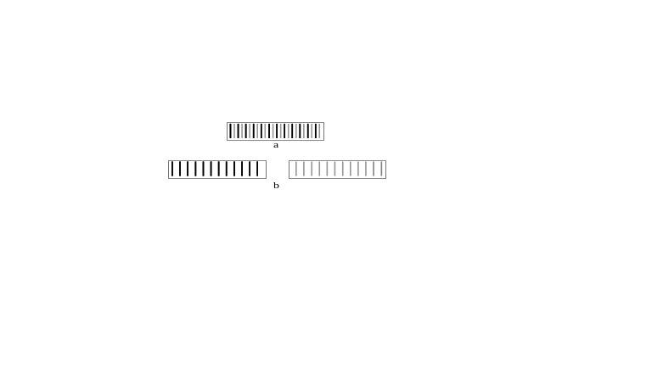
Figure 3. a) Transmission of consecutive samples, b) Transmission of alternate samples.

See: Audio Streaming, Networking Protocols for Audio Streaming, Interleaved Audio, Streaming Audio Player

References
- H. Schulzrinne, S. Casner, R. Frederick, and V. Jacobson, “RTP: A Transport Protocol for Real-Time Applications,” IETF RFC 1889, January 1996.
- H. Schulzrinne, A. Rao, and R. Lanphier, “Real Time Streaming Protocol (RTSP)”, IETF RFC 2326, April 1998.
- D. Hoffman, G. Fernando, V. Goyal, M. Civanlar, “RTP Payload Format for MPEG1/MPEG2 Video,” IETF RFC 2250, January 1998.
- R. Finlayson, “A More Loss-Tolerant RTP Payload Format for MP3 Audio,” IETF RFC 3119, June 2001.
- ITU-T G.711 Recommendation, "Pulse Code Modulation (PCM) of Voice Frequencies", International Telecommunication Union, Telecommunication Standardization Sector.
- ITU-T G.722 Recommendation, "7kHz Audio-coding Within 64 kbits/s," International Telecommunication Union, Telecommunication Standardization Sector.
- ITU-T G.723.1 Recommendation, "Dual rate speech coder for multimedia communications transmitting at 5.3 and 6.3 kbit/s," International Telecommunication Union, Telecommunication Standardization Sector.
- ITU-T G.726 Recommendation, "40, 32, 24, 16 kbit/s adaptive differential pulse code modulation (ADPCM)," International Telecommunication Union, Telecommu-nication Standardization Sector.
- ITU-T G.728 Recommendation, "Coding of speech at 16 kbit/s using low-delay code excited linear prediction," International Telecommunication Union, Telecommu-nication Standardization Sector.
- ITU-T G.729 Recommendation, "Coding of speech at 8 kbit/s using conjugate-structure algebraic-code-excited linear-prediction (CS-ACELP)," International Telecommunication Union, Telecommunication Standardization Sector.
- ISO/IEC 11172-3 “Information technology – Coding of moving pictures and associated audio for digital storage media at up to about 1,5 Mbit/s – Part 3: Audio,” International Organization for Standardization.

AUDIO and VIDEO INFORMATION IN MULTIMEDIA NEWS SYSTEMS
Definition: Contemporary news systems contain today visual media including audio and video information.

Historically most relevant information concerning progress in sciences and the growth of general information within human knowledge and accessible to mankind has been documented in written text and occasionally described in images and maps. The technological developments of the 20th century has brought tools and communication channels that increased the ways of communicating and distributing news concerning all facets of human live in various ways. Multimedia news services involve now besides enormous amounts of digitized textual information also images, audio and video material, supported by multiple technical tools for seamless integration and modern distribution.

Image captures people’s thrills, emotions, and concerns. Art can shock or inspire, and news images cover most relevant events over the entire globe. Most readers depend on visual and multimedia contents to understand the world around them and as a basis for further creative activities. The popularity of visual media such as photos, videos, and animations attests to their mainstream acceptance.

Technically, multimedia integration has been adopted to middleware software and content management applications to allow a seamless integration with current news management and distribution applications. XML standards like SMIL provide synchronization and integration frameworks and document description standards that cope with traditional and future text information and multimedia data that support modern user’s needs.

Modern multimedia services integrate content types of text, images, audio data and streams and current video formats such as MPEG2, MPEG4, MPEG7 and multimedia broadcasting technologies and initiatives like MHP and DVB for providing future interactive digital news access via television, internet and mobile devices.

General purpose news editing systems integrate easy-to-use textual interfaces, mostly based on Web architectures, with modern multimedia features like video studios, composing for example MPEG-4 audio-visual scenes (cf. MPEG-4 STUDIO in [1]).

Modern Internet protocols like HTTP for web-based presentation of text and images, and streaming protocols such as RTSP for audio and video streaming cover the distribution and presentation services of multimedia news systems. Besides the technical enabling of news presentation and distribution, multimedia news services have to face legal and commercial constraints. Recent misuse by illegal file sharing or copyright violence has introduced security topics to multimedia news services. Besides customer oriented access restrictions and modern billing systems, multimedia news have been enriched with up-to-date encrypting mechanisms. Especially for audio and video formats, the time constraints in encoding and decoding live streams have introduced challenges which are met by modern approaches such as encryption and watermarking for copyrighted MPEG [2]. Multimedia data security is vital for multimedia commerce. Early cryptography have focused and solved text data security. For multimedia applications, light weight encryption algorithms as discussed in [3] are attractive and appropriate.

See: Multimedia News Systems

References
- K. Cha and S. Kim, “MPEG-4 STUDIO: An Object-Based Authoring System for MPEG-4 Contents,” Multimedia Tools and Applications, Vol. 25, No. 1, January 2005, pp. 111-131.
- D. Simitopoulos, N. Zissis, P. Georgiadids, V. Emmanouilidis, and M. Strintzis, “Encryption and watermarking for the secure distribution of copyrighted MPEG video on DVD,” Multimedia Systems, Vol. 9, No. 3, September 2003, pp. 217-227.
- B. Bhargava, C. Shi, and S. Wang, “MPEG Video Encryption Algorithms,” Multimedia Tools and Applications, Vol. 24, No. 1, September 2004, pp. 57-79.

AUGMENTED REALITY
Definition: Augmented reality is a system that enhances the real world by superimposing computer-generated information on top of it.

Virtual Reality (VR) is the technology that provides almost real and/or believable experiences in a synthetic or virtual way. Augmented Reality (AR) can be thought of as a variation of VR. In the original publication [1] which coined the term, (Computer-) Augmented Reality was introduced as the opposite of VR: instead of driving the user into a purely-synthesized informational environment, the goal of AR is to augment the real world with synthetic information such as visualizations and audio. In other words, AR is a system that enhances the real world by superimposing computer-generated information on top of it. VR technologies completely immerse a user inside a synthetic environment. While immersed, the user can not see the real world around him/her. In contrast, AR allows the user to see the real world, but superimposes computer-generated information upon or composed with the real world. Therefore, AR supplements reality, rather than completely replacing it. Combining 3D graphics with the real world in a 3D space is useful in that it enhances a user’s perception of and interaction with the real world. In addition, the augmented information, such as annotations, speech instructions, images, videos, and 3D models, helps the user perform real world tasks. Figure 1 shows a wearable computer used for the implementation of AR of an industry training application.

See: Virtual and Augmented Reality

References
- P. Wellner, W. Mackay, and R. Gold, Eds. “Special issue on computer augmented environments: back to the real world,” Communications of the ACM, Vol. 36, Issue 7, July 1993.

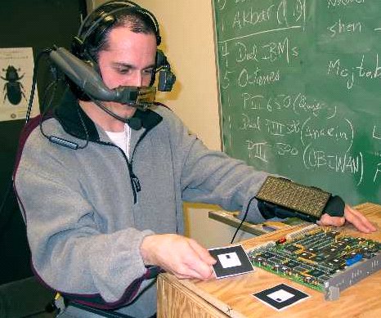

- Augmented reality.

AUTHORING AND SPECIFICATION
Definition: Authoring and specification tools provide development environment for multimedia applications and presentations.

Numerous multimedia authoring tools and specification techniques have been produced across both commercial and research domains. While many articles focus on particular niche, ranging from specific media (e.g., image editing) to complex multimedia scenarios, this article specifically overviews those that have addressed various aspects of multimedia synchronization.

Early efforts in the specification of multimedia synchronization were based on temporal intervals [1] and a broad array of Petri net based techniques, such as [2]. Language-based constructs started with HyTime [3], a SGML-based (Standardized General Markup Language) document language which offered inter-object hyperlinking, scheduling and synchronization. The evolution of such techniques broadened to support the various classes of media synchronization (content, space and time) and included efforts such as MHEG [4] and PREMO (Presentation Environment for Multimedia Objects) [5]. MHEG offered a platform independent, “final” non-editable specification for real-time multimedia presentation, synchronization and interactivity, while PREMO provided a framework/middleware-approach to facilitate a standardized development environment for multimedia applications. Based on a conceptual framework, the latter’s major goal was to provide a standard way to integrate emerging technologies from different media and presentation techniques to graphics packages and networks. Another series of research efforts addressed authoring of interactive multimedia presentations through a trio of projects which focused on the expression, specification and provision of media synchronization (DEMAIS, FLIPS and N-Sync [6]).

Recently, the SMIL (Synchronized Multimedia Integration Language) [7] markup language was developed by the World Wide Web Consortium (W3C) based on the eXtensible Markup Language (XML). It does not define any specific media format, but defines how various multimedia components should be played together or in sequence (including position, visibility, scheduling and duration). Complex multimedia scenario content is distributed amongst different servers, sent as independent streams (e.g., audio, video, text and images) and rendered together as a single unified presentation according to the SMIL specification.

See: Multimedia Synchronization – Area Overview

References
- J. F. Allen, “Maintaining Knowledge About Temporal Intervals,” Communications of the ACM, Vol. 26, No. 11, 1983, pp. 832 – 843.
- M. Diaz and P. Sénac, “Time Stream Petri Nets: A Model for Multimedia Streams Synchronization,” Proceedings of International Conference on Multimedia Modeling, Singapore, 1993, pp. 257 – 273.
- ISO, “Hypermedia/Time-Based Structure Language: HyTime (ISO 10744),” 1992.
- T. Meyer-Boudnik and W. Effelsberg, “MHEG Explained,” IEEE Multimedia, Vol. 2, No. 1, 1995, pp. 26 – 38.
- I. Herman, N. Correia, D. A. Duce, D. J. Duke, G. J. Reynolds, and J. Van Loo, “A Standard Model for Multimedia Synchronization: PREMO Synchronization Objects,” Multimedia Systems, Vol. 6, No. 2, 1998, pp. 88 – 101.
- B. P. Bailey, J. A. Konstan, and J. V. Carlis, “DEMAIS: Designing Multimedia Applications with Interactive Storyboards,” Proceedings of the 9th ACM International Conference on Multimedia, Ottawa, Canada, 2001, pp. 241 – 250.
- W3C, http://www.w3.org/AudioVideo, 2005.

