3.0 High Definition High Frame Rate Color Camera for Surveillance
PI: Dr. William E. Glenn

3.1 Summary

The objective of this segment of the project was to develop a high definition, high frame rate color camera for surveillance. A 3840x2160 30P color CMOS camera with variable frame rate and remotely controlled infrared filter changers was designed, fabricated, tested and demonstrated. The camera gathers 50 times the amount of information in its field of view as with standard resolution video cameras. A memory unit, solid-state store, for large amounts of imaging data generated by the camera was also designed, fabricated and tested. Field tests demonstrated that the camera’s high resolution makes it possible to do electronic zoom on sections of an image without the excessive loss of resolution present with standard cameras, and the high frame rate allows the use of moving target indication, velocity measurement and the observation of brief events that help classify suspected targets. It is recommended that work continue to upgrade the camera system and to add compression to the solid-state memory to allow increased record time. The HDMAX camera and solid-state recorder are ideally suited for video surveillance on ships, submarines, harbors, AUVs and drone aircraft.

3.2 Objective

The objective of this segment of the project was to develop a high definition, high frame rate color camera for surveillance. The proposed research, which also included the development of a memory unit for large amounts of imaging data generated by the camera, will contribute to improvement of imaging technology for use in surveillance.

All of the proposed tasks were completed. They are:
- Design, fabrication and test of a 3840x2160 30P color CMOS camera with variable frame rate and remotely controlled infrared filter changers
- Design, fabrication and test of a solid state store for the camera
- Develop display interface between the camera and display
- Provide fiberlink for camera
- Carry out field tests of camera

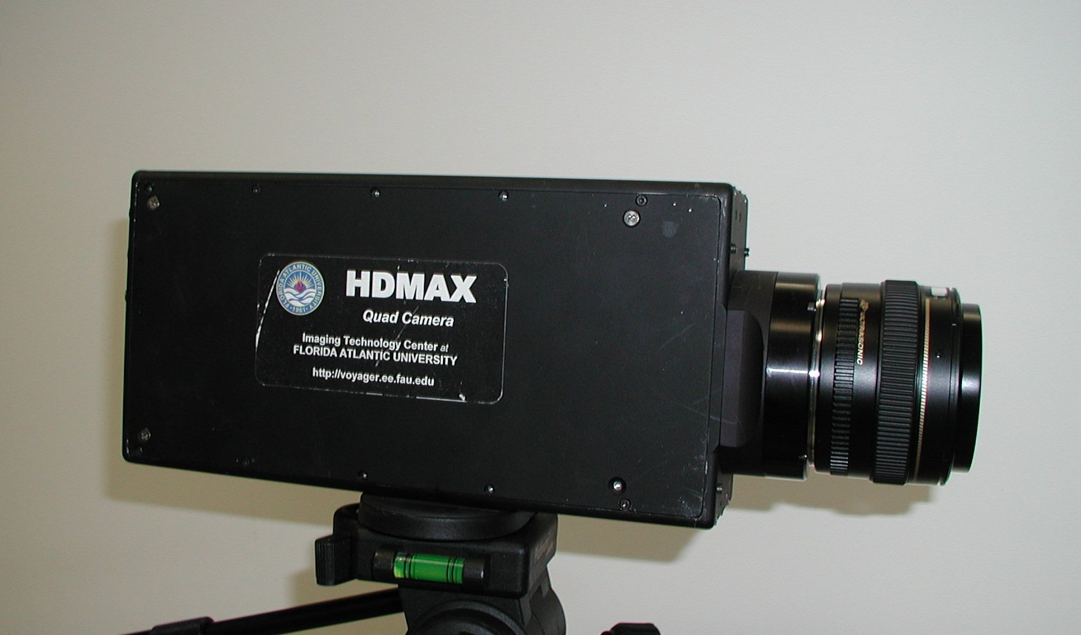
FAU ITC completed the design and fabrication of a 3840x2160 30P color CMOS camera with remotely controlled infrared filter changers and variable frame rate. The camera was most recently demonstrated in field tests held at Pt. Hueneme, CA, in March 2006. In these tests, images of test targets at ½ mi, 1, 3, 5 and 8 miles were taken. They included a water scooter, a small airplane and a boat with a test target on it. The HDMAX camera had a field of view that was 50 times as large as most video cameras when compared to its limiting resolution. The camera has the capability of both a large field-of-view at high resolution combined with a frame rate of 30FPS progressively scanned. This makes it possible to gather 50 times as much image information as standard resolution video cameras. By maintaining this high a frame rate, important signatures of targets can be acquired such as moving target indication and target velocity. Also brief activity on a target can be observed. The following picture from this test is of a boat with a test target at 3 miles distance. This first is of full long shot of the test target at 3 miles; the second is that shot at 5 times zoom, and the third is that shot at 10 times zoom. For all distances less than 3 miles, the camera resolution was better than the best resolution portion of the test target.

Fig. 3.1 HDMAX camera

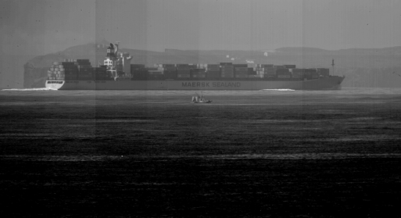

Fig. 3.2a Pt. Hueneme image test target at 3 miles – long shot

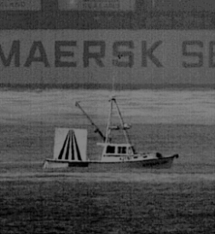
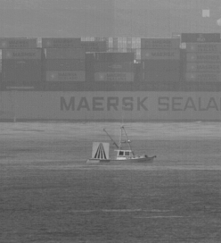

Fig. 3.2b Pt. Hueneme image test target at 3 miles – 5x zoom

Fig. 3.2c Pt. Hueneme image test target at 3 miles – 10x zoom

Fig. 3.2b Pt. Hueneme image test target at 3 miles – 5x zoom

Fig. 3.2b Pt. Hueneme image test target at 3 miles – 5x zoom
A test in the observation tower at Port Everglades was completed in November 2004. In this test the camera was remotely controlled using a fiber link and the full resolution images were sent by fiber for display at a remote location (About ¼ mile away). The remote control changed: focus, iris, IR filter in-out, optical image stabilization on-off, pan and tilt. A 200MM lens was used to give a telescopic view of the scene. It was found that the optical Image stabilization was necessary with this long a focal length lens since the tower swayed in the wind.
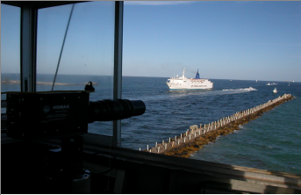Fig. 3.3 Image of the HDMAX test at Port Everglades

In addition, an underwater test of the camera was successfully completed with natural light.

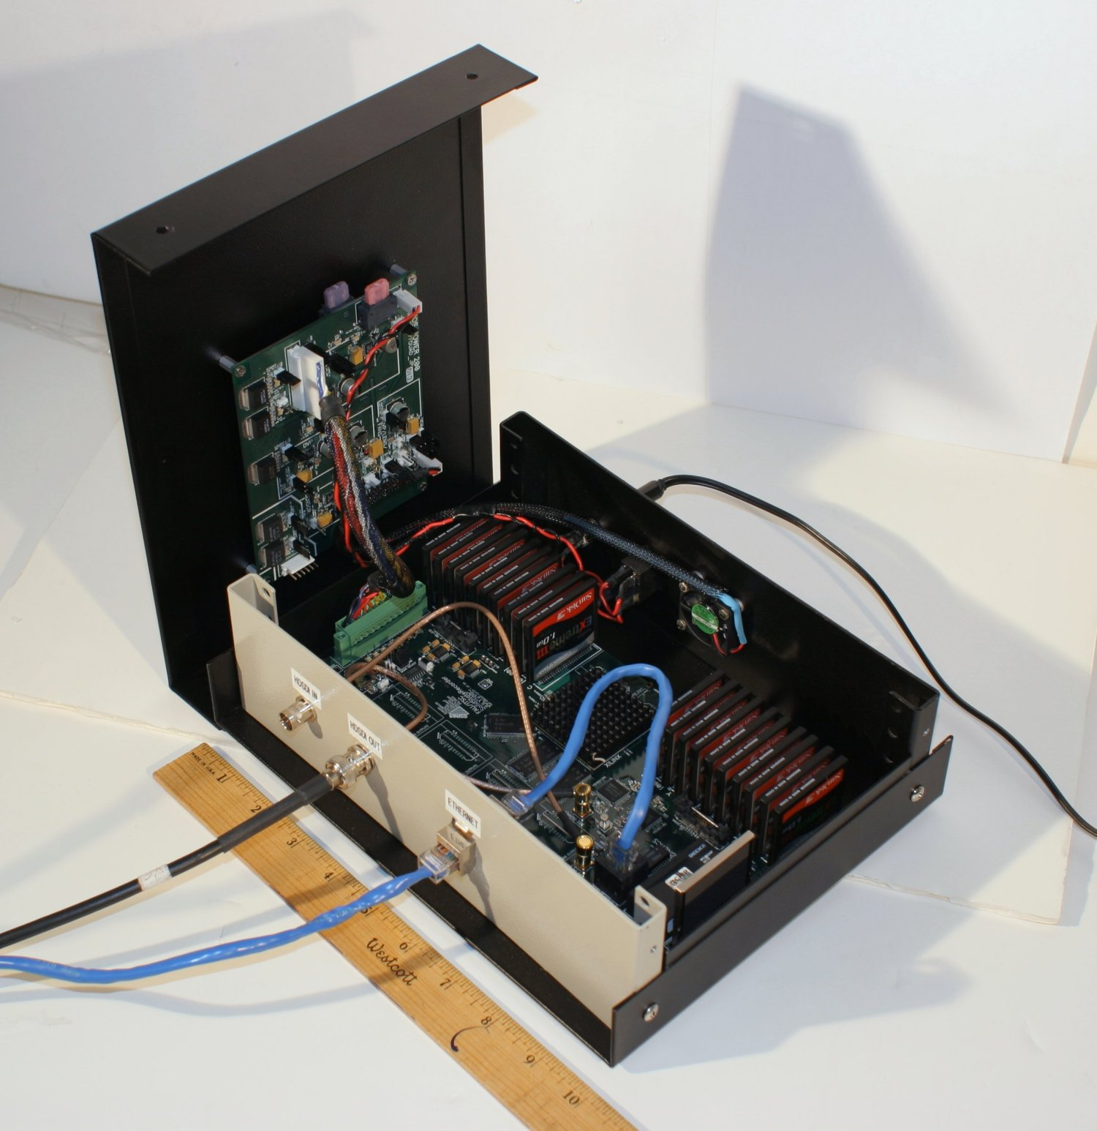
A Solid State Store for the CMOS camera was designed, fabricated and tested. A two-way fiber link for the CMOS camera was completed. The display interface for CMOS camera was completed. The recorder that was built records one 292 channel. Two of these are necessary to record the full resolution image. This recorder is much smaller, lighter and lower power consumption than the RAID recorders that were the only way that the images could be recorded previously.

Fig. 3.4b SSR - open
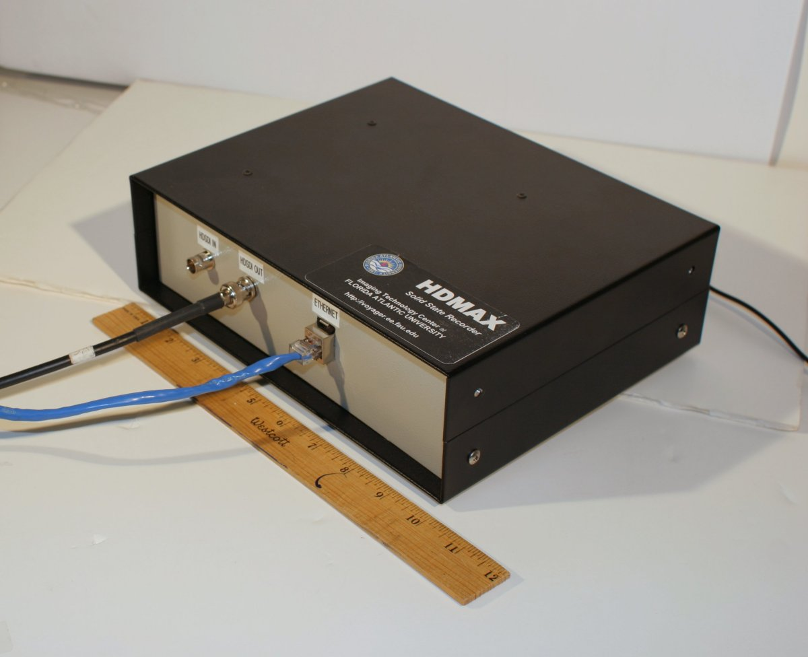
Fig. 3.4a ITC-developed solid-state store
The size, weight and power consumption are roughly all a factor of ten better than a RAID recorder. This makes it possible to consider this camera-recorder combination for use in AUVs or drone aircraft where the communication link does not have the capacity to send real time imagery. It is also useful for instant replay of events on a suspected target in a real time situation on a ship or in a harbor.

3.3 Results and Discussion

During Year 1 of the CCST project, all proposed high resolution CMOS camera and Solid State Store tasks were completed as listed in the following:
- Design and fabricate a 3840x2160 30P color CMOS camera with variable frame rate and remotely controlled infrared filter changers
- Design and develop a solid state store for the CMOS camera.
- Provide fiber link for the CMOS camera complete
- Develop display interface for CMOS camera complete
- Carry out field tests – at Pt. Everglades, FL and Pt. Hueneme, CA
- Monthly Technical Reports
- Final Test Report

The HDMAX specifications are beyond any commercial camera currently available. They are as follows:

- 12 bit encoding before gamma- 10 bit encoding after gamma.
- 33MM diagonal active frame (Uses standard 35MM cinema camera lens)
- Programmable gamma
- Auto black level
- Auto white balance
- Bad pixel correction
- Shading correction
- FPN correction
- Programmable color balance
- 1080 line output progressive or interlaced
- 1080 line frame grab output for computer download *
- Programmable color matrix on 1080 line signal
- Menu display on laptop for camera controls
- Remote digital camera control.
- Two SMPTE 292 serial digital outputs.
- Microcomputer and FLASH memory to provide ethernet interface for camera control and frame grab output.

Other specifications:
- Camera head power consumption: about 30 watts at 24 volts.
- Camera size 2.5"X4.5"X9.5"
- Weight without lens about 3.8 pounds.

Several measurements have been made on the camera. Pixel defects after exposure to high energy protons were less than one per million pixels. The bad pixel correction should handle a life of at least 10 years at high altitude.
The camera sensitivity has an equivalent ASA rating of about 400. By removing the IR filter the camera becomes sensitive to the near infrared since the color filters are transparent to infrared. In this condition it has the full monochrome 3840X2160 resolution. The sensitivity is much higher than to visible light. The IR sensitivity has not been quantitatively measured.

The S/N ratio without gamma and after FPN correction is approximately 64db.The CMOS sensor was tested and shown to be radiation tolerant. HDMAX satisfies the requirements for high-resolution video for the Navy in a small, low power package. It is compatible with the existing infrastructure for recording, transmission and display.

3.4 Patents Filed during this period:

One patent was filed during this period that is related to the technology developed: Single Sensor Video Camera System and Method.

3.5 Conclusion

The HDMAX camera and solid-state recorder are ideally suited for video surveillance on ships, submarines, harbors, AUVs and drone aircraft. The camera gathers 50 times the amount of information in its field of view as with standard resolution video cameras. The high resolution makes it possible to do electronic zoom on sections of the image without the excessive loss of resolution present with standard cameras. The high frame rate allows the use of moving target indication, velocity measurement and the observation of brief events that help classify suspected targets. The camera can operate as a color camera when that is an important signature. By removing the IR filter the camera becomes sensitive to the near infrared, which makes it more sensitive and able to penetrate fog and haze.

3.6 Recommendations

It is recommended that work continue to upgrade the camera system and to add compression to the solid-state memory to allow increased record time. It is proposed that in Year 2 of the project the following work will be completed:

- Communicate and coordinate with the NAVY to define HDMAX system requirements
- Modify HDMAX (developed in project Year 1) design and fabricate 2 upgraded HDMAX camera systems
- Modify HDMAX display interface (developed in project Year 1) and fabricate 2 upgraded HDMAX display interfaces
- Add compression to solid-state memory to allow increased record time.
- Carry out field tests: Test 1) Install HDMAX on gimble provided by ONR on aircraft carrier and test complete HDMAX system (HDMAX system includes camera, display interface and display with connectivity); Tests 2-3) complete 2 additional field tests of complete HDMAX camera system (one of the two tests will be conducted at Pt. Everglades in conjunction with Peter Tatro).
- Collaborate with FAU Department of Computer Science and Engineering staff on processing of 3-D images.
- Report

