Fourth LACCEI International Latin American and Caribbean Conference for Engineering and Technology (LACCET’2006)
“Breaking Frontiers and Barriers in Engineering: Education, Research and Practice”
21-23 June 2006, Mayagüez, Puerto Rico

Integrating Entrepreneurship with Engineering Education:
the Integrated Technology Ventures Program
at the University of Florida

Manuel E. Bermúdez
Computer and Information Science and Engineering
manuel@cise.ufl.edu
Keith Stanfill
Industrial and Systems Engineering
University of Florida
Gainesville, Florida, 32611
stanfill@ise.ufl.edu

Abstract

The Integrated Technology Ventures (ITV) program at the University of Florida combines three successful university activities: (1) the commercialization of faculty inventions by the University Office of Technology and Licensing, (2) business innovation by the Center for Entrepreneurship and Innovation in the College of Business, and (3) industry-sponsored engineering education by the College of Engineering, primarily through the Integrated Product and Process Design (IPPD) program, in which engineering student teams design and build authentic industry-sponsored products. As a result, ITV projects immerse engineering and business students in an intense, entrepreneurial experience of "real" product development, with "real" business considerations. We describe the activities and the pedagogical components of the ITV program, and the structure of the virtual start-up companies formed under its auspices. We also describe one particularly promising current ITV project, which consists of developing a robotic X-ray video imaging system, in which robotic arms will track, follow and produce X-ray video of a human joint in motion. We believe that this educational model can be emulated by other universities elsewhere, in university outreach mode, rather than the university-sponsored technology-commercialization mode of our ITV program.

Key words and phrases: engineering education, entrepreneurship, technology venture

1. Introduction.

The University of Florida Integrated Technology Ventures (ITV) program is designed to provide engineering and business students with an intense, immersive entrepreneurial experience. The ITV program builds upon successful UF industry interaction model programs such as the Integrated Product and Process Design (IPPD) program [1,2,3], where multidisciplinary student teams design and build authentic industry-sponsored products; the Center for Entrepreneurship and Innovation (CEI) [4], the Office of Technology and Licensing (OTL) [5], and two university-supported technology start-up incubator facilities [6,7]. The students learn the entrepreneurial process as “employees” of virtual companies led by volunteer CEOs. The companies are composed of a CEO, a business development team of two or more MBA students (coached by entrepreneurial faculty) and a multidisciplinary technology development team of up to six undergraduate engineers (coached by engineering faculty). The technology development teams participate in the two-semester IPPD course, which has been supplemented with Entrepreneurship lectures. The companies are responsible for creating business plans and alpha system prototypes for future commercial development.
ITV leverages key elements of these highly successful programs to provide a new entrepreneurial education experience for engineering and business students. Funding for the UF ITV Program has been provided by the Economic Development Administration (EDA—US Department of Commerce) [8], the National Collegiate Inventors and Innovators Alliance (NCIIA) [9], the UF College of Engineering, and MRI Devices Corporation, a small Gainesville, Florida based company. This year, two ITV projects were carried out. In Section 2 of this paper we describe the ITV program, and the structure of an ITV virtual company, including the technology development team and the business team. In Section 3 we describe the various activities carried out by the ITV program. In Section 4 we describe the pedagogical components of the ITV, and show how the program integrates entrepreneurship into engineering education. In Section 5, we report on the success of one particular project, a robotic X-ray video imaging system, in which robotic arms will track, follow and produce X-ray video of a human joint in motion. Finally, in Section 6, we present conclusions.

2. Description of the ITV program.

The ITV program is designed to provide engineering and business students with an intense, immersive entrepreneurial experience. Participating students learn the entrepreneurial process as “employees” of a virtual company led by a serial entrepreneur who acts as a volunteer CEO. The company is composed of a CEO, a business development team of several MBA students (coached by entrepreneurial faculty) and a multidisciplinary technology development team of 6 undergraduate engineering students, who participate in the Integrated Product and Process Design program. The students are coached by an engineering faculty member, who serves as Chief Technology Officer (CTO) of the virtual company. The technologies under development are selected from UF faculty inventions ready for commercialization, in conjunction with the University’s Office of Technology Licensing. The faculty inventor serves as an extended team member for the virtual company. A faculty member in the Center for Entrepreneurship and Innovation serves as Chief Business Officer (CBO), and leads the Business Development Team, consisting of graduate and undergraduate business students who perform market studies, develop financial analyses, and prepare presentations for possible venture capitalists and/or investors, as well as for the Office of Technology Licensing. The Chief Executive Officer (CEO) leads the company in the creation of an alpha system prototype and collateral materials such as a business plan and presentation for entry in academic business plan competitions. The structure of an ITV company is illustrated in Figure 1.

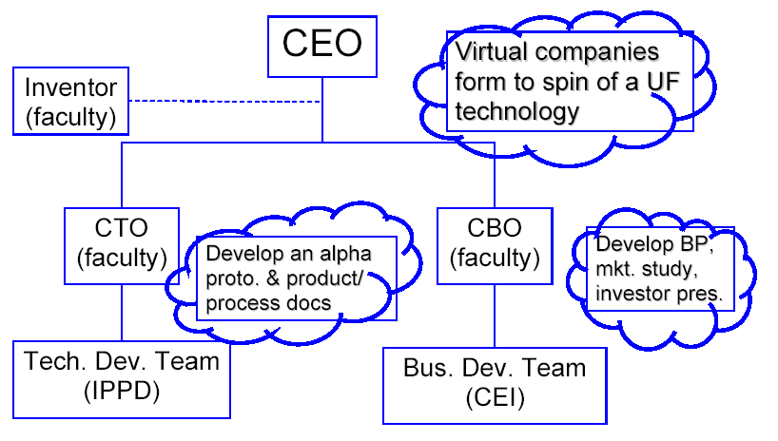
Figure 1 – ITV Company Organization

  - The Technology Development Team.

The engineering students from each virtual company are selected from a pool of students participating in the highly successful Integrated Product and Process Design (IPPD) program. IPPD is a 2-semester program where undergraduate students from various disciplines learn how to design products and processes. Working in multidisciplinary teams under the guidance of faculty coaches and liaison engineers from corporate sponsors, the students design authentic products for those industry sponsors. Students sign up for a two-semester (eight-month) 6 credit design course, which substitutes for the ordinary engineering capstone course, and a technical elective. Participating students are seniors from the Business School, Aerospace Engineering, Chemical Engineering, Civil & Coastal Engineering, Computer & Information Science & Engineering, Electrical Engineering, Environmental Engineering, Industrial & Systems Engineering, Material Science & Engineering, and Mechanical Engineering. Projects, technical advice, and financial support are provided by the corporate sponsors. In the case of an ITV project, the corporate sponsor is the ITV program rather than a corporation external to the university. The projects are carried out by multidisciplinary teams (5 to 6 per team) working with a faculty coach. Teams and individuals are evaluated against defined project deliverables and lecture/workshop performance. Since 1994, over 1400 students from 12 disciplines have participated in 242 projects from 62 sponsors, which include companies such as NASA, Boeing, Dell Computer, Dow Chemical, DuPont, Energizer, Florida Power Corp., General Dynamics, Harris, Honeywell, IBM, Kimberley-Clark, Kraft Foods, Lockheed Martin, Motorola, Pratt & Whitney, Raytheon, Siemens, Southern Nuclear, Sunbeam, Texas Instruments, Tropicana, and the US Air Force. Over two-thirds of projects come from repeat sponsors. The objectives of the IPPD program are as follows:

- Meet needs of industry
- Integrate engineering / manufacturing and business across the curriculum
- Provide students with experience of solving “Real World” engineering problems
- Prepare students
  - To work effectively in multidisciplinary teams
  - To improve their ability to communicate
  - To exercise and develop people and leadership skills
- Provide classroom & laboratory experience to new engineers, including:
  - How fundamental engineering science is relevant to effective product and process design.
  - The major product realization process concepts and practices.
  - That design involves not just function but also producibility, cost, schedule, reliability, customer preference and life cycle issues.
  - The A real life “Design and Build” project for an industrial customer
  - How to complete projects on time and within budget.
  - That engineering is a multidisciplinary team effort.

Survey responses from corporate sponsors have been excellent, including:

- Integrated engineering education is very important
- Teaching design in a multidisciplinary team on “Real World” projects is very good
- Subject content of program is what industry needs
- Reflects real engineering practices
- Improves industry / university relations
- Promotes continuous improvement of engineering curricula.

Details on the IPPD program appear in [1].

  - The Business team.

Business student participants in the ITV program are drawn from various undergraduate and masters degree programs offered through the Center for Entrepreneurship and Innovation (CEI), in the Warrington College of Business at the University of Florida. Many of these students learned the basics of business plan development through the Technology Venture Academy, [10] or Technology Venture courses. [11]. The CEI was created to introduce the concept of entrepreneurship to students, and to provide knowledge and experience to those who desire a deeper understanding of entrepreneurship. CEI offers courses such as Principles of Entrepreneurship, Fundamentals of New Venture Planning, and New Venture Creation. [12] The Center offers a minor degree in Entrepreneurship, and a Master’s degree in Entrepreneurship. ITV business teams normally enter the annual Howard J. Leonhardt Business Plan Competition, [13] sponsored by the CEI. In this competition, substantial cash prizes are awarded to the best business plans, which are presented in written form for selection of finalists, and orally in the final round of competition, to a panel of business experts. The competition is open to the entire university, and is carried out in several categories, including one for graduate students, one for undergraduate students, one for social ventures, and one for students at a local high-school. The business teams of several ITV projects have won various prizes in this competition over the last few years. This year, one of the ITV projects, called GatorRay, described later in this paper, won first place in the graduate category. [14]

  - The ITV Board of Directors (BOD)

The ITV BOD is responsible for the selection of candidate technologies for commercialization through the ITV program, recruitment of serial entrepreneurs to act as CEOs of virtual ITV companies, recruitment of faculty coaches to mentor ITV student teams, and ITV program oversight. This board comprises ITV program management, members or designees of sponsoring organizations, and others as deemed appropriate by the IPPD Director including:
- The IPPD Director.
- The Director of Industry Programs for the College of Engineering.
- The EDA (Economic Development Administration) University Center Program Coordinator.
- The Associate Director of the Office of Technology Licensing.
- The Associate Director of Center for Entrepreneurship and Innovation.

- ITV Program Activities.

The ITV program combines the best of several existing, successful programs to provide engineering and business students with an educational experience that is as close to a true entrepreneurial environment as one will face in an academic setting through the following major program activities:
- Project Selection: A strategic planning group comprised of university technology commercialization professionals and the ITV Principal Investigators, identifies a faculty-generated invention disclosure ready for marketing and business plan development and alpha prototype creation.
- Entrepreneur and Faculty Recruitment: A local, experienced entrepreneur is recruited as a CEO of a virtual company comprised of a business team (two to five MBA students) and a technology development team (typically four to six undergraduate engineering students). Part of the selection process is to identify a CEO interested in licensing the UF technology. Since the UF Office of Technology Licensing (OTL) routinely interacts with local and regional entrepreneurs with such interests, OTL took on the responsibility to find the CEO for each project. In parallel with locating a CEO, the ITV PI recruits a faculty “coach” with needed domain expertise for development of the technology toward a specific market application. This coach will serve as the CTO of the company.
- Student Recruitment: The faculty coach, the CEO, the technology inventor, and the ITV PI collaborate to determine the required discipline mix for the undergraduate technology development team. The coach then recruits this multidisciplinary team from the pool of IPPD program applicants while CEI recruits and counsels the MBA students who serve in the business team.
- Experiential Education: The technology development team participates in the IPPD course. Eight supplemental entrepreneurial workshops were developed to educate the technology team on entrepreneurial and business related issues. The business team participates in selected IPPD classes to understand engineering product and process development criteria for alpha prototype development. The business team receives course credit toward their MBA degree.
- Virtual Start-up Company Environment: The company CEO counsels and directs the entire virtual company (Engineering Team, Business Team, Faculty Coach, and Inventor as appropriate) weekly to assure that development of the deliverables, such as the market analysis, the prototype, and the business plan are progressing satisfactorily to fill market applications. At the same time, UF Engineering and CEI coaches meet with their teams individually to discuss specific engineering and business related issues.
- Educational and Entrepreneurial Deliverables: Collaboration among all of the students and the faculty coach and inventor, under the direction of the entrepreneur CEO, leads to a set of deliverables that includes development by the Technology Team of an alpha prototype that meets the market and business requirements developed by the Business Team. Concurrently, the Business Team will work with the Technology Team to produce collateral information such as a market analysis, business plan, and an investor presentation to present in the annual UF Howard J. Leonhardt Business Plan Competition and similar investor forums. The net result of the project is a team of Engineering and Business students working collaboratively with “real world experience” in a truly entrepreneurial environment.

- ITV Program Pedagogical Components.

The following are the major pedagogical components of the ITV program.

- Content and team formation. The IPPD program teaches the student participants the structured, top-down development process through two weekly just-in-time lectures with generic deliverable content, a training manual with generic deliverable requirements definitions, and a weekly coach-led workshop to tailor the deliverable content to the team’s project. Students have reading and research assignments, and they work in sub-teams and as individuals to create the project deliverable content. The ITV program follows this same proven methodology. Supplemental lecture content and additional deliverables have been defined for the ITV teams. Admission to the IPPD program is competitive and the correct number of students by discipline is recruited in aggregate each year to staff all project teams (up 180 students and 31 teams). Team formation is based upon the skill mix required of the ITV team, the qualifications of the students, and the students’ preferences.
- Entrepreneurial approaches to problem solving. The very nature of the ITV program drives project teams to take an entrepreneurial approach to problem solving. Project teams are structured and act as a virtual start-up company complete with roles, titles, and responsibilities, an entrepreneurial need to focus on limited resources, and appropriate urgency in product development to meet market demands. The teams, through the direction of the entrepreneurial CEOs, engage other resources in the university and entrepreneurial community as necessary to meet milestones. The designed multidisciplinary nature of the course and team require an entrepreneurial approach to orchestrate disparate disciplines (engineering, marketing, production, sales, etc.) in problem solving to meet technology and corporate development milestones.
- Learning objectives. The ITV program incorporates unique learning objectives including applying engineering knowledge in an entrepreneurial environment, understanding the entrepreneurial process through experiential learning, understanding and using principles of multidisciplinary team work, understanding and utilizing principles of effective oral and written communications and presentations for audiences ranging from technical specialists (researchers) to generalists (investors), and improving students’ abilities to conduct independent research to solve problems utilizing an entrepreneurial approach to problem solving.
- Supplemental modules. In addition to the regular IPPD course offerings, entrepreneurial supplement modules have been developed and offered to ITV students approximately every two weeks. The extra classes are open to all IPPD students, but required for the ITV teams. These modules are offered to provide needed information at the appropriate point in the virtual company development and include the following:

  - entrepreneurial idea generation and feasibility analysis
  - entrepreneurship and company formation
  - market analysis and research
  - building and working in a multidisciplinary business team
  - business planning and plans
  - marketing in an entrepreneurial environment
  - financing models (fundraising), financials (income statement, balance sheet, and cash flow statement)

Additional details of the ITV program structure, pedagogy and other program aspects appear in [15,16].

- A Sampling of ITV projects.

Since its inception in 2003, several successful ITV projects have been carried out. Among them we can cite:

- A respiratory muscle strengthening device for human use.
- A large-animal wireless health monitoring system.
- A passive flux meter (PFM) to monitor contamination flows in groundwater.
- An autonomous highway traffic beacon system.
- A ventricular assist device.
- A dynamic radiographic imaging control system.

We now briefly describe the last project in this list, a particularly successful and exciting ITV project carried out during the
2005-2006 academic year.

  - A Dynamic Radiographic Imaging Control System.

Diagnostic imaging techniques range from simple radiographs to powerful systems for fluoroscopy, computed tomography and magnetic resonance imaging. Unfortunately, no commercial or proposed technology is available to permit practical acquisition of dynamic images of the patient during normal activities such as walking, lifting, or throwing a ball. DRI (Dynamic Radiographic Imaging) is a new imaging platform to provide 2D and 3D imaging of the skeleton during normal dynamic activities. The imaging platform is based on an X-ray source and an image sensor mounted on independent robotic arms, whose motion is synchronized to the patient’s movements using motion capture technology. This platform will permit image sequences (X-ray video) of any skeletal region to be captured while the patient performs routine motions.
The system involves a motion capture subsystem which tracks active markers positioned in close proximity to the target, and two robotic arms which, guided by tracking information from the motion capture subsystem, follow the target as it moves. One robotic arm carries an X-ray source, and the other robotic arm carries an X-ray receiver panel, as shown in Figure 2.
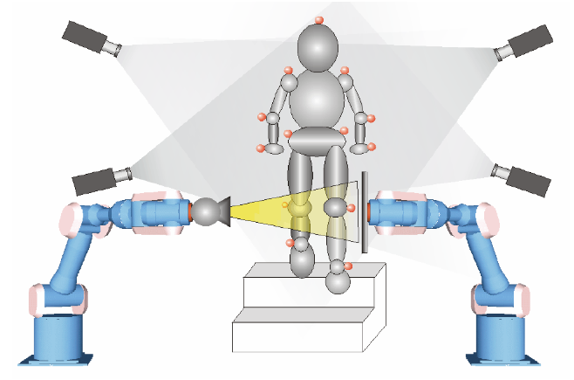 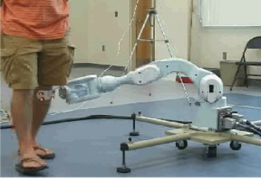 Figure 2 – Dynamic Radiographic Imaging Platform Figure 3. A robotic arm tracking a motion capture
marker cluster on a patient.

In real time, the two robotic arms move in a coordinated fashion, maintaining the target in their line of sight, enabling the image sequence to show the human joint in motion from a fixed angle. In the computed tomography mode, the robotic arms will circle around a stationary target, producing a 3-dimensional view from continuously changing angles. A robot tracking a “patient” wearing motion capture markers in our laboratory is shown in Figure 3. This capability does not currently exist in medical imaging. This technology promises to significantly enhance the observation, diagnosis, treatment and rehabilitation of people suffering from joint disease and injury.

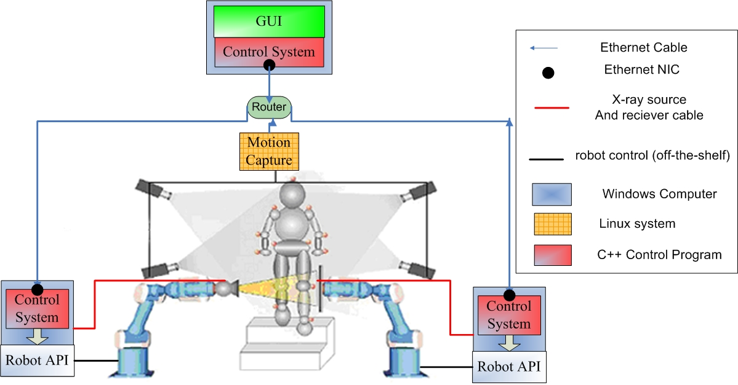
Figure 4. Radiographic Robotic Imaging System-level Architecture.

The DRI (fondly known as GatorRay) system was invented by professor of mechanical engineering Scott Banks at the University of Florida, whose on-going research is still developing the robotic technology to carry out the robot tracking. This ITV project consisted of developing a hardware/software control system and a graphical user interface (GUI) for the DRI system. An IPPD team was coached by author Bermúdez, serving as the CTO of the ITV virtual company. Author Stanfill is the Director of the IPPD program at the University of Florida. The IPPD team designed, implemented and tested the control system, whose system-level architecture is shown in Figure 4. The control system is distributed among several computers, including the central computer which exerts overall control, obeying operator commands through the GUI. A local area network was implemented to provide communication between the various subsystems. To design the GUI, the engineering team interviewed several radiologists and observed several existing imaging systems at the University of Florida’s Shands Hospital. They story-boarded the patient’s experience, and identified four steps in the process:

- Patient identification. Patient data is entered, or retrieved from a database.
- Joint selection. The motion capture marker cluster is selected for the specific joint and examination requested.
- X-ray calibration. X-ray parameters are set by the system’s operator. Test images may be obtained and checked.
- Imagine acquisition. While the patient performs the necessary movements, the robotic system tracks the joint, and acquires the image sequence.

The GUI design parallels these four activities, with four tabs in the main GUI window. The GUI showing the third tab (X-ray calibration) with a simulated X-ray of a prosthetic knee, appears in Figure 5.

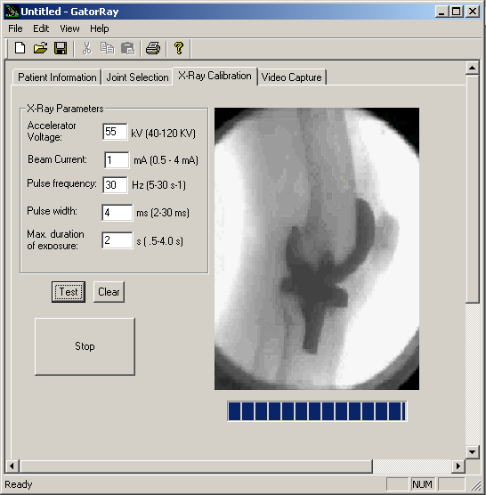
Figure 5. X-ray Calibration Window

We consider this ITV project to have been quite successful. Although the goal of building a full alpha prototype of the DRI system has not yet been achieved, the current system, with one robot rather than two, and with a video camera rather than an X-ray camera, has successfully tracked a motion capture marker cluster on a target, and a video of the target has been produced in real time, with all these activities actuated by the control system and the GUI. The resulting video of a student volunteer’s knee is uninteresting and not shown here. However, the engineering team did succeed in developing and testing the necessary hardware/software distributed control system. Its design is extendable, and we hope to expand it in the future to handle the additional functionality required by a full DRI system prototype, such as the second robot and capturing and post-processing X-ray video.
The business team was very successful as well. They prepared a business plan, and presented it recently in the 2006 Howard J. Leonhardt Business Plan Competition [13], sponsored the Center for Entrepreneurship and Innovation at the University of Florida, where they won first prize in the graduate category. [14]

7. Conclusions.

We believe the ITV program is a win-win situation for all involved. We have observed the following benefits in the case of the DRI ITV project:

- The faculty inventor now possesses (at very low cost) a tool for controlling his DRI system, which can now be extended to incorporate the second robot and an X-ray camera. His research toolkit has been significantly enhanced, and the commercialization prospects of his invention have been significantly increased.
- The CBO (a business faculty member) has guided his team through the process of developing a very successful business plan. Clearly, his educational objectives have been achieved.
- The Office of Technology and Licensing can benefit from this business plan for future commercial development of this product.
- The CTO (author and faculty member Bermúdez) has had the opportunity to contribute to enhancing the educational objectives of the IPPD program.
- Finally, and most importantly, the educational benefit to all students involved is significant, and very tangible. They have experienced, participated in, contributed to, and succeeded in, a real entrepreneurial engineering/business endeavor. Upon graduation, every one of their resumes will proudly display this item.

In this paper we have described the Integrated Technology Ventures program at the University of Florida, described the virtual start-up companies that are formed, described the roles of the various participants, their activities and the pedagogical value of the program. We also described one of our most recent ITV success stories, the Dynamic Radiographic Imaging system. We believe that this model of interdisciplinary, collaborative education does indeed integrate and enhance entrepreneurship, engineering, and business education, to the benefit of everyone involved. We believe also that this educational model can be emulated by other universities everywhere. Although the commercialization prospects for faculty inventions may be lower elsewhere, faculty inventions need not be the sole source of such projects. We believe this model can be applied in university outreach mode, rather than the university-sponsored commercialization-of-technology mode of the ITV program at the University of Florida. The source of projects, in that case, would be entrepreneurial activities in the economic community surrounding the university.

References.

- Integrated Product and Process Design. 2006. World Wide Web: (http://www.ippd.ufl.edu)
- Stanfill, R.K., G.J. Wiens, W.E. Lear and E.D. Whitney, “Institutionalized University and Industry Partnership in Multidisciplinary Design and Build: Product and Process Realization,” Proceedings, 2001 ASME International Mechanical Engineering Congress and Exposition, ASME Press, NY, NY.
- Stanfill, R. K., G. J. Wiens , W. R. Eisenstadt and O. D. Crisalle, “Lessons Learned in Integrated Product and Process Design Education,” Proceedings, 2002 ASEE Southeast Section Conference, April 2002, Gainesville, FL.
- Center for Entrepreneurship and Innovation. 2006. World Wide Web: (http://www.ufventure.com)
- Office of Technology Licensing. 2006. World Wide Web: (http://rgp.ufl.edu/otl/)
- Gainesville Technology Enterprise Center. 2006. World Wide Web: (http://www.gtecflorida.com)
- Sid Martin Biotechnology Development Incubator. 2006. World Wide Web: (http://www.biotech.ufl.org/)
- Economic Development Administration. 2006. World Wide Web: (http://www.doc.gov/eda)
- National Collegiate Inventors and Innovators Alliance. 2006. World Wide Web: (http://www.nciia.org)
- Technology Venture Academy. 2006. World Wide Web: (http://www.ufventure.com/about.asp?page_id=28&n=43)
- Technology Venture Sequence. 2006. World Wide Web: (http://www.ufventure.com/about.asp?page_id=9&n=34)
- Center for Entrepreneurship and Innovation courses: World Wide Web: (http://www.ufventures.com/about.asp?page_id=30&n=45)
- Howard J. Leonhardt Business Plan Competition. World Wide Web: (http://www.ufventures.com/about.asp?page_id=8&n=35)
- 2006 Howard J. Leonhardt Business Plan Competition Winners. World Wide Web: (http://www.ufventures.com/news.asp?page_id=1&n=1&tertNav=1)
- Stanfill, R. K., Sander, E. J., Rossi, W. J., Ingley, H. A., Whitney, E. D., Hoit, M. I., “The University of Florida Integrated Technology Ventures (ITV) Program,” Proceedings of the NCIIA 8th Annual Meeting—Education That Works: Invention, Innovation, and Entrepreneurship in Practice, San Jose, CA, March 18-20, 2004, p. 93-98.
- Stanfill, R. K., Sander, E. J., Rossi, W. J., Ingley, H. A., Whitney, E. D., Hoit, M. I., “Integrating Entrepreneurial Projects into a Successful Multidisciplinary Capstone Design Program at the University of Florida,” Proceedings of the American Society for Engineering Education 2004 Annual Conference & Exposition, Salt Lake City, Utah, June 20-23, 2004, 9 pp. (CD-ROM).

